**Year 10 – Teacher Booklet A TRILOGY**

Key Stage 4 Science:

**Chemical Changes**

**This booklet is for use in your Science lessons. Please look after it in the same way you would your exercise book and ensure that your presentation is always PROUD.**

**Ensure that your booklet is returned to your class book box at the end of the lesson.**

**Lesson Breakdown**

Lesson 1: 4.4.1.1 Metal oxides (practical – pattern seeking enquiry)

Lesson 2: 4.4.1.2 The reactivity series (practical – pattern seeking enquiry)(water and acids)

4.4.2.1 Reactions of acids with metals

Lesson 3: 4.4.1.2 Displacement reactions

Lesson 4: 4.4.1.3 Extraction of metals and reduction

Lesson 5: 4.4.2.4 The pH scale and neutralisation & 4.4.2.6 Strong and weak acids (HT only)

Lesson 6: 4.4.2.2 Neutralisation of acids and salt production

Lesson 7: 4.4.2.3 Soluble salts & **Required practical:** Preparing a salt (practical – reinforcing theory)

Lesson 8: 4.4.3.1 The process of electrolysis & 4.4.3.2 Electrolysis of molten ionic compounds

Lesson 9: 4.4.3.3 Using electrolysis to extract metals

Lesson 10: 4.4.3.4 Electrolysis of aqueous solutions

Lesson 11: **Required practical 3**: Electrolysis of aqueous solutions

***Embedded in several lessons: 4.4.1.4 Oxidation and reduction in terms of electrons (HT only)***

***Embedded in lesson 8 – 11: 4.4.3.5 Representation of reactions at electrodes as half equations (HT only)***

**Keystone words**

Oxidise

Reduce

Atom

Element

Ion

Neutralisation

Solution

**Lesson 1: Teacher notes**

**AQA Content**

When metals react with other substances the metal atoms form positive ions. The reactivity of a metal is related to its tendency to form positive ions. Metals can be arranged in order of their reactivity in a reactivity series.

Metals react with oxygen to produce metal oxides. The reactions are oxidation reactions because the metals gain oxygen.

Reduction involves the loss of oxygen.

**Students should be able to** explain reduction and oxidation in terms of loss or gain of oxygen.

**Chunking**

1. What does reactivity mean?
2. Oxidation and reduction reactions – the gain and loss of oxygen (microscopic and symbolic levels).
3. Practical (Mg / Fe / Cu reacting with oxygen). Focus on observations used to determine reactivity. (Macroscopic level).
4. Interpreting and explaining observations.

**Practical work**

**This lesson involves practical work. Careful consideration needs to be given to the format of the practical.**

**Type of enquiry: Pattern seeking**

Students observe the reactions of metals with oxygen. They use these observations to put metals in order of reactivity.

The high priority parts of the enquiry are making observations and identifying the pattern.

**Appropriate types of practical**

Reactions with oxygen: Demonstration or class practical (give consideration to which will lead to more learning).

Information related to the types of scientific enquiry can be found here:

<https://www.ogdentrust.com/wp-content/uploads/2021/10/> (scroll down to filenames starting with ‘WS’).

**Key direct and explicit teacher explanations:**

a) In chemistry, substances react when:

1. They interact with other substances and form new products. For example, hydrogen reacts with oxygen to make water. Hydrogen and oxygen are the reactants and water is the product.
2. A molecule breaks up into smaller molecules; we call this decomposition. For example, calcium carbonate decomposes to form calcium oxide and carbon dioxide.

In all cases, the atoms rearrange to form new substances. Electrons from the outer shell of atoms may be given, taken or shared differently after the reaction has occurred (see Structures and Bonding).

Some substances react more readily than others; they are more reactive. For example, potassium is more reactive than lithium metal. Potassium has a higher reactivity.

Substances that have a higher reactivity also have a greater tendency to form ions. For example, group 1 metals form positive ions. However, potassium has a greater tendency to form ions because it is more reactive. This is because the attraction between the nucleus and outer shell electrons is weaker in more reactive substances.

b) In this lesson you will learn about oxidation and reduction reactions. You will also use examples of these to put three metals in order of reactivity.

Oxidation reactions happen when oxygen is added to a substance. For example, when magnesium reacts with oxygen, magnesium oxide is produced.

One way of representing this is shown in the Connect task. We can also use word and symbol equations and also show the particles:

Reduction reactions are the opposite of oxidation reactions. Oxygen is removed from a substance.

There is another definition of oxidation and reduction that you will come across in this topic.

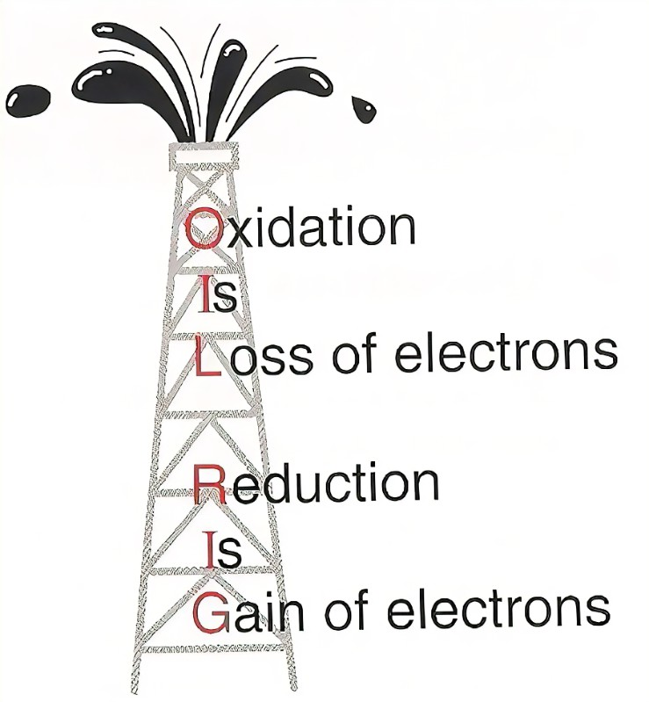

c) **Ideally done as slow practicals. FOCUS should be used.**

d) **Opportunity to use Turn & Talk so students discuss their thoughts on the order of reactivity and the observations that contribute to this.**

This type of oxidation and reduction happen when atoms or ions gain and lose electrons.

**Teacher notes (e.g. key questions, examples, non-examples, explanations)**

____________________________________________________________________________________________________________________________________________________________________________________________________________________________________________________________________________________________________________________________________________________________________________________________________________________________________________________________________________________________________________________________________________________________________________________________________________________________________________________________________________________________________________________________________________________________________________________________________________________________________________________________________________________________________________________________________________________________________________________________________________________________________________________________________________________________________________________________________________________________________________________________________________________________________________________________________________________________________________________________________________________________________________________________________________________________________________________________________________________________________________________________________________________________________________________________________________________________________________________________________________________________________________________________________________________________________________________________________________________________________________________________________________________________________________________________________________________________________________________________________________________________________________________________________________________________________________________________________________________________________________________________

**Lesson 1: 4.4.1.1 Metal oxides**

**Objective: You are learning to describe the reactions of metals with oxygen on the macroscopic, microscopic and symbolic levels and to put the metals in order of reactivity.**

**Skills Drill / Retrieval**

|  |  |  |
| --- | --- | --- |
| Answer | | PA / SA |
| 1 |  |  |
| 2 |  |  |
| 3 |  |  |
| 4 |  |  |
| 5 |  |  |

**Connect**

**We will be looking at reactions that involve atoms gaining or losing electrons as part of this topic. We will relate this to reactivity and extracting metals. We covered this content in Structures and Bonding.**

**When metals react with non-metals they form ionic bonds. The metal gives electrons to the non-metal; this enables the atoms to become stable ions (atoms that have gained or lost electrons).**

**For example:**

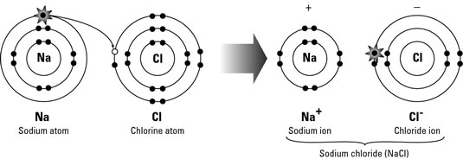

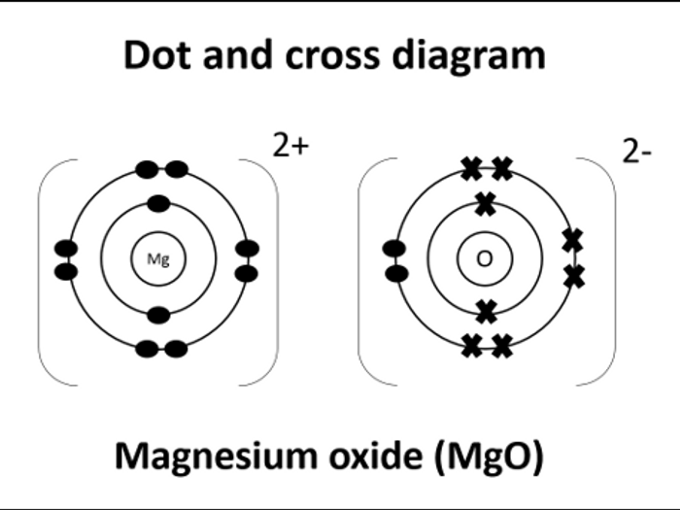

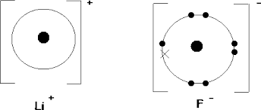

**-1**

**+1**

**Draw the structure of the ions formed when these elements react:**

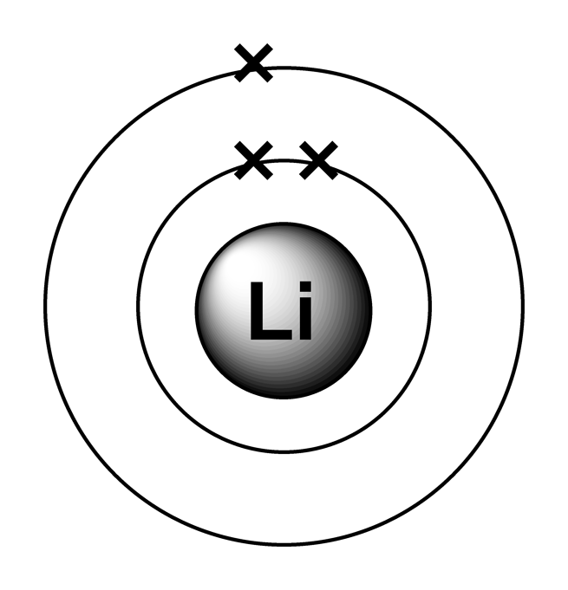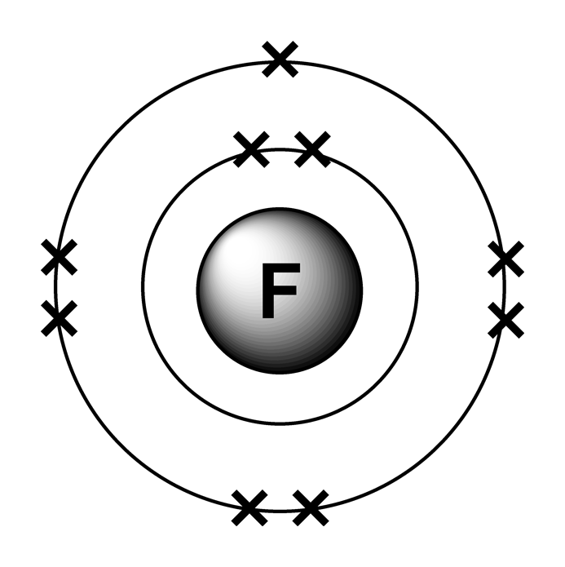

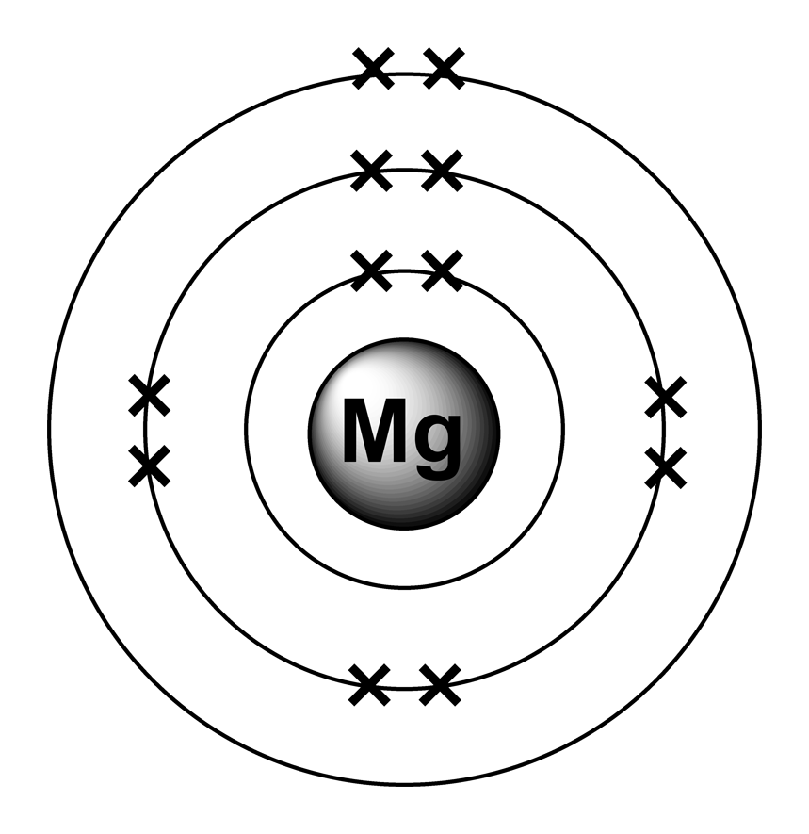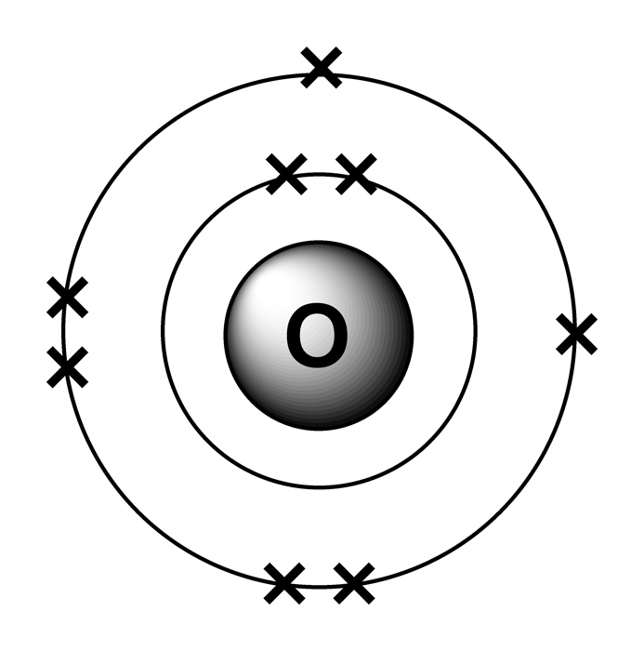

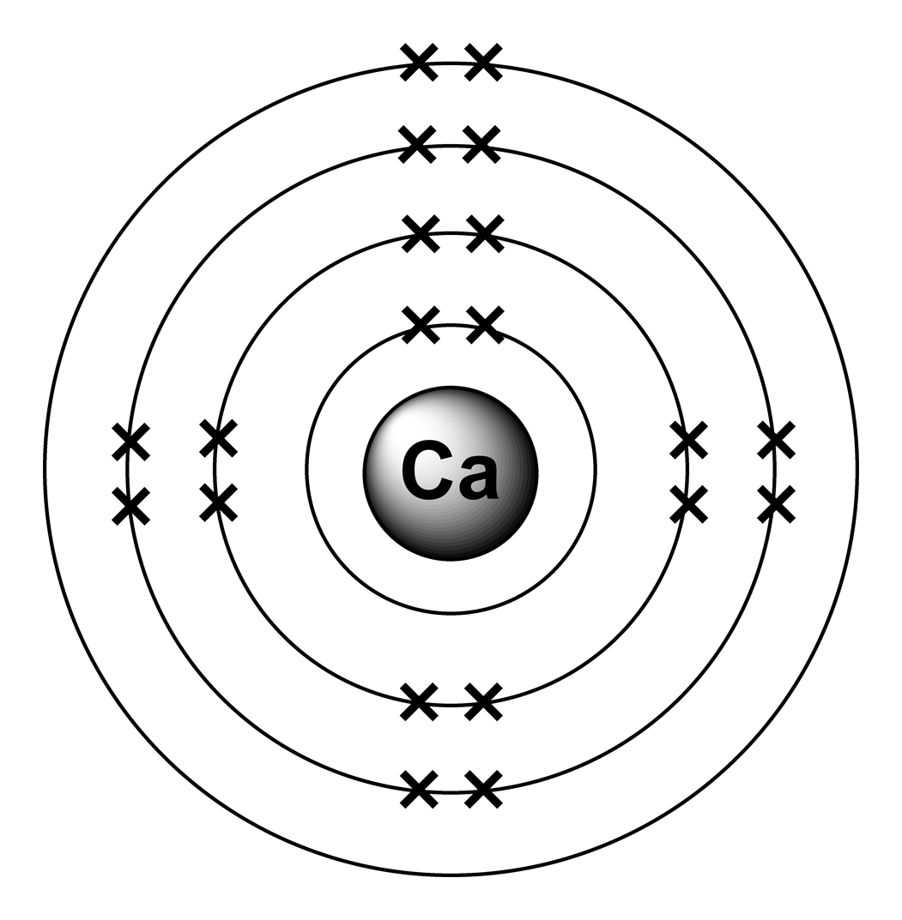

**The sodium atom has one electron in its outer shell. This makes it unstable. It will be more stable if it can donate (give) its outer shell electron to another atom. In this example it gives the outer shell electron to a chlorine atom. This also makes the chlorine atom stable because its outer shell is now full.**

**Atoms that have gained or lost electrons are called ions (in this case, sodium and chloride ions form).**

2Mg(s) + O2(g) 🡪 2MgO(s)

Magnesium + oxygen 🡪 magnesium oxide

2Ca(s) + O2(g) 🡪 2CaO(s)

Calcium + oxygen 🡪 calcium oxide





+

When copper reacts with oxygen it forms copper oxide.

The copper atoms are oxidised because they gain oxygen.

This can be represented as:

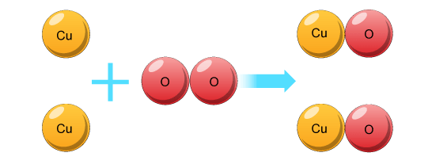

We can write this as a word equation:

**Copper + Oxygen 🡪 Copper Oxide**

We can also write this as a symbol equation:

**2Cu + O2 🡪 2CuO**

1. Represent the following reaction as word equations and symbol equations:

Word equation: ___________________________________________________________________________

Symbol equation: __________________________________________________________________________

1. Magnesium (Mg) reacts with oxygen (O2) to make magnesium oxide (MgO).

Write the word equations for this reaction.

___________________________________________________________________________

1. Write the balanced symbol equation for the same reaction.

___________________________________________________________________________

**Defining Oxidation:**

In the last activity copper and magnesium were shown reacting with oxygen.

These were examples of oxidation reactions.

1. When metals are oxidised, do they gain or lose oxygen?

______________________________________________________________________________________________________________________________________________________

In the Connect task, calcium and magnesium were also shown reacting with oxygen.

However, the electronic arrangements of the atoms were shown.

These examples also showed oxidation reactions.

1. When metals react with oxygen, do the at metal atoms gain or lose electrons?

_________________________________________________________________________________________________________________________________________________________________________________________________________________________________

Reduced, oxidised

Oxidised, reduced

Reduced, oxidised

Oxidised , reduced

Reduced, oxidised

Oxidised

Reduced

Reduced

Oxidised

Reduced

Lose

Gain

**Oxidation and reduction mastery**

When substances gain oxygen they are said to be oxidised.

When they lose oxygen, they are said to be reduced.

For each of the following reactions, state whether the **bold and underlined** substance is oxidised or reduced:

1. **Aluminium oxide** 🡪 aluminium + oxygen ________________________________
2. **Nickel** + oxygen 🡪 nickel oxide ________________________________
3. Carbon + **zinc oxide** 🡪 carbon dioxide + zinc ________________________________
4. Aluminium + **chromium oxide** 🡪 aluminium oxide + chromium ______________________
5. **Aluminium** + oxygen 🡪 aluminium oxide ________________________________

For each of the following reactions, underline the substance that is being oxidised and draw a circle around the substance being reduced.

1. Iron oxide + hydrogen 🡪 iron + water
2. Hydrogen + copper oxide 🡪 copper + water
3. Tungsten oxide + hydrogen 🡪 tungsten + water
4. Magnesium + iron oxide 🡪 magnesium oxide + iron
5. Iron oxide + carbon 🡪 Iron + carbon dioxide

Metal atoms have equal numbers of positively charged protons and negatively charged electrons.

When they react they lose electrons. Number of protons is greater than electrons.

Positive

Mg, Fe, Cu

Mg, Fe, Cu)

Copper. Colour change occurred very slowly. Energy transferred slowly (may not be recognised).

Magnesium. Reacted most vigorously. Energy transferred quickly.

Black powder forms on surface slowly (CuO).

Glows red, heat.

Bright white light, heat, white ‘smoke’ (MgO).

**The reactions of metals with oxygen**

**Metals react with oxygen in the air to make metal oxides.**

**In these experiments you will observe what happens when different metals react with oxygen.**

**You will then use your observations to put the metals in order based on reactivity; this is a pattern seeking enquiry.**

**Your teacher will either demonstrate the experiment or explain how to do it.**

|  |  |
| --- | --- |
| **Name of metal** | **Observations** |
| **Iron** |  |
| **Copper** |  |
| **Magnesium** |  |

1. Which metal was most reactive? How do you know this?

______________________________________________________________________________________________________________________________________________________

1. Which metal was least reactive? How do you know this?

______________________________________________________________________________________________________________________________________________________

1. List the metals in order of reactivity (most reactive first).

___________________________________________________________________________

1. List the metals in order of their tendency to form ions (greatest tendency first).

___________________________________________________________________________

1. Did the metals form positive or negative ions when they reacted with oxygen?

___________________________________________________________________________

1. Use your knowledge of sub-atomic particles to explain why the ions have this charge.

_________________________________________________________________________________________________________________________________________________________________________________________________________________________________

**Lesson 2: Teacher notes**

**AQA Content**

When metals react with other substances the metal atoms form positive ions. The reactivity of a metal is related to its tendency to form positive ions. Metals can be arranged in order of their reactivity in a reactivity series. The metals potassium, sodium, lithium, calcium, magnesium, zinc, iron and copper can be put in order of their reactivity from their reactions with water and dilute acids.

**Students should be able to:** • recall and describe the reactions, if any, of potassium, sodium, lithium, calcium, magnesium, zinc, iron and copper with water or dilute acids and where appropriate, to place these metals in order of reactivity • explain how the reactivity of metals with water or dilute acids is related to the tendency of the metal to form its positive ion • deduce an order of reactivity of metals based on experimental results. The reactions of metals with water and acids are limited to room temperature and do not include reactions with steam.

**4.4.1.4 (HT only)** Oxidation is the loss of electrons and reduction is the gain of electrons. Student should be able to: • write ionic equations for displacement reactions • identify in a given reaction, symbol equation or half equation which species are oxidised and which are reduced.

**Chunking**

1. Reactions of metals with water (macroscopic)
2. Representing reactions of metals with water (microscopic and symbolic)
3. Reactions of metals with acids (macroscopic)
4. Representing reactions of metals with acids (microscopic and symbolic)

**Practical work**

**This lesson involves practical work. Careful consideration needs to be given to the format of the practical.**

**Type of enquiry: Pattern seeking**

Students observe the reactions of metals with water and acid (where appropriate). They use these observations to put metals in order of reactivity.

The high priority parts of the enquiry are making observations and identifying the pattern.

**Appropriate types of practical**

Reactions with water: Demonstration (alkali metals with water).

Reactions with acids: Demonstration or class practical (give consideration to which will lead to more learning).

Information related to the types of scientific enquiry can be found here:

<https://www.ogdentrust.com/wp-content/uploads/2021/10/> (scroll down to filenames starting with ‘WS’).

**Key direct and explicit teacher explanations:**

1. **This is a teacher demonstration only. Students should use FOCUS.**

Yesterday we used the reaction of metals with oxygen to put metals in order of reactivity. We will now use the reactions of metals with water and acids to see if we get a similar pattern.

You need to make careful observations as the metals are added to water. Note down your observations in the table in your booklet.

**Good opportunity for Turn and Talk before students complete the questions.**

1. When metals react with water there are several indications that a chemical reaction is happening. A gas is produced, heat is generated (K and Na melt into a ball) and ‘smoke’ appears. The pH of the water in the trough also changes. The high pH tells us that an alkali is being made.

Group 1 metals with water to make metal hydroxides and hydrogen gas.

Other metals tend to form metal oxides and hydrogen gas.

Metal oxides and hydroxides contain positive metal ions; the metal has been oxidised because it has lost electrons.

With metal oxides, we can also say the metal is oxidised because the metal gains oxygen.

1. **The focus needs to remain on learning from the practical and observations. A demonstration is probably the best vehicle to facilitate this. It would also lessen the chances of students getting overloaded with practicals in this topic.**

**Students should use FOCUS.**

Metals react with acids more readily than they do with water. This practical will allow us to put the less reactive metals in order of reactivity.

1. When metals react with acids they form a salt (a metal ion bonded to a non-metal ion or ions). We look at naming salts in a different lesson. In this case we used sulphuric acid so the salt will be a metal sulphate.

Hydrogen gas is also produced.

**Good opportunity for Turn and Talk before students complete the questions.**

**A synoptic question is given at the end of the activities. This can be completed at any convenient point in this lesson or another.**

**Teacher notes (e.g. key questions, examples, non-examples, explanations)**

____________________________________________________________________________________________________________________________________________________________________________________________________________________________________________________________________________________________________________________________________________________________________________________________________________________________________________________________________________________________________________________________________________________________________________________________________________________________________________________________________________________________________________________________________________________________________________________________________________________________________________________________________________________________________________________________________________________________________________________________________________________________________________________________________________________________________________________________________________________________________________________________________________________________________________________________________________________________________________________________________________________________________________________________________________________________________________________________________________________________________________________________________________________________________________________________________________________________________________________________________________________________________________________________________________________________________________________________________________________________________________________________________________________________________________________________________________________________________________________________________________________________________________________________________________________________________________________________________________________________________________________________

**Lesson 2: 4.4.1.2 The reactivity series**

**Objective: You are learning to put metals in order of their reactivity using observations of metals reacting with water and dilute acids.**

**Skills Drill / Retrieval**

|  |  |  |
| --- | --- | --- |
| Answer | | PA / SA |
| 1 |  |  |
| 2 |  |  |
| 3 |  |  |
| 4 |  |  |
| 5 |  |  |

**Catch up (complete this if you were absent last lesson):**

Use your knowledge booklet to answer these questions:

1. When metals react with other substances, do they form positive or negative ions?

______________________________________________________________________________

1. When metals react with oxygen, they gain oxygen to form a metal oxide.

Is the metal oxidised or reduced?

______________________________________________________________________________

1. When metals react with non-metals they lose electrons.

Are the metals being oxidised or reduced when they lose electrons?

______________________________________________________________________________

1. Put these metals in order of reactivity (most reactive first):

Copper, magnesium, iron

_____________________________________________________________________________

1. What does it mean if we say ‘more reactive elements have a greater tendency to form positive ions’?

____________________________________________________________________________________________________________________________________________________________

More reactive elements have a weaker attraction between the nucleus and the outer shell electrons.

Magnesium, iron, copper

Oxidised

Oxidised

Positive

High melting and boiling points.

Conduct electricity (but only if they are molten or dissolved).

Hard when a solid (due to strong electrostatic forces).



The metals atoms lost electrons to form metal ions.

**Connect – use your knowledge booklet / textbook for reminders.**

In the last lesson, we reacted metals with oxygen (a non-metal).

The way in which substances react was taught in KS4 Structures and Bonding. This built on content taught at KS3 and in KS4 Atomic Structure and the Periodic Table.

1. The metals were oxidised during the reaction. What does this mean?

________________________________________________________________________________________________________________________________________________________

1. The metal and non-metal formed an ionic compound.

Draw the electronic structure of magnesium; it has 12 electrons.

________________________________________________________________________________________________________________________________________________________________________________________________________________________________________________________________________________________________________________________________________________________________________________________________________________________________________________________________________

1. Draw the electronic structure of the magnesium ion that is produced when magnesium reacts with oxygen.

________________________________________________________________________________________________________________________________________________________________________________________________________________________________________________________________________________________________________________________________________________________________________________________________________________________________________________________________________

1. List the physical properties that you would expect magnesium oxide to have (it is an ionic compound).

____________________________________________________________________________________________________________________________________________________________________________________________________________________________________________________________________________________________________________________________________________________________________________________________________________________________________________________________________________________________________________________________________________________________________________________________________________________________________________________________________________________________________________

Nothing other than it sinks.

Nothing other than it sinks.

Some bubbles may be produced albeit very slowly. Sinks.

Floats. Red flame (if present). Bubbles / effervescence. Indicator goes blue. May spark.

Floats. Orange flame (if present). Bubbles / effervescence. Indicator goes blue. May spark. Metal melts to form a sphere.

Floats. Lilac flame. Bubbles / effervescence. Indicator goes blue. May spark. Metal melts to form a sphere.

Potassium, sodium, lithium, magnesium, copper / iron (both unreactive).

Magnesium may also appear unreactive.

Common answer: Speed of metal if less dense that water. Rate of production of bubbles.

Potassium, sodium, lithium, magnesium, copper / iron (both unreactive).

Magnesium may also appear unreactive.

**Reactions of metals with water**

You are going to observe what happens when different metals are added to water.

You will then put the metals in order of their reactivity.

Write your observations in the table below:

|  |  |
| --- | --- |
| **Metal added to water** | **Observations** |
| Lithium |  |
| Sodium |  |
| Potassium |  |
| Magnesium |  |
| Copper |  |
| Iron |  |

1. Use your observations to put the metals in order of reactivity (most reactive first)

____________________________________________________________________________________________________________________________________________________________

1. Which of your observations helped you the most when you were putting the metals in order of reactivity? Explain your answer.

__________________________________________________________________________________________________________________________________________________________________________________________________________________________________________

1. We learnt in the last lesson that reactivity is related to a metals tendency to form ions.

Put the metals in order of their tendency to form ions (greatest tendency first).

__________________________________________________________________________________________________________________________________________________________________________________________________________________________________________

Bubbles produced slowly.

Bubbles produced slowly if at all.

Container becomes warm / hot. Bubbles produced at a fast rate.

Potassium, sodium, lithium, magnesium, iron, copper.

Magnesium, iron, copper.

Rate of production of bubbles.

Magnesium, iron, copper.

**Reactions of metals with acid**

You are going to observe what happens when different metals are added to a dilute acid.

You will then put the metals in order of their reactivity.

Write your observations in the table below:

|  |  |
| --- | --- |
| **Metal added to water** | **Observations** |
| Magnesium |  |
| Copper |  |
| Iron |  |

1. Use your observations to put the metals in order of reactivity (most reactive first).

____________________________________________________________________________________________________________________________________________________________

1. Which of your observations helped you the most when you were putting the metals in order of reactivity? Explain your answer.

__________________________________________________________________________________________________________________________________________________________________________________________________________________________________________

1. We learnt in the last lesson that reactivity is related to a metals tendency to form ions.

Put the metals in order of their tendency to form ions (greatest tendency first).

__________________________________________________________________________________________________________________________________________________________________________________________________________________________________________

1. Look at all of your observations from last lesson and this lesson. Put all of the metals in order of reactivity (most reactive first).

__________________________________________________________________________________________________________________________________________________________________________________________________________________________________________

2K(s) + 2H2O(l) 🡪 2 KOH(aq) + H2(g)

2Na

(s) + 2H2O(l) 🡪 2 NaOH(aq) + H2(g)

Sodium + water 🡪 sodium hydroxide + hydrogen

**Representing reactions symbolically (as equations)**

Reactions of metals with water

When lithium reacts with water, the products are lithium hydroxide and hydrogen gas:

**Word equation:** Lithium + water 🡪 lithium hydroxide + hydrogen

**Symbol equation:** 2Li(s) + 2H2O(l) 🡪 2LiOH(aq) + H2(g)

Other alkali metals also form metal hydroxides.

When metals that aren’t in group 1 react with water they make metal oxides. For example, when magnesium reacts with water:

**Word equation:** Magnesium + water 🡪 magnesium oxide + hydrogen

**Symbol equation:** Mg(s) + H2O(l) 🡪 MgO(aq) + H2(g)

**Questions:** Complete the work and symbol equations for the following reactions:

1. When sodium (Na) reacts with water (H2O), the products are sodium hydroxide (NaOH) and hydrogen gas (H2).

**Word equation:** _____________________________________________________________________

**Symbol equation:** ___________________________________________________________________

1. When potassium (K) reacts with water (H2O), the products are potassium hydroxide (KOH) and hydrogen gas (H2).

**Word equation:** _____________________________________________________________________

**Symbol equation:** ___________________________________________________________________

**For each reaction, underline the reactant that is oxidised.**

Potassium + water 🡪 Potassium hydroxide + hydrogen

They are reactive metals. The reaction is likely to be dangerous.

2Na(s) + H2SO4(aq) 🡪 Na2SO4(aq) + H2(g)

Fe(s) + H2SO4(aq) 🡪 FeSO4(aq) + H2(g)

Cu(s) + H2SO4(aq) 🡪 CuSO4(aq) + H2(g)

Sodium + sulphuric acid 🡪 sodium sulphate + hydrogen

Iron + sulphuric acid 🡪 iron sulphate + hydrogen

Copper + sulphuric acid 🡪 copper sulphate + hydrogen

**Representing reactions symbolically (as equations)**

Reactions of metals with sulphuric acid

When metals react with sulphuric acid the products are a metal sulphate (a type of salt) and hydrogen gas.

**Word equation:** Magnesium + sulphuric acid 🡪 magnesium sulphate + hydrogen

**Symbol equation:** Mg(s) + H2SO4(aq) 🡪 MgSO4(aq) + H2(g)

**Questions:** Complete the work and symbol equations for the following reactions:

1. When copper (Cu) reacts with sulphuric acid (H2SO4), the products are copper sulphate (CuSO4) and hydrogen gas (H2).

**Word equation:** _____________________________________________________________________

**Symbol equation:** ___________________________________________________________________

1. When iron (Fe) reacts with sulphuric acid (H2SO4), the products are iron sulphate (FeSO4) and hydrogen gas (H2).

**Word equation:** _____________________________________________________________________

**Symbol equation:** ___________________________________________________________________

1. If we reacted sodium (Na) with sulphuric acid (H2SO4), the products would be sodium sulphate (Na2SO4) and hydrogen gas (H2).

**Word equation:** _____________________________________________________________________

**Symbol equation:** ___________________________________________________________________

1. We didn’t react lithium, sodium and potassium with sulphuric acid. Why would it be a bad idea to react these metals with sulphuric acid?

__________________________________________________________________________________________________________________________________________________________________________________________________________________________________________

**For each reaction, underline the reactant that is oxidised.**

So far in this topic you have observed the following reactions:

* Metals + oxygen
* Metals + water
* Metals + dilute acid

In all of these reactions, a metal was reacted with a non-metal; an ionic salt was produced.

**Question: Rubidium is an alkali metal that is below potassium in group 1.**

**Describe what would happen if we reacted rubidium with water.**

You should justify your answers using your scientific knowledge from several topics.

You should include the following:

1. What you would see and hear when rubidium is added to water.
2. The electronic structure of rubidium atoms & ions (Atomic Structure/Bonding & Structure).
3. An explanation relating the electronic structure of rubidium to why you think it is more or less reactive than lithium, sodium and potassium (Atomic Structure).
4. The physical properties that you would expect the product to have (Bonding and Structure).
5. Word and symbol equations for the reaction.

____________________________________________________________________________________________________________________________________________________________________________________________________________________________________________________________________________________________________________________________________________________________________________________________________________________________________________________________________________________________________________________________________________________________________________________________________________________________________________________________________________________________________________________________________________________________________________________________________________________________________________________________________________________________________________________________________________________________________________________________________________________________________________________________________________________________________________________________________________________________________________________________________________________________________________________________________________________________________________________________________________________________________________________________________________________________________________________________________________________________________________________________________________________________________________________________________________________________________________________________________________________________________________________________________________________________________________________________________________________________________

**Lesson 3: Teacher notes**

**AQA Content – Displacement**

When metals react with other substances the metal atoms form positive ions. The reactivity of a metal is related to its tendency to form positive ions. Metals can be arranged in order of their reactivity in a reactivity series.

A more reactive metal can displace a less reactive metal from a compound.

**(HT only) Students should be able to:** • explain in terms of gain or loss of electrons, that these are redox reactions • identify which species are oxidised and which are reduced in given chemical equations.

**Knowledge of reactions limited to those of magnesium, zinc and iron with hydrochloric and sulfuric acids.**

**4.4.1.4 (HT only) Student should be able to:** • write ionic equations for displacement reactions • identify in a given reaction, symbol equation or half equation which species are oxidised and which are reduced.

**Chunking**

1. The reactivity series
2. Displacement reactions
3. (HT only) Representing displacement reactions.

**Practical work**

**This lesson involves practical work. Careful consideration needs to be given to the format of the practical.**

**Purpose of practical: Practical demonstration of the theory underpinning displacement reactions.**

Students use their knowledge of the reactivity series to predict the outcomes of displacement reactions. They then observe the reactions.

The high priority parts of the enquiry are predicting outcomes and observing.

**Appropriate types of practical**

Displacement reactions: Demonstration or class practical (give consideration to which will lead to more learning in the time allocated).

Information related to the types of scientific enquiry can be found here:

<https://www.ogdentrust.com/wp-content/uploads/2021/10/> (scroll down to filenames starting with ‘WS’).

*Details of this practical can be found here:

<https://edu.rsc.org/experiments/displacement-reactions-between-metals-and-their-salts/720.article>

**Key direct and explicit teacher explanations:**

1. In the previous two lessons we used experimental observations to put metals in order of reactivity. A more complete Reactivity Series exists that contains more metals. It also contains carbon and hydrogen; these non-metals are included because scientists often use them in displacement reactions.
2. Displacement reactions are reactions in which a more reactive element displaces a less reactive element from a compound. For example, potassium can displace sodium from sodium chloride.

Potassium + sodium chloride 🡪 potassium chloride + sodium

It is always the case that the more reactive element displaces the less reactive one.

It is also always the case that the bigger the difference in reactivity, the more vigorous the reaction. So, using potassium to displace copper from copper chloride would be a much more vigorous reaction than the previous one.

**This is probably the best point at which to do the experiment.**

**Students do need to predict outcomes of reactions.**

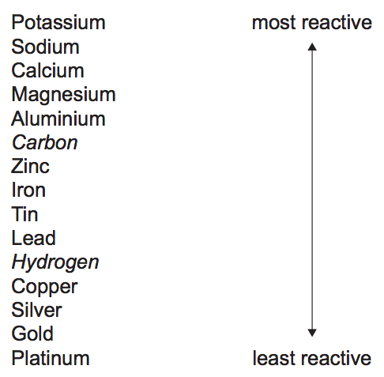

1. **(HT only)** Displacement reactions can be represented by ionic equations. These are similar to symbol equations. However, they only show changes to ions and atoms.

There are several steps needed if you are to successfully write ionic equations. The first is to write a balanced symbol equation. The atoms ions associated with the reactants and products are then written out separately.

We only want to see changes to atoms and ions, so we can cancel out any ions that do not change. This leaves us with the final ionic equation.

**Teacher notes (e.g. key questions, examples, non-examples, explanations)**

____________________________________________________________________________________________________________________________________________________________________________________________________________________________________________________________________________________________________________________________________________________________________________________________________________________________________________________________________________________________________________________________________________________________________________________________________________________________________________________________________________________________________________________________________________________________________________________________________________________________________________________________________________________________________________________________________________________________________________________________________________________________________________________________________________________________________________________________________________________________________________________________________________________________________________________________________________________________________________________________________________________________________________________________________________________________________________________________________________________________________________________________________________________________________________________________________________________________________________________________________________________________________________________________________________________________________________________________________________________________________________________________________________________________________________________________________________________________________________________________________________________________________________________________________________________________________________________________________________________________________________________________

**Lesson 3: 4.4.1.2 Displacement reactions**

**Objective:** You are learning to use the reactivity series to predict the products of a reaction and how to write the equation for the reactions used.

**Skills Drill / Retrieval**

|  |  |  |
| --- | --- | --- |
| Answer | | PA / SA |
| 1 |  |  |
| 2 |  |  |
| 3 |  |  |
| 4 |  |  |
| 5 |  |  |

Sodium hydroxide

Magnesium oxide

Iron sulphate

Calcium

Magnesium

Zinc

Copper

_________________________

_________________________

_________________________

_________________________



**Catch up (complete this if you were absent last lesson):**

Use your knowledge booklet to answer these questions:

1. Complete these word equations:

Sodium + water 🡪 ______________ __________________ + hydrogen

Magnesium + water 🡪 ________________ __________________ + hydrogen

Iron + sulphuric acid 🡪 ________________ ___________________ + hydrogen

1. The metals shown in the image are reacting with an acid. List them in order of reactivity (most reactive first).

They lose electrons from the outer shell / energy level.

Potassium

In order of reactivity:

1 > 2 > 3 > 4 > TM

1

1

2

2

3

4

Transition metal (TM)

TM

4

1

TM

TM

TM

TM

1. If you ignore Carbon and Hydrogen, what pattern can you see in the group numbers?

________________________________________________________________________________________________________________________________________________________________________________________________________________________

1. Which of the elements have the greatest tendency to form ions?

________________________________________________________________________

1. Do the metals gain or lose electrons when they react?

________________________________________________________________________

_________________________________________________________________________________________________________________________________________________________________________________________________________________________________________________________________________________________________________________________________________________________

**Connect**

The Reactivity Series is one of the most important concepts in chemistry. It is used to design devices to transfer energy, purify metals and to understand how the body works at a molecular level.

You were introduced to the Reactivity Series at KS3. We build on that knowledge in this topic.

A copy of the Reactivity Series is shown below.

Find each element on the Periodic Table and write down the group it is found in.

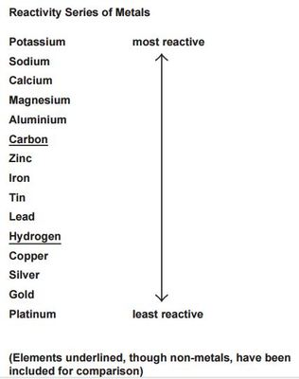

The following react:

G, h, I, j, k.

**Predictions -** Predict whether there will be a reaction or no reaction.

1. Zinc nitrate + magnesium Reaction________________________________

Reason:_____Magnesium is more reactive than zinc_______________________________________ _________________________________________________________________________________

1. Zinc nitrate + copper No reaction___ __________________________

Reason: _____Copper is less reactive than zinc_________________________ __________________

_________________________________________________________________________________

1. Zinc nitrate + lead _______________________________________

Reason:____________________________________________________________________________________________________________________________________________________________

1. Magnesium nitrate + zinc _______________________________________

Reason:____________________________________________________________________________________________________________________________________________________________

1. Magnesium nitrate + copper _______________________________________

Reason:____________________________________________________________________________________________________________________________________________________________

1. Magnesium nitrate + lead _______________________________________

Reason:____________________________________________________________________________________________________________________________________________________________

1. Copper nitrate + zinc _______________________________________

Reason:____________________________________________________________________________________________________________________________________________________________

1. Copper nitrate + magnesium _______________________________________

Reason:____________________________________________________________________________________________________________________________________________________________

1. Copper nitrate + lead _______________________________________

Reason:____________________________________________________________________________________________________________________________________________________________

1. Lead nitrate + zinc _______________________________________

Reason:____________________________________________________________________________________________________________________________________________________________

1. Lead nitrate + magnesium _______________________________________

Reason:____________________________________________________________________________________________________________________________________________________________

1. Lead nitrate + copper _______________________________________

Reason:____________________________________________________________________________________________________________________________________________________________

|  |  |  |  |
| --- | --- | --- | --- |
| **Reactants** | **Reaction** | **No Reaction** | **Was your prediction, right?** |
| Zinc nitrate + magnesium |  |  |  |
| Zinc nitrate + copper |  |  |  |
| Zinc nitrate + lead |  |  |  |
| Magnesium nitrate + zinc |  |  |  |
| Magnesium nitrate + copper |  |  |  |
| Magnesium nitrate + lead |  |  |  |
| Copper nitrate + zinc |  |  |  |
| Copper nitrate + magnesium |  |  |  |
| Copper nitrate + lead |  |  |  |
| Lead nitrate + zinc |  |  |  |
| Lead nitrate + magnesium |  |  |  |
| Lead nitrate + copper |  |  |  |



**Practical: Displacement reactions**

3 x CO32-

2 x Al3+

1 x OH-

1 x Li

1 x O2-

2 x Na+

2 x OH-

1 x Cu2+

2 x H+

1 x O2-

2 x K=1

1 x SO42-

2 x Br-

1 x Ca2+

1 x Cl-

1 x Na+1

**Ionic equations (HT only)**

***Complete the below table by filling in the ions that make up each of the ionic compounds:***

|  |  |  |
| --- | --- | --- |
| **Ionic formula** | **Ion 1 (positive)** | **Ion 2 (negative)** |
| CuSO4 | 1 x Cu2+ | 1 x SO42- |
| Zn(OH)2 | 1 x Zn2+ | 2 x OH- |
| NaCl |  |  |
| CaBr2 |  |  |
| K2O |  |  |
| H2SO4 |  |  |
| Cu(OH)2 |  |  |
| Na2O |  |  |
| LiOH |  |  |
| Al2(CO3)3 |  |  |

**Common ions:**

Pb2+ Fe2+  Cu2+ Zn2+ Mg2+ Ca2+ Li+  Na+ K+ Ag+ H+

SO42- CO32- O2- NO3- OH- Br- Cl-

***\*Credit for original document goes to ‘Iondinium’ (TES resources)***

1 x SO42-

**Worked example:**

This equation describes the displacement reaction between aqueous copper sulphate and solid zinc metal. Remember that the solid form of a metal means it is neutrally charged. Only aqueous (aq) metals have a charge.

1. CuSO4(aq) + Zn(s)🡪 ZnSO4(aq) + Cu(s)

**Break down each ionic compound into its constituent ions:**

1. Cu2+ + SO42- + Zn 🡪 Zn2+ + SO42- + Cu

**Cancel out the ions that are on both sides.**

1. Cu2+ + **~~SO~~~~4~~~~2-~~**+ Zn 🡪 Zn2+ + **~~SO~~~~4~~~~2-~~**+ Cu

**Write the overall equation.**

1. Cu2+ + Zn 🡪 Zn2+ + Cu

**Questions:**

1. **Complete these ionic equation steps for the following reaction.**
2. Mg(s) + ZnSO4(aq) 🡪 MgSO4(aq) + Zn(s)
3. Mg(s) + _____ + _____ 🡪 _____ + ______ + Zn(s)
4. Mg + ______ 🡪 Zn + ______
5. Oxidised = ____________ ; Reduced = ______________
6. **Complete the ionic equation steps for the following reaction.**
7. Ca(s) + 2NaCl(aq) 🡪 2Na(s) + CaCl2(aq)
8. _____ + _____ + _____ 🡪 ____ + ____ + ____
9. _____ + _____ 🡪 _____ +_____
10. Oxidised = _______________; Reduced = ____________
11. **Complete the ionic equation steps for the following reaction.**
12. 2AgNO3(aq) + Cu(s) 🡪 Cu(NO3)­2(aq) + 2Ag(s)
13. ______ + ______ + Cu(s) 🡪 _____ +______ + ______
14. ______ + ______ 🡪 ______ + _______
15. Oxidised = ____________; Reduced = ________________
16. **Write ionic equations for the following reactions.** 
    1. *The displacement reaction between iron filings (Fe) and copper (II) sulfate solution.*

___________________________________________________________________

Oxidised = ______________; Reduced = __________________

* 1. *Solid magnesium is heated with solid lead (II) oxide.*

___________________________________________________________________

Oxidised = _______________; Reduced = __________________

**Lesson 4: Teacher notes**

**AQA Content**

Unreactive metals such as gold are found in the Earth as the metal itself but most metals are found as compounds that require chemical reactions to extract the metal.

Metals less reactive than carbon can be extracted from their oxides by reduction with carbon.

Reduction involves the loss of oxygen.

Knowledge and understanding are limited to the reduction of oxides using carbon. Knowledge of the details of processes used in the extraction of metals is not required.

**Students should be able to:** • interpret or evaluate specific metal extraction processes when given appropriate information • identify the substances which are oxidised or reduced in terms of gain or loss of oxygen.

**Chunking**

1. Extraction methods & relating reactivity to extraction methods.
2. Extracting metals using reduction with carbon.
3. Application of knowledge.

**Key direct and explicit teacher explanations:**

1. One of the most important industrial uses of displacement reactions is the extraction of metals from ores. Ores are rocks that contain enough metal, or a compound of a metal, to make extracting the metal economically viable; in other words, somebody can make a profit from it.

Some metals are found as pure metals in the ground. For example, gold and silver. This is because they are unreactive and so do not react with water, oxygen etc. Physical methods are used to extract them from the ground. For example, sieving and washing.

Metals that are below carbon in the reactivity series can be extracted by reacting them with carbon. For example, iron ore contains iron oxide. When iron oxide is reacted with carbon, the carbon displaces the iron.

Metals that are above carbon in the reactivity series cannot be extracted by reacting them with carbon. This is because the carbon is not reactive enough to displace the metal. These metals are extracted using electrolysis. We learn about this at the end of the topic.

1. Several metals have an extraction process that uses displacement with carbon; the metal is reduced because oxygen is removed (and the ions gain electrons). These include extracting iron, tungsten and titanium. Often the extraction procedure has multiple steps and only some of them use carbon.

Typically, the displacement reaction produces carbon dioxide:

Metal oxide + carbon 🡪 metal + carbon dioxide

MO + C 🡪 M + CO2

1. Understanding the extraction of metals requires you to understand many different aspects of chemistry. So, you need to learn to link ideas and retrieve, select and apply a broad range of principles.

**Examples and non-examples: A range of examples and non-examples are given to enable interpolation and limit**

**extrapolation:**

Examples of viruses: They show a range of morphology. However, they all have a protein coat and contain genetic material).

Some viruses have a lipid envelope derived from the host cells (e.g., HIV). This makes it harder for the immune system to recognise.

Ebola: RNA Smallpox: DNA Tobacco rattle virus: RNA SARS-CoV-2: RNA

**Teacher notes (e.g. key questions, examples, non-examples, explanations)**

____________________________________________________________________________________________________________________________________________________________________________________________________________________________________________________________________________________________________________________________________________________________________________________________________________________________________________________________________________________________________________________________________________________________________________________________________________________________________________________________________________________________________________________________________________________________________________________________________________________________________________________________________________________________________________________________________________________________________________________________________________________________________________________________________________________________________________________________________________________________________________________________________________________________________________________________________________________________________________________________________________________________________________________________________________________________________________________________________________________________________________________________________________________________________________________________________________________________________________________________________________________________________________________________________________________________________________________________________________________________________________________________________________________________________________________________________________________________________________________________________________________________________________________________________________________________________________________________________________________________________________________________

**Lesson 4: 4.4.1.3 Extraction of metals and reduction**

**Objective: You are learning to describe how metals are extracted and to evaluate methods for extracting metals.**

**Skills Drill / Retrieval**

|  |  |  |
| --- | --- | --- |
| Answer | | PA / SA |
| 1 |  |  |
| 2 |  |  |
| 3 |  |  |
| 4 |  |  |
| 5 |  |  |

**Catch up (complete this if you were absent last lesson):**

In the last lesson we learnt about displacement reactions.

1. Use the Reactivity Series to predict the outcome of the following reactions:

1. Use the model answer to write an ionic equation for this reaction:
   * Mg(s) + ZnSO4(aq) 🡪 MgSO4(aq) + Zn(s)
   * Mg(s) + _____ + _____ 🡪 _____ + ______ + Zn(s)
   * Mg + ______ 🡪 Zn + ______

Mg2+

Zn+2

SO42-

Mg2+

SO42-

Zn+2+

Yes

No

No

No

No

All metals above carbon in the Reactivity Series.

Carbon is not reactive enough to displace them from a compound.

All metals below carbon in the Reactivity Series.

Carbon is reactive enough to displace them from a metal compound.

Ores often contain metal oxides. The metal is extracted by reducing the metal oxide (removing the oxygen).

Which of the metals listed above could be extracted by reacting them with carbon?

______________________________________________________________________________Explanation:______________________________________________________________________________________________________________________________________________________________________________________________________________________________________________________________________________________________________________

Which of the metals listed above could not be extracted by reacting them with carbon?

______________________________________________________________________________Explanation:______________________________________________________________________________________________________________________________________________________________________________________________________________________________________________________________________________________________________________

**Connect**

You were introduced to the Reactivity Series in this topic and at KS3.

One of the most important uses of the Reactivity Series is the extraction of metals from ores.



Q1     An ore contains a mixture of zinc carbonate and lead carbonate.

The metals zinc and lead are produced from this ore in two stages:

**Stage 1** decomposing the carbonates to produce a mixture of zinc oxide and lead oxide.

**Stage 2** mixing the oxides with carbon and heating in a furnace.

Some of the reactions in the furnace are:

|  |  |  |  |  |  |  |
| --- | --- | --- | --- | --- | --- | --- |
| zinc oxide | + | carbon |  | zinc | + | carbon dioxide |

|  |  |  |  |  |  |  |
| --- | --- | --- | --- | --- | --- | --- |
| lead oxide | + | carbon |  | lead | + | carbon dioxide |

|  |  |  |  |  |
| --- | --- | --- | --- | --- |
| carbon | + | oxygen |  | carbon dioxide |

Use the information given to help you to answer these questions.

(i)      Draw a ring around the correct answer to complete the sentence.

The reaction between carbon and oxygen that heats the

|  |  |
| --- | --- |
|  | combustion. |
| furnace is called | decomposition. |
|  | evaporation. |

**(1)**

(ii)     Tick () **one** reason why carbon reacts with zinc oxide to produce zinc.

|  |  |
| --- | --- |
| **Reason** | **Tick ()** |
| carbon is less reactive than zinc |  |
| carbon is more reactive than zinc |  |
| carbon is similar in reactivity to zinc |  |

**(1)**

(iii)    In the furnace zinc is a gas but lead is a liquid.

Suggest why.

______________________________________________________________

______________________________________________________________

______________________________________________________________

____________________________________________________________**(2)**

**Q2.**

Titanium is used for replacement hip joints because it has a low density, is strong and does not corrode.  
Titanium is extracted from titanium dioxide (TiO2) in three stages.

(a)     **Stage 1**Titanium dioxide is converted into titanium chloride (TiCl4) because the metal cannot be extracted from its oxide by *reduction* with carbon.

(i)      What does *reduction* mean?

______________________________________________________________

______________________________________________________________

**(1)**

(ii)     Balance the chemical equation for the conversion of titanium dioxide to titanium chloride.

|  |  |  |  |  |  |  |  |  |
| --- | --- | --- | --- | --- | --- | --- | --- | --- |
| TiO2 | + | Cl2 | + | C | → | TiCl4 | + | CO2 |

**(1)**

(iii)    Chemical equations are always balanced. Explain why.

______________________________________________________________

______________________________________________________________

______________________________________________________________

**(1)**

(b)     **Stage 2**Titanium is extracted from the titanium chloride by reacting it with sodium at 1000 °C in a reactor.  
The only other substance in the reactor is argon gas.

|  |  |  |  |  |  |  |
| --- | --- | --- | --- | --- | --- | --- |
| TiCl4 | + | 4Na | → | Ti | + | 4NaCl |

(i)      What does this tell you about the reactivity of sodium compared with titanium?

______________________________________________________________

______________________________________________________________

**(1)**

(ii)     Suggest why the reactor contains argon and **not** air.

______________________________________________________________

______________________________________________________________ **(1)**

(c)     **Stage 3**After **Stage 2** the titanium is separated from the products by washing out the sodium chloride with water.  
The diagrams show sections through the lattice of titanium metal and the lattice of sodium chloride.

How do the diagrams show that:

(i)      titanium is an element

______________________________________________________________

______________________________________________________________

**(1)**

(ii)     sodium chloride is a compound?

______________________________________________________________

______________________________________________________________

______________________________________________________________

______________________________________________________________

**(2)**

(d)  Tungsten (W) is a metal.

Tungsten is extracted from tungsten oxide (WO3).

All other solid products from the extraction method must be separated from the tungsten.

The table below shows information about three possible methods to extract tungsten from tungsten oxide.

|  |  |  |  |
| --- | --- | --- | --- |
| **Method** | **Reactant** | **Relative cost of reactant** | **Products** |
| 1 | Carbon | Low | Tungsten solid Carbon dioxide gas Tungsten carbide solid |
| 2 | Hydrogen | High | Tungsten solid Water vapour |
| 3 | Iron | Low | Tungsten solid Iron oxide solid |

Evaluate the three possible methods for extracting tungsten from tungsten oxide.

___________________________________________________________________

___________________________________________________________________

___________________________________________________________________

___________________________________________________________________

___________________________________________________________________

___________________________________________________________________

___________________________________________________________________

___________________________________________________________________

___________________________________________________________________

___________________________________________________________________

___________________________________________________________________

___________________________________________________________________

**(4)**

**Lesson 5: Teacher notes**

**AQA Content**

Acids produce hydrogen ions (H+ ) in aqueous solutions.

Aqueous solutions of alkalis contain hydroxide ions (OH– ).

The pH scale, from 0 to 14, is a measure of the acidity or alkalinity of a solution, and can be measured using universal indicator or a pH probe.

A solution with pH 7 is neutral. Aqueous solutions of acids have pH values of less than 7 and aqueous solutions of alkalis have pH values greater than 7.

In neutralisation reactions between an acid and an alkali, hydrogen ions react with hydroxide ions to produce water.

This reaction can be represented by the equation: 

**Students should be able to:**

• describe the use of universal indicator or a wide range indicator to measure the approximate pH of a solution • use the pH scale to identify acidic or alkaline solutions.

**(HT only)** A strong acid is completely ionised in aqueous solution. Examples of strong acids are hydrochloric, nitric and sulfuric acids.

A weak acid is only partially ionised in aqueous solution. Examples of weak acids are ethanoic, citric and carbonic acids.

For a given concentration of aqueous solutions, the stronger an acid, the lower the pH.

As the pH decreases by one unit, the hydrogen ion concentration of the solution increases by a factor of 10.

**Students should be able to:** • use and explain the terms dilute and concentrated (in terms of amount of substance), and weak and strong (in terms of the degree of ionisation) in relation to acids.

* describe neutrality and relative acidity in terms of the effect on hydrogen ion concentration and the numerical value of pH (whole numbers only).

**Chunking**

1. The pH scale
2. Ions and their concentration
3. Neutralisation
4. Strong / weak & dilute / concentrated acids

**Explicit and direct explanations:**

1. You learnt about the pH scale at KS3. You used it alongside Universal Indicator to see if different household substances were acidic, alkali or neutral.

The pH scale is used with aqueous solutions; acids and alkalis that are dissolved in water. pH 7 I neutral. Number slower than this are acidic; the lower the number, the stronger the acid (for a given concentration). Numbers above 7 are alkaline. The higher the number the stronger the alkali (for a given concentration).

1. All acids have one thing in common; they release hydrogen ions. The more hydrogen ions they release, the more acidic they are. Alkalis release hydroxide ions. The more hydroxide ions they release the stronger the alkali.

**Explicit and direct explanations:**

b) Continued.

The pH number tells you the relative number of hydrogen ions compared to another pH. For example, pH3 has ten times the concentration of hydrogen ions as pH4. pH3 has 100 times (10 x 10) the concentration of hydrogen ions as pH5.

**Good opportunity to use Show Me followed by Cold Call to see if students understand that 1 pH unit represents an order of magnitude difference in concentration.**

c) The reaction between acids and alkalis are a type of neutralisation reaction. In these reactions the hydrogen ions from the acid react with the hydroxide ions from the alkali. This reaction forms water:

H+(aq) + OH—(aq) 🡪 H2O(l)

The pH changes because hydrogen ions and hydroxide ions are removed from the solution.

d) Acids can be classified as strong or weak acids. The strength of an acid is determined by the extent to which they ionise. Strong acids fully ionise. This means that every acid molecule releases hydrogen ions. For example:

HCl(aq) 🡪 H+(aq) + Cl-(aq).

Weak acids only partially ionise. This means that only a tiny percentage of acid molecules release hydrogen ions at any one time.

Acids can also be concentrated or dilute. This depends upon how much water the acid is dissolved in. If there is a lot of water, the acid is dilute (low concentration). The acid is more concentrated if it is dissolved in less water.

Sulphuric, nitric and hydrochloric acid are strong acids. Ethanoic, citric and carbonic acids are weak acids.

**Practical work**

**This lesson involves practical work. Careful consideration needs to be given to the format of the practical.**

**Type of enquiry: Pattern seeking**

Students perform serial dilutions of an acid and relate this to the pH value.

The high priority parts of the enquiry are accuracy of measurements and evaluating methods and suggesting possible improvements and further investigations.

**Appropriate types of practical**

Serial dilutions: Demonstration or class practical (give consideration to which will lead to more learning in the time allocated).

Information related to the types of scientific enquiry can be found here:

<https://www.ogdentrust.com/wp-content/uploads/2021/10/> (scroll down to filenames starting with ‘WS’).

*Details of this practical can be found here:

<https://www.prospectridgeacademy.org/ourpages/auto/2018/5/7/40814054/8%20Serial%20Dilution%20Activity.pdf>

**Teacher notes (e.g. key questions, examples, non-examples, explanations)**

____________________________________________________________________________________________________________________________________________________________________________________________________________________________________________________________________________________________________________________________________________________________________________________________________________________________________________________________________________________________________________________________________________________________________________________________________________________________________________________________________________________________________________________________________________________________________________________________________________________________________________________________________________________________________________________________________________________________________________________________________________________________________________________________________________________________________________________________________________________________________________________________________________________________________________________________________________________________________________________________________________________________________________________________________________________________________________________________________________________________________________________________________________________________________________________________________________________________________________________________________________________________________________________________________________________________________________________________________________________________________________________________________________________________________________________________________________________________________________________________________________________________________________________________________________________________________________________________________________________________________________________________

**Lesson 5: 4.4.2.4 The pH scale and neutralisation & 4.4.2.6 Strong and weak acids (HT only)**

**Objective: You are learning about the relationship between pH, the ions in a solution and how they interact.**

**Skills Drill / Retrieval**

|  |  |  |
| --- | --- | --- |
| Answer | | PA / SA |
| 1 |  |  |
| 2 |  |  |
| 3 |  |  |
| 4 |  |  |
| 5 |  |  |

**Catch up (complete this if you were absent last lesson):**

**Use your knowledge booklet to find the answers.**

1. Find out what an ‘ore’ is.

____________________________________________________________________________________________________________________________________________________________

1. List three metals that are extracted by reducing their oxide with carbon.

__________________________________________________________________________________________________________________________________________________________________________________________________________________________________________

1. List three metals that could not be extracted by reducing their oxide with carbon.

__________________________________________________________________________________________________________________________________________________________________________________________________________________________________________

1. List two metals that are found as pure metals in the ground.

__________________________________________________________________________________________________________________________________________________________________________________________________________________________________________

Gold, silver, platinum.

Potassium, sodium, lithium etc.

Iron, titanium, tungsten.

A rock containing enough metal to make it economically viable to remove.

They do not give you the pH.

Colour change clearly shows when neutralisation occurs.

1 -2

Red

12 – 14

Blue

**Connect – the pH scale**

In the KS3 Acids and Alkalis topic you learnt about the pH scale.

You used universal indicator to find out the pH of different household substances.

You also learnt about neutralisation; neutralisation happens when acids react with alkalis or bases.

**The pH scale:**

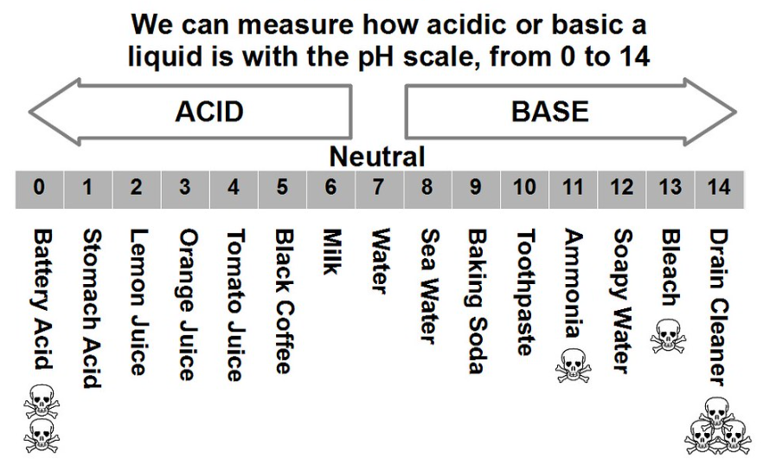

**Questions:**

1. What pH value do strong acids have? _________________
2. What colour does universal indicator go in a strong acid? _________________
3. What pH value do strong alkalis / bases have? _________________
4. What colour does universal indicator go in a strong alkali? _________________
5. Some indicators only have two colours; they turn one colour in an acid and another colour in an alkali (a soluble base). These indicators are called dichromic indicators.

Give one advantage of using a dichromic indicator instead of using universal indicator.

________________________________________________________________________________________________________________________________________________________________________________________________________________________________________________________________________________________________________________________

1. Give one disadvantage of using a dichromic indicator instead of using universal indicator.

________________________________________________________________________________________________________________________________________________________________________________________________________________________________________________________________________________________________________________________

As concentration of hydrogen ions decreases the pH increases.

It increases.

Add a few drops to the substance.

Compare the colour to a colour chart for Universal indicator.

**Practical – serial dilutions**

|  |  |  |  |
| --- | --- | --- | --- |
| Serial dilution of 1.0mol.dm-3 HCl | Concentration of H+ (mol.dm-3) | Colour with universal indicator | pH |
| Original acid solution | 0.1 |  |  |
| 1 | 0.01 |  |  |
| 2 | 0.001 |  |  |
| 3 | 0.0001 |  |  |
| 4 | 0.00001 |  |  |
| 5 | 0.000001 |  |  |
| 6 | 0.0000001 |  |  |
| 7 | 0.00000001 |  |  |

1. Describe how to use universal indicator to determine the approximate pH of a solution.

____________________________________________________________________________________________________________________________________________________________________________________________________________________________________________________________________________________________________________________________________________________________________________________________________________________________________

1. What happens to the pH of the solution as it becomes more dilute?

____________________________________________________________________________________________________________________________________________________________________________________________________________________________________________________________

1. What is the relationship between hydrogen ion concentration and pH?

________________________________________________________________________________________________________________________________________________________________________________________________________________________________________________________________________________________________________________________________________________

pH decreases as hydroxide ion concentration increases.

pH decreases.

Volumes could be measured more accurately using a burette or pipette.

Possible use of a pH probe.

**Practical – serial dilutions**

|  |  |  |  |  |  |
| --- | --- | --- | --- | --- | --- |
| Serial dilution of 1.0mol.dm-3 NaOH | Concentration of OH-  (mol.dm-3) | | Colour with universal indicator | | pH |
| Original solution | 0.1 | |  | |  |
| 1 | 0.01 | |  | |  |
| 2 | 0.001 | |  | |  |
| 3 | 0.0001 | |  | |  |
| 4 | 0.00001 | |  | |  |
| 5 | | 0.000001 | |  |  | |
| 6 | | 0.0000001 | |  |  | |
| 7 | | 0.00000001 | |  |  | |

1. Suggest how the method for this experiment could be improved to make the results more reproducible or repeatable.

____________________________________________________________________________________________________________________________________________________________________________________________________________________________________________________________________________________________________________________________________________________________________________________________________________________________________

1. What happens to the pH of the solution as it becomes more dilute?

____________________________________________________________________________________________________________________________________________________________________________________________________________________________________________________________

1. What is the relationship between hydroxide ion concentration and pH?

________________________________________________________________________________________________________________________________________________________________________________________________________________________________________________________________________________________________________________________________________________

X

X

**HT only**

(c)

**Lesson 6: Teacher notes**

**AQA Content**

Acids are neutralised by alkalis (eg soluble metal hydroxides) and bases (eg insoluble metal hydroxides and metal oxides) to produce salts and water, and by metal carbonates to produce salts, water and carbon dioxide.

The particular salt produced in any reaction between an acid and a base or alkali depends on: • the acid used (hydrochloric acid produces chlorides, nitric acid produces nitrates, sulfuric acid produces sulfates) • the positive ions in the base, alkali or carbonate.

**Students should be able to:** • predict products from given reactants • use the formulae of common ions to deduce the formulae of salts.

**Chunking**

1. What are neutralisation reactions? Acids, bases and alkalis.
2. Types of neutralisation reactions (carbonates etc).
3. Naming salts.
4. Formulae of salts.

**Key direct and explicit teacher explanations:**

1. Neutralisation reactions occur when an acid is reacted with a base or alkali. Bases are molecules that can accept hydrogen ions and so neutralise acids. Alkalis are bases that dissolve in water.

The pH of a solution increases when a neutralisation reaction happens because the hydrogen ion concentration in the solution decreases.

1. Bases, including alkalis, react with acids to make a salt and water. A salt is a compound containing a metal ion and a non-metal ion. They also make water.

Metal oxide + acid 🡪 salt + water

Metal hydroxide + acid 🡪 salt + water

Metal carbonates are also bases. They react with acids to produce a salt, water and carbon dioxide.

Metal carbonate + acid 🡪 salt + water + carbon dioxide

1. There are many different salts. The salt made in a neutralisation reaction depends upon the acid used and the metal in the base.

The names of bases have two parts. The first part of the name comes from the metal in the base. The second part is determined by the acid used.

Nitric acid always produces a metal nitrate.

Sulphuric acid produces a metal sulphate.

Hydrochloric acid produces a metal chloride.

For example, if copper oxide neutralises sulphuric acid, the salt made is copper sulphate. Water is also made.

Copper oxide + sulphuric acid 🡪 copper sulphate + water.

**Examples and non-examples: A range of examples and non-examples are given to enable interpolation and limit**

**extrapolation:**

Examples of viruses: They show a range of morphology. However, they all have a protein coat and contain genetic material).

Some viruses have a lipid envelope derived from the host cells (e.g., HIV). This makes it harder for the immune system to recognise.

Ebola: RNA Smallpox: DNA Tobacco rattle virus: RNA SARS-CoV-2: RNA

**Teacher notes (e.g. key questions, examples, non-examples, explanations)**

____________________________________________________________________________________________________________________________________________________________________________________________________________________________________________________________________________________________________________________________________________________________________________________________________________________________________________________________________________________________________________________________________________________________________________________________________________________________________________________________________________________________________________________________________________________________________________________________________________________________________________________________________________________________________________________________________________________________________________________________________________________________________________________________________________________________________________________________________________________________________________________________________________________________________________________________________________________________________________________________________________________________________________________________________________________________________________________________________________________________________________________________________________________________________________________________________________________________________________________________________________________________________________________________________________________________________________________________________________________________________________________________________________________________________________________________________________________________________________________________________________________________________________________________________________________________________________________________________________________________________________________________

**Lesson 6: 4.4.2.2 Neutralisation of acids and salt production**

**Objective: You are learning to represent neutralisation reactions as word equations and balanced symbol equations.**

**Skills Drill / Retrieval**

|  |  |  |
| --- | --- | --- |
| Answer | | PA / SA |
| 1 |  |  |
| 2 |  |  |
| 3 |  |  |
| 4 |  |  |
| 5 |  |  |

**Catch up (complete this if you were absent last lesson):**

At KS3 you used Universal Indicator to find the pH of different solutions.

1. What information does the pH scale give us about a solution?

________________________________________________________________________________________________________________________________________________________________

1. Strong acids are fully ionised in water; they release a lot of hydrogen ions.

What pH would you expect them to be? ______________________________________________

What colour might they turn Universal Indicator? ______________________________________

1. Weak acids are partially ionised in water; they release only a few of hydrogen ions.

What pH would you expect them to be? ______________________________________________

What colour might they turn Universal Indicator? ______________________________________

1. In neutralisation reactions, hydrogen ions can react with hydroxide ions.

What is the formula of a hydrogen ion: ________

What is the formula of a hydroxide ion: _________

What substance would be made if hydrogen ions reacted with hydroxide ions? _______________

H+

OH-

H2O or water

Yellow to orange

3 - 6

Red

1 or 2

Whether a substance is an acid, alkali or neutral. How strong the acid or alkali is for a given concentration.

Magnesium + water 🡪 magnesium oxide + hydrogen

Potassium + water 🡪 potassium hydroxide + hydrogen

Lithium + water 🡪 lithium hydroxide + hydrogen

Sodium + water 🡪 sodium hydroxide + hydrogen

Iron + sulphuric acid 🡪 iron sulphate + hydrogen

Zinc + hydrochloric acid 🡪 magnesium chloride + hydrogen

Magnesium + sulphuric acid 🡪 magnesium sulphate + hydrogen

**Connect**

You learnt to write word equations for neutralisation reaction sin the **KS3 Acids and Alkalis** topic.

You have also written word equations for reactions in this topic.

You also learnt in the **KS3 Acids and Alkalis** topic that salts are made using these reactions.

Salts are compounds that contain a metal ion and a non-metal ion.

Complete the word equations for these reactions:

1. Magnesium metal reacts with sulphuric acid to produce magnesium sulphate and hydrogen gas.

_____________________________________________________________________________

1. Zinc metal reacts with hydrochloric acid to produce magnesium chloride and hydrogen gas.

_____________________________________________________________________________

1. Iron metal reacts with sulphuric acid to produce iron sulphate and hydrogen gas.

_____________________________________________________________________________

1. Sodium reacts with water to produce sodium hydroxide and hydrogen gas.

_____________________________________________________________________________

1. Lithium reacts with water to produce lithium hydroxide and hydrogen gas.

_____________________________________________________________________________

1. Potassium reacts with water.

_____________________________________________________________________________

1. Magnesium reacts with water to produce magnesium oxide and hydrogen gas.

_____________________________________________________________________________

**For each reaction, underline the salt.**

**Word equations for neutralisation reactions**

|  |
| --- |
| **Guided Example** |
| In neutralisation reactions, an acid reacts with a base (alkali) to form a salt and water.  **acid** + **base** 🡪 salt + water  Hydro**chloric** acid always makes a metal **chloride**, **nitric** acid always makes a metal **nitrate**, and **sulfuric** acid always makes a metal **sulfate**.  For example:  **copper** oxide + **hydrochloric** acid 🡪 **copper chloride** + water |

Complete the word equations below.

1. **hydrochloric** acid + **magnesium** oxide 🡪 **m**____________ **chloride** + water
2. **sulfuric** acid + **copper** oxide 🡪 ____________ **sulfate** + water
3. **nitric** acid + **potassium** hydroxide 🡪 _____________ **nitrate** + water
4. **hydrochloric** acid + **sodium** hydroxide 🡪 __________ ____________ + water
5. **lithium** oxide + **sulfuric** acid 🡪 ____________ ____________ + water
6. **calcium** oxide + **nitric** acid 🡪 ___________ _____________ + water
7. **hydrochloric** acid + **zinc** oxide 🡪 ___________ ____________ + __________
8. **sulfuric** acid + **iron** oxide 🡪 _________ _____________ + ___________
9. **lead** hydroxide + **nitric** acid 🡪 __________ ____________ + ___________
10. _________ oxide + __________ acid 🡪 **zinc nitrate** + water
11. aluminium oxide + hydrochloric acid 🡪 ____________ __________ + _________
12. copper oxide + nitric acid 🡪 _________ ___________ + ___________
13. sulfuric acid + magnesium oxide 🡪 ___________ __________ + ____________
14. nitric acid + silver oxide 🡪 __________ ___________ + ___________
15. __________ oxide + _____________ acid 🡪 lithium chloride + water

**\*Original author ‘eleanor-crook’. Purchased from TES resources.**

NaCl

KCl

ZnCl2

NaNO3

Na2SO4

MgSO4

MgCl2

CaSO4

Ca(NO3­)2

Write the formula of the following salts:

1. Sodium Chloride ___________________
2. Potassium Chloride ___________________
3. Zinc Chloride ___________________
4. Sodium Nitrate ___________________
5. Sodium Sulphate ___________________
6. Magnesium Sulphate __________________
7. Magnesium Chloride __________________
8. Calcium Sulphate __________________
9. Calcium Nitrate __________________

**Common ions:**

Al3+ Pb2+ Fe2+  Cu2+ Zn2+ Mg2+ Ca2+ Li+  Na+ K+ Ag+ H+

SO42- CO32- O2- NO3- OH- Br- Cl-

**ACIDS, BASES AND SALTS**

1. Zinc oxide, ZnO, and aluminum hydroxide, Al(OH)3, are examples of insoluble bases which may react with acids to produce salts.

a) Name and give the formula of the salt which is produced by reacting zinc oxide with sulfuric acid. __________________________________________________________________________________(2) b) Zinc oxide also reacts with nitric acid. Write a balanced equation to show the reaction which happens. __________________________________________________________________________________(2)

c) Name and give the formula of the salt which is produced by reacting aluminium hydroxide with hydrochloric acid.

__________________________________________________________________________________(2)

d) Aluminum hydroxide also reacts with sulfuric acid. Write a balanced equation to show the reaction which happens.

__________________________________________________________________________________(2)

2. Magnesium carbonate, MgCO3, reacts readily with hydrochloric acid and also with sulfuric acid.

a) Describe what you would see if magnesium carbonate was reacted with excess hydrochloric acid.

__________________________________________________________________________________(2) b) Write a balanced equation to show the reaction which happens as magnesium carbonate and hydrochloric acid react.

_________________________________________________________________________________(2)

Al3+ Pb2+ Fe2+  Cu2+ Zn2+ Mg2+ Ca2+ Li+  Na+ K+ Ag+ H+

SO42- CO32- O2- NO3- OH- Br- Cl-

**\*Original author ‘ChemSchoolTV’s Shop’. Purchased from TES resources.**