**Year 7- Knowledge booklet**

Key Stage 3 Science:

**Forces**



**FORCES**

**This booklet is for use in your Science lessons. Please look after it in the same way you would your exercise book and ensure that your presentation is always PROUD.**

**Ensure that your booklet is returned to your class book box at the end of the lesson.**



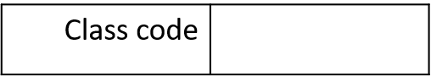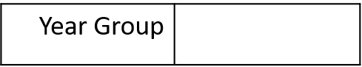

**Lesson 1: What do forces do?**

|  |  |
| --- | --- |
| 1  2  3  4 | A force is a push or a pull which can act upon an object.  A force acts upon an object. It is not a property of an object.  Forces cannot be seen. Their effects when acting upon an object can be seen.  Forces can have different effects on an object. Forces can change the speed of an object, change the direction of an object or change the shape of an object. |

***Example 1: Changing the shape of an object.***

**Pull forces** are acting on each end of the plasticine, pulling in different directions.

This **changes the shape** of the object.



***Example 2: Changing the direction of an object.***

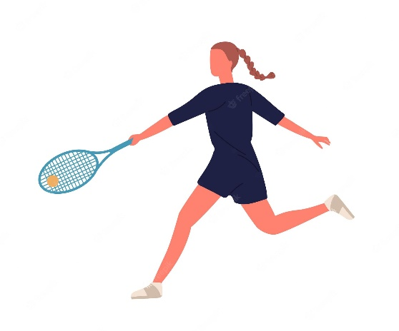

**A push force** acts upon a tennis ball when the tennis player hits it back to her opponent. The push force is acting in the opposite direction to the movement of the tennis ball.

This **changes the direction** of the object.

***Example 3: Changing the speed of an object.***

**A pull force (gravity)** acts upon the apple, pulling it towards the ground.

The apple has gone from being stationary (not moving) to accelerating towards the ground.

The force has **changed the speed** of the object.

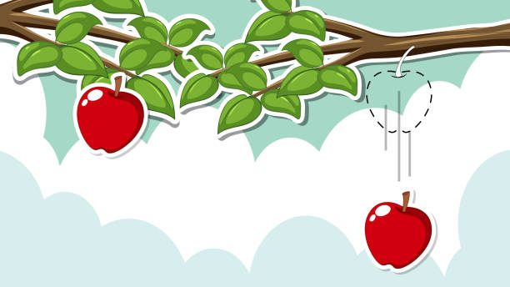

**The scientific method:**

|  |  |
| --- | --- |
| 8  9  10  11  12  13  14 | Science aims to develop a good explanation of natural events (phenomena) that are observed.  Scientists develop explanations using the scientific method. This follows a specific way of working:   * They identify an observation or a process that they want to be able to explain. * They make a hypothesis, an idea which might explain the observation or process, and which can be tested. * They carry out experiments to test the hypothesis which may support or disprove the hypothesis. * If the evidence supports the hypothesis, scientists will repeat the process many times with different observations and different experiments- perhaps using different instruments and different researchers. * If the hypothesis is tested in many different ways and is not disproved, it develops into a theory. A theory that is accepted by scientists may later be replaced by another theory if it is disproved. |

**Isaac Newton:**

|  |  |
| --- | --- |
| 15  16  17  18  19  20 | Isaac Newton was one of the great figures in the history of science.  His ideas about motion and gravity are very important to the science of **physics**.  Legend has it that Isaac Newton formulated gravitational theory in 1665 or 1666 after watching an apple fall and asking why the apple fell straight down, rather than sideways or even upward. Newton decided that matter must have a force that pulls other matter toward it. The larger the object, the greater the force.  Newton also theorized that the force that pulls falling objects to the ground is the same force that keeps the Moon moving around the Earth.  Newton used mathematic equations to describe the force of gravity. |

**Albert Einstein:**

|  |  |
| --- | --- |
| 21  22  23  24  25  26  27 | Albert Einstein was one of the great figures in the history of science.  Einstein is famous for his theory of relativity.  Einstein preferred to work visually, and to use his imagination to develop his scientific understanding and theories. His “thought experiments” relied on imagination, inspiration and complicated mathematics.  Einstein received poor reports in school due to his rebellious nature.  Without lab work, Einstein was able to develop new concepts about how the universe works.  These included black holes and his theory of relativity. Practical experiments have subsequently proved his key theories to be correct. |

**Lesson 2: The main forces, their magnitude and direction**

|  |  |
| --- | --- |
| 1  2  3  4  5  6  7  8  9 | **Forces:**  Gravitational force: Gravity always pulls two objects towards each other. Gravitational force is experienced by a mass when it is sufficiently close to another mass.  Friction: Friction is a force that opposes motion. It is caused by the interaction of surfaces moving over one another. It is called ‘drag’ if one surface is a fluid.  Tension: tension is a pulling force exerted on an object by a string, a rope or a rod.  Air resistance: Air resistance acts against the direction of movement. The force is caused by air particles hitting the front of an object, causing it to slow down.  Upthrust: Upthrust is an upwards force that acts on an object when it is in a fluid (a liquid or a gas).  Thrust: Thrust is a driving force which pushes an object forwards.  Normal reaction force: When an object pushes on a surface, such as a table / wall or the ground, the surface pushes back on the object with a balancing force. The normal reaction force always acts at right angles to the surface.  Magnetic force: Magnetic force is experienced by a magnet or a magnetic material when placed in a magnetic field. The force can cause two objects to attract or to repel.  Electrostatic force: Electrostatic force is experienced by a charged particle in an electrical field. This force can either be attractive or repulsive. |

**Contact vs non-contact forces**

|  |  |
| --- | --- |
| 10  11  12  13  14 | There are 2 main categories of forces- contact and non-contact forces.  A contact force is a force that acts between two objects that are physically touching.  Examples of contact forces include: Friction, air resistance, tension, thrust force.  A non-contact force is a force that acts between two objects that are not physically touching.  Examples include: Gravitational force, magnetic force, electrostatic force. |

**Example 1: Magnetic force**

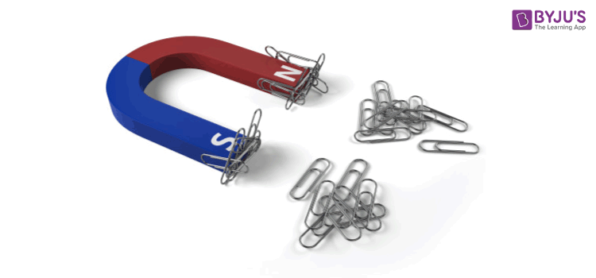

Magnetic force is a **non-contact force** as it does not require two objects to be physically touching.

In this case, the magnet does not need to be physically touching the paperclips in order for the attractive force to act.

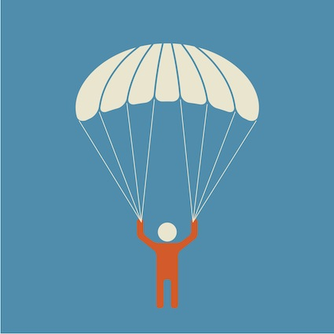**Example 2: Air resistance**

Air resistance is a **contact force** because an object must be physically touching air particles in order for the force to act.

In this case, the air particles are physically pushing against the fabric of the parachute.

|  |  |
| --- | --- |
| 15  16  17  18  19  20  21  22  23  24 | **Representing forces:**  Multiple forces act on an object at the same time.  The size and direction of these forces determines the movement of the object.  Forces acting in the same direction will be added together.  **Free body diagrams**  We can show the forces acting on an object using a free body diagram.  The arrows represent the size and direction of the forces acting.  ***When drawing a force diagram:***  Represent the object with a small box or dot.  Draw the arrows with a pencil and a ruler.  Draw the arrows from the centre of the box or dot.  Label the arrow with the name of the force and the size of the force. |

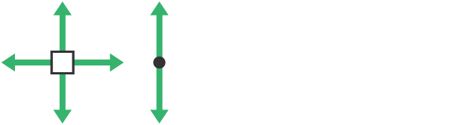

**Example: A moving car**

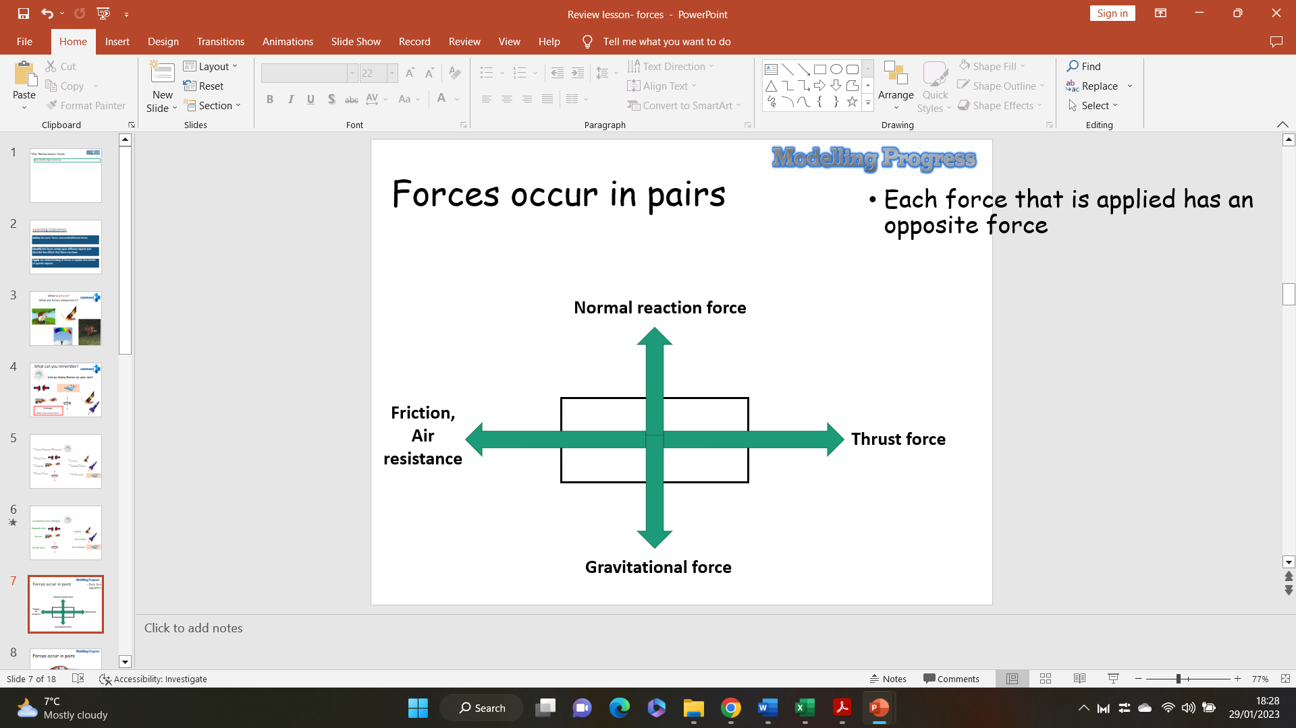

**Lesson 3 – Balanced and unbalanced forces**

|  |  |
| --- | --- |
| 1  2  3  4  5  6  7  8  9  10  11  12  13 | All forces are vectors. This means they have both magnitude (size) and direction. Certain forces will always act in a particular direction, depending on the situation.   * Gravity will always act towards the centre of mass (e.g. the core of the Earth). * Friction, air resistance and water resistance will always act in the opposite direction to the movement of an object. * Upthrust / buoyancy will always act upwards against an object in a fluid.     All forces are measured in Newtons (N). This unit comes from the scientist Sir Isaac Newton, who was famous for his work on forces (particularly his discovery of gravity).  When representing forces acting on a particular object, we can draw a force diagram. In a force diagram, each force acting on the object is represented by an arrow, pointing in the direction the force is acting.  For example, let’s imagine the forces acting on a shopping cart:  **Reaction force**  Image result for shopping cart being pushed cartoon    **Air resistance / friction**  **Gravity / weight**  **Thrust** |
| 1  2  3  4  5  6  7  8  9  10  11  12  13  14  15  16  1  2  3  4  5  6  7  8  9  10  11  12 | In a force diagram, the size of the arrow represents the magnitude of the force.  For example, a large force would be represented by a large arrow:  A smaller force would be represented by a smaller arrow:  In a force diagram, arrows acting in opposite directions work against each other. If these two forces have the same magnitude, they are balanced. If they have different magnitudes, they are unbalanced.  If opposing forces are balanced, this would mean that an object would be stationary (not moving) if it wasn’t already moving. If it was moving, then it would remain at a constant speed, travelling in a straight line.   * This car would either remain stationary, or continue moving at a constant speed in straight line.   If the opposing forces are unbalanced, this would mean that the object would either accelerate (speed up), decelerate (slow down), or change direction.     * This car would accelerate.      * This car would decelerate   When forces are acting in opposite directions, they work against each other. However, when they act in the same direction, they add together to produce a larger force. If we know the magnitude and direction of the forces acting on an object, we can calculate what is called the “resultant force”, which is the net force produced by all of the forces acting at the same time.  Example 1:    **100 N**  **10 N**  Resultant force = 100 N (right) – 10 N (left) = **90 N (right)**  Example 2:    **50 N**  **50 N**  Resultant force = 50 N (right) – 50 N (left) = **0 N (no direction)**  Resultant forces can also occur in multiple planes:  Example 3:  **50 N**    **130 N**  **40 N**  **20 N**  Resultant force (up/down) = 50 N (up) – 20 N (down) = **30 N (up)**  Resultant force (left/right) = 130 N (left) – 40 N (right) = **90 N (left)** | |

**Lesson 4 – Forces and their effects on equilibrium**

|  |  |
| --- | --- |
| 1  2  3  4  5  6  7  8  9  10  11  12  13  14  15  16  1  2  3  4  5  6  7  8  9  10  11  12  13  14 | Forces acting in the same direction on the same object are known as **additive** forces. This means they work together to produce a larger force acting in that direction.     * Two small forces are acting in the same direction on the same object. * These forces add together to produce a larger total force acting in that direction.   Forces acting in opposite directions on the same object are known as **opposing** forces. This means they work against each other, and produce a resultant force. If these forces are equal, they are known as an **“interaction pair”**.   * Two forces are acting against each other. A resultant force is produced.   Balanced forces are forces acting in opposite directions which have the same magnitude. When opposing forces are balanced, there is no resultant force because they cancel each other out. This is known as **equilibrium**.  Image result for asteriskImage result for asterisk  **KEY DEFINITION**: Equilibrium is a state in which the opposing forces are balanced.  When an object is in equilibrium, two things can happen:   * If the object is stationary (not moving), it will **remain stationary**. * If the object is moving, it will **remain at a constant speed**, travelling in a straight line.   Example 1: A box on a table.  The box on this table is not moving. Because the opposing forces are in equilibrium, the box will remain stationary.  Example 2: A sky diver.    This sky diver is currently in motion, moving downwards. Because the opposing forces are in equilibrium, the sky diver will remain in motion at a constant speed, in a straight line. |

**5: Measuring Forces/Factors Affecting Drag**

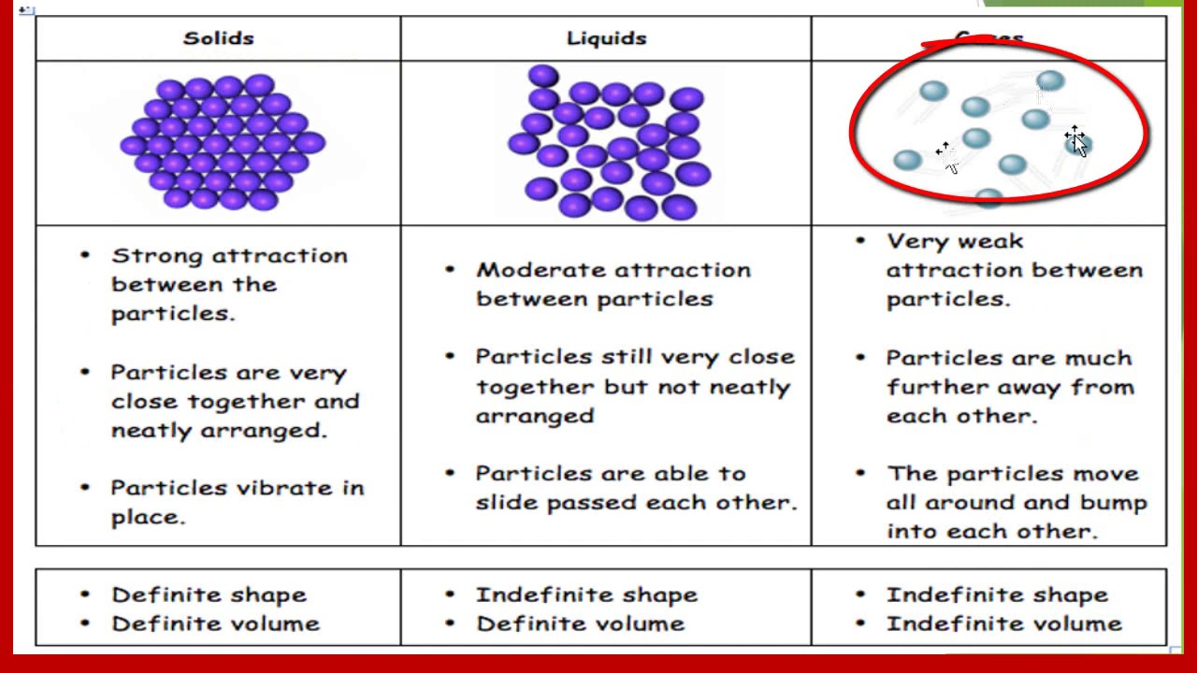

|  |  |  |
| --- | --- | --- |
| 1 | | The image shows the arrangement and movement of particles in solids, liquids and gases |
| 2 | | The particles in a solid are touching and are in an organised arrangement. |
| 3 | | The particles in a solid cannot flow past each other because there are strong forces of attraction holding the particles in position. |
| 4 | | The particles in a liquid are touching and are randomly arranged. |
| 5 | | The particles in a liquid can flow past each other because there are weaker forces of attraction between the particles. | |
| 6 | | The particles in a gas are not touching and are randomly arranged. | |
| 7 | | The particles in a gas move rapidly and randomly in all directions, there are few, weak forces between the particles. | |
| 8 | | Friction occurs when movement occurs between 2 substances | |
| 9 | | Examples of friction between 2 solids are a bike chain on the gear wheel and types on the road | |
| 10 | | Examples of friction between a solid and a liquid are a water-skier, the hull of a ship on the water, or a submarine | |
| 11 | | Examples of friction between a solid and a gas are a parachute, aeroplane or helicopter | |
| 12 | | When we think about forces, we usually think of forces as working against each other in pairs known as an **interaction pair**. | |
| 13 | | One of these forces is usually the **driving force**, trying to move the object | |
| 14 | | The other force is usually a **resistive force**, trying to stop or slow the object. | |

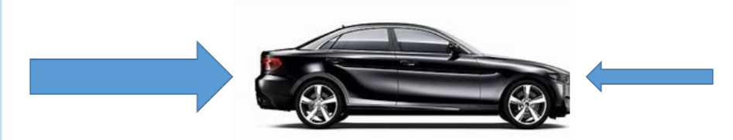 

|  |  |
| --- | --- |
| 15 | For example, when a car is driving along a road: |
| 16 | The **driving force** comes from the engine of the car, driving the car forwards. |
| 17 | The **resistive forces** work against this driving force:   * Friction from the road against the tyres. * Air resistance from the air against the car. |
| 18 | Resistive forces are often only caused as a result of a driving force. |
| 19 | Resistive forces can only exist if there is a driving force to work against. |
| 20 | If the car isn’t producing a driving force, there would be no resistive forces working against the car (shown below) |

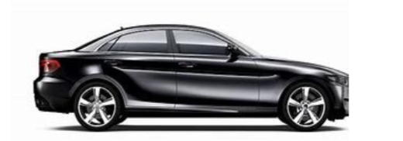 

|  |  |
| --- | --- |
| **21** | Because gravity is always affecting every object on Earth, there will always be resistive forces acting against it. |
| **22** | If an object isn’t “resting” on a surface then the gravity causes it to fall.  If an object is falling then the resistive force would be air resistance. |
| **23** |  |
| **24** | If an object is resting on a surface, e.g. a box on a table, the resistive force would be a reaction force from that surface. |

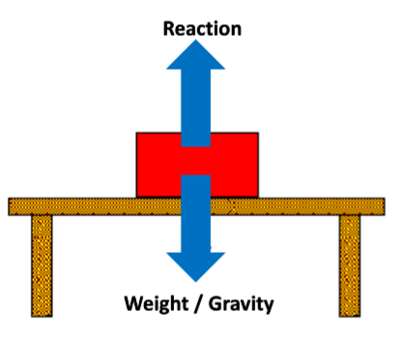

|  |  |
| --- | --- |
| 25 | Here is the method you will use to test the effect of different surfaces on friction: |
| 26 | Independent Variable: The surface  Dependent Variable: The time taken  Control Variables: The length of the slope, the height/angle of the slope, the car |
| 27 | **Equipment: Ramp, Car, Different surface materials, Stopwatch** |
| 28 | **Collect the equipment from the equipment list, Set up your ramp.** |
| 29 | **Use one of the different materials to cover the ramp.** |
| 30 | **Place the car at the top of the ramp, start a stopwatch and release the car down the ramp.** |
| 31 | **Stop the stopwatch when the car reaches the bottom of the ramp** |
| 32 | **Repeat steps 4-5 twice.** |
| 33 | **Repeat steps 3-6 with the other materials.** |
| 34 | The type of data affects the advantages and disadvantages of tables and graphs, explains the University of Syracuse. |
| 35 | Tables are useful for data with specific amounts rather than approximations. |
| 36 | Tables take viewers longer to comprehend and read due to the structure, and they also do not provide a simplistic method for capturing trends in data. |
| 37 | Instead, the viewer must connect the dots between the data. |
| 38 | Graphs are useful for comparison data. |
| 39 | Researchers use circle graphs for situations in which it is beneficial to explain how one section of the data impacts the entirety. |
| 40 | Bar graphs help explain and provide visualization for trends. |
| 41 | Computations for graphs are more difficult, as it involves proportions and percentages. |
| 42 | It is also easier to manipulate the data in graph form to make it appear as though the data is askew or reaches a certain conclusion. |
| 43 | This occurs when a person places more than one type of data on a single graph, such as the use of different interval levels for each variable. |

**Lesson 6: The Effects of Forces on Deformations**

|  |  |
| --- | --- |
| 1 | In lesson 5 you learnt the 3 effects of forces |
| 2 | When forces are applied, they change the speed, direction or shape of an object |
| 3 | A change in shape is also known as a deformation |
| 4 | Elastic deformation is reversed when the force is removed – the object returns to its original shape |
| 5 | Examples of elastic deformation are rubber bands, springs, bouncy balls, footballs etc. |
| 6 | Inelastic deformation is not fully reversed when the force is removed - there is a permanent change in shape |
| 7 | Examples of inelastic deformation are metal cans, play-dough, plasticine etc. |
| 8 | Inelastic deformation is also known as plastic deformation. |

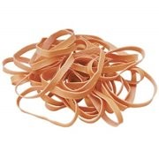 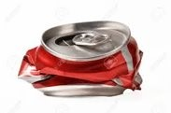

|  |  |
| --- | --- |
| 9 | Hooke’s Law is the relationship between a force and the extension. |
| 10 | Hooke’s Law is often tested with a spring or a wire. |

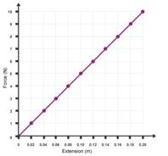

|  |  |
| --- | --- |
| 11 | Extension of an elastic object is directly proportional to the force applied to it. |
| 12 | If the force applied is doubled, the extension doubles. |
| 13 | If no force is applied, there is no extension. |
| 14 | The (0,0) point of the graph is known as The Origin. |
| 15 | However, elastic objects have an elastic limit. |
| 16 | This means that if they stretch too much, they can’t return to their original shape. |
| 17 | If they continue to be stretched, they will reach their breaking point. |

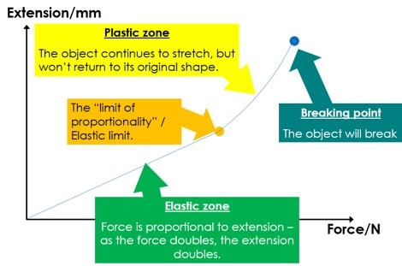

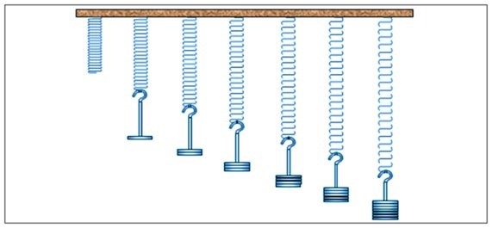

|  |  |
| --- | --- |
| 18 | Below is a set of results that you will use to draw a graph of force against extension. |

|  |  |
| --- | --- |
| **Force applied (N)** | **Extension (cm)** |
| 1 | 3.0 |
| 2 | 6.5 |
| 3 | 9.5 |
| 4 | 12.0 |
| 5 | 12.5 |
| 6 | 16.0 |
| 7 | 19.5 |
| 8 | 22.0 |
| 9 | 27.5 |
| 10 | 38.0 |