s

**Year 7- Teacher booklet**

Key Stage 3 Science:

**Forces**

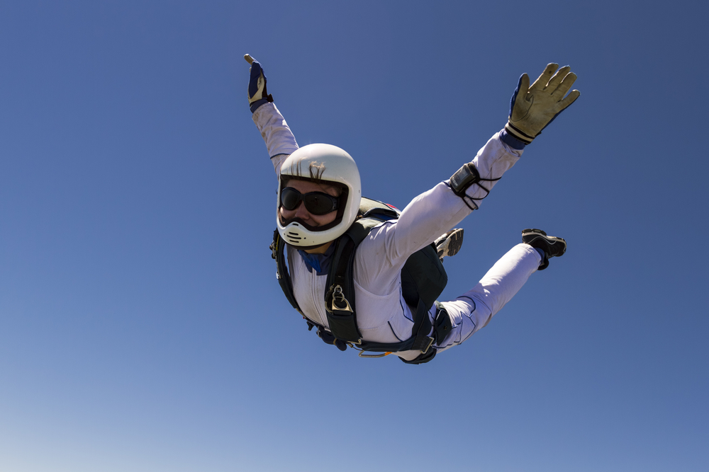

**FORCES**

**This booklet is for use in your Science lessons. Please look after it in the same way you would your exercise book and ensure that your presentation is always PROUD.**

**Ensure that your booklet is returned to your class book box at the end of the lesson.**



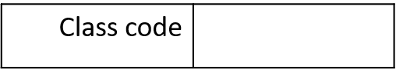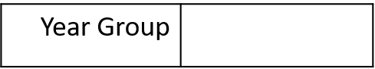

**Contents**

Lesson 1: What do forces do?

Lesson 2: The main forces, their magnitude and direction.

Lesson 3: Balanced and unbalanced forces (resultant forces).

Lesson 4: Forces on objects at equilibrium.

Lesson 5: Measuring forces / factors affecting drag.

Lesson 6: The effect of forces on deformation (Hooke’s law).

Lesson 7: Moments

Lesson 8: The laws of moments.

**Keystone Words**

Force

Push

Pull

Contact

Non-contact

Direction

Magnitude

Resultant force

Equilibrium

Compression

Deformation

**Lesson 1: Teacher notes**

**AQA Content**

If the overall, resultant force on an object is non-zero, its motion changes and it slows down, speeds up or changes direction.

One effect of a force is to change an object’s form, causing it to be stretched or compressed. In some materials, the change is proportional to the force applied.

**Key direct and explicit teacher explanations:**

1. A force is a push or a pull which acts **on** an object (rather than being a property of an object).
2. Forces cannot be seen but we can see their effects.
3. The effects that a force can have on an object include:
   1. Changing the speed of an object.
   2. Changing the shape of an object.
   3. Changing the direction of an object.
4. The scientific method:

Science aims to develop a good explanation of natural events (phenomena) that are observed.

Scientists develop explanations using the scientific method. This follows a specific way of working:

* They identify an observation or a process that they want to be able to explain.
* They make a hypothesis, an idea which might explain the observation or process, and which can be tested.
* They carry out experiments to test the hypothesis which may support or disprove the hypothesis.
* If the evidence supports the hypothesis, scientists will repeat the process many times with different observations and different experiments- perhaps using different instruments and different researchers.
* If the hypothesis is tested in many different ways and is not disproved, it develops into a theory. A theory that is accepted by scientists may later be replaced by another theory if it is disproved.

**Chunking**

1. **(Connect)** Draw out students’ prior understanding of forces to generate a definition and to identify the effects that a force can have on an object.
2. Students apply their understanding to describe the effects of different forces on different objects.
3. Discuss the characteristics that are important to be a good scientist and justify these.
4. Scientific method (review from the Speed module)- what is meant by working scientifically and why is this an important method to follow?
5. Students research Isaac Newton’s work on gravity and his methodology- answer reading task questions.

**Teacher notes (e.g. key questions, examples, non-examples, explanations)**

____________________________________________________________________________________________________________________________________________________________________________________________________________________________________________________________________________________________________________________________________________________________________________________________________________________________________________________________________________________________________________________________________________________________________________________________________________________________________________________________________________________________________________________________________________________________________________________________________________________________________________________________________________________________________________________________________________________________________________________________________________________________________________________________________________________________________________________________________________________________

________________________________________________________________________________________________________________________________________________________________________________________________________________________________________________________

**USE EXAMPLES AND NON-EXAMPLES TO ILLUSTRATE THE DIFFERENCE.**

*Effects of forces:*

1. The first image shows how **pull forces** can **change the shape** of the plasticine when applied in different directions.

**Emphasise** that the force is acting **upon** the plasticine, creating the change.

1. The second image shows how a **push force** can **change the direction** of the tennis ball when applied in a different direction to its motion.
2. The third image shows how a **pull force** (students may be able to identify this force as gravitational force) can **change the speed** of the apple.

**To note: An object that is stationary still has forces acting upon it. These forces are balanced.**

**Teacher notes (e.g. key questions, examples, non-examples, explanations)**

__________________________________________________________________________________________________________________________________________________________________________________________________________________________________________________________________________________________________________________________________________________________________________________________________________________________________________________________________________________________________________________________________________________________________________________________________________________________________________________________________________________________________________________________________________________________________________________________________________________________________________________________________________________________________________________________________________________________________**______________________________________________________________**

**Teacher notes (e.g. key questions, examples, non-examples, explanations)**

____________________________________________________________________________________________________________________________________________________________________________________________________________________________________________________________________________________________________________________________________________________________________________________________________________________________________________________________________________________________________________________________________________________________________________________________________________________________________________________________________________________________________________________________________________________________________________________________________________________________________________________________________________________________________________________________________________________________________________________________________________________________________________________________________________________________________________________________________________________________________________________________________________________________________________________________________________________________________________________________________________________________________________________________________________________________________________________________________________________________________________________________________________________________________________________________________________________________________________________________________________________________________________________________________________________________________________________________________________________________________________________________________________________________________________________________________________________________________________________________________________________________________________________________________________________________________________________________________________________________________________________________

**Lesson 1: What do forces do?**

**Skills Drill / Retrieval**

|  |  |  |
| --- | --- | --- |
| Answer | | PA / SA |
| 1 |  |  |
| 2 |  |  |
| 3 |  |  |
| 4 |  |  |
| 5 |  |  |
| 6 |  |  |
| 7 |  |  |
| 8 |  |  |

**Connect**

**Definition:** A force is **a push or a pull which acts on an object.**

**Task:** Use the images below to identify the three effects that a force can have on an object:

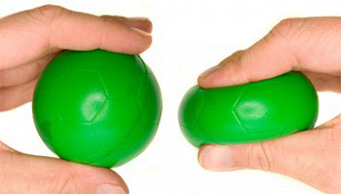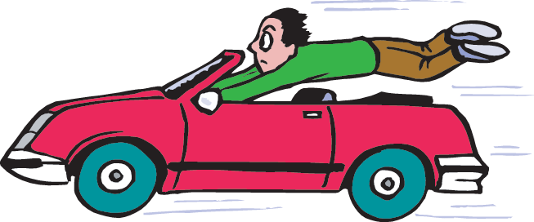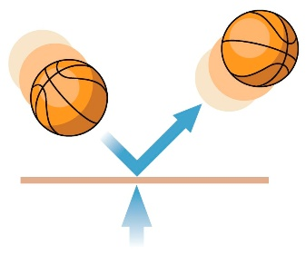

1. A force can change **the speed of an object.**
2. A force can change **the direction of an object.**
3. A force can change **the shape of an object.**

Challenge: If we are unable to **see** forces, how do we know when they are acting?

**Answer: We can see the effect of the force acting on the object.**

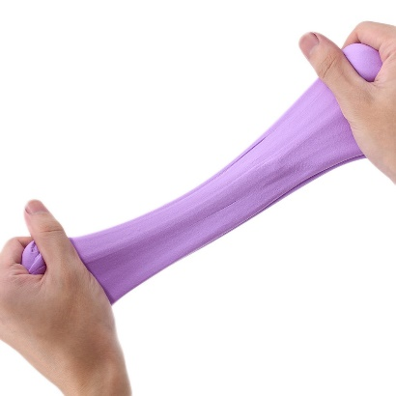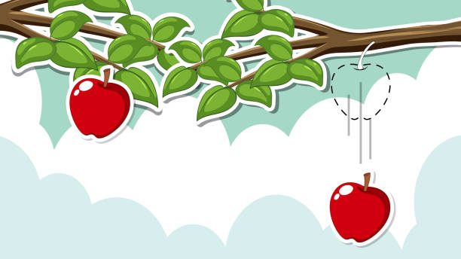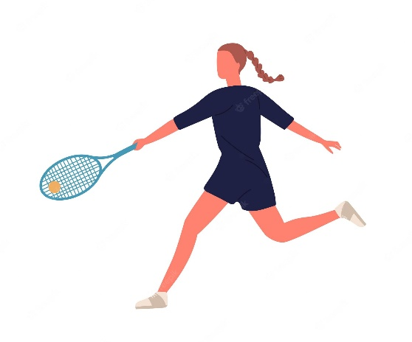

Push or pull? **Push**

Effect of the force on the object:

**The force changes the direction of the object.**

Push or pull? **Pull**

Effect of the force on the object:

**The force changes the speed of the object as the apple goes from being stationary (not moving) to accelerating downwards.**

Push or pull? **Pull**

Effect of the force on the object:

**The force changes the shape of the object.**

**Task 1: The effect of forces**

**For each of the forces below:**

1. State whether a **push** or a **pull** force has been exerted.
2. Describe the effect that the force has had on the object.
3. A piece of plasticine is stretched.
4. A tennis player hits the tennis ball back across the court towards her opponent.
5. An apple falls from a tree.

**Stretch:** A ball is sat stationary (not moving) on a desk. Does this ball have forces acting upon it? Explain your answer.

**Task 3:**

**Using the scientific method:**

* **Identify an observation / process**
* **Form a hypothesis which may explain the process.**
* **Carry out an experiment to test their hypothesis**
* **Reject or accept the hypothesis on the basis of the results.**

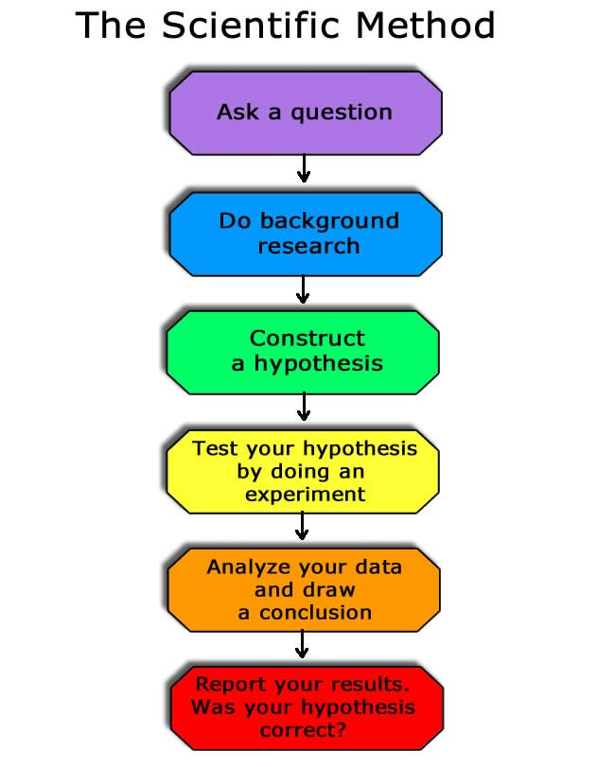

**Task 2: Discuss with the person next to you…**

Which characteristics are important in a scientist? Why?

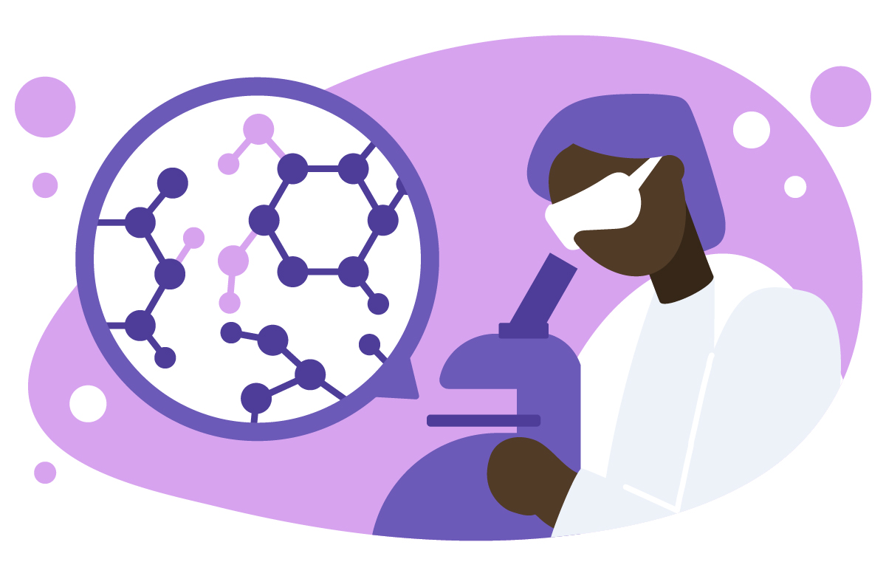

**Students suggest their own ideas of important traits for scientists and justify these.**

**Teacher to guide discussion- emphasise and discuss how curiosity, asking questions and communication is central to science.**

Task 4: Reading task

**Why was Isaac Newton such a giant?**

Most people associate Isaac Newton with gravity. Of all the forces of nature, gravity is the one whose effects are most obvious to us, and have been since prehistoric times. Everyone knows that an apple falls vertically downwards, as if drawn towards the centre of the Earth. Anyone who has spent any time gazing up at the night sky knows that the Moon and planets follow regular, predictable orbits. But obvious as these things are, the ultimate explanation – that they are all due to the same universal force – is far from obvious.

Newton did more than just wave his hands in the air and say ‘look, there’s a universal force of attraction between all material things’. He came up with a precise mathematical equation to describe that force. In the course of time, this equation would allow his successors to discover new planets, to predict the reappearance of comets and to travel to the Moon.

Newton made the single greatest breakthrough in the history of physical science…but it wasn’t his discovery of the law of gravity. It was an even more fundamental discovery: that it is possible to predict the behaviour of the physical world by representing it in the form of mathematical symbols and equations. The implications of this discovery reach beyond theoretical physics into all branches of engineering and technology. It is no exaggeration to say that the modern, high-tech world we live in today wouldn’t exist without it.

For Newton, mathematics was the key that unlocked the secrets of the universe. To most of his contemporaries, Aristotle’s two-thousand-year-old system of ‘natural philosophy’ still provided the standard picture of the physical world – and Aristotle’s theory contains no mathematics. But when Newton published his masterpiece in 1687, he called it Philosophiae Naturalis Principia Mathematica – Mathematical Principles of Natural Philosophy. The book was a revolution, and the essence of that revolution is summed up in the title. Before 1687, Mathematical Principles and Natural Philosophy were two completely different branches of knowledge, poles apart. After Principia they would be tied together by a bond that has become more and more powerful in the intervening centuries.

The situation in Newton’s time was, in a sense, the mirror image of the present day. What then seemed to be a bizarre and mystical notion – that the universe obeys simple mathematical laws – is now seen as the 'rational' view. But in those days, 'rational' people tended to assume the exact opposite. The world looks complex, chaotic and unpredictable…so clearly it can have nothing to do with the elegance and simplicity of mathematics.

**By Andrew May (The History Press).**

**Reading task questions:**

1. Which force is Isaac Newton known for his work on? **Gravity**
2. In which direction does gravity pull objects? **Towards the centre of the mass which is exerting the gravitational pull.**
3. Do you think that Newton used the scientific method to develop his theory? Explain your answer.

_________________________________________________________________________

_________________________________________________________________________

_________________________________________________________________________

_________________________________________________________________________

1. How was Aristotle’s theory of the physical different to Newton’s?

__________________________________________________________________________

__________________________________________________________________________

**Stretch task:** Isaac Newton had to be encouraged to publish his ideas. Do you think that it is important that new scientific ideas are communicated? Why / why not?

**Lesson 2: Teacher notes**

**Key direct and explicit teacher explanations:**

Identifying forces:

1. Gravitational force: Gravity always pulls two objects towards each other. Gravitational force is experienced by a mass when it is sufficiently close to another mass.
2. Friction: Friction is a force that opposes motion. It is caused by the interaction of surfaces moving over one another. It is called ‘drag’ if one surface is a fluid.
3. Tension: tension is a pulling force exerted on an object by a string, a rope or a rod.
4. Air resistance: Air resistance acts against the direction of movement. The force is caused by air particles hitting the front of an object, causing it to slow down.
5. Upthrust: Upthrust is an upwards force that acts on an object when it is in a fluid (a liquid or a gas).
6. Thrust: Thrust is a driving force which pushes an object forwards.
7. Normal reaction force: When an object pushes on a surface, such as a table / wall or the ground, the surface pushes back on the object with a balancing force. The normal reaction force always acts at right angles to the surface.
8. Magnetic force: Magnetic force is experienced by a magnet or a magnetic material when placed in a magnetic field. The force can cause two objects to attract or to repel.
9. Electrostatic force: Electrostatic force is experienced by a charged particle in an electrical field. This force can either be attractive or repulsive.

**Chunking**

1. **(Connect)** Review students’ understanding of the effect of forces on different objects (previous lesson content).
2. Identify different types of forces.
3. Categorise these forces as being contact or non-contact forces.
4. Students determine whether objects are being acted upon by a contact force or a non-contact force and form their own explanations.
5. Drawing force diagrams.

**AQA Content**

If the overall, resultant force on an object is non-zero, its motion changes and it slows down, speeds up or changes direction.

One effect of a force is to change an object’s form, causing it to be stretched or compressed. In some materials, the change is proportional to the force applied.

Key definition:

**Contact force:** One that acts by direct contact.

Skill:

Students should be able to sketch the forces acting on an object, and label their size and direction.

**USE EXAMPLES AND NON-EXAMPLES TO ILLUSTRATE THE DIFFERENCE.**

*Contact and non-contact forces:*

|  |  |
| --- | --- |
| **Contact force** | **Non-contact force** |
| **Air resistance**  **Friction**  **Thrust force**  **Tension** | **Gravitational force**  **Electrostatic force**  **Magnetic force** |

**Example 1:** The first image shows a falling raindrop. The raindrop is being acted upon by the force of gravity. Gravity is a non-contact force as it does not require two objects to be physically touching.

*Alternative explanation:* The raindrop is being acted upon by the force of air resistance. Air resistance opposes the downwards motion of the raindrop and is a contact force as it does require two objects to be physically touching.

**Example 2:** The second image shows a magnet held above a pile of iron nails. The iron nails are attracted to the magnet due to the action of magnetic force. This is a non-contact force as the magnet and the nails do not need to physically touch in order for the force to act.

**Example 3:** The third image shows a child kicking a football. This is a contact force as the push force relies upon the child’s foot being in physical contact with the football.

**Key direct and explicit teacher explanations:**

***Contact and non-contact forces***

There are 2 main categories of forces- contact and non-contact forces.

* A contact force is a force that acts between two objects that are physically touching.
  + Examples include: Friction, air resistance, tension, thrust force.
* A non-contact force is a force that acts between two objects that are not physically touching.
  + Examples include: Gravitational force, magnetic force, electrostatic force.

***Representing forces:***

* Multiple forces act on an object at the same time.
* The size and direction of these forces determines the movement of the object.
* Forces acting in the same direction will be additive.

**Free body diagrams**

Show the forces acting on an object in a free body diagram. The arrows represent the size and direction of the forces acting.

When drawing a force diagram:

* represent the object with a small box or dot
* draw the arrows with a pencil and ruler
* draw the arrows from the centre of the box or dot
* label the arrow with the name of the force and the size of the force

**Teacher notes (e.g. key questions, examples, non-examples, explanations)**

____________________________________________________________________________________________________________________________________________________________________________________________________________________________________________________________________________________________________________________________________________________________________________________________________________________________________________________________________________________________________________________________________________________________________________________________________________________________________________________________________________________________________________________________________________________________________________________________________________________________________________________________________________________________________________________________________________________________________________________________________________________________________________________________________________________________________________________________________________________________________________________________________________________________________________________________________________________________________________________________________________________________________________________________________________________________________________________________________________________________________________________________________________________________________________________________________________________________________________________________________________________________________________________________________________________________________________________________________________________________________________________________________________________________________________________________________________________________________________________________________________________________________________________________________________________________________________________________________________________________________________________________

**Lesson 2: The main forces, their magnitude and direction**

**Skills Drill / Retrieval**

|  |  |  |
| --- | --- | --- |
| Answer | | PA / SA |
| 1 |  |  |
| 2 |  |  |
| 3 |  |  |
| 4 |  |  |
| 5 |  |  |
| 6 |  |  |
| 7 |  |  |
| 8 |  |  |

**Connect Task:** Describe the effect that each force is having upon the object.

1. 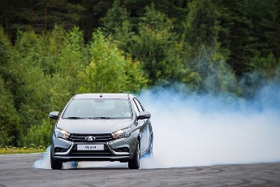A driver is driving down the street. They then press the brakes to stop their car.

The forces changes **the speed of the car.**

1. A child squeezes their carton of juice to push out the liquid.

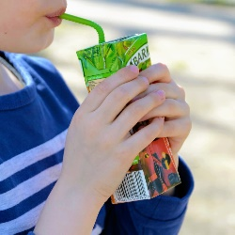

The forces changes **the shape of the box.**

1. 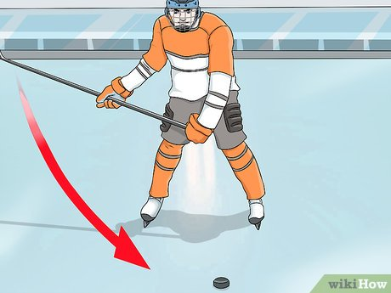A hockey player hits a moving puck away from their goal.

The forces changes **the direction of the puck.**

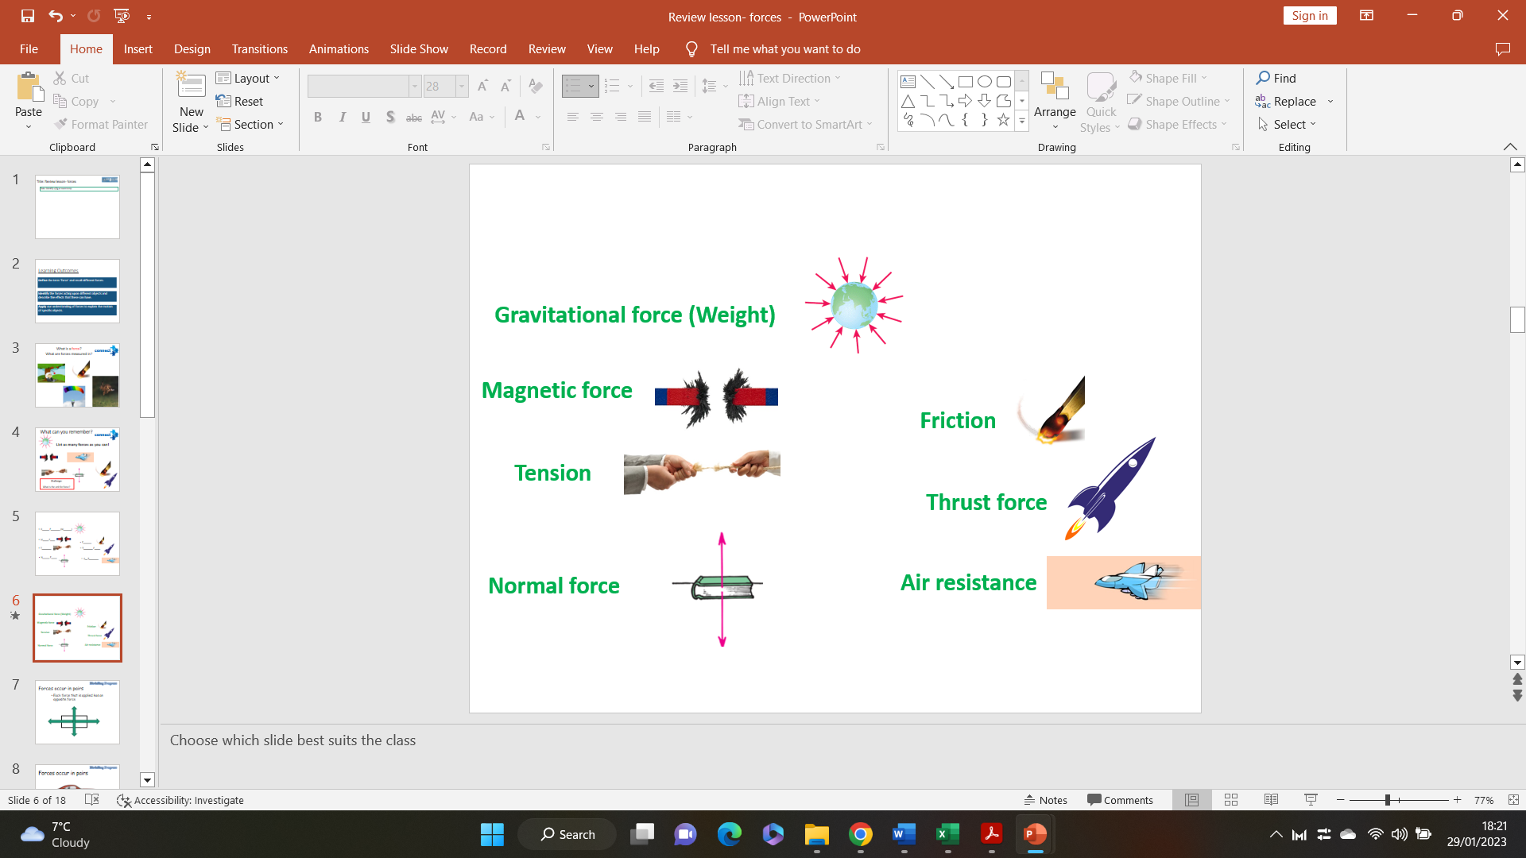

**Task 2: Contact and non-contact forces**

Categorise the following forces as **contact** or **non-contact** forces by adding them into the table below.

**Gravity Air resistance Friction Magnetic force**

**Electrostatic force Thrust force Tension**

|  |  |
| --- | --- |
| **Contact force** | **Non-contact force** |
| **Air resistance**  **Friction**  **Thrust force**  **Tension** | **Gravity**  **Magnetic force**  **Electrostatic force** |

**Task 1: Naming forces**

1. Name the forces shown by the diagrams below.
2. For each of the forces, state whether they are a **push force** or a **pull force**.

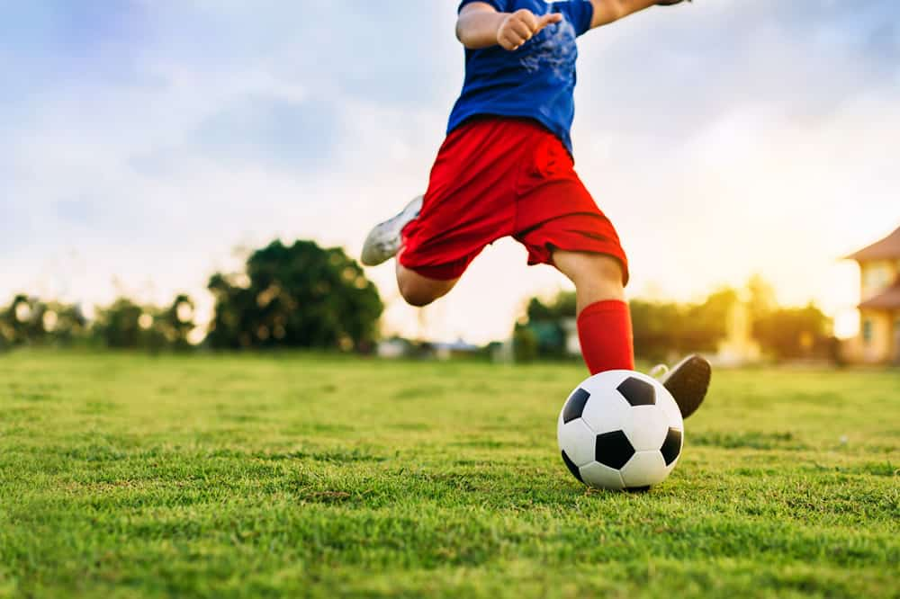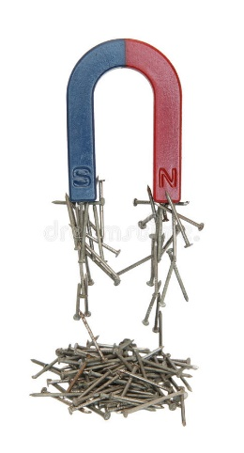

Contact or non-contact force? **Contact force.**

Explanation: **The boy’s foot had to be in physical contact with the ball in order for the push force to act.**

Contact or non-contact force? **Non-contact force (magnetic force)**

Explanation: **The magnet does not need to be in physical contact with the nails in order for the force to act.**

Contact or non-contact force? **Non-contact force (gravity)**

Explanation: **The force does not require two objects to be physically touching in order to interact.**

**Task 3: Explaining contact and non-contact forces.**

For each of the following examples, state whether the object is being acted upon by a **contact force** or a **non-contact force**. Explain your answers.

1. A falling raindrop.



1. A magnet attracting metal nails.
2. A child kicking a football.

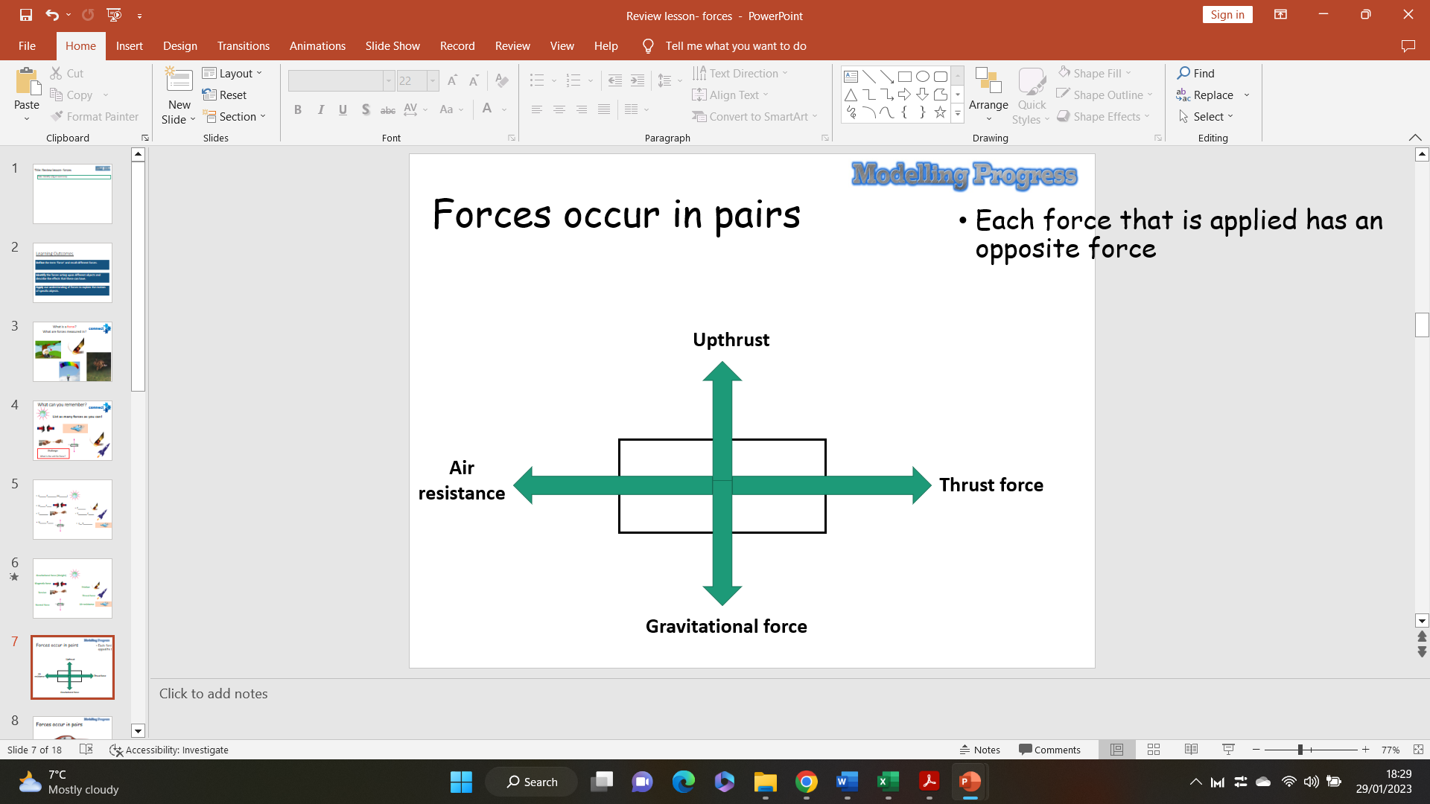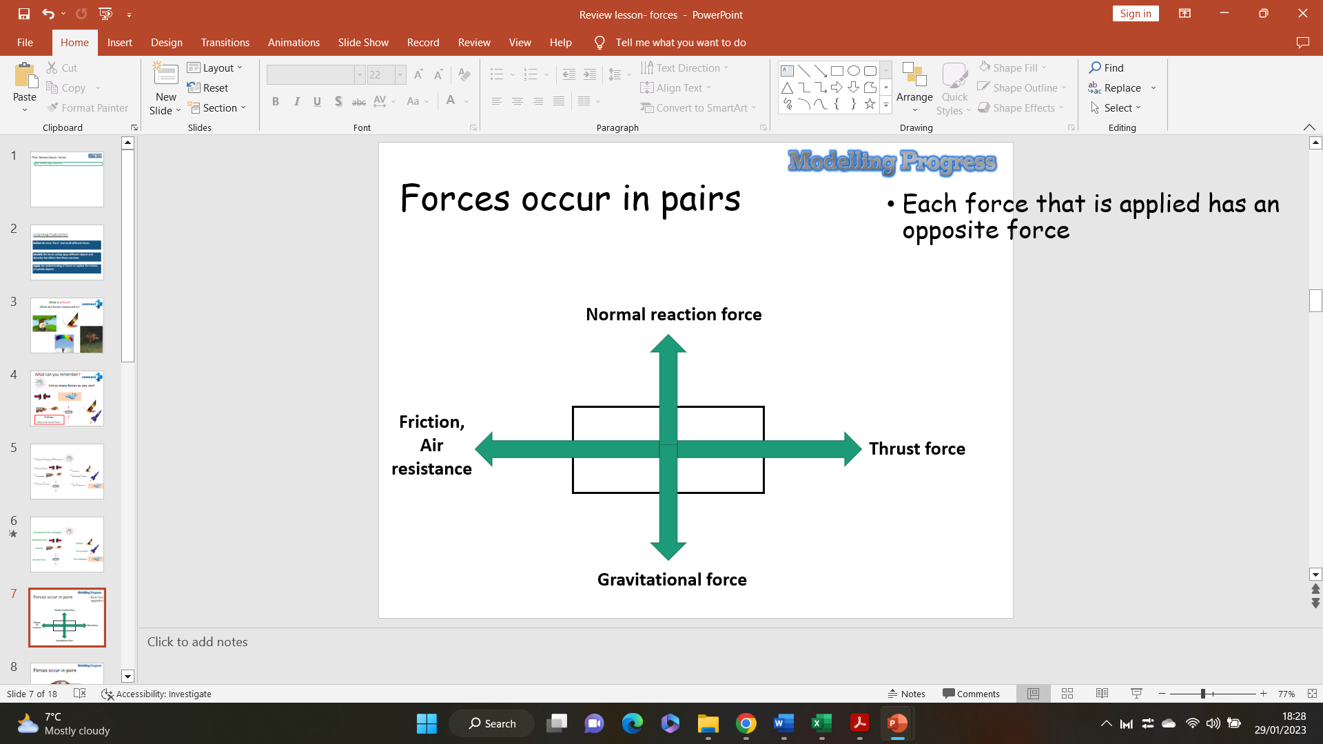

Task 4: Representing forces- Force diagrams

**I do:** Identify the forces acting on a moving car.

1. **How can you tell which direction the forces are acting in?**

**(The direction of the force is shown by the direction of the arrow).**

1. **How can you tell the size of the forces acting on the object?**

**(The size / magnitude of the force is shown by the length of the arrow).**

**We do: Add arrows to the box to illustrate the forces acting on an aeroplane travelling through the air at a constant speed.**

**Stretch:** Which force would have to increase to increase the speed of the plane? **Thrust force**

Which force would have to decrease for the plane to descend? **Upthrust**

**We do / you do:**

Tasha puts a small block of wood on a smooth surface.



She puts different forces on the block.  
The diagrams below show the size and direction of these forces.

Will each block move to the **left**, to the **right**or **stay still**?  
Tick the correct box in each row.

**forces on block                                   moves     moves**

**to the      to the    stays**

**left          right     still**

   

(i)

              

1 mark

(ii)

              

1 mark

(iii)

              

1 mark

(iv)

              

1 mark

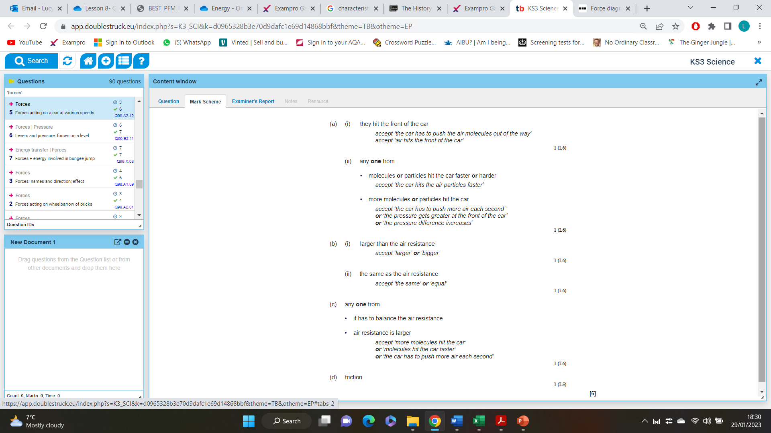

**You do:**

When a car is being driven along, two horizontal forces affect its motion.  
One is air resistance and the other is the forward force.

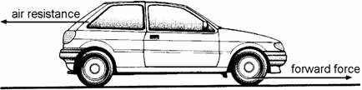

(a)     (i)      Explain how molecules in the air cause air resistance.

.............................................................................................................

.............................................................................................................

1 mark

(ii)     Explain why air resistance is larger when the car is travelling faster.

.............................................................................................................

.............................................................................................................

1 mark

(b)     (i)      Compare the sizes of the forward force and the air resistance when the car is speeding up.

The forward force is .............................................................................

.............................................................................................................

1 mark

(ii)     Compare the sizes of the two forces while the car is moving at a steady 30 miles per hour.

The forward force is ............................................................................

............................................................................................................

1 mark

(c)     The forward force has to be larger when the car is travelling at a steady 60 mph than when it is travelling at a steady 30 mph. Why is this?

......................................................................................................................

......................................................................................................................

1 mark

(d)     The forward force is the result of the tyres **not** being able to spin on the road surface.  
What is the name of the force that stops the tyres spinning?

.....................................................................

1 mark

Maximum 6 marks

**Lesson 3 – Balanced and unbalanced forces: Teacher notes**

**AQA Content**

**Students should know** that when the resultant force on an object is zero, it is in equilibrium and does not move, or remains at a constant speed in a straight line.

**Chunking**

1. All forces have a **direction**, and are measured in **Newtons (N)**.
2. Arrows are used to represent forces, and their sizes represent the **magnitude** of the force.
3. **Balanced forces** result in objects either not moving or remaining at a constant speed. **Unbalanced forces** result in a change in velocity, depending on the direction of the resultant force.
4. How to calculate the resultant force on an object and determine its direction.

**Key direct and explicit teacher explanations:**

1. All forces act in a particular direction. Use key examples to exemplify this:
   * Gravity always acts towards the centre of gravity (e.g. the centre of the Earth).
   * Friction, air resistance and water resistance always acts against the direction of motion.
   * Upthrust/buoyancy always acts upwards against an object in a fluid.

All forces are measured in Newtons (N). The unit comes from the scientist Isaac Newton (who did a lot

of work with forces).

1. Use diagrams of objects with arrows representing forces to demonstrate that the **length** of the arrow represents the magnitude of the force (longer arrow = larger force, shorter arrow = smaller force etc.). Discuss with students that arrows acting in opposite directions represent forces working against each other. If opposite arrows are the same size, the forces are balanced (equal). If one arrow is bigger than the other, the forces are unbalanced (unequal).
2. Use diagrams to show the effects of balanced and unbalanced forces. Use common examples to exemplify this (e.g. sky diver, car accelerating, pushing a trolley etc.)
   * Balanced forces – object remains stationary / remains at a constant speed in the same direction
   * Unbalanced forces – the velocity of the object will change (either increase or decrease, depending on the direction).
3. To calculate the resultant force, you need to subtract opposing angles away from each other. You need to add forces together if they work in the same direction. Use interleaving to exemplify this. The **direction** of the resultant force is whichever way the larger force (or sum of forces) was acting. This can be in two planes (x and y) if there was more than one set of opposing forces.

**Examples: A range of examples and non-examples are given to enable interpolation and limit extrapolation:**

Examples of forces and their direction:

* Gravity – always acts towards the centre of gravity (e.g. the centre of the Earth)
* Air resistance, friction and water resistance (drag forces) always act against the motion of an object.
* Upthrust / buoyancy always acts upwards against an object in a fluid.

The **length** of an arrow represents the magnitude of a force:

Examples of balanced forces:

* A sky diver that has reached terminal velocity – effect = speed and direction remain constant
* A car travelling at a constant speed along a road – effect = speed and direction remain constant
* Standing on a surface – effect = remains stationary

Examples of unbalanced forces:

* A sky diver immediately after jumping – effect = sky diver accelerates downwards (gravity > air resistance)
* A car braking at a traffic light - effect = car decelerates (friction > thrust)
* A plane taking off – effect = plane accelerates forwards and lifts off the ground – (thrust and buoyancy > friction/air resistance and gravity)

= Small force

= Big force

**Teacher notes (e.g. key questions, examples, non-examples, explanations)**

____________________________________________________________________________________________________________________________________________________________________________________________________________________________________________________________________________________________________________________________________________________________________________________________________________________________________________________________________________________________________________________________________________________________________________________________________________________________________________________________________________________________________________________________________________________________________________________________________________________________________________________________________________________________________________________________________________________________________________________________________________________________________________________________________________________________________________________________________________________________________________________________________________________________________________________________________________________________________________________________________________________________________________________________________________________________________________________________________________________________________________________________________________________________________________________________________________________________________________________________________________________________________________________________________________________________________________________________________________________________________________________________________________________________________________________________________________________________________________________________________________________________________________________________________________________________________________________________________________________________________________________________

**An object does not have to be physically touching the centre of gravity to be affected by it e.g. dropping an object**

Friction, air resistance, water resistance, buoyancy/upthrust, tension, reaction force

A force that acts between objects that are physically touching

**Lesson 3 – Balanced and unbalanced forces**

**Skills Drill / Retrieval**

|  |  |  |
| --- | --- | --- |
| Answer | | PA / SA |
| 1 |  |  |
| 2 |  |  |
| 3 |  |  |
| 4 |  |  |
| 5 |  |  |
| 6 |  |  |
| 7 |  |  |
| 8 |  |  |

**Connect**

So far in this unit you have learned about the different types of force: contact forces and non-contact forces.

What is a contact force?

________________________________________________________________________

________________________________________________________________________

What are some examples of contact forces?

________________________________________________________________________________________________________________________________________________

Explain why gravity is not a contact force.

________________________________________________________________________________________________________________________________________________

Speeding up, as the forward force is greater than the backwards force.

Remains at a constant speed, because the forward and backward forces are equal.

Slowing down **(decelerating)**, as the upwards force is greater than the downwards force.

Speeding up **(accelerating)**, as the forward force is greater than the backwards force

The forces are balanced as the upwards arrow is the same **length** as the downward arrow.

The forces are unbalanced as the forward force arrow is **longer** than the backwards force arrow

**Task 1**: Are the forces in each diagram below balanced or unbalanced? How do you know?

a) b)

1. ____________________________________________________________________________________________________________________________________________________________________
2. ____________________________________________________________________________________________________________________________________________________________________

**Task 2**: Would the objects below be speeding up, slowing down, or remaining at a constant speed? Why?

1. Record your results from the investigation in the table below:
2. From the investigation, answer the following questions:
   1. How does this experiment allow you to measure the energy content of food?

_____________________________________________________________________________________________________________________________________________________________________________________________________________________________________________

(100N + 35N) – 47N = 88N

Direction = right

250N – 250N = 0N

No direction

(260N + 92N) – (157N + 195N) = 0N

No direction

300N – 300N = 0N

No direction

450N – 210 N = 240N

Direction = right

370N – 150N = 220N

Direction = up

b.

a.

c.

(7N + 2N) – 4N = 5N

Direction = up

100N – 0N = 100N

Direction = right

4N – (3N + 1N) = 0N

No direction.

The object will remain at a constant speed, or remain stationary

The object will decelerate / slow down.

The object will accelerate / speed up.

c.

b.

a.

**Task 3**: Explain what happens to the motion of an object when:

* 1. The forward force on an object is **greater than** the backwards force:

______________________________________________________________________________________________________________________________________________________________

* 1. The forward force on an object is **lower than** the backwards force:

______________________________________________________________________________________________________________________________________________________________

* 1. The forward force on an object is **equal to** the backwards force:

______________________________________________________________________________________________________________________________________________________________

**Task 4**: Calculate the resultant force on each object, and state the direction of that resultant force:

**Task 5**: Calculate the resultant force on each object in both planes (x and y), and state the direction for each:

**Lesson 4 – Forces and their effect on equilibrium: Teacher notes**

**AQA Content**

**Students should know**: If the overall, resultant force on an object is non-zero, its motion changes and it slows down, speeds up or changes direction.

**Students should know**: When the resultant force on an object is zero, it is in equilibrium and does not move, or remains at a constant speed in a straight line.

**Chunking**

1. Recap how forces in the same direction on an object are additive, and forces in opposite directions are opposing.
2. Recap how to calculate resultant forces, and identify balanced/unbalanced pairs.
3. Discuss what happens when opposing forces are equal – define equilibrium.
4. The effect of unbalanced forces on equilibrium.

**Key direct and explicit teacher explanations:**

1. Forces acting in the same direction on the same object are additive. This means they work together to produce a larger force acting in that direction. Forces acting in opposite directions on the same object are opposing, and work against each other.
2. Calculating a resultant force involves adding up all forces acting in the same direction on an object. You then subtract the sum of forces acting in the opposing direction. The result is called the resultant force. The direction of this resultant force is whichever direction had the larger sum of forces. In these cases, the forces are unbalanced. If there is no resultant force (the sums of opposing forces was equal), the forces are balanced.
3. Equilibrium occurs when opposing forces are equal. This balance means there is no resultant force. In the event of equilibrium, the object will either remain stationary, or continue moving at a constant speed in a straight line. This is known as **Newton’s first law of motion**.
4. If the opposing forces on an object are not equal, they are unbalanced. This produces a resultant force, which negates equilibrium and affects the motion of the object. An object not in equilibrium will speed up, slow down, or change direction.

**Examples: A range of examples and non-examples are given to enable interpolation and limit extrapolation:**

Forces acting in the same direction are additive:

* Friction and air resistance against a car

Forces acting in opposite directions are opposing:

* Thrust and friction

Equilibrium is when opposing forces are balanced, meaning there is no resultant force. Examples of equilibrium include:

* A car driving at a constant speed on a motorway (not changing direction)
* A plane flying at the same altitude at cruising speed
* A book sitting on a table
* A car parked at the side of a road

Equilibrium is not achieved if opposing forces are unbalanced. This results in the object speeding up, slowing down, or changing direction. Examples of this include:

* A car setting off at traffic lights.
* A plane beginning its descent.
* A book being picked up off a table.

**Teacher notes (e.g. key questions, examples, non-examples, explanations)**

________________________________________________________________________________________________________________________________________________________________________________________________________________________________________________________________________________________________________________________________________________________________________________________________________________________________________________________________________________________________________________________________________________________________________________________________________________________________________________________________________________________________________________________________________________________________________________________________________________________________________________________________________________________________________________________________________________________________________________________________________________________________

**Teacher notes (e.g. key questions, examples, non-examples, explanations)**

____________________________________________________________________________________________________________________________________________________________________________________________________________________________________________________________________________________________________________________________________________________________________________________________________________________________________________________________________________________________________________________________________________________________________________________________________________________________________________________________________________________________________________________________________________________________________________________________________________________________________________________________________________________________________________________________________________________________________________________________________________________________________________________________________________________________________________________________________________________________________________________________________________________________________________________________________________________________________________________________________________________________________________________________________________________________________________________________________________________________________________________________________________________________________________________________________________________________________________________________________________________________________________________________________________________________________________________________________________________________________________________________________________________________________________________________________________________________________________________________________________________________________________________________________________________________________________________________________________________________________________________________

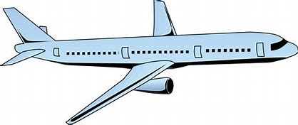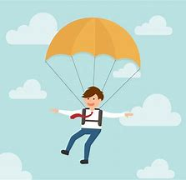

**Air resistance**

**Upthrust**

**Thrust**

**Gravity**

**Gravity**

**Air resistance**

**Lesson 4 – Forces and their effects on equilibrium**

**Skills Drill / Retrieval**

|  |  |  |
| --- | --- | --- |
| Answer | | PA / SA |
| 1 |  |  |
| 2 |  |  |
| 3 |  |  |
| 4 |  |  |
| 5 |  |  |
| 6 |  |  |
| 7 |  |  |
| 8 |  |  |

**Connect**

We have previously said that all forces act in a particular direction. For each image below, identify the forces that would be affecting each object, and label their direction with an arrow.

**100 N – 100 N = 0 N**

**It is in equilibrium**

**860 N - 150 N = 710 N right**

**It is not in equilibrium**

**220 N – 75 N = 145 N down**

**It is not in equilibrium**

**No forces in this plane 🡪 It is in equilibrium.**

**Task 1**: For each of the examples below:

* 1. Calculate the resultant force in the x-plane (left/right).
  2. State whether the object is in equilibrium in the x-plane.
  3. Calculate the resultant force in the y-plane (up/down).
  4. State whether the object is in equilibrium in the y-plane.

X-plane (left/right) : _____________________________ __________________________________________________________________________________________________________________________________________

Y-plane (left/right) : _____________________________ __________________________________________________________________________________________________________________________________________

X-plane (left/right) : _____________________________ __________________________________________________________________________________________________________________________________________

Y-plane (left/right) : _____________________________ __________________________________________________________________________________________________________________________________________

**The car would begin to decelerate / slow down, because the backwards force would be greater than the forwards force.**

**The car would begin to accelerate / speed up, because the forwards force would then be greater than the backwards force.**

**The car will be moving at a constant speed in a straight line / the same direction.**

**This is because all of the forces are in equilibrium.**

**Reaction force**

**Gravity**

**Air resistance / friction**

**Thrust**

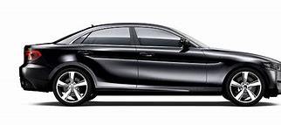

**A**

**B**

**C**

**D**

**Task 2**: This car is driving along the motorway. Right now, all the opposing forces (A-B and C-D) are balanced.

1. Identify the forces A-D:

A 🡪 __________________________

B 🡪 __________________________

C 🡪 __________________________

D 🡪 __________________________

1. Describe the movement and speed of the car, and give a reason for this.

______________________________________________________________________________________________________________________________________________________________________________________________________________________________________________________

1. Explain what would happen if the size of force A increased.

______________________________________________________________________________________________________________________________________________________________________________________________________________________________________________________

1. Explain what would happen if the size of force B increased.

______________________________________________________________________________________________________________________________________________________________________________________________________________________________________________________

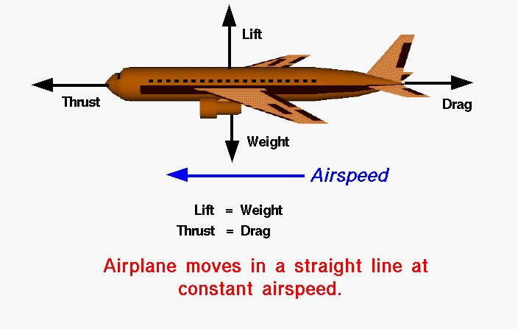

**Task 3**: Read the following NASA article discussing equilibrium.

## Vector

1. A very basic concept when dealing with either forces or torques (moments) is the idea

2. of **equilibrium** or **balance**. Forces and torques are **vector** quantities which means that they have

3. both a magnitude and a direction associated with them. Two forces with the same magnitude but

4. different directions are not equal forces. In general, an object can be acted on by several different

5. forces or torques at any one time. The vector sum of all of the forces acting on a body is a single

6. force called the **resultant** force. The vector sum of all the torques is a single torque called the

7. resultant torque. If the resultant force (resultant torque) is equal to zero, the object is said to be in

8. equilibrium.

**Four Forces**

9. There are four forces that act on an aircraft in flight: lift, weight, thrust, and drag. A force is a vector

10. quantity which means that it has both a magnitude (size) and a direction associated with it. If the

11. size and direction of the forces acting on an object are exactly balanced, then there is no **resultant**

12. **force** acting on the object and the object is said to be in equilibrium. From Newton’s first law of

13. motion we know that an object at rest will stay at rest, and an object in motion (constant velocity) will stay in

14. motion unless acted on by an external force. If there is no resultant external force, the object will maintain a

15. constant velocity.

**The weight would need to become greater than the lift.**

**The thrust would need to become greater than the drag.**

**Lift needs to be balanced by weight, and thrust needs to be balanced by drag.**

**At equilibrium, an object at rest will stay at rest, and an object in motion will stay in motion unless acted on by an external force.**

**The object is in equilibrium.**

**A quantity which has both a magnitude and a direction.**

**Cruise Velocity**

16. In an ideal situation, the forces acting on an aircraft in flight can produce no resultant external force. In this

17. situation the lift is equal to the weight, and the thrust is equal to the drag. The closest example of this

18. condition is a **cruising** airliner. While the weight decreases due to fuel burned, the change is very small

19. relative to the total aircraft weight. The aircraft maintains a constant airspeed called the **cruise velocity**.

**Force**

20. If the pilot changes the throttle setting, or increases the wing angle of attack, the forces become

21. unbalanced. The aircraft will move in the direction of the greater force, and we can compute acceleration of

22. the aircraft from Newton’s second law of motion.

1. What is a vector quantity?

__________________________________________________________________________________________________________________________________________________________________________

1. What happens if resultant forces is zero?

__________________________________________________________________________________________________________________________________________________________________________

1. What is Newton’s first law of motion?

__________________________________________________________________________________________________________________________________________________________________________

1. Which forces need to be balanced for the airplane to be in equilibrium?

__________________________________________________________________________________________________________________________________________________________________________

1. What would need to happen to the forces for the plane to speed up?

__________________________________________________________________________________________________________________________________________________________________________

1. What would need to happen to the forces for the plane to start to descend?

__________________________________________________________________________________________________________________________________________________________________________