**Year 10 – Teacher Booklet A (Trilogy)**

Key Stage 4 Science:

**Atomic Structure (PHY)**

**This booklet is for use in your Science lessons. Please look after it in the same way you would your exercise book and ensure that your presentation is always PROUD.**

**Ensure that your booklet is returned to your class book box at the end of the lesson.**

**Lesson Breakdown**

Lesson 1: 4.4.1.1 / 4.4.1.2 The structure of an atom / mass number & atomic number

Lesson 2: 4.4.1.2 Isotopes

Lesson 3: 4.4.1.3 The development of the model of the atom

Lesson 4: 4.4.1.3 The scattering experiment

Lesson 5: 4.4.2.1 Radioactive decay

Lesson 6: 4.4.2.1 Uses of radiation

Lesson 7: 4.4.2.2 Nuclear equations

Lesson 8: 4.4.2.3 Half-lives and the random nature of radioactive decay

Lesson 9 (HT only): 4.4.2.3 New decline expressed as a ratio

Lesson 10: 4.4.2.4 Radioactive contamination

**Keystone words**

1. Atomic

2. Radioactive

3. Decay

4. Nuclear

5. Contamination

6. Irradiation

**Lesson 1: Teacher notes**

**AQA Content**

Atoms are very small, having a radius of about 1 × 10-10 metres.

The basic structure of an atom is a positively charged nucleus composed of both protons and neutrons surrounded by negatively charged electrons.

The radius of a nucleus is less than 1/10 000 of the radius of an atom. Most of the mass of an atom is concentrated in the nucleus.

The electrons are arranged at different distances from the nucleus (different energy levels). The electron arrangements may change with the absorption of electromagnetic radiation (move further from the nucleus; a higher energy level) or by the emission of electromagnetic radiation (move closer to the nucleus; a lower energy level).

In an atom the number of electrons is equal to the number of protons in the nucleus. Atoms have no overall electrical charge. All atoms of a particular element have the same number of protons. The number of protons in an atom of an element is called its atomic number. The total number of protons and neutrons in an atom is called its mass number. Atoms can be represented as shown

**Chunking**

1. The size of atoms
2. The structure of an atom
3. Atomic number & atomic mass
4. What happens when atoms absorb or emit energy?

**Key direct and explicit teacher explanations:**

1. Anything that has mass is made up of particles. There are many types of particles. For example, atoms, molecules, protons, neutrons and electrons. Atoms are one of the simplest types of particles; all of the types of atoms that we know about can be found on the Periodic Table.

Atoms are incredibly small; they are so small that they can only be seen using specialised techniques. For example, X-ray crystallography and scamming-tunnelling electron microscopy.

Atoms are so small that if we lined up 20,000,000,000 atoms in a row, the line would only be one metre long; an atom has a radius of approximately 1 × 10-10 metres.

1. Atoms are made up of smaller particles called protons, neutrons and electrons; you studied these, and learnt to draw the electronic structure of atoms, in the Atomic Structure topic in Chemistry.

The number of protons in the nucleus is always the same for every atom of a particular element.

Protons and neutrons are found in the nucleus of an atom. The nucleus is found at the centre of the atom. The electrons are found in shells or energy levels that are around the nucleus.

The nucleus is very small compared to the size of an atom; it is approximately 10,000 times smaller than the atom. If a nucleus was the size of a pea, the atom would be about the same size as Wembley stadium.

Protons and neutrons have a mass of one. Electrons are much smaller than protons and neutrons; so, the mass of an atom is mostly found in the nucleus.

In an atom, the number of protons is always equal to the number of electrons. Atoms do not have an overall electrical charge. This is because electrons are negatively charged, and protons are positively charged. The positive and negative charged cancel out. Neutrons do not have a charge, so they do not affect the charge of an atom.

**MWBs ought to be used to retrieve and apply content.**

1. We can work out how many protons, neutrons and electrons an atom has using information on the Periodic Table. The atomic number (or proton number) tells us how many protons an atom has. It also tells us how many electrons an atom has; in an atom, the number of protons is always the same as the number of electrons. The total number of neutrons and protons in an atom is given by the mass number. To determine the number of neutrons, the atomic number is subtracted from the mass number.

**MWBs ought to be used to check understanding. E.g. calculating PEN numbers for different elements.**

1. Electrons are found in energy levels or shells; these are around the nucleus. The electrons in the outer shell have more energy than those in the inner shells. When atoms absorb energy, when they absorb light for example, electrons can move to higher energy levels which are further from the nucleus. They can then return to lower energy levels (that are closer to the nucleus) when the amount of energy that the atom has decreases. This energy is usually transferred as heat.

**This is quite dry; use examples to check understanding to colour due to absorption and emission of light (fluorescence); this is to help retention by enabling students to make connections with examples.**

**Examples and non-examples**

1. **Examples:**

**Graphene: 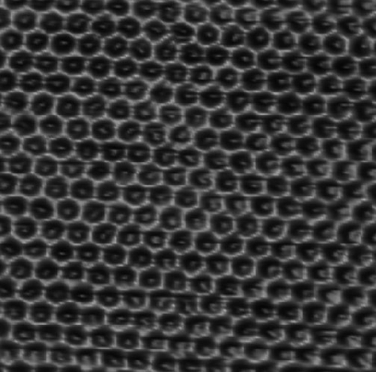

**4. Examples:**

* **Absorption of light of different wavelengths (absorb light energy at specific wavelength as electrons move to**

**higher energy level / thermal energy emitted as the electron returns to a lower energy level)**

* **Flame tests (absorb thermal energy to excite the electron / emit light as electrons return to lower energy level)**
* **Fluorescence (often absorb UV light to excite the electron / emit light as electrons return to lower energy level)**

**Teacher notes (e.g. key questions, examples, non-examples, explanations)**

________________________________________________________________________________________________________________________________________________________________________________________________________________________________________________________________________________________________________________________________________________________________________________________________________________________________________________________________________________________________________________________________________________________________________________________________________________________________________________________________________________________________________________________________________________________________________________________________________________________________________________________________________________________________________________________________________________________________________________________________________________________________

**Teacher notes (e.g. key questions, examples, non-examples, explanations)**

____________________________________________________________________________________________________________________________________________________________________________________________________________________________________________________________________________________________________________________________________________________________________________________________________________________________________________________________________________________________________________________________________________________________________________________________________________________________________________________________________________________________________________________________________________________________________________________________________________________________________________________________________________________________________________________________________________________________________________________________________________________________________________________________________________________________________________________________________________________________________________________________________________________________________________________________________________________________________________________________________________________________________________________________________________________________________________________________________________________________________________________________________________________________________________________________________________________________________________________________________________________________________________________________________________________________________________________________________________________________________________________________________________________________________________________________________________________________________________________________________________________________________________________________________________________________________________________________________________________________________________________________

**Lesson 1:** The structure of an atom / mass number & atomic number

**Objective: By the end of this lesson you will be able to describe the structure of an atom and what happens when atoms absorb energy.**

**Skills Drill / Retrieval**

|  |  |  |
| --- | --- | --- |
| Answer | | PA / SA |
| 1 |  |  |
| 2 |  |  |
| 3 |  |  |
| 4 |  |  |
| 5 |  |  |

**Connect**

Atoms are very small particles. They are made up of protons, neutrons and electrons.

Work out how many protons, neutrons and electrons the following atoms have (use the knowledge booklet if you need help):

1. **Lithium**: Protons:__________________________________________________________________________Neutrons:_________________________________________________________________________Electrons:_________________________________________________________________________
2. **Magnesium**: Protons:__________________________________________________________________________Neutrons:_________________________________________________________________________Electrons:_________________________________________________________________________
3. **Oxygen**: Protons:__________________________________________________________________________Neutrons:_________________________________________________________________________Electrons:_________________________________________________________________________

The diagram represents an atom of beryllium. The three types of particle that make up the atom have been labelled.

1. Which particles have a mass of one? _____________________________________________
2. Which particle is positively charged? ____________________________________________
3. Which particle doesn’t have a charge? ___________________________________________
4. What is the centre of the atom called? ____________________________________________
5. Which particles are found there? ________________________________________________
6. Where are electrons found in the atom? __________________________________________
7. What is the atomic number of Beryllium? _________________________________________
8. What is the mass number of Beryllium? __________________________________________

Neutrons and protons

Protons

Neutrons

Nucleus

Protons and neutrons

Energy levels / shells

4

9

The table gives information about the three types of particle that make up an atom.

|  |  |  |
| --- | --- | --- |
| **Particle** | **Relative mass** | **Relative charge** |
| Proton |  | +1 |
| Neutron | 1 |  |
| Electron | very small | –1 |

(a)     Complete the table by adding the **two**missing values.

(b)     Use the information in the table to explain why an atom has no overall electrical charge.

___________________________________________________________________

___________________________________________________________________

___________________________________________________________________

___________________________________________________________________

Use your Periodic Table, and knowledge of atomic mass and atomic number, to fill in the gaps.

The atomic number gives the number of protons. Sodium has 11 protons.

It also has 11 electrons. Because the number of protons in an atom is always the same as the number of electrons.

Protons have a mass of one and a charge of +1.

Neutrons have a mass of one and are neutral / don’t have a charge.

Electrons have a negligible mass and a charge of -1.

Protons and neutrons are found in the nucleus; the nucleus is at the centre of the atom.

Therefore, most of the mass of an atom is found in the nucleus (because it contains the protons and neutrons which have a much greater mass than electrons).

The nucleus is about 10,000 times smaller than the entire atom.

Describe the structure of a sodium atom.

You should include:

1. The number of protons, neutrons and electrons (and how you worked this out).
2. The mass and charge of protons, neutrons and electrons.
3. Where protons, neutrons and electrons can be found.
4. Where most of the mass of an atom is concentrated.
5. Explain ‘d’ in terms of where you find protons, neutrons and electrons.
6. The size of the central part of the atom compared to the whole atom.

_________________________________________________________________________________________________________________________________________________________________________________________________________________________________________________________________________________________________________________________________________________________________________________________________________________________________________________________________________________________________________________________________________________________________________________________________________________________________________________________________________________________________________________________________________________________________________________________________________________________________________________________________________________________________________________________________________________________________________________________________________________________________________________________________________________________________________________________________________________________________________________________________________________________________________________________________________________________________________________________________________________________

**Lesson 2: Teacher notes**

**AQA Content**

Atoms of the same element can have different numbers of neutrons; these atoms are called isotopes of that element. Atoms turn into positive ions if they lose one or more outer electron(s).

**Students should be able to** relate differences between isotopes to differences in conventional representations of their identities, charges, and masses.

**Chunking**

1. Why do atoms become charged when they gain or lose electrons?
2. What is an isotope?
3. Interpreting different representations of isotopes.

**Key direct and explicit teacher explanations:**

1. Atoms are made up of three types of particles; protons, electrons and neutrons. Protons are positively charged, and electrons are negatively charged. Atoms do not have an overall charge because they have exactly the same number of protons as neutrons; they have the same number of positive charges as negative charges so they cancel out.

When atoms react, they sometimes lose or gain electrons to form ions. Atoms that gain electrons become negatively charged, because electrons are negatively charged.

Atoms that lose electrons become positively charged. This is because they will have more protons (positively charged) than electrons (negatively charged).

1. Some elements have more than one form. For example, carbon has three forms called carbon-12, carbon-13 and carbon-14. The number tells you the mass number of the atom. These different forms of the same element are called isotopes.

Isotopes are different forms of the same element with different numbers of neutrons.

**Examples should be given (e.g. isotopes of carbon, hydrogen, magnesium, silicon etc). It needs to be clear that the numbers of protons and electrons are constant. The number of neutrons changes. Non-examples would be isobars (e.g. Ar-40 & K-40 & Ca-40; Na & Mg; Fe & Ni; Co & Ni). Isobars have the same atomic mass but different numbers of protons.**

1. Isotopes can be identified from the electronic structures of different elements. Usually, these diagrams will show the numbers of protons, electrons and neutrons. You need to look carefully at the diagrams and count the numbers of protons and neutrons in each diagram. The isotopes will have the same number of protons and different numbers of neutrons.

You can also be shown graphs and asked to identify isotopes on them. You can identify them because the number of protons will be the same for two or more atoms. However, their atomic masses will be different.

**Examples: A range of examples and non-examples are given to enable interpolation and limit extrapolation:**

1. **Examples: Isotopes of carbon, hydrogen, magnesium, silicon etc**

**Non-examples: Isobars - Ar-40 & K-40 & Ca-40; Na & Mg; Fe & Ni; Co & Ni**

1. **Exam questions expect students to identify isotopes from graphs, electronic structures. Examples should include these.**

**Teacher notes (e.g. key questions, examples, non-examples, explanations)**

________________________________________________________________________________________________________________________________________________________________________________________________________________________________________________________________________________________________________________________________________________________________________________________________________________________________________________________________________________________________________________________________________________________________________________________________________________________________________________________________________________________________________________________________________________________________________________________________________________________________________________________________________________________________________________________________________________________________________________________________________________________________

**Teacher notes (e.g. key questions, examples, non-examples, explanations)**

____________________________________________________________________________________________________________________________________________________________________________________________________________________________________________________________________________________________________________________________________________________________________________________________________________________________________________________________________________________________________________________________________________________________________________________________________________________________________________________________________________________________________________________________________________________________________________________________________________________________________________________________________________________________________________________________________________________________________________________________________________________________________________________________________________________________________________________________________________________________________________________________________________________________________________________________________________________________________________________________________________________________________________________________________________________________________________________________________________________________________________________________________________________________________________________________________________________________________________________________________________________________________________________________________________________________________________________________________________________________________________________________________________________________________________________________________________________________________________________________________________________________________________________________________________________________________________________________________________________________________________________________

**Lesson 2: Isotopes**

**Objective: By the end of this lesson you will be able to identify isotopes from examples of atoms shown in different ways.**

**Skills Drill / Retrieval**

|  |  |  |
| --- | --- | --- |
| Answer | | PA / SA |
| 1 |  |  |
| 2 |  |  |
| 3 |  |  |
| 4 |  |  |
| 5 |  |  |

**Connect**

Atoms are composed of three sub-atomic particles; protons, electron and neutrons.

Protons have a relative mass of one and a charge of +1.

Electrons have a relative mass of close to zero and a charge of -1.

Neutrons have a relative mass of one and are neutral.

When metals react with non-metals, the metal atom gives electrons to the non-metal atom.

1. What charge would an atom have if it gained an electron? Explain your answer.

______________________________________________________________________________________________________________________________________________________________________________________________________________________________________________________________________________________________________________________________________________________________________________________________________________________________________________________________________________

Negative one.

The atom gained one electron.

Electrons have a charge of -1.

1. What charge would an atom have if it lost an electron? Explain your answer.

______________________________________________________________________________________________________________________________________________________________________________________________________________________________________________________________________________________________________________________________________________________________________________________________________________________________________________________________________________

Plus / positive 1.

The atom lost one electron.

The atom will have one more proton than electrons.

Protons have a charge of plus / positive one.

The graph shows the atomic number and mass number of five atoms (labelled A – E).

Calculate the number of protons, neutrons and electrons in atoms A – E.

**I DO**

**Atom

**WE DO / YOU DO**

**Atom

Protons = 88

Electrons = 88

Neutrons = 226 – 88 = 138

Protons = 86

Electrons = 86

Neutrons = 234 – 86 = 148

**WE DO / YOU DO**

**Atom C.** _________________________________________________________________________________________________________________________________________________________________________________________________________________________________________________________________________________________________________________________________________________________________________________________________________________________________________ **Atom D.** _________________________________________________________________________________________________________________________________________________________________________________________________________________________________________________________________________________________________________________________________________________________________________________________________________________________________________**Atom

**Atoms of the same element that have different numbers of neutrons are called isotopes.**

**Explain why D and E are isotopes of the same elementxplain why A and C are not isotopes of the same element** _________________________________________________________________________________________________________________________________________________________________________________________________________________________________________________________________________________________________________________________________________________________________________________________________________________________________________

Protons = 90

Electrons = 90

Neutrons = 234 – 90 = 144

Atoms A and C have different numbers of protons

Atoms of the same element have the same number of protons

Atoms D and E have the same number of protons

But different numbers of neutrons

Protons = 92

Electrons = 92

Neutrons = 235 – 92 = 143

Protons = 92

Electrons = 92

Neutrons = 238 – 92 = 146

The image shows three atoms labelled L – M).

For each atom, state the number of protons, neutrons and electrons.

For each atom, state the atomic number and atomic mass.

**I DO**

**Atom

**WE DO / YOU DO**

**Atom

**Atom M.** _________________________________________________________________________________________________________________________________________________________________________________________________________________________________________________________________________________________________________________________________________________________________________________________________________________________________________ **Which two atoms are isotopes? Explain your answer

K & L

Both have one proton

Different number of neutrons

Protons = 2

Electrons = 2

Neutrons = 2

Protons = 1

Electrons = 1

Neutrons = 2

Protons = 1

Electrons = 1

Neutrons = 1

B, E & G

All have 88 protons

Different numbers of neutrons (calculated from mass number and atomic number)

Atomic number: 88

Mass number: 138

Atomic number: 89

Mass number: 139

Atomic number: 90

Mass number: 140

Atomic number: 88

Mass number: 140

Atomic number: 86

Mass number: 140

The graph shows the atomic number and mass number of five atoms (labelled A – G).

Determine the atomic number and atomic mass for the following atoms.

**I DO**

**Atom A.** __________________________________________________________________________________________________________________________________________________________________________

**WE DO / YOU DO**

**Atom B.** __________________________________________________________________________________________________________________________________________________________________________

**Atom C.** __________________________________________________________________________________________________________________________________________________________________________ **Atom D.** __________________________________________________________________________________________________________________________________________________________________________

**Atom E.** __________________________________________________________________________________________________________________________________________________________________________

**Identify three atoms that are isotopes of the same element. Explain your answer.**

_______________________________________________________________________________________________________________________________________________________________________________________________________________________________________________________________

**I DO**

**Argon and Calcium both have an atomic mass that rounds to 40, but they have different atomic numbers. Use the information given to show that they aren’t isotopes.**

________________________________________________________________________________________________________________________________________________________________________________________________________________________________________________________________________________________________________________________________________________________________________________________________________________________________________________________________________________________________________________________________________________________________________________________________________________________________________________________________________________________________________

**WE DO / YOU DO**

**Cobalt and Nickel both have an atomic mass that rounds to 59, but they have different atomic numbers. Use the information given to show that they aren’t isotopes.**

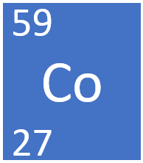

________________________________________________________________________________________________________________________________________________________________________________________________________________________________________________________________________________________________________________________________________________________________________________________________________________________________________________________________________________________________________________________________________________________________________________________________________________________________________________________________________________________________________

Cobalt has 27 protons

Nickel has 28 protons

They can’t be isotopes of the same element as they have different numbers of protons

Atoms of the same element always have the same number of protons

Argon has 18 protons

Calcium has 20 protons

They can’t be isotopes of the same element because they have different numbers of neutrons

Atoms of the same element always have the same number of protons

**Lesson 3: Teacher notes**

**AQA Content**

New experimental evidence may lead to a scientific model being changed or replaced.

Before the discovery of the electron, atoms were thought to be tiny spheres that could not be divided.

The discovery of the electron led to the plum pudding model of the atom. The plum pudding model suggested that the atom is a ball of positive charge with negative electrons embedded in it.

The results from the alpha particle scattering experiment led to the conclusion that the mass of an atom was concentrated at the centre (nucleus) and that the nucleus was charged. This nuclear model replaced the plum pudding model.

Niels Bohr adapted the nuclear model by suggesting that electrons orbit the nucleus at specific distances. The theoretical calculations of Bohr agreed with experimental observations.

Later experiments led to the idea that the positive charge of any nucleus could be subdivided into a whole number of smaller particles, each particle having the same amount of positive charge. The name proton was given to these particles.

The experimental work of James Chadwick provided the evidence to show the existence of neutrons within the nucleus. This was about 20 years after the nucleus became an accepted scientific idea.

**Chunking**

1. New evidence changes scientific ideas
2. Ideas about atoms have changed over time

**Key direct and explicit teacher explanations:**

1. Scientists strive to understand the world around us. They do this by asking questions, making observations and then trying to explain those observations. When scientists think they can explain a set of observations, they test their ideas using more experiments. The scientific community also tests the ideas. The aim is to disprove the scientific theory.

This process can lead to a theory being totally disproven. Alternatively, it might be modified.

1. Ideas about particles and the structure of the atom have changed a lot since the Democritus and other atomists first described particles. The history of the atom is a good example of how scientific ideas change as new evidence becomes available

**Examples**

1. Lamarckism being replaced by Darwinism. However, geneticists can now show Lamarckism occurs in some situations. E.g. Drosophila undergo morphological changes in response to environmental stimuli. Some of these changes are passed onto to offspring for several generations.

Aristotle’s idea of everything being composed of earth, air, fire and water. This was replaced by the ideas of atomists. Ideas about atomic structure have changed further.

Einstein’s static Universe was replaced by Hubble’s Law of Cosmological Expansion after Hubble discovered the red-shift and explained its meaning.

There are many more examples!

**Teacher notes (e.g. key questions, examples, non-examples, explanations)**

____________________________________________________________________________________________________________________________________________________________________________________________________________________________________________________________________________________________________________________________________________________________________________________________________________________________________________________________________________________________________________________________________________________________________________________________________________________________________________________________________________________________________________________________________________________________________________________________________________________________________________________________________________________________________________________________________________________________________________________________________________________________________________________________________________________________________________________________________________________________________________________________________________________________________________________________________________________________________________________________________________________________________________________________________________________________________________________________________________________________________________________________________________________________________________________________________________________________________________________________________________________________________________________________________________________________________________________________________________________________________________________________________________________________________________________________________________________________________________________________________________________________________________________________________________________________________________________________________________________________________________________________

**Lesson 3: The development of the model of the atom**

**Objective: By the end of this lesson, you will be able to explain how and why the model of the atom has changed in response to new evidence**

**Skills Drill / Retrieval**

|  |  |  |
| --- | --- | --- |
| Answer | | PA / SA |
| 1 |  |  |
| 2 |  |  |
| 3 |  |  |
| 4 |  |  |
| 5 |  |  |

**Connect**

There are strong forces between the particles.

These hold the particles together.

A strong force needs to be applied to overcome the forces between particles.

Explain why solids have a fixed shape.

_____________________________________________________________________________________________________________________________________________________________________________________________________________________________________________________________________________________________________________________________________________________________________________________________________________________________________________________________________________________________________________________________________________________________________________________________________________________________________________________________________________________________________________________

The particles in solids have a regular arrangement. They also have strong forces between the particles.

|  |  |  |  |  |
| --- | --- | --- | --- | --- |
| **1**  **2**  **3**  **4**  **5**  **6**  **7**  **8**  **9**  **10**  **11**  **12**  **13**  **14**  **15**  **16**  **17**  **18**  **19**  **20**  **21**  **22**  **23**  **24**  **25**  **26**  **27**  **28**  **29**  **30**  **31**  **32**  **33**  **34**  **35**  **36**  **37**  **38**  **39**  **40**  **41**  **42**  **43**  **44**  **45**  **46**  **47**  **48**  **49**  **50**  **51**  **52**  **53**  **54**  **55**  **56**  **57**  **58**  **59**  **60**  **61**  **62**  **63**  **64**  **65**  **66**  **67**  **68**  **69**  **70**  **71**  **72**  **73**  **74**  **75**  **76**  **77**  **78**  **79**  **80**  **81**  **82**  **83**  **84**  **85**  **86**  **87**  **88**  **89**  **90**  **91**  **92**  **93**  **94**  **95**  **96**  **97**  **98** | **Atoms and Atomic Structure**  The word atom comes from a Greek word meaning small or something that can’t be split into anything smaller. In 450 BC, Democritus the Greek scholar describes all substances as being made of atoms; these were small, solid spheres that could not be divided. (This was not a new idea even then, Indian and Greek scholars had discussed the theory for two hundred years before Democritus came up with the name, atom.) Paper was made of paper atoms, sand of sand atoms, water of water atoms, etc.  In 1661 Robert Boyle defined an element as “a substance that cannot be broken down into a simpler substance by a chemical reaction.” This simple definition is still taught in schools today.  In 1803 Dalton gave a lecture to the Royal Institution in which he set out his atomic theory;  *All matter is composed of atoms. Atoms cannot be made or destroyed. Atoms of the same element are identical. Different elements have different types of atoms. Chemical reactions occur when atoms are rearranged. Compounds are formed from atoms of the constituent elements.*  *Atoms were believed to be small, solid, spheres.*   |  |  | | --- | --- | |  |  |   In 1894, Stoney published a paper discussing the work of several scientists over the previous decade and proposes the term “electron” for the smallest particle of electricity. Finally in 1897, J. J. Thomson, Cavendish Professor of Experimental Physics at Cambridge, managed to isolate and measure the charge to mass ratio of these “electrons”..  J.J. Thomson proposed the *electron* as a fundamental sub-atomic particle present in all matter. He came up with a model of the atom, called the plum pudding model, where 96,000 electrons were held in a positive “ether” to form an atom. Subsequent discoveries disproved Thomson’s model and the quiet, shy man who had taught seven Nobel prize winners and 27 Fellows of the Royal Society gave up his work on the atom.  In 1909, Rutherford was working with alpha particles. As a Professor he oversaw the work of Dr Hans Geiger and his student James Marsden. They were firing alpha particles at a thin piece of gold foil in a vacuum.  They knew that the plum pudding atoms would let the alpha particles through and deflect them slightly. They could see this from tiny flashes when the alpha particles hit a zinc sulphide screen inside the apparatus. Things didn’t go to plan! Marsden saw that there were big deflections of the alpha particles, when Geiger checked it he found not just deflections but reflections too. They took their findings to Rutherford who said, “It was almost as incredible as if you fired a 15-inch shell at a piece of tissue paper and it came back and hit you. On consideration, I realized that this scattering backward must be the result of a single collision.” The collision was between a fast-moving alpha particle and the small but very dense nucleus of a gold atom, a bit like kicking a football at a tank, sometimes the ball glances off and sometimes it comes right back at you. In 1911 Rutherford published a paper in which he proposed a new model of the atom, *the nuclear model*. At the centre of the atom there was a small positive centre, a *nucleus*, where the mass of the atom sat. Around this the *electrons* orbited. The nucleus is only one ten thousandth of the width of the whole atom. So Geiger and Marsden were very lucky to hit the nucleus at all, let alone to get to see the reflected alpha particles.  In 1913, Neils Bohr, published his work on Rutherford’s nuclear atom. Bohr showed that the electrons travelled around the nucleus in shells; the shells are a specific distance from the nucleus. His calculations showed that the first shell could hold two electrons. The third electron had to go into a new or second shell. This second shell could only hold eight electrons. The third shell also could only hold eight electrons. This matches up perfectly with the periodic table where the first period has two elements while the second and third periods have eight elements each. Bohr also showed that the number of electrons in the outer shell determines the chemical properties of the element. So elements with one electron in their outer shell like lithium and sodium will have similar properties.  Also in 1913 Henry Moseley showed that the positive charge on the nucleus was equal to the atomic number of the atom. This was discovered during experiments with x-rays. It was found that each element produced x-rays with a characteristic wavelength. Moseley worked out an equation to calculate the wavelength and found that the atomic number of the element had to be in it. Up until this point the atomic number was just that, the number of the atom in the periodic table, Moseley had shown that it was a fundamental part of the structure of the atom.  In 1919 Rutherford published the results of experiments showing that the nucleus of every atom contained the same particle as a hydrogen nucleus. Rutherford named this particle the *proton*, the number of protons in the nucleus was equal to the atom’s atomic number. Rutherford had shown that protons have the same mass as a hydrogen atom, a relative mass of one. He also showed that protons couldn’t account for all of the mass in the nucleus and proposed a new particle, the neutron, which had no charge but was as heavy as a proton. In 1932 James Chadwick eventually discovered the existence of the neutron which had the properties that Rutherford proposed.  The model of the atom that we use at GCSE was now filled in;  a tiny central nucleus containing protons and neutrons with the electrons whizzing around the nucleus in shells. The number of positive protons in the nucleus is equal to the atomic number of the atom.  The number of negative electrons is also equal to the atomic number, making atoms electrically neutral.  The number of neutrons is found by taking the atomic number from the mass number of the atom.  The study of the structure of the atom continues. Physicists break the nuclear particles into ever smaller pieces, quarks, leptons, muons, taus, gluons and bosons. Others have studied nuclear fission and fusion to gain more insight. Electrons are no longer particles but are treated as three dimensional waveforms. Complicated mathematics has given us models of heavier elements that allow us to explain their properties. |  |

**Timeline: The History Of The Structure Of An Atom**

The neutron.

In 1919 Rutherford published the results of experiments showing that the nucleus of every atom contained the same particle as a hydrogen nucleus. Rutherford named this particle the *proton*, the number of protons in the nucleus was equal to the atom’s atomic number.

Bohr showed that the electrons travelled around the nucleus in shells; the shells are a specific distance from the nucleus.

At the centre of the atom there was a small positive centre, a nucleus, where the mass of the atom sat. Around this the electrons orbited.

Cloud or dough of positive charge with negatively charged electrons embedded in it

Atoms were small, solid spheres that could not be divided

**What did Chadwick discover in 1932?**

**What did Rutherford demonstrate in 1919?**

**Shells/ energy levels**

What did Bohr demonstrate in 1911?

**The scattering experiment**

Describe the model published by Rutherford in 1911

**After electrons were discovered**

Describe J.J. Thomson’s model

Describe the atomic model used before the discovery of the electron.

Neutrons were formally included in the nucleus.

Nucleus contained positively charged protons.

Proposed to contain neutrons.

Electrons were in shells / energy levels that were a specific distance from the nucleus.

The nuclear model.

Small, central, positive nucleus. Negatively charged lectrons orbit the nucleus.

Electrons had a negative charge. This needed to be balanced with an equal positive charge. Electrons shown embedded in a cloud / dough of positive charge.

Small, solid spheres that could not be divided.

1. Describe Democritus’s model of the atom.

__________________________________________________________________________________________________________________________________________________________________________________________________________________________________________

1. How did the discovery of the electron change the model of the atom?

__________________________________________________________________________________________________________________________________________________________________________________________________________________________________________

1. What changes were made to the model of the atom after Rutherford and his team did the scattering experiment?

__________________________________________________________________________________________________________________________________________________________________________________________________________________________________________

1. Name Rutherford’s model of the atom.

__________________________________________________________________________________________________________________________________________________________________________________________________________________________________________

1. What changes were made to the model by Bohr?

__________________________________________________________________________________________________________________________________________________________________________________________________________________________________________

1. In 1919, Rutherford discovered protons. What changes were made to the model after this discovery?

__________________________________________________________________________________________________________________________________________________________________________________________________________________________________________

1. How did Chadwick’s discovery of the nucleus change the model?

__________________________________________________________________________________________________________________________________________________________________________________________________________________________________________________________________________________________________________________________________________________________________________________________________________________________________________________________________________________________________________________________________________________________________

**Lesson 4: Teacher notes**

**AQA Content**

Students should be able to describe:

* the difference between the plum pudding model of the atom and the nuclear model of the atom.
* why the new evidence from the scattering experiment led to a change in the atomic model

**Chunking**

1. The plum pudding model
2. Comparing the plum pudding model and the modern model of the atom (focus on differences)
3. The scattering experiment – results
4. Explaining the results of the scattering experiment

**Key direct and explicit teacher explanations with examples / non-examples:**

1. **After the discovery of electrons J.J Thomson published the plum pudding model of the atom. This model contains equal amounts of positive charges and negative charges; the atom is neutral overall.**

**The positive charge was thought to be spread out so it was referred to as a cloud or dough of positive charge. The electrons were embedded in the cloud or dough of positive charge.**

1. **The plum pudding model of the atom is very different to the modern model of the atom. In the modern model of the atom the positive charge is confined to a small central nucleus (it is the protons that are positively charged). In the plum pudding model the positive charge is spread out.**

**In the modern model of the atom, the electrons are found in shells or energy levels that are a specific distance from the nucleus. Whereas the electrons are embedded in the cloud or dough of positive charge in plum pudding model.**

1. **The plum pudding model was devised by J.J. Thomson and became widely accepted. However, the Rutherford laboratory did an experiment that showed that the model was wrong. This was a massive shock to many scientists; it caused J.J. Thomson, a highly respected scientist and mentor, to retire.**

**In the scattering experiment, alpha particles were fired at a thin piece of gold foil. The scientists then used a detector to see if the alpha particles went straight through the gold foil or whether they were deflected.**

Examples of apparatus for experiment: Showing multiple representations can help students develop understanding of how the experiment was set up.

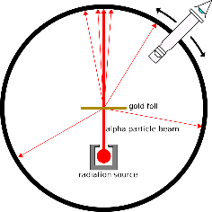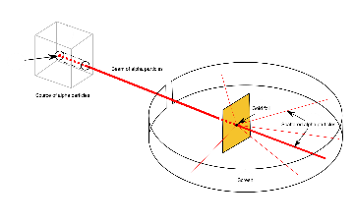

**If the plum-pudding model was right, all of the alpha particles were expected to go straight through or be deflected by 4 degrees or less (due to being attracted to positive dough / two alpha particles repelling). However, they found that a small percentage of the alpha particles were deflected. The scientists made over 100,000 measurements and a small percentage were always deflected.**

**Exam board images**

**4. The plum pudding model was discarded as it wasn’t consistent with the results of the experiment. Rutherford published his laboratory’s work and included the nuclear model of the atom.**

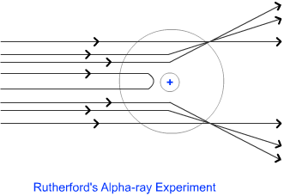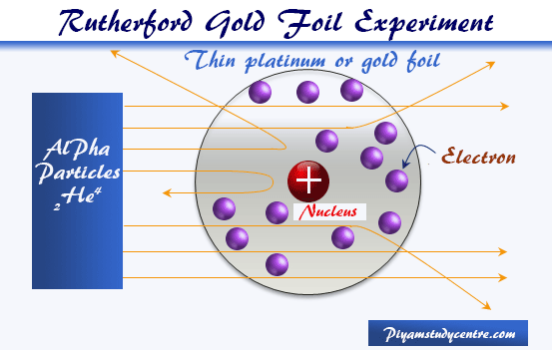

**In the scattering experiment, a small number of alpha particles were deflected by a small amount. They explained this by saying that the nucleus was small, positive and central in the atom. Some alpha particles were deflected because the alpha particles are positively charged and the nucleus is positively charged; they repelled each other.**

**A tiny number of alpha particles were deflected by a large amount. This tiny number suggested that the nucleus must be very small. These alpha particles got very close to the nucleus and so were deflected by a large amount.**

**Most alpha particles went straight through the gold foil; they were not deflected. They weren’t deflected because they didn’t get close to the nucleus. This suggested that most of the atom is empty space that alpha particles could move through without being deflected.**

Examples of the nuclear model: Note that the electrons aren’t at a specific distance from nucleus. Also, neutrons had not been discovered.

**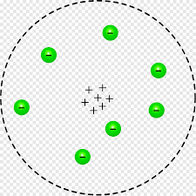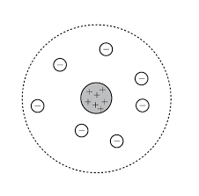

**Non-examples (all available via google and incorrectly labelled as the nuclear model!)**

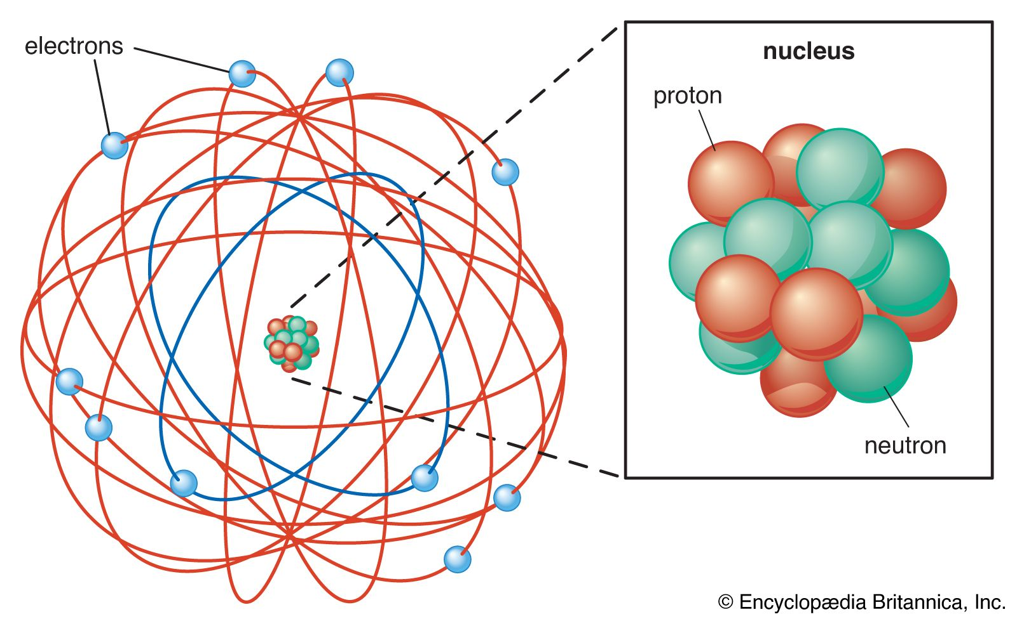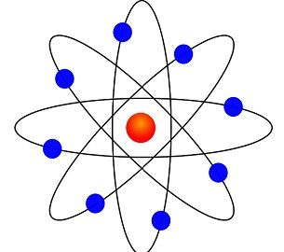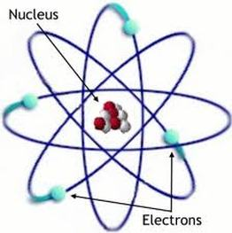

**Teacher notes (e.g. key questions, examples, non-examples, explanations)**

____________________________________________________________________________________________________________________________________________________________________________________________________________________________________________________________________________________________________________________________________________________________________________________________________________________________________________________________________________________________________________________________________________________________________________________________________________________________________________________________________________________________________________________________________________________________________________________________________________________________________________________________________________________________________________________________________________________________________________________________________________________________________________________________________________________________________________________________________________________________________________________________________________________________________________________________________________________________________________________________________________________________________________________________________________________________________________________________________________________________________________________________________________________________________________________________________________________________________________________________________________________________________________________________________________________________________________________________________________________________________________________________________________________________________________________________________________________________________________________________________________________________________________________________________________________________________________________________________________________________________________________________

**Lesson 4: The scattering experiment**

**Objective: By the end of this lesson, you will be able to compare the plum pudding model and nuclear model of the atom and describe the experimental evidence that led to the model of the atom changing.**

**Skills Drill / Retrieval**

|  |  |  |
| --- | --- | --- |
| Answer | | PA / SA |
| 1 |  |  |
| 2 |  |  |
| 3 |  |  |
| 4 |  |  |
| 5 |  |  |

**Connect**

New evidence might prove the theory to be completely wrong.

It might also suggest an alternative theory that explains the data better.

Scientists continually seek to understand thew world and how it works. New evidence can help with this.

Science is a process for producing knowledge. The process depends both on making careful observations of phenomena and on inventing theories for making sense out of those observations. Change in knowledge is inevitable because new observations may challenge prevailing theories. No matter how well one theory explains a set of observations, it is possible that another theory may fit just as well or better, or may fit a still wider range of observations. In science, the testing and improving and occasional discarding of theories, whether new or old, go on all the time. Scientists assume that even if there is no way to secure complete and absolute truth, increasingly accurate approximations can be made to account for the world and how it works.

**http://www.project2061.org/publications/sfaa/online/chap1.htm**

**Why scientists publish a theory, they often try to disprove the theory.**

**Why might they do this?**

**____________________________________________________________________________________________________________________________________________________________________________________________________________________________________________________________________________________________________________________________________________________________________________________________________________________________________________________________________________________________________________________________________________________________________________________________________________**

1. Compare the plum pudding of the atom to the nuclear model of the atom.

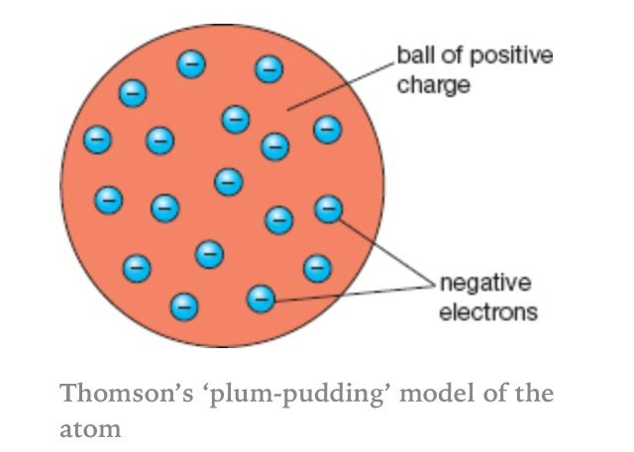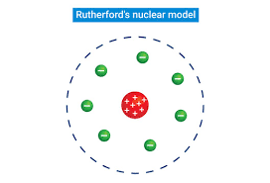

________________________________________________________________________________________________________________________________________________________________________________________________________________________________________________________________________________________________________________________________________________________________________________________________________________________________________________________________________________________________________________________________________________________________________________________________________________________

1. Compare the plum pudding of the atom to the modern model of the atom.

________________________________________________________________________________________________________________________________________________________________________________________________________________________________________________________________________________________________________________________________________________________________________________________________________________________________________________________________________________________________________________________________________________________________________________________________________________________

As for previous question but with electrons in shells / energy levels that are a specific distance from the nucleus

Similarities:

Both have electrons

Both have positive charges

Negative charge of electrons exactly balanced by positive charge

3. In the early 20th century, scientists developed an alpha particle scattering experiment using

gold foil.

1. What did the scientists expect to happen if the plum-pudding model was correct?

____________________________________________________________________________________________________________________________________________________________________________________________________________________________________________________________________________________________________________

The diagram shows the paths of some of the alpha particles in the alpha particle scattering experiment.

1. Explain how the paths of the alpha particles were used to develop the nuclear model of the atom.

_____________________________________________________________________________________________________________________________________________________________________________________________________________________________________________________________________________________________________________________________________________________________________________________________________________________________________________________________________________________________________________________________________________

1. Niels Bohr adapted the nuclear model by suggesting electrons orbited the nucleus at specific distances.

Explain how the distance at which an electron orbits the nucleus may be changed.

______________________________________________________________________________________________________________________________________________________________________________________________________________________________________________________________________________________________________________________________________________________________

When electrons absorb energy (e.g. light) they can become excited and move to a higher shell / energy level.

Excited electrons lose energy and return to a lower shell / energy level.

The alpha particles that were deflected indicated a central nucleus that was positively charged (it repels the positively charged alpha particles).

This nucleus had to be small because so few alpha particles were defected.

The majority of alpha particles were not deflected indicating that most of the atom is made of empty space.

Alpha particles either go straight through without deflection or get deflected up to 4 degrees.

**Lesson 5: Teacher notes**

**AQA Content**

Some atomic nuclei are unstable. The nucleus gives out radiation as it changes to become more stable. This is a random process called radioactive decay. Activity is the rate at which a source of unstable nuclei decays. Activity is measured in becquerel (Bq)

Count-rate is the number of decays recorded each second by a detector (eg Geiger-Muller tube).

The nuclear radiation emitted may be: • an alpha particle (α) – this consists of two neutrons and two protons, it is the same as a helium nucleus • a beta particle (β) – a high speed electron ejected from the nucleus as a neutron turns into a proton • a gamma ray (γ) – electromagnetic radiation from the nucleus • a neutron (n).

Required knowledge of the properties of alpha particles, beta particles and gamma rays is limited to their penetration through materials, their range in air and ionising power.

**Chunking**

1. Nuclear decay vs chemical reactions
2. Measuring nuclear decay
3. The three types of decay
4. Properties of alpha, beta and gamma radiation

**Key direct and explicit teacher explanations:**

1. **The reactions we have looked at so far are chemical reactions. When molecules react, bonds are broken and bonds are made. The bonds involve giving, taking or sharing electrons. For example, electrons are shared when covalent bonds are made. This happens when two non-metals are bonded together. When a metal reacts with a non-metal, electrons on a metal atom are given to a non-metal atom.**

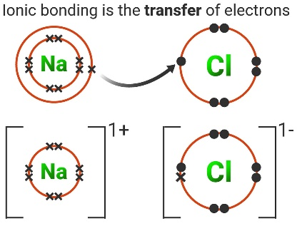

**The reactions we are going to look at now are different. Electrons are now involved. All of the changes happen in the nucleus.**

**The nucleus of some atoms is unstable. In order to become more stable, the nuclei decay. When they do this, energy and radiation can be emitted. This process is random. So, if we had a million nuclei that are unstable, we could not predict which nuclei would decay next.**

1. **The activity of radioactive sources is measured in Becquerels. We can also measure the count-rate of a radioactive source using a Geiger-Muller tube. This measures the number of decays per second. We can use a Geiger-Muller tube to investigate the properties of radioactive materials.**
2. **There are three types of radioactivity; alpha, beta and gamma. They have different compositions and different properties.**

**Alpha radiation, which was used in the scattering experiment, is composed of two protons and two neutrons.**

This is equivalent to the nucleus of a helium atom. It has a charge of 2+ because it contains two protons.

Beta radiation is composed of high energy or fast-moving electrons. They have a charge of 1- just like the electrons found in the shells of atoms.

Both alpha and beta radiation are composed of particles. Gamma radiation is different, it is an electromagnetic wave. It is similar to a light wave but it has a much higher frequency (so it contains more energy).

4. **Penetration through materials and range in air (alpha) should be demonstrated.** Alpha, beta and gamma radiation have very different properties. The main properties that we look at are penetration through materials, range in air and ionising power.

Penetrating power is a measure of the radiations ability to penetrate materials. Alpha radiation is the least penetrating and gamma radiation is the most penetrating (we would expect this because gamma radiation is a high energy electromagnetic wave). Alpha radiation can not penetrate a piece of paper or a few centimetres of air. Gamma radiation can penetrate a few centimetres of lead (a very dense material) or several feet of concrete. Beta radiation can be absorbed by a few millimetres of aluminium.

The pattern for the range in air is the same as for penetration through materials. We expect this because air is a material. If a substance has high penetrating power, we would expect it to travel a long distance through the air.

Ions are atoms that have gained or lost electrons. If an atom gains an electron, the ion has a negative charge (because electrons are negatively charged). If atoms lose an electron, they become positively charged.

Alpha radiation has the greatest ionising power. This is because it has the greatest charge. Gamma radiation is not charged, so it is the most weakly ionising. This is because it does not carry a charge. Beta radiation is more ionising that gamma radiation but less ionising that alpha radiation. This is because it has a greater charge than gamma radiation but a lower charge than alpha radiation.

**Teacher notes (e.g. key questions, examples, non-examples, explanations)**

________________________________________________________________________________________________________________________________________________________________________________________________________________________________________________________________________________________________________________________________________________________________________________________________________________________________________________________________________________________________________________________________________________________________________________________________________________________________________________________________________________________________________________________________________________________________________________________________________________________________________________________________________________________________________________________________________________________________________________________________________________________________

**Teacher notes (e.g. key questions, examples, non-examples, explanations)**

____________________________________________________________________________________________________________________________________________________________________________________________________________________________________________________________________________________________________________________________________________________________________________________________________________________________________________________________________________________________________________________________________________________________________________________________________________________________________________________________________________________________________________________________________________________________________________________________________________________________________________________________________________________________________________________________________________________________________________________________________________________________________________________________________________________________________________________________________________________________________________________________________________________________________________________________________________________________________________________________________________________________________________________________________________________________________________________________________________________________________________________________________________________________________________________________________________________________________________________________________________________________________________________________________________________________________________________________________________________________________________________________________________________________________________________________________________________________________________________________________________________________________________________________________________________________________________________________________________________________________________________________

**Lesson 5: Radioactive decay**

**Objective: By the end of this lesson, you will be able to describe three types of nuclear radiation, the properties of each and the changes to the atom that cause them to be released.**

**Skills Drill / Retrieval**

|  |  |  |
| --- | --- | --- |
| Answer | | PA / SA |
| 1 |  |  |
| 2 |  |  |
| 3 |  |  |
| 4 |  |  |
| 5 |  |  |

**Connect**

To contain radioactive material when accidents happen.

Concrete, lead and steel.

1. What are containment buildings made of?

_______________________________________________________________________________________________________________________________________________________________________________________________________________________________________

1. What is the purpose of the containment building?

____________________________________________________________________________________________________________________________________________________________________________________________________________________________________________________________________________________________________________________

Nuclear reactors are usually enclosed in a containment building made of reinforced concrete, steel and lead. The containment building is designed to temporarily contain radioactive materials if something goes wrong. The materials are chosen because they form a strong barrier that radioactive substances can’t penetrate. If an accident should happen, the radioactive material stays safely within the containment building

**Activity A**

(f) Use your knowledge of the composition of alpha, beta and gamma radiation to explain why alpha radiation the most ionising and gamma radiation is least ionising.

____________________________________________________________________________________________________________________________________________________________________________________________________________________________________________________________________________________________________________________________________________________________________________________________________________________________________________________________________________________________________________________________________________________________________________________________________________________________________________________________________________________________________________________________________________________________________________________________________________________________________________________________________________________________________________________________________________________________

Alpha is composed of two protons and two neutrons. So, it has a charge of 2+. This is because protons are positively charged.

Gamma is an electromagnetic wave; it does not have a charge.

Ionising power is related to the charge that the radiation has. Radiation with a charge is more ionising. So Alpha is most ionising and gamma is least ionising.

(e)

(d)