**Year 7- Student booklet**

Key Stage 3 Science:

**Forces**

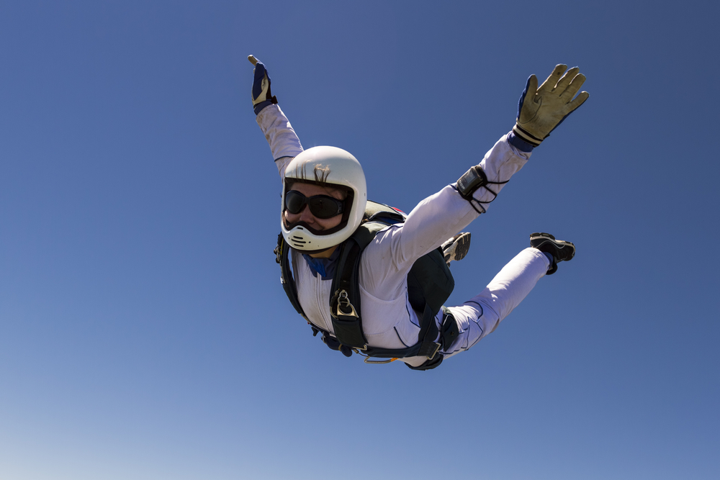

**FORCES**

**This booklet is for use in your Science lessons. Please look after it in the same way you would your exercise book and ensure that your presentation is always PROUD.**

**Ensure that your booklet is returned to your class book box at the end of the lesson.**



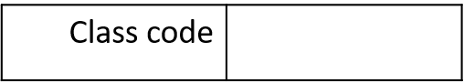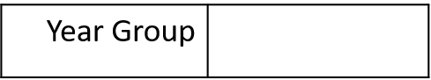

**Contents**

Lesson 1: What do forces do?

Lesson 2: The main forces, their magnitude and direction.

Lesson 3: Balanced and unbalanced forces (resultant forces).

Lesson 4: Forces on objects at equilibrium.

Lesson 5: Measuring forces / factors affecting drag.

Lesson 6: The effect of forces on deformation (Hooke’s law).

Lesson 7: Moments

Lesson 8: The laws of moments.

**Keystone Words**

Force

Push

Pull

Contact

Non-contact

Direction

Magnitude

Resultant force

Equilibrium

Compression

Deformation

**Knowledge Test Tracker**

|  |  |  |
| --- | --- | --- |
| **Lesson** | **Marks achieved** | **Percentage** |
|  |  |  |
|  |  |  |
|  |  |  |
|  |  |  |
|  |  |  |
|  |  |  |
|  |  |  |
|  |  |  |
|  |  |  |

**Lesson 1: What do forces do?**

**Date: ____________________________________________________________**

**Objective: By the end of this lesson, you will be able to describe the actions and effects of different forces and compare the scientific methods of two scientists.**

**Skills Drill / Retrieval**

|  |  |  |
| --- | --- | --- |
| Answer | | PA / SA |
| 1 |  |  |
| 2 |  |  |
| 3 |  |  |
| 4 |  |  |
| 5 |  |  |

**Connect**

**Definition:** A force is…_____________________________________________________________________

_______________________________________________________________________________________

**Task:** Use the images below to identify the three effects that a force can have on an object:

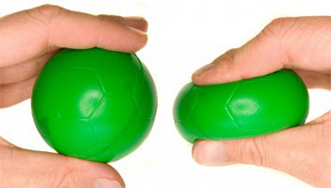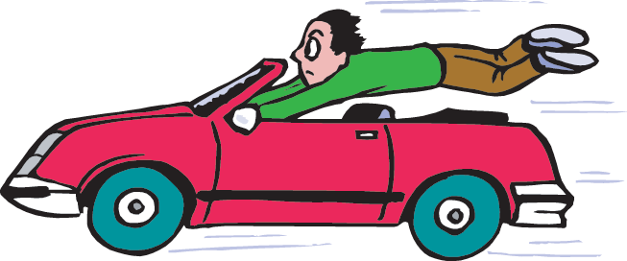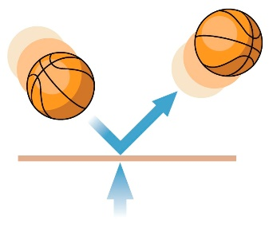

1. A force can change…
2. A force can change…
3. A force can change…

Challenge: If we are unable to **see** forces, how do we know when they are acting?

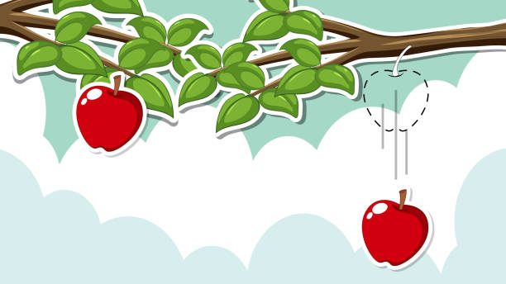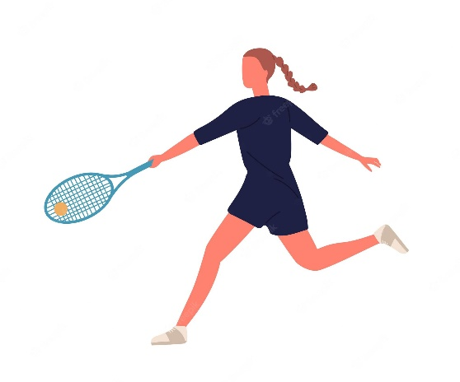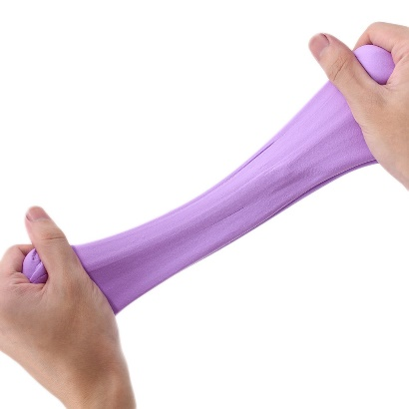

**Task 1: The effect of forces**

**For each of the forces below:**

1. State whether a **push** or a **pull** force has been exerted.
2. Describe the effect that the force has had on the object.
3. A piece of plasticine is stretched.
4. A tennis player hits the tennis ball back across the court towards her opponent.
5. An apple falls from a tree.

Push or pull? ________________________

Effect of the force on the object:

__________________________________________

__________________________________________

Push or pull? ________________________

Effect of the force on the object:

__________________________________________

__________________________________________

Push or pull? ________________________

Effect of the force on the object:

__________________________________________

__________________________________________

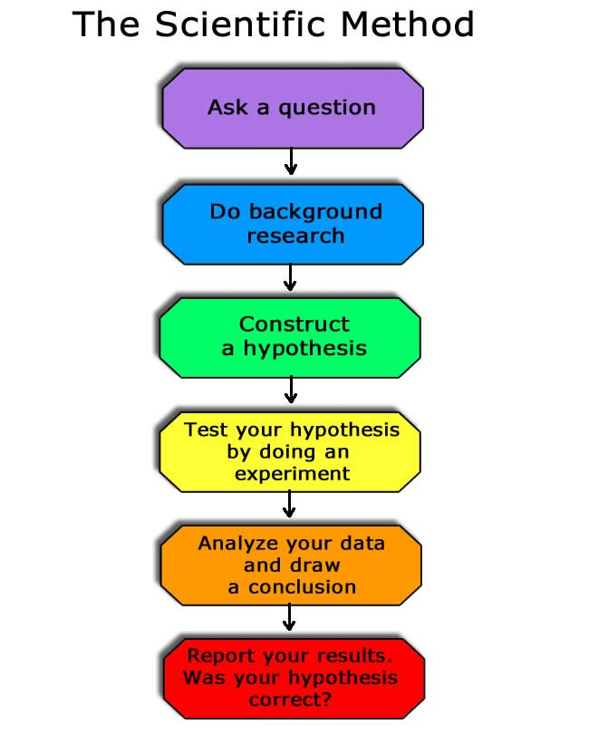

**Task 3:**

**What do we mean by ‘working scientifically’?**

**Why do you think that this process is important?**

**Task 2: Discuss with the person next to you…**

Which characteristics are important in a scientist? Why?

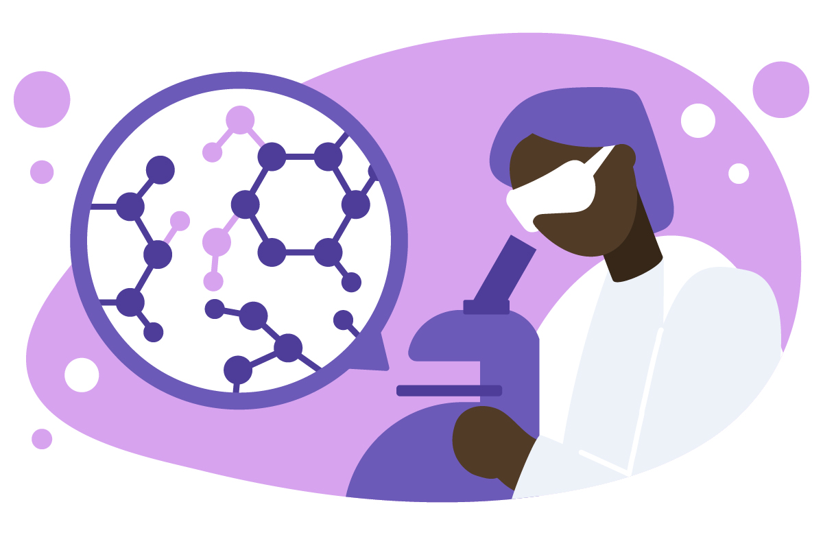

**Characteristic: ___________________________________________________________________**

**Explanation: _____________________________________________________________________**

**________________________________________________________________________________**

**Characteristic: ___________________________________________________________________**

**Explanation: _____________________________________________________________________**

**________________________________________________________________________________**

**Characteristic: ___________________________________________________________________**

**Explanation: _____________________________________________________________________**

**________________________________________________________________________________**

**Why was Isaac Newton such a giant?**

Most people associate Isaac Newton with gravity. Of all the forces of nature, gravity is the one whose effects are most obvious to us, and have been since prehistoric times. Everyone knows that an apple falls vertically downwards, as if drawn towards the centre of the Earth. Anyone who has spent any time gazing up at the night sky knows that the Moon and planets follow regular, predictable orbits. But obvious as these things are, the ultimate explanation – that they are all due to the same universal force – is far from obvious.

Newton did more than just wave his hands in the air and say ‘look, there’s a universal force of attraction between all material things’. He came up with a precise mathematical equation to describe that force. In the course of time, this equation would allow his successors to discover new planets, to predict the reappearance of comets and to travel to the Moon.

Newton made the single greatest breakthrough in the history of physical science…but it wasn’t his discovery of the law of gravity. It was an even more fundamental discovery: that it is possible to predict the behaviour of the physical world by representing it in the form of mathematical symbols and equations. The implications of this discovery reach beyond theoretical physics into all branches of engineering and technology. It is no exaggeration to say that the modern, high-tech world we live in today wouldn’t exist without it.

For Newton, mathematics was the key that unlocked the secrets of the universe. To most of his contemporaries, Aristotle’s two-thousand-year-old system of ‘natural philosophy’ still provided the standard picture of the physical world – and Aristotle’s theory contains no mathematics. But when Newton published his masterpiece in 1687, he called it Philosophiae Naturalis Principia Mathematica – Mathematical Principles of Natural Philosophy. The book was a revolution, and the essence of that revolution is summed up in the title. Before 1687, Mathematical Principles and Natural Philosophy were two completely different branches of knowledge, poles apart. After Principia they would be tied together by a bond that has become more and more powerful in the intervening centuries.

The situation in Newton’s time was, in a sense, the mirror image of the present day. What then seemed to be a bizarre and mystical notion – that the universe obeys simple mathematical laws – is now seen as the 'rational' view. But in those days, 'rational' people tended to assume the exact opposite. The world looks complex, chaotic and unpredictable…so clearly it can have nothing to do with the elegance and simplicity of mathematics.

**By Andrew May (The History Press).**

# **Einstein’s Relativity Explained in 4 Simple Steps**

The revolutionary physicist used his imagination rather than fancy math to come up with his most famous and elegant equation.

Albert Einstein’s theory of relativity is famous for predicting some really weird but true phenomena, like astronauts aging slower than people on Earth and solid objects changing their shapes at high speeds.

But the thing is, if you pick up a copy of Einstein’s original paper on relativity from 1905, it’s a straightforward read. His text is plain and clear, and his equations are mostly just algebra—nothing that would bother a typical high-schooler.

That’s because fancy math was never the point for Einstein. He liked to think visually, coming up with experiments in his mind’s eye and working them around in his head until he could see the ideas and physical principles with crystalline clarity.

## *1895: Running Beside a Light Beam*

By this point, Einstein’s ill-disguised contempt for his native Germany’s rigid, authoritarian educational methods had already gotten him kicked out of the equivalent of high school, so he moved to Zurich in hopes of attending the Swiss Federal Institute of Technology (ETH).

First, though, Einstein decided to put in a year of preparation at a school in the nearby town of Aarau—a place that stressed avant garde methods like independent thought and visualization of concepts. In that happy environment, he soon he found himself wondering what it would be like to run alongside a light beam.

**BY MITCH WALDROP (National geographic)**

**Reading task questions:**

1. Which force is Isaac Newton known for his work on? ________________________
2. What did Newton use to describe this force? ______________________________________

__________________________________________________________________________

1. Do you think that Newton used the scientific method to develop his theory? Explain your answer.

_________________________________________________________________________

_________________________________________________________________________

1. How did Einstein develop his theories?

__________________________________________________________________________

1. How did Einstein’s method compare with Newton’s? ____________________________________

_______________________________________________________________________________

1. Which scientist do you think used the scientific method in their work? Explain your answer.

_______________________________________________________________________________

_______________________________________________________________________________

_______________________________________________________________________________

_______________________________________________________________________________

**Stretch task:** Isaac Newton had to be encouraged to publish his ideas. Do you think that it is important that new scientific ideas are communicated? Why / why not?

_______________________________________________________________________________

_______________________________________________________________________________

_______________________________________________________________________________

_______________________________________________________________________________

**Notes**

1. ________________________________________________________________
2. ________________________________________________________________
3. ________________________________________________________________
4. ________________________________________________________________
5. ________________________________________________________________
6. ________________________________________________________________
7. ________________________________________________________________
8. ________________________________________________________________
9. ________________________________________________________________
10. ________________________________________________________________
11. ________________________________________________________________
12. ________________________________________________________________
13. ________________________________________________________________
14. ________________________________________________________________
15. ________________________________________________________________
16. ________________________________________________________________
17. ________________________________________________________________
18. ________________________________________________________________
19. ________________________________________________________________
20. ________________________________________________________________
21. ________________________________________________________________
22. ________________________________________________________________
23. ________________________________________________________________
24. ________________________________________________________________
25. ________________________________________________________________
26. ________________________________________________________________
27. ________________________________________________________________
28. ________________________________________________________________
29. ________________________________________________________________
30. ________________________________________________________________
31. ________________________________________________________________
32. ________________________________________________________________
33. ________________________________________________________________
34. ________________________________________________________________
35. ________________________________________________________________
36. ________________________________________________________________
37. ________________________________________________________________
38. ________________________________________________________________

**Lesson 2: The main forces, their magnitude and direction**

**Date: ____________________________________________________________**

**Objective: By the end of this lesson, you will be able to describe the main forces, including their magnitude and direction when acting on a given object.**

**Skills Drill / Retrieval**

|  |  |  |
| --- | --- | --- |
| Answer | | PA / SA |
| 1 |  |  |
| 2 |  |  |
| 3 |  |  |
| 4 |  |  |
| 5 |  |  |

**Connect Task:** Describe the effect that each force is having upon the object.

**Stretch:** Is each force a push or a pull force?

1. 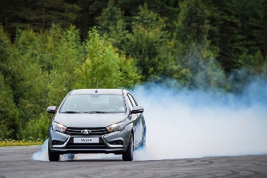A driver is driving down the street. They then press the brakes to stop their car.

The forces changes…

1. A child squeezes their carton of juice to push out the liquid.

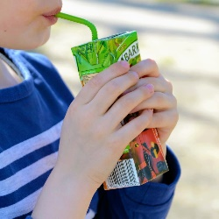

The forces changes…

1. 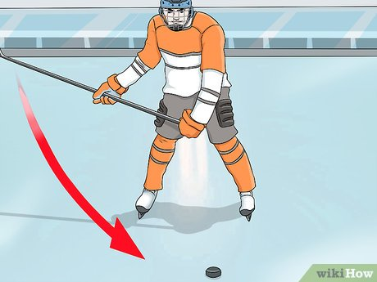A hockey player hits a moving puck away from their goal.

The forces changes…

**Task 2: Contact and non-contact forces**

Categorise the following forces as **contact** or **non-contact** forces by adding them into the table below.

**Gravity Air resistance Friction Magnetic force**

**Electrostatic force Thrust force Tension**

|  |  |
| --- | --- |
| **Contact force** | **Non-contact force** |
|  |  |

**Task 1: Naming forces**

1. Name the forces shown by the diagrams below.

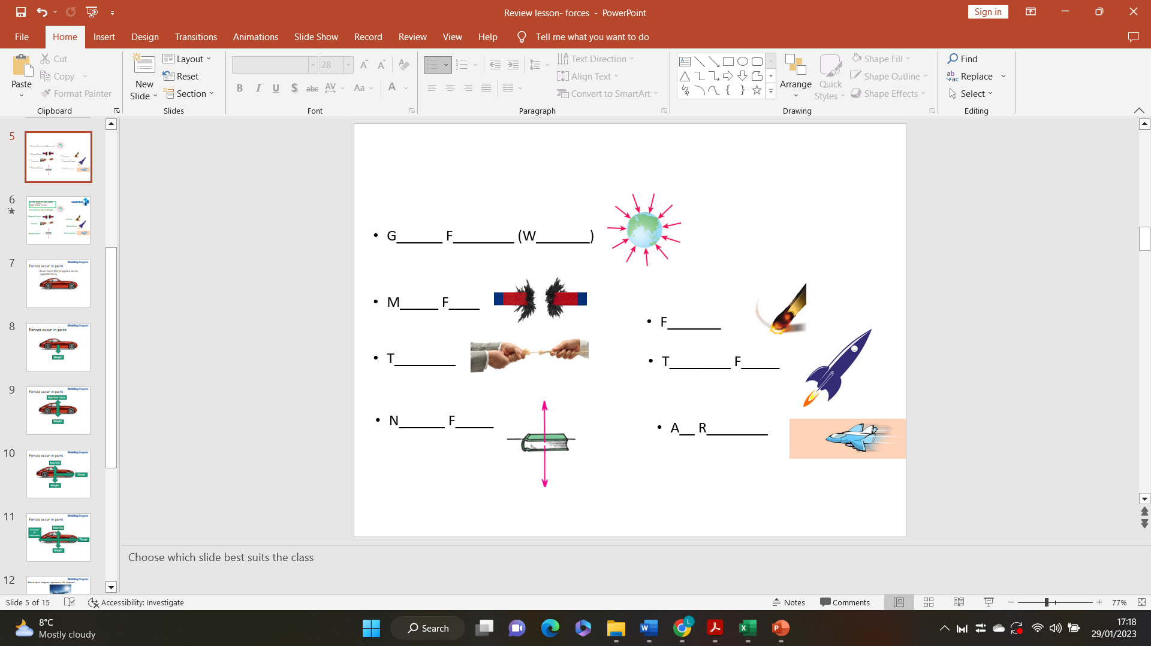

1. For each of the forces, state whether they are a **push force** or a **pull force**.

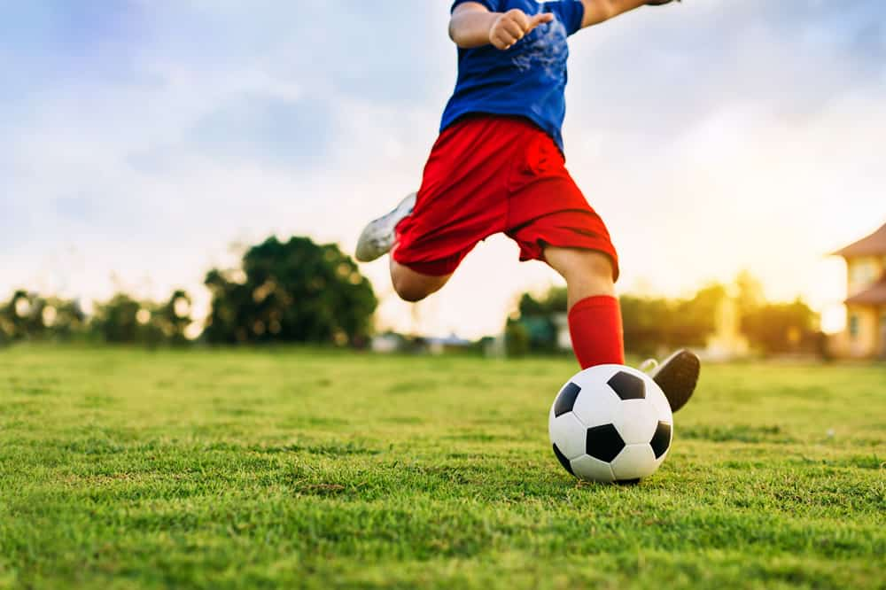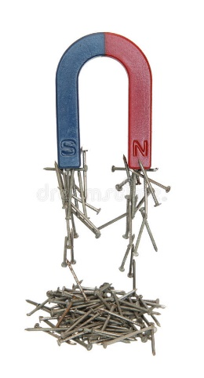

**Task 3: Explaining contact and non-contact forces.**

For each of the following examples, state whether the object is being acted upon by a **contact force** or a **non-contact force**. Explain your answers.

1. A falling raindrop.



1. A magnet attracting metal nails.
2. A child kicking a football.

Contact or non-contact force? ___________________________

Explanation: _________________________________________

____________________________________________________

____________________________________________________

Contact or non-contact force? ___________________________

Explanation: _________________________________________

____________________________________________________

____________________________________________________

Contact or non-contact force? ___________________________

Explanation: _________________________________________

____________________________________________________

____________________________________________________

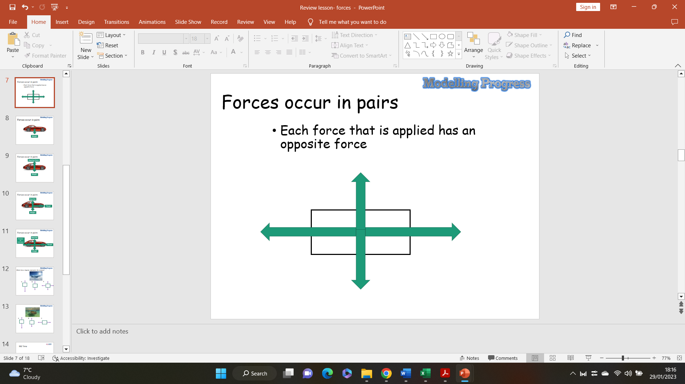

Task 4: Representing forces- Force diagrams

**I do:** Identify the forces acting on a moving car.

1. **How can you tell which direction the forces are acting in?**
2. **How can you tell the size of the forces acting on the object?**

**We do: Add arrows to the box to illustrate the forces acting on an aeroplane travelling through the air at a constant speed.**

**Stretch:** Which force would have to increase to increase the speed of the plane?

Which force would have to decrease for the plane to descend?

**We do / you do:**

Tasha puts a small block of wood on a smooth surface.



She puts different forces on the block.  
The diagrams below show the size and direction of these forces.

Will each block move to the **left**, to the **right**or **stay still**?  
Tick the correct box in each row.

**forces on block                                   moves     moves**

**to the      to the    stays**

**left          right     still**

   

(i)

              

1 mark

(ii)

              

1 mark

(iii)

              

1 mark

(iv)

              

1 mark

**You do:**

When a car is being driven along, two horizontal forces affect its motion.  
One is air resistance and the other is the forward force.

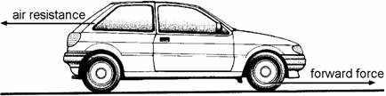

(a)     (i)      Explain how molecules in the air cause air resistance.

.............................................................................................................

.............................................................................................................

1 mark

(ii)     Explain why air resistance is larger when the car is travelling faster.

.............................................................................................................

.............................................................................................................

1 mark

(b)     (i)      Compare the sizes of the forward force and the air resistance when the car is speeding up.

The forward force is .............................................................................

............................................................................................................. 1 mark

(ii)     Compare the sizes of the two forces while the car is moving at a steady 30 miles per hour.

The forward force is ............................................................................

............................................................................................................ 1 mark

(c)     The forward force has to be larger when the car is travelling at a steady 60 mph than when it is travelling at a steady 30 mph. Why is this?

......................................................................................................................

......................................................................................................................

1 mark

(d)     The forward force is the result of the tyres **not** being able to spin on the road surface.  
What is the name of the force that stops the tyres spinning?

.....................................................................

1 mark

Maximum 6 marks

**Notes**

1. ________________________________________________________________
2. ________________________________________________________________
3. ________________________________________________________________
4. ________________________________________________________________
5. ________________________________________________________________
6. ________________________________________________________________
7. ________________________________________________________________
8. ________________________________________________________________
9. ________________________________________________________________
10. ________________________________________________________________
11. ________________________________________________________________
12. ________________________________________________________________
13. ________________________________________________________________
14. ________________________________________________________________
15. ________________________________________________________________
16. ________________________________________________________________
17. ________________________________________________________________
18. ________________________________________________________________
19. ________________________________________________________________
20. ________________________________________________________________
21. ________________________________________________________________
22. ________________________________________________________________
23. ________________________________________________________________
24. ________________________________________________________________
25. ________________________________________________________________
26. ________________________________________________________________
27. ________________________________________________________________
28. ________________________________________________________________
29. ________________________________________________________________
30. ________________________________________________________________
31. ________________________________________________________________
32. ________________________________________________________________
33. ________________________________________________________________
34. ________________________________________________________________
35. ________________________________________________________________
36. ________________________________________________________________
37. ________________________________________________________________
38. ________________________________________________________________

**Lesson 3 – Balanced and unbalanced forces**

**Date: ____________________________________________________________**

**Objective: By the end of this lesson, you will be able to identify and describe the effects of balanced and unbalanced forces acting on an object.**

**Skills Drill / Retrieval**

|  |  |  |
| --- | --- | --- |
| Answer | | PA / SA |
| 1 |  |  |
| 2 |  |  |
| 3 |  |  |
| 4 |  |  |
| 5 |  |  |

**Connect**

So far in this unit you have learned about the different types of forces: contact forces and non-contact forces.

What is a contact force?

___________________________________________________________________________________

____________________________________________________________________________________

What are some examples of contact forces?

________________________________________________________________________________________________________________________________________________________________________

Explain why gravity is not a contact force.

________________________________________________________________________________________________________________________________________________________________________

**Stretch:** What is the unit for force?

**Task 1**: Are the forces in each diagram below balanced or unbalanced? How do you know?

a) b)

1. ____________________________________________________________________________________________________________________________________________________________________
2. ____________________________________________________________________________________________________________________________________________________________________

**Task 2**: Would the objects below be speeding up, slowing down, or remaining at a constant speed? Why?

1. Record your results from the investigation in the table below:
2. From the investigation, answer the following questions:
   1. How does this experiment allow you to measure the energy content of food?

_____________________________________________________________________________________________________________________________________________________________________________________________________________________________________________

**Task 3**: Explain what happens to the motion of an object when:

1. The forward force on an object is **greater than** the backwards force:

__________________________________________________________________________________________________________________________________________________________________

1. The forward force on an object is **less than** the backwards force:

____________________________________________________________________________________________________________________________________________________________

1. The forward force on an object is **equal to** the backwards force:

____________________________________________________________________________________________________________________________________________________________

**Task 4**: Calculate the resultant force on each object, and state the direction of that resultant force:

**Task 5**: Calculate the resultant force on each object in both planes (x and y), and state the direction for each:

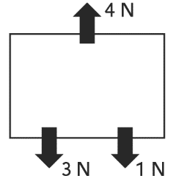

a.

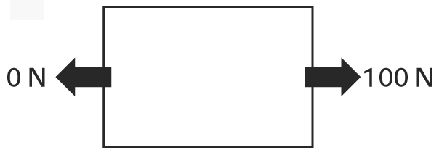

b.

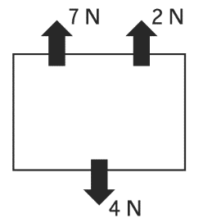

c.

**Notes**

1. ________________________________________________________________
2. ________________________________________________________________
3. ________________________________________________________________
4. ________________________________________________________________
5. ________________________________________________________________
6. ________________________________________________________________
7. ________________________________________________________________
8. ________________________________________________________________
9. ________________________________________________________________
10. ________________________________________________________________
11. ________________________________________________________________
12. ________________________________________________________________
13. ________________________________________________________________
14. ________________________________________________________________
15. ________________________________________________________________
16. ________________________________________________________________
17. ________________________________________________________________
18. ________________________________________________________________
19. ________________________________________________________________
20. ________________________________________________________________
21. ________________________________________________________________
22. ________________________________________________________________
23. ________________________________________________________________
24. ________________________________________________________________
25. ________________________________________________________________
26. ________________________________________________________________
27. ________________________________________________________________
28. ________________________________________________________________
29. ________________________________________________________________
30. ________________________________________________________________
31. ________________________________________________________________
32. ________________________________________________________________
33. ________________________________________________________________
34. ________________________________________________________________
35. ________________________________________________________________
36. ________________________________________________________________
37. ________________________________________________________________
38. ________________________________________________________________

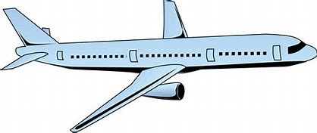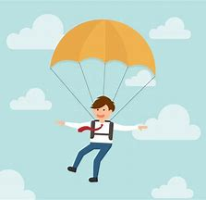

**Lesson 4 – Forces and their effects on equilibrium**

**Date: ____________________________________________________________**

**Objective: By the end of this lesson, you will be able to identify and describe the effect of interaction pairs of forces.**

**Skills Drill / Retrieval**

|  |  |  |
| --- | --- | --- |
| Answer | | PA / SA |
| 1 |  |  |
| 2 |  |  |
| 3 |  |  |
| 4 |  |  |
| 5 |  |  |

**Connect**

We have previously said that all forces act in a particular direction. For each image below, identify the forces that would be affecting each object, and label their direction with an arrow.

**Task 1**: For each of the examples below:

1. Calculate the resultant force in the x-plane (left/right).
2. State whether the object is in equilibrium in the x-plane.
3. Calculate the resultant force in the y-plane (up/down).
4. State whether the object is in equilibrium in the y-plane.

X-plane (left/right) : __________________________________________ ____________________________________________________________________________________

Y-plane (left/right) : __________________________________________ ____________________________________________________________________________________

X-plane (left/right) : __________________________________________ ______________________________________________________________________________________________________________________________

Y-plane (left/right) : __________________________________________ ______________________________________________________________________________________________________________________________

**Task 2**: This car is driving along the motorway. Right now, all the opposing forces (A-B and C-D) are balanced.

1. Identify the forces A-D:

A 🡪 __________________________

B 🡪 __________________________

C 🡪 __________________________

D 🡪 __________________________

1. The forces above are interaction pairs. Describe what this means, and identify which forces are paired. ______________________________________________________________________________________________________________________________________________________________________________________________________________________________________________________
2. Describe the movement and speed of the car, and give a reason for this.

______________________________________________________________________________________________________________________________________________________________________________________________________________________________________________________

1. Explain what would happen if the size of force B increased.

______________________________________________________________________________________________________________________________________________________________________________________________________________________________________________________

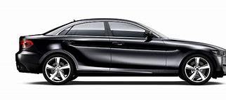

**A**

**B**

**C**

**D**

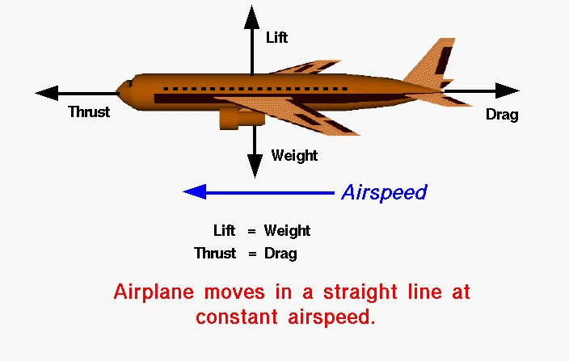

**Task 3**: Read the following NASA article discussing equilibrium.

## Vector

1. A very basic concept when dealing with either forces or torques (moments) is the idea

2. of **equilibrium** or **balance**. Forces and torques are **vector** quantities which means that they have

3. both a magnitude and a direction associated with them. Two forces with the same magnitude but

4. different directions are not equal forces. In general, an object can be acted on by several different

5. forces or torques at any one time. The vector sum of all of the forces acting on a body is a single

6. force called the **resultant** force. The vector sum of all the torques is a single torque called the

7. resultant torque. If the resultant force (resultant torque) is equal to zero, the object is said to be in

8. equilibrium.

**Four Forces**

9. There are four forces that act on an aircraft in flight: lift, weight, thrust, and drag. A force is a vector

10. quantity which means that it has both a magnitude (size) and a direction associated with it. If the

11. size and direction of the forces acting on an object are exactly balanced, then there is no **resultant**

12. **force** acting on the object and the object is said to be in equilibrium. From Newton’s first law of

13. motion we know that an object at rest will stay at rest, and an object in motion (constant velocity) will stay in

14. motion unless acted on by an external force. If there is no resultant external force, the object will

15. maintain a constant velocity.

**Cruise Velocity**

16. In an ideal situation, the forces acting on an aircraft in flight can produce no resultant external

17. force. In this situation the lift is equal to the weight, and the thrust is equal to the drag. The closest

18. example of this condition is a **cruising** airliner. While the weight decreases due to fuel burned, the

19. change is very small relative to the total aircraft weight. The aircraft maintains a constant airspeed

20. called the **cruise velocity**.

**Force**

21. If the pilot changes the throttle setting, or increases the wing angle of attack, the forces become

22. unbalanced. The aircraft will move in the direction of the greater force, and we can compute

22. acceleration of the aircraft from Newton’s second law of motion.

1. What is a vector quantity?

____________________________________________________________________________

What happens if resultant forces is zero?

____________________________________________________________________________________________________________________________________________________________What is Newton’s first law of motion?

____________________________________________________________________________________________________________________________________________________________Which forces need to be balanced for the airplane to be in equilibrium?

______________________________________________________________________________What would need to happen to the forces for the plane to speed up?

______________________________________________________________________________

1. What would need to happen to the forces for the plane to start to descend?

______________________________________________________________________________

**Notes**

1. ________________________________________________________________
2. ________________________________________________________________
3. ________________________________________________________________
4. ________________________________________________________________
5. ________________________________________________________________
6. ________________________________________________________________
7. ________________________________________________________________
8. ________________________________________________________________
9. ________________________________________________________________
10. ________________________________________________________________
11. ________________________________________________________________
12. ________________________________________________________________
13. ________________________________________________________________
14. ________________________________________________________________
15. ________________________________________________________________
16. ________________________________________________________________
17. ________________________________________________________________
18. ________________________________________________________________
19. ________________________________________________________________
20. ________________________________________________________________
21. ________________________________________________________________
22. ________________________________________________________________
23. ________________________________________________________________
24. ________________________________________________________________
25. ________________________________________________________________
26. ________________________________________________________________
27. ________________________________________________________________
28. ________________________________________________________________
29. ________________________________________________________________
30. ________________________________________________________________
31. ________________________________________________________________
32. ________________________________________________________________
33. ________________________________________________________________
34. ________________________________________________________________
35. ________________________________________________________________
36. ________________________________________________________________
37. ________________________________________________________________
38. ________________________________________________________________

  **Lesson 5: Measuring Forces/Factors Affecting Drag**

**Date: ____________________________________________________________**

**Objective: By the end of this lesson, you will be able to describe and explain the factors that affect resistive forces.**

**Skills Drill / Retrieval**

|  |  |  |
| --- | --- | --- |
| Answer | | PA / SA |
| 1 |  |  |
| 2 |  |  |
| 3 |  |  |
| 4 |  |  |
| 5 |  |  |

**Connect**

In the Particles topic you were taught that particles move differently depending upon what state of matter they are in

1. **What are the 3 states of matter?** _______________________________________

1. **Describe the movement of particles in a solid, liquid and in a gas**

______________________________________________________________________

______________________________________________________________________

______________________________________________________________________

______________________________________________________________________

______________________________________________________________________

______________________________________________________________________

______________________________________________________________________

______________________________________________________________________

1. **Draw a diagram of the particles in solids, liquids and gases**

|  |  |  |  |
| --- | --- | --- | --- |
|  | Solid | Liquid | Gas |
| Diagram |  |  |  |
| Arrangement and movement |  |  |  |
| Volume and Shape |  |  |  |

**Task 1:**

1. Forces work in ________________.

2. Forces change the ______________________, __________________________ and/or ___________________________ of an object.

3. If an object is not moving then there are _________________  ________________________ acting between the surfaces.

4. A driving force tries to ___________________________ an object whereas a _________________  __________________ works in the opposite direction to the driving force.

5. The driving force for a car comes from the _____________

6. Two examples of resistive forces for a car are between

a. The tyres and ____________________________

b. The air and ______________________________

**Task 2:** On the diagrams below, label the interaction pairs of forces.

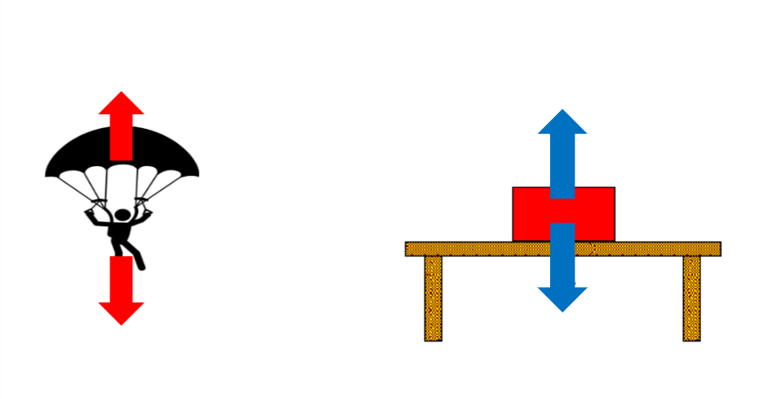

The ______________ the parachute, the ________________ the object falls.

This is because: _________________________________________________________________________________________________________________________________________________________________________________________________________________________________________________________

The greater the _____________________ of the fluid, the ____________________ the ball sinks.

This is because: _________________________________________________________________________________________________________________________________________________________________________________________________________________________________________________________

**Task 3:**

You are investigating the effect of different surfaces on the time taken for a car to ravel down a slope.

What are the independent, dependent and control variables in this experiment?

Independent Variable: ___________________________________________________________

Dependent Variable: _____________________________________________________________

Control Variables (3): ____________________________________________________________

Complete the table by filling in the correct information at the top of each column then carry out the experiment.

|  |  |  |  |  |
| --- | --- | --- | --- | --- |
|  |  |  |  |  |
|  |  |  |  |  |
|  |  |  |  |  |
|  |  |  |  |  |

 From my results I conclude that the greatest friction was between the car and the _______________ surface.

This is because ____________________________________________________________________

__________________________________________________________________________________

The least friction was exerted by the _________________ surface.

 This is because ____________________________________________________________________

What is an advantage of comparing data using a graph over using a table?

______________________________________________________________________________________________________________________________________________________________________________

What is an advantage of comparing data using a table over using a graph?

______________________________________________________________________________________________________________________________________________________________________________

**Notes**

1. ________________________________________________________________
2. ________________________________________________________________
3. ________________________________________________________________
4. ________________________________________________________________
5. ________________________________________________________________
6. ________________________________________________________________
7. ________________________________________________________________
8. ________________________________________________________________
9. ________________________________________________________________
10. ________________________________________________________________
11. ________________________________________________________________
12. ________________________________________________________________
13. ________________________________________________________________
14. ________________________________________________________________
15. ________________________________________________________________
16. ________________________________________________________________
17. ________________________________________________________________
18. ________________________________________________________________
19. ________________________________________________________________
20. ________________________________________________________________
21. ________________________________________________________________
22. ________________________________________________________________
23. ________________________________________________________________
24. ________________________________________________________________
25. ________________________________________________________________
26. ________________________________________________________________
27. ________________________________________________________________
28. ________________________________________________________________
29. ________________________________________________________________
30. ________________________________________________________________
31. ________________________________________________________________
32. ________________________________________________________________
33. ________________________________________________________________
34. ________________________________________________________________
35. ________________________________________________________________
36. ________________________________________________________________
37. ________________________________________________________________
38. ________________________________________________________________

**Lesson 6: The Effect of Forces on Deformation (Hooke’s Law)**

**Date: ____________________________________________________________**

**Objective: By the end of this lesson, you will be able to describe the relationship between the force applied to an object, and the compression / extension and deformation of the object.**

**Skills Drill / Retrieval**

|  |  |  |
| --- | --- | --- |
| Answer | | PA / SA |
| 1 |  |  |
| 2 |  |  |
| 3 |  |  |
| 4 |  |  |
| 5 |  |  |

**Connect**

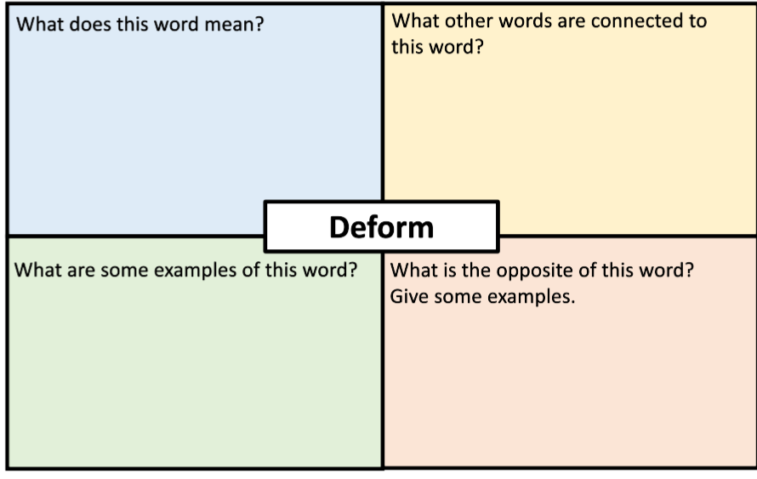

**Task 1:**

A deformation is a _______________________________________________.

A deformation is caused when a _____________________ is applied to an object.

If the object returns to its original length or shape when the force is removed this is known as an ______________________ deformation.

An example of this type of deformation is _____________________________________________________

If the object does not return to its original length or shape when the force is removed this is known as ______________________________ deformation.

An example of this type of deformation is _____________________________________________________

When a force is applied to a spring then it _______________________

If the force applied is doubled then the extension is ________________________

This is only true if it is an ____________________________ deformation.

This is known as a ____________________________ __________________________ relationship.

If too great a force is applied then the spring will extend beyond its _________________ _______________.

At this point the spring will not return to its __________________________ length.

This is known as _____________________________ deformation.

If no force is applied, there is ___________________________ _________________________.

The point of a graph at position (0,0) is known as the ______________________.

**Demonstration of Hooke’s Law**

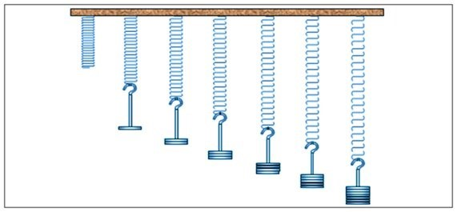

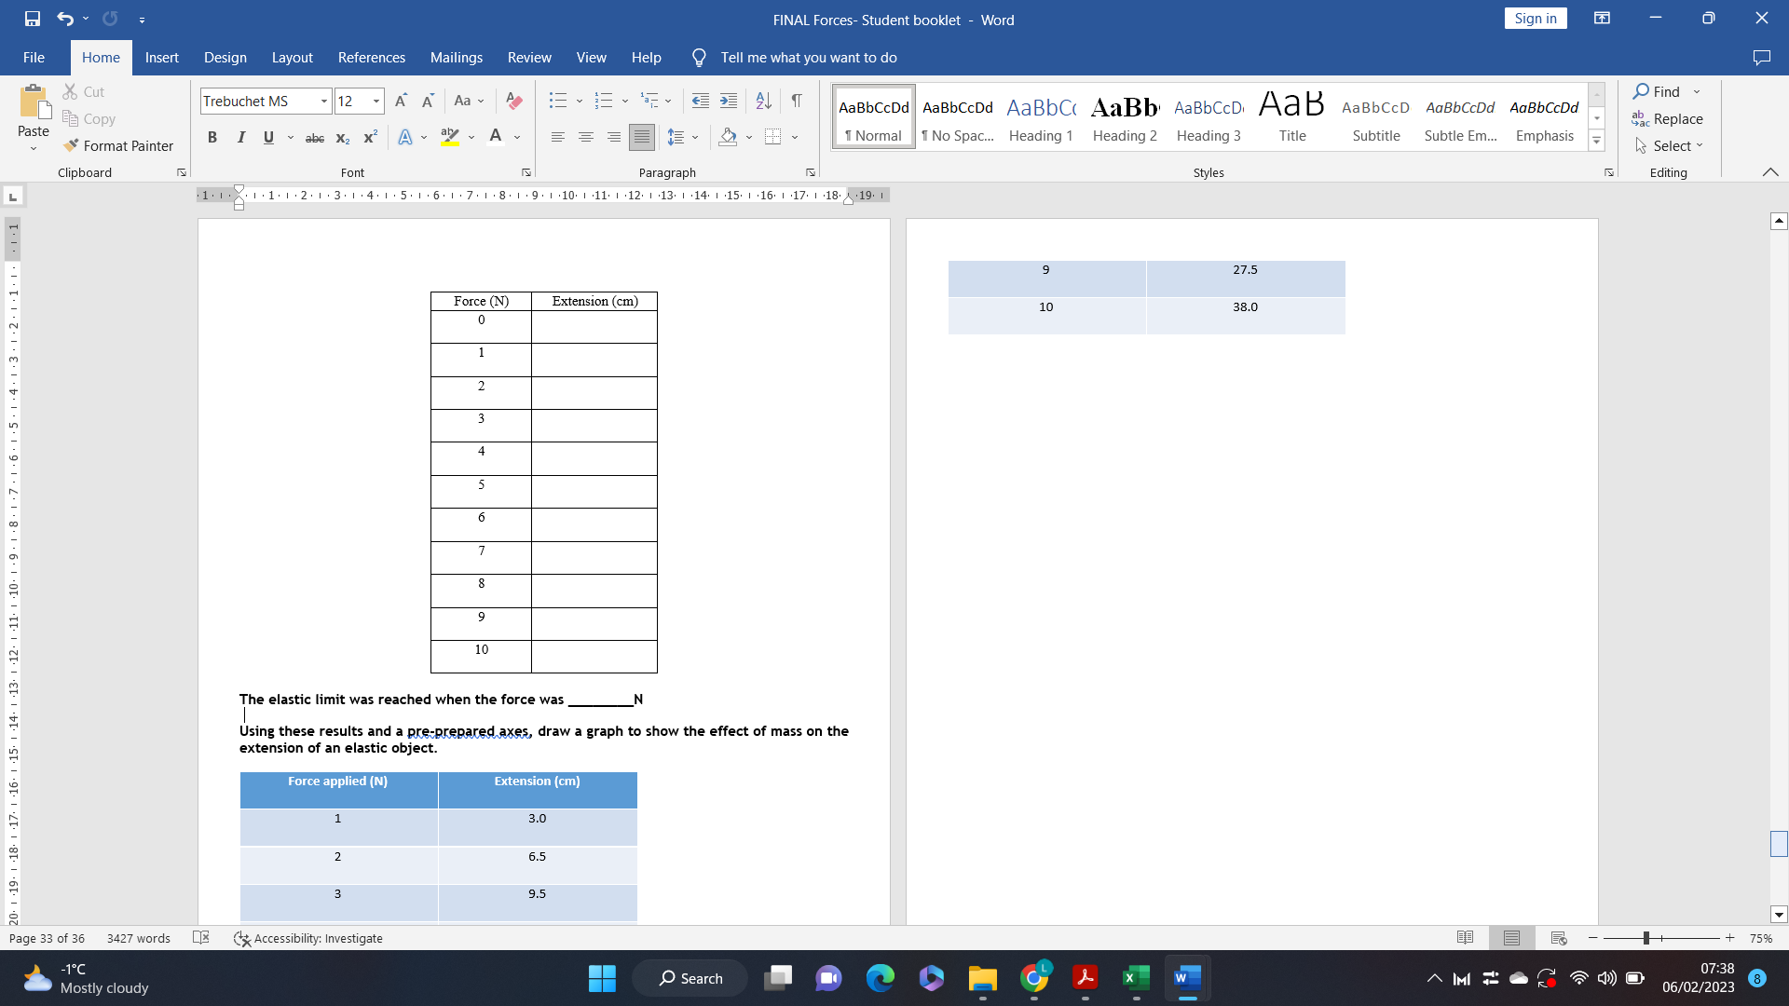

**The elastic limit was reached when the force was ________N**

**Using these results and a pre-prepared axes, draw a graph to show the effect of mass on the extension of an elastic object.**

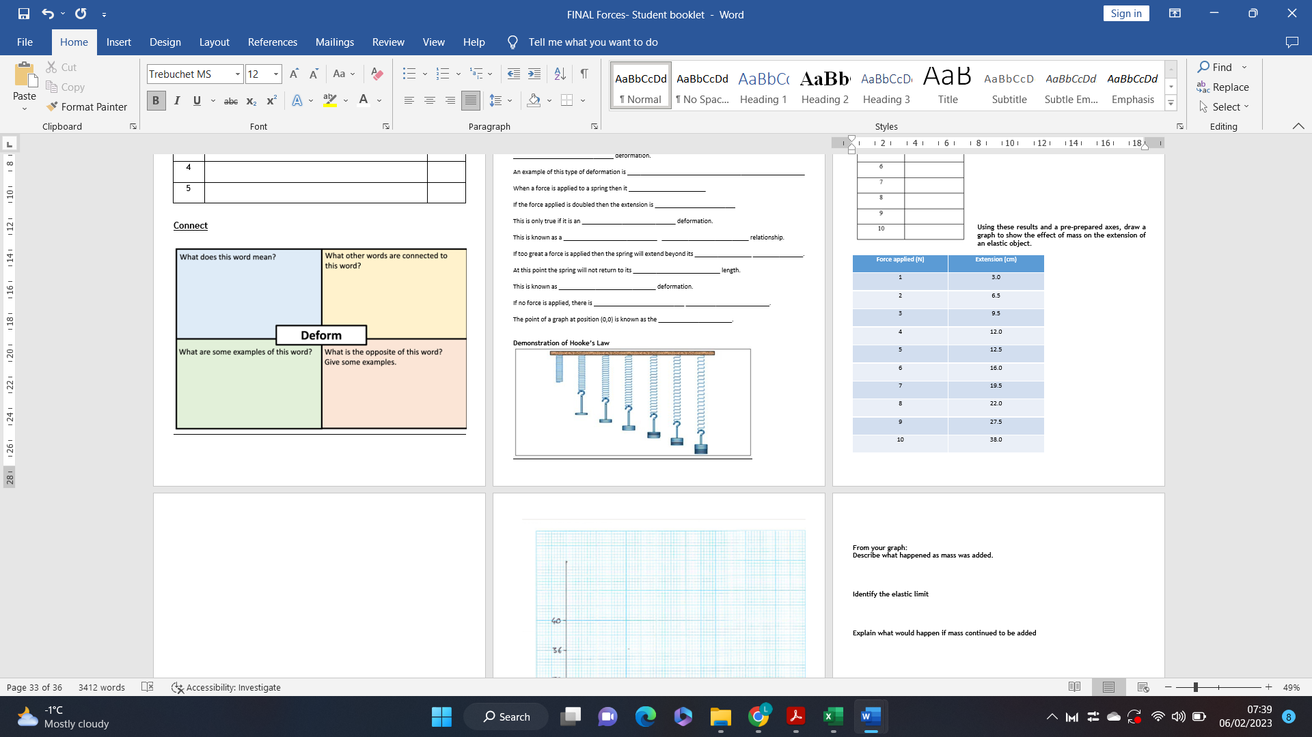

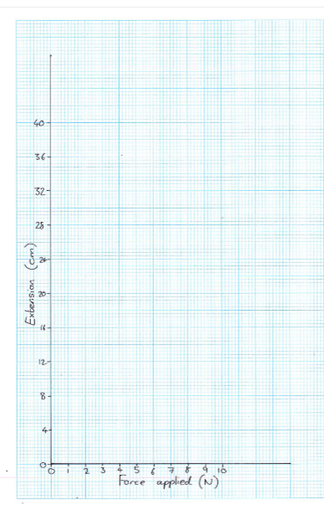

**From your graph:**

**Describe what happened as mass was added.**

___________________________________________________________________________________

___________________________________________________________________________________

___________________________________________________________________________________

___________________________________________________________________________________

___________________________________________________________________________________

**Identify the elastic limit:**

___________________________________________________________________________________

**Explain what would happen if mass continued to be added**

___________________________________________________________________________________

___________________________________________________________________________________

___________________________________________________________________________________

___________________________________________________________________________________

___________________________________________________________________________________

___________________________________________________________________________________

**Stretch:** Does the graph show a directly proportional relationship between the force applied to a spring and its extension?

How can you tell?

___________________________________________________________________________________

___________________________________________________________________________________

___________________________________________________________________________________

___________________________________________________________________________________

**Notes**

1. ________________________________________________________________
2. ________________________________________________________________
3. ________________________________________________________________
4. ________________________________________________________________
5. ________________________________________________________________
6. ________________________________________________________________
7. ________________________________________________________________
8. ________________________________________________________________
9. ________________________________________________________________
10. ________________________________________________________________
11. ________________________________________________________________
12. ________________________________________________________________
13. ________________________________________________________________
14. ________________________________________________________________
15. ________________________________________________________________
16. ________________________________________________________________
17. ________________________________________________________________
18. ________________________________________________________________
19. ________________________________________________________________
20. ________________________________________________________________
21. ________________________________________________________________
22. ________________________________________________________________
23. ________________________________________________________________
24. ________________________________________________________________
25. ________________________________________________________________
26. ________________________________________________________________
27. ________________________________________________________________
28. ________________________________________________________________
29. ________________________________________________________________
30. ________________________________________________________________
31. ________________________________________________________________
32. ________________________________________________________________
33. ________________________________________________________________
34. ________________________________________________________________
35. ________________________________________________________________
36. ________________________________________________________________
37. ________________________________________________________________
38. ________________________________________________________________

**Lesson 7: Moments**

**Date: ____________________________________________________________**

**Objective: By the end of this lesson, you will be able to describe the factors which affect the magnitude of a moment and use a given equation to calculate moments.**

**Skills Drill/ Retrieval Practice**

**Connect:** Describe what a lever is using a named example and explain why it is useful. You Must write in full sentences

____________________________________________________________________________________________________________________________________________________________________________________________________________________________________________________________

____________________________________________________________________________________

________________________________________________________________________________________________________________________________________________________________________

|  |  |  |
| --- | --- | --- |
| Answer | | PA / SA |
| 1 |  |  |
| 2 |  |  |
| 3 |  |  |
| 4 |  |  |
| 5 |  |  |

Task 2: Name the two factors that affect the magnitude of a moment include an example of where this can be manipulated in real life.

________________________________________________________________________________________________________________________________________________________________________________________________________________________________________________________________________________________________________________________________________________

____________________________________________________________________________________

____________________________________________________________________________________

Task 1: Define a moment including an example

________________________________________________________________________________________________________________________________________________________________________________________________________________________________________________________________________________________________________________________________________________

____________________________________________________________________________________

**Notes**

1. ________________________________________________________________
2. ________________________________________________________________
3. ________________________________________________________________
4. ________________________________________________________________
5. ________________________________________________________________
6. ________________________________________________________________
7. ________________________________________________________________
8. ________________________________________________________________
9. ________________________________________________________________
10. ________________________________________________________________
11. ________________________________________________________________
12. ________________________________________________________________
13. ________________________________________________________________
14. ________________________________________________________________
15. ________________________________________________________________
16. ________________________________________________________________
17. ________________________________________________________________
18. ________________________________________________________________
19. ________________________________________________________________
20. ________________________________________________________________
21. ________________________________________________________________
22. ________________________________________________________________
23. ________________________________________________________________
24. ________________________________________________________________
25. ________________________________________________________________
26. ________________________________________________________________
27. ________________________________________________________________
28. ________________________________________________________________
29. ________________________________________________________________
30. ________________________________________________________________
31. ________________________________________________________________
32. ________________________________________________________________
33. ________________________________________________________________
34. ________________________________________________________________
35. ________________________________________________________________
36. ________________________________________________________________
37. ________________________________________________________________
38. ________________________________________________________________

**Lesson 8: Law of Moments**

**Skills Drill/ Retrieval Practice**

**Date: ____________________________________________________________**

**Objective: By the end of this lesson, you will be able to use calculations of clockwise and anticlockwise moments to determine the direction of rotation.**

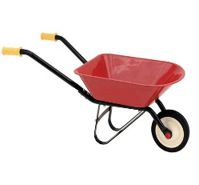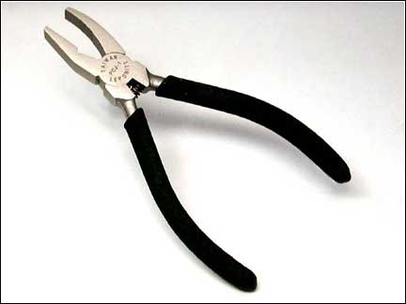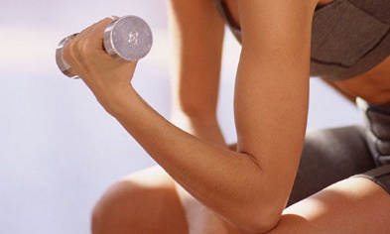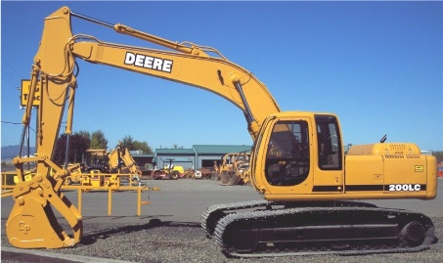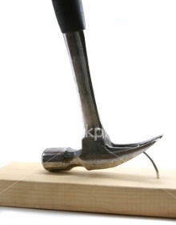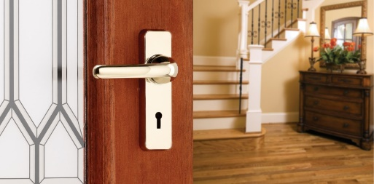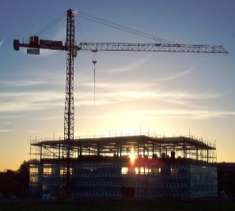

**Connect**: From the examples of levers below describe how you could increase / decrease the magnitude of the moment. You must write in full sentences.

__________________________________________________________________________________

____________________________________________________________________________________________________________________________________________________________________________________________________________________________________________________________

____________________________________________________________________________________

________________________________________________________________________________________________________________________________________________________________________

|  |  |  |
| --- | --- | --- |
| Answer | | PA / SA |
| 1 |  |  |
| 2 |  |  |
| 3 |  |  |
| 4 |  |  |
| 5 |  |  |

Task 2:



Task 1: **Consider a seesaw where TWO moments are acting…**

If the seesaw is not moving and perfectly balanced, what can you say about the anti-clockwise and clockwise moments?

____________________________________________________________________________________________________________________________________________________________________________________________________________________________________________________________

____________________________________________________________________________________

Task 3: For each of the examples below, calculate the size of the moment.

**State whether the rotation will be clockwise or anticlockwise**.

For each of the examples given below:

1. Calculate the size of the clockwise moment.
2. Calculate the size of the anticlockwise moment.
3. State the direction of rotation.

**Balancing Levers**

|  |  |  |  |  |  |
| --- | --- | --- | --- | --- | --- |
| force 1 (N) | distance 1 (m) | moment 1 (Nm) | force 2 (N) | distance 1 (m) | moment 2 (Nm) |
|  |  |  |  |  |  |
|  |  |  |  |  |  |
|  |  |  |  |  |  |
|  |  |  |  |  |  |
|  |  |  |  |  |  |
|  |  |  |  |  |  |
|  |  |  |  |  |  |
|  |  |  |  |  |  |
|  |  |  |  |  |  |
|  |  |  |  |  |  |

Describe how errors were minimised in the experiment.

_____________________________________________________________________________________________________________________________________________________________________________________________________________________________________________________________________________________________________________________________________________________________________________________________________________________________________________________________________________________________________________________________________________________________________________________________________

Are the results reproducible? Use evidence from other groups to explain your answer.

____________________________________________________________________________________________________________________________________________________________________________________________________________________________________________________________________________________________________________________________________________________________________________________________________________________________________________________________________________________________________________________________________________________________________________________________________________

What patterns are there in the results?

____________________________________________________________________________________________________________________________________________________________________________________________________________________________________________________________________________________________________________________________________________________________________________________________________________________________________________________________________________________________________________________________________________________________________________________________________________

**Notes**

1. ________________________________________________________________
2. ________________________________________________________________
3. ________________________________________________________________
4. ________________________________________________________________
5. ________________________________________________________________
6. ________________________________________________________________
7. ________________________________________________________________
8. ________________________________________________________________
9. ________________________________________________________________
10. ________________________________________________________________
11. ________________________________________________________________
12. ________________________________________________________________
13. ________________________________________________________________
14. ________________________________________________________________
15. ________________________________________________________________
16. ________________________________________________________________
17. ________________________________________________________________
18. ________________________________________________________________
19. ________________________________________________________________
20. ________________________________________________________________
21. ________________________________________________________________
22. ________________________________________________________________
23. ________________________________________________________________
24. ________________________________________________________________
25. ________________________________________________________________
26. ________________________________________________________________
27. ________________________________________________________________
28. ________________________________________________________________
29. ________________________________________________________________
30. ________________________________________________________________
31. ________________________________________________________________
32. ________________________________________________________________
33. ________________________________________________________________
34. ________________________________________________________________
35. ________________________________________________________________
36. ________________________________________________________________
37. ________________________________________________________________
38. ________________________________________________________________