**Year 10 – Student Booklet A TRILOGY**

Key Stage 4 Science:

**Chemical Changes**

**This booklet is for use in your Science lessons. Please look after it in the same way you would your exercise book and ensure that your presentation is always PROUD.**

**Ensure that your booklet is returned to your class book box at the end of the lesson.**

**Lesson Breakdown**

Lesson 1: 4.4.1.1 Metal oxides (practical – pattern seeking enquiry)

Lesson 2: 4.4.1.2 The reactivity series (practical – pattern seeking enquiry)(water and acids)

4.4.2.1 Reactions of acids with metals

Lesson 3: 4.4.1.2 Displacement reactions

Lesson 4: 4.4.1.3 Extraction of metals and reduction

Lesson 5: 4.4.2.4 The pH scale and neutralisation & 4.4.2.6 Strong and weak acids (HT only)

Lesson 6: 4.4.2.2 Neutralisation of acids and salt production

Lesson 7: 4.4.2.3 Soluble salts & **Required practical:** Preparing a salt (practical – reinforcing theory)

Lesson 8: 4.4.3.1 The process of electrolysis & 4.4.3.2 Electrolysis of molten ionic compounds

Lesson 9: 4.4.3.3 Using electrolysis to extract metals

Lesson 10: 4.4.3.4 Electrolysis of aqueous solutions

Lesson 11: **Required practical 3**: Electrolysis of aqueous solutions

***Embedded in several lessons: 4.4.1.4 Oxidation and reduction in terms of electrons (HT only)***

***Embedded in lesson 8 – 11: 4.4.3.5 Representation of reactions at electrodes as half equations (HT only)***

**Keystone words**

Oxidise

Reduce

Atom

Element

Ion

Neutralisation

Solution

**Lesson 1: 4.4.1.1 Metal oxides**

**Date:_____________________________________________________________**

**Objective: You are learning to describe the reactions of metals with oxygen on the macroscopic, microscopic and symbolic levels and to put the metals in order of reactivity.**

**Skills Drill / Retrieval**

|  |  |  |
| --- | --- | --- |
| Answer | | PA / SA |
| 1 |  |  |
| 2 |  |  |
| 3 |  |  |
| 4 |  |  |
| 5 |  |  |

**Connect**

**We will be looking at reactions that involve atoms gaining or losing electrons as part of this topic. We will relate this to reactivity and extracting metals. We covered this content in Structures and Bonding.**

**When metals react with non-metals they form ionic bonds. The metal gives electrons to the non-metal; this enables the atoms to become stable ions (atoms that have gained or lost electrons).**

**For example:**

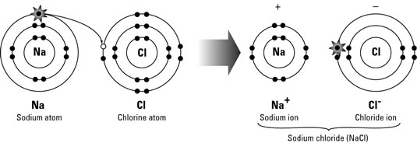

**-1**

**+1**

**Draw the structure of the ions formed when these elements react:**

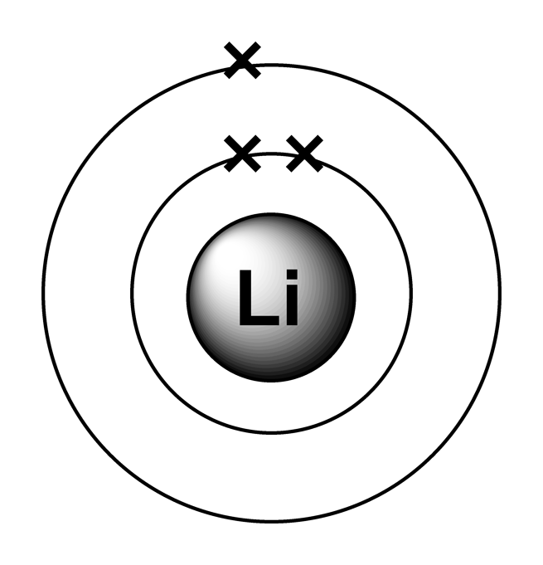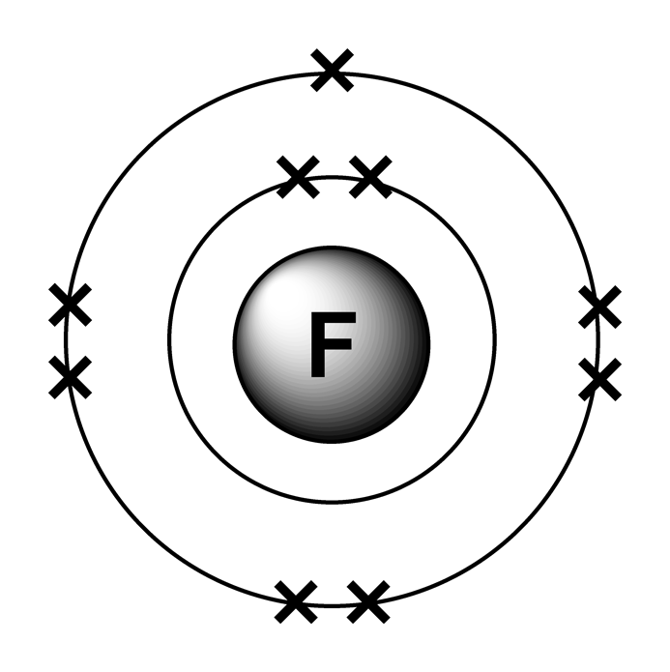

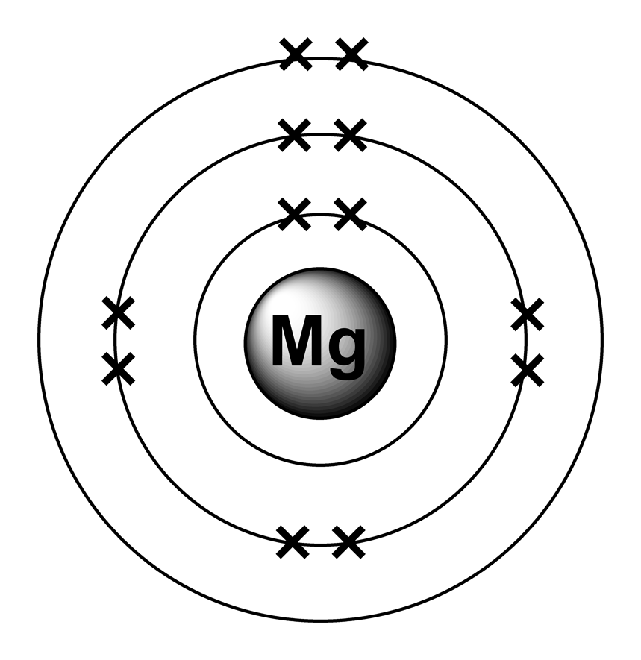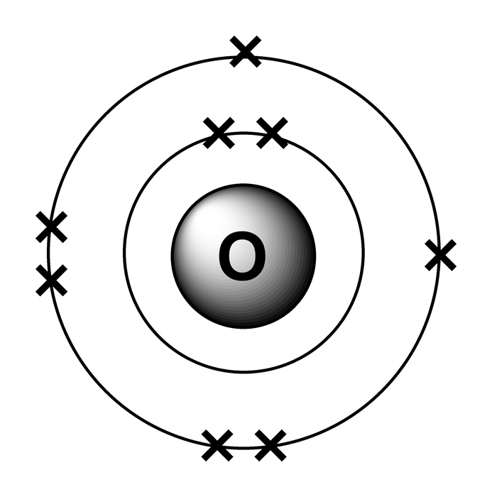

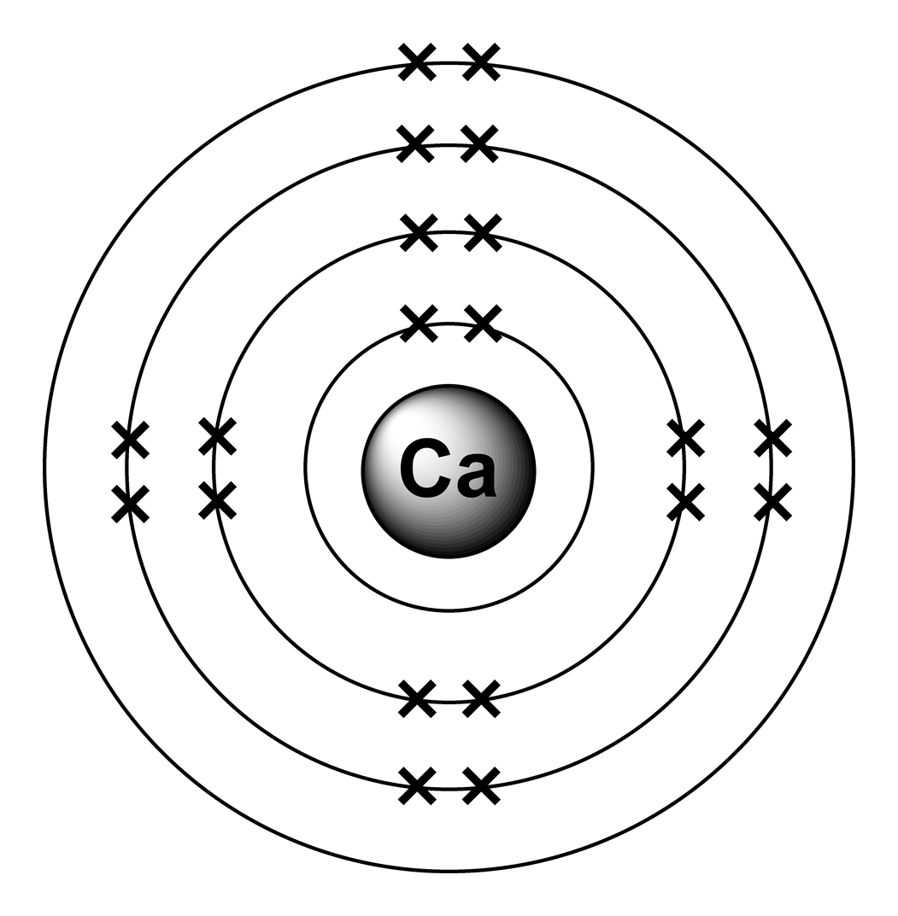

**The sodium atom has one electron in its outer shell. This makes it unstable. It will be more stable if it can donate (give) its outer shell electron to another atom. In this example it gives the outer shell electron to a chlorine atom. This also makes the chlorine atom stable because its outer shell is now full.**

**Atoms that have gained or lost electrons are called ions (in this case, sodium and chloride ions form).**

**Notes**

____________________________________________________________________________________________________________________________________________________________________________________________________________________________________________________________________________________________________________________________________________________________________________________________________________________________________________________________________________________________________________________________________________________________________________________________________________________________________________________________________________________________________________________________________________________________________________________________________________________________________________________________________________________________________________________________________________________________________________________________________________________________________________________________________________________________________________________________________________________________________________________________________________________________________________________________________________________________________________________________________________________________________________________________________________________________________________________________________________________________________________________________________________________________________________________________________________________________________________________________________________________________________________________________________________________________________________________________________________________________________________________________________________________________________________________________________________________________________________________________________________________________________________________________________________________________________________________________________________________________________________________________





+

When copper reacts with oxygen it forms copper oxide.

The copper atoms are oxidised because they gain oxygen.

This can be represented as:

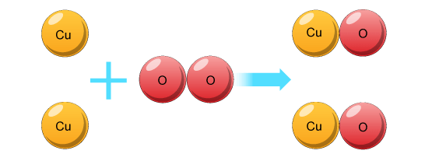

We can write this as a word equation:

**Copper + Oxygen 🡪 Copper Oxide**

We can also write this as a symbol equation:

**2Cu + O2 🡪 2CuO**

1. Represent the following reaction as word equations and symbol equations:

Word equation: ___________________________________________________________________________

Symbol equation: __________________________________________________________________________

1. Magnesium (Mg) reacts with oxygen (O2) to make magnesium oxide (MgO).

Write the word equations for this reaction.

___________________________________________________________________________

1. Write the balanced symbol equation for the same reaction.

___________________________________________________________________________

**Defining Oxidation:**

In the last activity copper and magnesium were shown reacting with oxygen.

These were examples of oxidation reactions.

1. When metals are oxidised, do they gain or lose oxygen?

______________________________________________________________________________________________________________________________________________________

In the Connect task, calcium and magnesium were also shown reacting with oxygen.

However, the electronic arrangements of the atoms were shown.

These examples also showed oxidation reactions.

1. When metals react with oxygen, do the at metal atoms gain or lose electrons?

_________________________________________________________________________________________________________________________________________________________________________________________________________________________________

**Oxidation and reduction mastery**

When substances gain oxygen they are said to be oxidised.

When they lose oxygen, they are said to be reduced.

For each of the following reactions, state whether the **bold and underlined** substance is oxidised or reduced:

1. **Aluminium oxide** 🡪 aluminium + oxygen ________________________________
2. **Nickel** + oxygen 🡪 nickel oxide ________________________________
3. Carbon + **zinc oxide** 🡪 carbon dioxide + zinc ________________________________
4. Aluminium + **chromium oxide** 🡪 aluminium oxide + chromium ______________________
5. **Aluminium** + oxygen 🡪 aluminium oxide ________________________________

For each of the following reactions, underline the substance that is being oxidised and draw a circle around the substance being reduced.

1. Iron oxide + hydrogen 🡪 iron + water
2. Hydrogen + copper oxide 🡪 copper + water
3. Tungsten oxide + hydrogen 🡪 tungsten + water
4. Magnesium + iron oxide 🡪 magnesium oxide + iron
5. Iron oxide + carbon 🡪 Iron + carbon dioxide

**The reactions of metals with oxygen**

**Metals react with oxygen in the air to make metal oxides.**

**In these experiments you will observe what happens when different metals react with oxygen.**

**You will then use your observations to put the metals in order based on reactivity; this is a pattern seeking enquiry.**

**Your teacher will either demonstrate the experiment or explain how to do it.**

|  |  |
| --- | --- |
| **Name of metal** | **Observations** |
| **Iron** |  |
| **Copper** |  |
| **Magnesium** |  |

1. Which metal was most reactive? How do you know this?

______________________________________________________________________________________________________________________________________________________

1. Which metal was least reactive? How do you know this?

______________________________________________________________________________________________________________________________________________________

1. List the metals in order of reactivity (most reactive first).

___________________________________________________________________________

1. List the metals in order of their tendency to form ions (greatest tendency first).

___________________________________________________________________________

1. Did the metals form positive or negative ions when they reacted with oxygen?

___________________________________________________________________________

1. Use your knowledge of sub-atomic particles to explain why the ions have this charge.

_________________________________________________________________________________________________________________________________________________________________________________________________________________________________

**Lesson 2: 4.4.1.2 The reactivity series**

**Date: .**

**Objective: You are learning to put metals in order of their reactivity using observations of metals reacting with water and dilute acids.**

**Skills Drill / Retrieval**

|  |  |  |
| --- | --- | --- |
| Answer | | PA / SA |
| 1 |  |  |
| 2 |  |  |
| 3 |  |  |
| 4 |  |  |
| 5 |  |  |

**Catch up (complete this if you were absent last lesson):**

Use your knowledge booklet to answer these questions:

1. When metals react with other substances, do they form positive or negative ions?

______________________________________________________________________________

1. When metals react with oxygen, they gain oxygen to form a metal oxide.

Is the metal oxidised or reduced?

______________________________________________________________________________

1. When metals react with non-metals they lose electrons.

Are the metals being oxidised or reduced when they lose electrons?

______________________________________________________________________________

1. Put these metals in order of reactivity (most reactive first):

Copper, magnesium, iron

_____________________________________________________________________________

1. What does it mean if we say ‘more reactive elements have a greater tendency to form positive ions’?

____________________________________________________________________________________________________________________________________________________________

**Connect – use your knowledge booklet / textbook for reminders.**

In the last lesson, we reacted metals with oxygen (a non-metal).

The way in which substances react was taught in KS4 Structures and Bonding. This built on content taught at KS3 and in KS4 Atomic Structure and the Periodic Table.

1. The metals were oxidised during the reaction. What does this mean?

________________________________________________________________________________________________________________________________________________________

1. The metal and non-metal formed an ionic compound.

Draw the electronic structure of magnesium; it has 12 electrons.

________________________________________________________________________________________________________________________________________________________________________________________________________________________________________________________________________________________________________________________________________________________________________________________________________________________________________________________________________

1. Draw the electronic structure of the magnesium ion that is produced when magnesium reacts with oxygen.

________________________________________________________________________________________________________________________________________________________________________________________________________________________________________________________________________________________________________________________________________________________________________________________________________________________________________________________________________

1. List the physical properties that you would expect magnesium oxide to have (it is an ionic compound).

____________________________________________________________________________________________________________________________________________________________________________________________________________________________________________________________________________________________________________________________________________________________________________________________________________________________________________________________________________________________________________________________________________________________________________________________________________________________________________________________________________________________________________

**Notes**

____________________________________________________________________________________________________________________________________________________________________________________________________________________________________________________________________________________________________________________________________________________________________________________________________________________________________________________________________________________________________________________________________________________________________________________________________________________________________________________________________________________________________________________________________________________________________________________________________________________________________________________________________________________________________________________________________________________________________________________________________________________________________________________________________________________________________________________________________________________________________________________________________________________________________________________________________________________________________________________________________________________________________________________________________________________________________________________________________________________________________________________________________________________________________________________________________________________________________________________________________________________________________________________________________________________________________________________________________________________________________________________________________________________________________________________________________________________________________________________________________________________________________________________________________________________________________________________________________________________________________________________________

**Reactions of metals with water**

You are going to observe what happens when different metals are added to water.

You will then put the metals in order of their reactivity.

Write your observations in the table below:

|  |  |
| --- | --- |
| **Metal added to water** | **Observations** |
| Lithium |  |
| Sodium |  |
| Potassium |  |
| Magnesium |  |
| Copper |  |
| Iron |  |

1. Use your observations to put the metals in order of reactivity (most reactive first)

____________________________________________________________________________________________________________________________________________________________

1. Which of your observations helped you the most when you were putting the metals in order of reactivity? Explain your answer.

__________________________________________________________________________________________________________________________________________________________________________________________________________________________________________

1. We learnt in the last lesson that reactivity is related to a metals tendency to form ions.

Put the metals in order of their tendency to form ions (greatest tendency first).

__________________________________________________________________________________________________________________________________________________________________________________________________________________________________________

**Reactions of metals with acid**

You are going to observe what happens when different metals are added to a dilute acid.

You will then put the metals in order of their reactivity.

Write your observations in the table below:

|  |  |
| --- | --- |
| **Metal added to water** | **Observations** |
| Magnesium |  |
| Copper |  |
| Iron |  |

1. Use your observations to put the metals in order of reactivity (most reactive first).

____________________________________________________________________________________________________________________________________________________________

1. Which of your observations helped you the most when you were putting the metals in order of reactivity? Explain your answer.

__________________________________________________________________________________________________________________________________________________________________________________________________________________________________________

1. We learnt in the last lesson that reactivity is related to a metals tendency to form ions.

Put the metals in order of their tendency to form ions (greatest tendency first).

__________________________________________________________________________________________________________________________________________________________________________________________________________________________________________

1. Look at all of your observations from last lesson and this lesson. Put all of the metals in order of reactivity (most reactive first).

__________________________________________________________________________________________________________________________________________________________________________________________________________________________________________

**Representing reactions symbolically (as equations)**

Reactions of metals with water

When lithium reacts with water, the products are lithium hydroxide and hydrogen gas:

**Word equation:** Lithium + water 🡪 lithium hydroxide + hydrogen

**Symbol equation:** 2Li(s) + 2H2O(l) 🡪 2LiOH(aq) + H2(g)

Other alkali metals also form metal hydroxides.

When metals that aren’t in group 1 react with water they make metal oxides. For example, when magnesium reacts with water:

**Word equation:** Magnesium + water 🡪 magnesium oxide + hydrogen

**Symbol equation:** Mg(s) + H2O(l) 🡪 MgO(aq) + H2(g)

**Questions:** Complete the work and symbol equations for the following reactions:

1. When sodium (Na) reacts with water (H2O), the products are sodium hydroxide (NaOH) and hydrogen gas (H2).

**Word equation:** _____________________________________________________________________

**Symbol equation:** ___________________________________________________________________

1. When potassium (K) reacts with water (H2O), the products are potassium hydroxide (KOH) and hydrogen gas (H2).

**Word equation:** _____________________________________________________________________

**Symbol equation:** ___________________________________________________________________

**For each reaction, underline the reactant that is oxidised.**

**Representing reactions symbolically (as equations)**

Reactions of metals with sulphuric acid

When metals react with sulphuric acid the products are a metal sulphate (a type of salt) and hydrogen gas.

**Word equation:** Magnesium + sulphuric acid 🡪 magnesium sulphate + hydrogen

**Symbol equation:** Mg(s) + H2SO4(aq) 🡪 MgSO4(aq) + H2(g)

**Questions:** Complete the work and symbol equations for the following reactions:

1. When copper (Cu) reacts with sulphuric acid (H2SO4), the products are copper sulphate (CuSO4) and hydrogen gas (H2).

**Word equation:** _____________________________________________________________________

**Symbol equation:** ___________________________________________________________________

1. When iron (Fe) reacts with sulphuric acid (H2SO4), the products are iron sulphate (FeSO4) and hydrogen gas (H2).

**Word equation:** _____________________________________________________________________

**Symbol equation:** __________________________________________________________________

1. If we reacted sodium (Na) with sulphuric acid (H2SO4), the products would be sodium sulphate (Na2SO4) and hydrogen gas (H2).

**Word equation:** _____________________________________________________________________

**Symbol equation:** ___________________________________________________________________

1. We didn’t react lithium, sodium and potassium with sulphuric acid. Why would it be a bad idea to react these metals with sulphuric acid?

__________________________________________________________________________________________________________________________________________________________________________________________________________________________________________

**For each reaction, underline the reactant that is oxidised.**

So far in this topic you have observed the following reactions:

* Metals + oxygen
* Metals + water
* Metals + dilute acid

In all of these reactions, a metal was reacted with a non-metal; an ionic salt was produced.

**Question: Rubidium is an alkali metal that is below potassium in group 1.**

**Describe what would happen if we reacted rubidium with water.**

You should justify your answers using your scientific knowledge from several topics.

You should include the following:

1. What you would see and hear when rubidium is added to water.
2. The electronic structure of rubidium atoms & ions (Atomic Structure/Bonding & Structure).
3. An explanation relating the electronic structure of rubidium to why you think it is more or less reactive than lithium, sodium and potassium (Atomic Structure).
4. The physical properties that you would expect the product to have (Bonding and Structure).
5. Word and symbol equations for the reaction.

____________________________________________________________________________________________________________________________________________________________________________________________________________________________________________________________________________________________________________________________________________________________________________________________________________________________________________________________________________________________________________________________________________________________________________________________________________________________________________________________________________________________________________________________________________________________________________________________________________________________________________________________________________________________________________________________________________________________________________________________________________________________________________________________________________________________________________________________________________________________________________________________________________________________________________________________________________________________________________________________________________________________________________________________________________________________________________________________________________________________________________________________________________________________________________________________________________________________________________________________________________________________________________________________________________________________________________________________________________________________________

**Lesson 3: 4.4.1.2 Displacement reactions**

**Date: .**

**Objective:** You are learning to use the reactivity series to predict the products of a reaction and how to write the equation for the reactions used.

**Skills Drill / Retrieval**

|  |  |  |
| --- | --- | --- |
| Answer | | PA / SA |
| 1 |  |  |
| 2 |  |  |
| 3 |  |  |
| 4 |  |  |
| 5 |  |  |

**Catch up (complete this if you were absent last lesson):**

Use your knowledge booklet to answer these questions:

1. Complete these word equations:

Sodium + water 🡪 ______________ __________________ + hydrogen

Magnesium + water 🡪 ________________ __________________ + hydrogen

Iron + sulphuric acid 🡪 ________________ ___________________ + hydrogen

1. The metals shown in the image are reacting with an acid. List them in order of reactivity (most reactive first).

_________________________

_________________________

_________________________

_________________________



1

1

2

2

3

4

Transition metal (TM)

TM

4

1

TM

TM

TM

TM

1. If you ignore Carbon and Hydrogen, what pattern can you see in the group numbers?

________________________________________________________________________________________________________________________________________________________________________________________________________________________

1. Which of the elements have the greatest tendency to form ions?

________________________________________________________________________

1. Do the metals gain or lose electrons when they react?

________________________________________________________________________

_________________________________________________________________________________________________________________________________________________________________________________________________________________________________________________________________________________________________________________________________________________________

**Connect**

The Reactivity Series is one of the most important concepts in chemistry. It is used to design devices to transfer energy, purify metals and to understand how the body works at a molecular level.

You were introduced to the Reactivity Series at KS3. We build on that knowledge in this topic.

A copy of the Reactivity Series is shown below.

Find each element on the Periodic Table and write down the group it is found in.

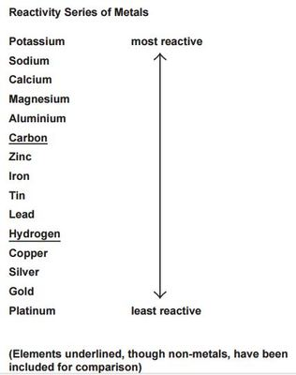

**Notes**

____________________________________________________________________________________________________________________________________________________________________________________________________________________________________________________________________________________________________________________________________________________________________________________________________________________________________________________________________________________________________________________________________________________________________________________________________________________________________________________________________________________________________________________________________________________________________________________________________________________________________________________________________________________________________________________________________________________________________________________________________________________________________________________________________________________________________________________________________________________________________________________________________________________________________________________________________________________________________________________________________________________________________________________________________________________________________________________________________________________________________________________________________________________________________________________________________________________________________________________________________________________________________________________________________________________________________________________________________________________________________________________________________________________________________________________________________________________________________________________________________________________________________________________________________________________________________________________________________________________________________________________________

**Predictions -** Predict whether there will be a reaction or no reaction.

1. Zinc nitrate + magnesium Reaction________________________________

Reason:_____Magnesium is more reactive than zinc_______________________________________ _________________________________________________________________________________

1. Zinc nitrate + copper No reaction___ __________________________

Reason: _____Copper is less reactive than zinc_________________________ __________________

_________________________________________________________________________________

1. Zinc nitrate + lead _______________________________________

Reason:____________________________________________________________________________________________________________________________________________________________

1. Magnesium nitrate + zinc _______________________________________

Reason:____________________________________________________________________________________________________________________________________________________________

1. Magnesium nitrate + copper _______________________________________

Reason:____________________________________________________________________________________________________________________________________________________________

1. Magnesium nitrate + lead _______________________________________

Reason:____________________________________________________________________________________________________________________________________________________________

1. Copper nitrate + zinc _______________________________________

Reason:____________________________________________________________________________________________________________________________________________________________

1. Copper nitrate + magnesium _______________________________________

Reason:____________________________________________________________________________________________________________________________________________________________

1. Copper nitrate + lead _______________________________________

Reason:____________________________________________________________________________________________________________________________________________________________

1. Lead nitrate + zinc _______________________________________

Reason:____________________________________________________________________________________________________________________________________________________________

1. Lead nitrate + magnesium _______________________________________

Reason:____________________________________________________________________________________________________________________________________________________________

1. Lead nitrate + copper _______________________________________

Reason:____________________________________________________________________________________________________________________________________________________________

|  |  |  |  |
| --- | --- | --- | --- |
| **Reactants** | **Reaction** | **No Reaction** | **Was your prediction, right?** |
| Zinc nitrate + magnesium |  |  |  |
| Zinc nitrate + copper |  |  |  |
| Zinc nitrate + lead |  |  |  |
| Magnesium nitrate + zinc |  |  |  |
| Magnesium nitrate + copper |  |  |  |
| Magnesium nitrate + lead |  |  |  |
| Copper nitrate + zinc |  |  |  |
| Copper nitrate + magnesium |  |  |  |
| Copper nitrate + lead |  |  |  |
| Lead nitrate + zinc |  |  |  |
| Lead nitrate + magnesium |  |  |  |
| Lead nitrate + copper |  |  |  |



**Practical: Displacement reactions**

**Ionic equations (HT only)**

***Complete the below table by filling in the ions that make up each of the ionic compounds:***

|  |  |  |
| --- | --- | --- |
| **Ionic formula** | **Ion 1 (positive)** | **Ion 2 (negative)** |
| CuSO4 | 1 x Cu2+ | 1 x SO42- |
| Zn(OH)2 | 1 x Zn2+ | 2 x OH- |
| NaCl |  |  |
| CaBr2 |  |  |
| K2O |  |  |
| H2SO4 |  |  |
| Cu(OH)2 |  |  |
| Na2O |  |  |
| LiOH |  |  |
| Al2(CO3)3 |  |  |

**Common ions:**

Pb2+ Fe2+  Cu2+ Zn2+ Mg2+ Ca2+ Li+  Na+ K+ Ag+ H+

SO42- CO32- O2- NO3- OH- Br- Cl-

***\*Credit for original document goes to ‘Iondinium’ (TES resources)***

**Worked example:**

This equation describes the displacement reaction between aqueous copper sulphate and solid zinc metal. Remember that the solid form of a metal means it is neutrally charged. Only aqueous (aq) metals have a charge.

1. CuSO4(aq) + Zn(s)🡪 ZnSO4(aq) + Cu(s)

**Break down each ionic compound into its constituent ions:**

1. Cu2+ + SO42- + Zn 🡪 Zn2+ + SO42- + Cu

**Cancel out the ions that are on both sides.**

1. Cu2+ + **~~SO~~~~4~~~~2-~~**+ Zn 🡪 Zn2+ + **~~SO~~~~4~~~~2-~~**+ Cu

**Write the overall equation.**

1. Cu2+ + Zn 🡪 Zn2+ + Cu

**Questions:**

1. **Complete these ionic equation steps for the following reaction.**
2. Mg(s) + ZnSO4(aq) 🡪 MgSO4(aq) + Zn(s)
3. Mg(s) + _____ + _____ 🡪 _____ + ______ + Zn(s)
4. Mg + ______ 🡪 Zn + ______
5. Oxidised = ____________ ; Reduced = ______________
6. **Complete the ionic equation steps for the following reaction.**
7. Ca(s) + 2NaCl(aq) 🡪 2Na(s) + CaCl2(aq)
8. _____ + _____ + _____ 🡪 ____ + ____ + ____
9. _____ + _____ 🡪 _____ +_____
10. Oxidised = _______________; Reduced = ____________
11. **Complete the ionic equation steps for the following reaction.**
12. 2AgNO3(aq) + Cu(s) 🡪 Cu(NO3)­2(aq) + 2Ag(s)
13. ______ + ______ + Cu(s) 🡪 _____ +______ + ______
14. ______ + ______ 🡪 ______ + _______
15. Oxidised = ____________; Reduced = ________________
16. **Write ionic equations for the following reactions.** 
    1. *The displacement reaction between iron filings (Fe) and copper (II) sulfate solution.*

___________________________________________________________________

Oxidised = ______________; Reduced = __________________

* 1. *Solid magnesium is heated with solid lead (II) oxide.*

___________________________________________________________________

Oxidised = _______________; Reduced = __________________

**Lesson 4: 4.4.1.3 Extraction of metals and reduction**

**Date: .**

**Objective: You are learning to describe how metals are extracted and to evaluate methods for extracting metals.**

**Skills Drill / Retrieval**

|  |  |  |
| --- | --- | --- |
| Answer | | PA / SA |
| 1 |  |  |
| 2 |  |  |
| 3 |  |  |
| 4 |  |  |
| 5 |  |  |

**Catch up (complete this if you were absent last lesson):**

In the last lesson we learnt about displacement reactions.

1. Use the Reactivity Series to predict the outcome of the following reactions:

1. Use the model answer to write an ionic equation for this reaction:
   * Mg(s) + ZnSO4(aq) 🡪 MgSO4(aq) + Zn(s)
   * Mg(s) + _____ + _____ 🡪 _____ + ______ + Zn(s)
   * Mg + ______ 🡪 Zn + ______

Ores often contain metal oxides. The metal is extracted by reducing the metal oxide (removing the oxygen).

Which of the metals listed above could be extracted by reacting them with carbon?

______________________________________________________________________________Explanation:______________________________________________________________________________________________________________________________________________________________________________________________________________________________________________________________________________________________________________

Which of the metals listed above could not be extracted by reacting them with carbon?

______________________________________________________________________________Explanation:______________________________________________________________________________________________________________________________________________________________________________________________________________________________________________________________________________________________________________

**Connect**

You were introduced to the Reactivity Series in this topic and at KS3.

One of the most important uses of the Reactivity Series is the extraction of metals from ores.



**Notes**

____________________________________________________________________________________________________________________________________________________________________________________________________________________________________________________________________________________________________________________________________________________________________________________________________________________________________________________________________________________________________________________________________________________________________________________________________________________________________________________________________________________________________________________________________________________________________________________________________________________________________________________________________________________________________________________________________________________________________________________________________________________________________________________________________________________________________________________________________________________________________________________________________________________________________________________________________________________________________________________________________________________________________________________________________________________________________________________________________________________________________________________________________________________________________________________________________________________________________________________________________________________________________________________________________________________________________________________________________________________________________________________________________________________________________________________________________________________________________________________________________________________________________________________________________________________________________________________________________________________________________________________________

Q1     An ore contains a mixture of zinc carbonate and lead carbonate.

The metals zinc and lead are produced from this ore in two stages:

**Stage 1** decomposing the carbonates to produce a mixture of zinc oxide and lead oxide.

**Stage 2** mixing the oxides with carbon and heating in a furnace.

Some of the reactions in the furnace are:

|  |  |  |  |  |  |  |
| --- | --- | --- | --- | --- | --- | --- |
| zinc oxide | + | carbon |  | zinc | + | carbon dioxide |

|  |  |  |  |  |  |  |
| --- | --- | --- | --- | --- | --- | --- |
| lead oxide | + | carbon |  | lead | + | carbon dioxide |

|  |  |  |  |  |
| --- | --- | --- | --- | --- |
| carbon | + | oxygen |  | carbon dioxide |

Use the information given to help you to answer these questions.

(i)      Draw a ring around the correct answer to complete the sentence.

The reaction between carbon and oxygen that heats the

|  |  |
| --- | --- |
|  | combustion. |
| furnace is called | decomposition. |
|  | evaporation. |

**(1)**

(ii)     Tick () **one** reason why carbon reacts with zinc oxide to produce zinc.

|  |  |
| --- | --- |
| **Reason** | **Tick ()** |
| carbon is less reactive than zinc |  |
| carbon is more reactive than zinc |  |
| carbon is similar in reactivity to zinc |  |

**(1)**

(iii)    In the furnace zinc is a gas but lead is a liquid.

Suggest why.

______________________________________________________________

______________________________________________________________

______________________________________________________________

____________________________________________________________**(2)**

**Q2.**

Titanium is used for replacement hip joints because it has a low density, is strong and does not corrode.  
Titanium is extracted from titanium dioxide (TiO2) in three stages.

(a)     **Stage 1**Titanium dioxide is converted into titanium chloride (TiCl4) because the metal cannot be extracted from its oxide by *reduction* with carbon.

(i)      What does *reduction* mean?

______________________________________________________________

______________________________________________________________

**(1)**

(ii)     Balance the chemical equation for the conversion of titanium dioxide to titanium chloride.

|  |  |  |  |  |  |  |  |  |
| --- | --- | --- | --- | --- | --- | --- | --- | --- |
| TiO2 | + | Cl2 | + | C | → | TiCl4 | + | CO2 |

**(1)**

(iii)    Chemical equations are always balanced. Explain why.

______________________________________________________________

______________________________________________________________

______________________________________________________________

**(1)**

(b)     **Stage 2**Titanium is extracted from the titanium chloride by reacting it with sodium at 1000 °C in a reactor.  
The only other substance in the reactor is argon gas.

|  |  |  |  |  |  |  |
| --- | --- | --- | --- | --- | --- | --- |
| TiCl4 | + | 4Na | → | Ti | + | 4NaCl |

(i)      What does this tell you about the reactivity of sodium compared with titanium?

______________________________________________________________

______________________________________________________________

**(1)**

(ii)     Suggest why the reactor contains argon and **not** air.

______________________________________________________________

______________________________________________________________ **(1)**

(c)     **Stage 3**After **Stage 2** the titanium is separated from the products by washing out the sodium chloride with water.  
The diagrams show sections through the lattice of titanium metal and the lattice of sodium chloride.

How do the diagrams show that:

(i)      titanium is an element

______________________________________________________________

______________________________________________________________

**(1)**

(ii)     sodium chloride is a compound?

______________________________________________________________

______________________________________________________________

______________________________________________________________

______________________________________________________________

**(2)**

(d)  Tungsten (W) is a metal.

Tungsten is extracted from tungsten oxide (WO3).

All other solid products from the extraction method must be separated from the tungsten.

The table below shows information about three possible methods to extract tungsten from tungsten oxide.

|  |  |  |  |
| --- | --- | --- | --- |
| **Method** | **Reactant** | **Relative cost of reactant** | **Products** |
| 1 | Carbon | Low | Tungsten solid Carbon dioxide gas Tungsten carbide solid |
| 2 | Hydrogen | High | Tungsten solid Water vapour |
| 3 | Iron | Low | Tungsten solid Iron oxide solid |

Evaluate the three possible methods for extracting tungsten from tungsten oxide.

___________________________________________________________________

___________________________________________________________________

___________________________________________________________________

___________________________________________________________________

___________________________________________________________________

___________________________________________________________________

___________________________________________________________________

___________________________________________________________________

___________________________________________________________________

___________________________________________________________________

___________________________________________________________________

___________________________________________________________________

**(4)**

**Lesson 5: 4.4.2.4 The pH scale and neutralisation & 4.4.2.6 Strong and weak acids (HT only)**

**Date: .**

**Objective: You are learning about the relationship between pH, the ions in a solution and how they interact.**

**Skills Drill / Retrieval**

|  |  |  |
| --- | --- | --- |
| Answer | | PA / SA |
| 1 |  |  |
| 2 |  |  |
| 3 |  |  |
| 4 |  |  |
| 5 |  |  |

**Catch up (complete this if you were absent last lesson):**

**Use your knowledge booklet to find the answers.**

1. Find out what an ‘ore’ is.

____________________________________________________________________________________________________________________________________________________________

1. List three metals that are extracted by reducing their oxide with carbon.

__________________________________________________________________________________________________________________________________________________________________________________________________________________________________________

1. List three metals that could not be extracted by reducing their oxide with carbon.

__________________________________________________________________________________________________________________________________________________________________________________________________________________________________________

1. List two metals that are found as pure metals in the ground.

__________________________________________________________________________________________________________________________________________________________________________________________________________________________________________

**Connect – the pH scale**

In the KS3 Acids and Alkalis topic you learnt about the pH scale.

You used universal indicator to find out the pH of different household substances.

You also learnt about neutralisation; neutralisation happens when acids react with alkalis or bases.

**The pH scale:**

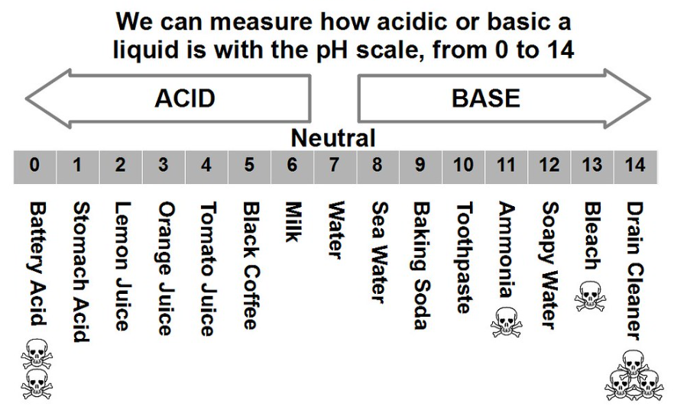

**Questions:**

1. What pH value do strong acids have? _________________
2. What colour does universal indicator go in a strong acid? _________________
3. What pH value do strong alkalis / bases have? _________________
4. What colour does universal indicator go in a strong alkali? _________________
5. Some indicators only have two colours; they turn one colour in an acid and another colour in an alkali (a soluble base). These indicators are called dichromic indicators.

Give one advantage of using a dichromic indicator instead of using universal indicator.

________________________________________________________________________________________________________________________________________________________________________________________________________________________________________________________________________________________________________________________

1. Give one disadvantage of using a dichromic indicator instead of using universal indicator.

________________________________________________________________________________________________________________________________________________________________________________________________________________________________________________________________________________________________________________________

**Notes**

____________________________________________________________________________________________________________________________________________________________________________________________________________________________________________________________________________________________________________________________________________________________________________________________________________________________________________________________________________________________________________________________________________________________________________________________________________________________________________________________________________________________________________________________________________________________________________________________________________________________________________________________________________________________________________________________________________________________________________________________________________________________________________________________________________________________________________________________________________________________________________________________________________________________________________________________________________________________________________________________________________________________________________________________________________________________________________________________________________________________________________________________________________________________________________________________________________________________________________________________________________________________________________________________________________________________________________________________________________________________________________________________________________________________________________________________________________________________________________________________________________________________________________________________________________________________________________________________________________________________________________________________

**Practical – serial dilutions**

|  |  |  |  |
| --- | --- | --- | --- |
| Serial dilution of 1.0mol.dm-3 HCl | Concentration of H+ (mol.dm-3) | Colour with universal indicator | pH |
| Original acid solution | 0.1 |  |  |
| 1 | 0.01 |  |  |
| 2 | 0.001 |  |  |
| 3 | 0.0001 |  |  |
| 4 | 0.00001 |  |  |
| 5 | 0.000001 |  |  |
| 6 | 0.0000001 |  |  |
| 7 | 0.00000001 |  |  |

1. Describe how to use universal indicator to determine the approximate pH of a solution.

____________________________________________________________________________________________________________________________________________________________________________________________________________________________________________________________________________________________________________________________________________________________________________________________________________________________________

1. What happens to the pH of the solution as it becomes more dilute?

____________________________________________________________________________________________________________________________________________________________________________________________________________________________________________________________

1. What is the relationship between hydrogen ion concentration and pH?

________________________________________________________________________________________________________________________________________________________________________________________________________________________________________________________________________________________________________________________________________________

**Practical – serial dilutions**

|  |  |  |  |  |  |
| --- | --- | --- | --- | --- | --- |
| Serial dilution of 1.0mol.dm-3 NaOH | Concentration of OH-  (mol.dm-3) | | Colour with universal indicator | | pH |
| Original solution | 0.1 | |  | |  |
| 1 | 0.01 | |  | |  |
| 2 | 0.001 | |  | |  |
| 3 | 0.0001 | |  | |  |
| 4 | 0.00001 | |  | |  |
| 5 | | 0.000001 | |  |  | |
| 6 | | 0.0000001 | |  |  | |
| 7 | | 0.00000001 | |  |  | |

1. Suggest how the method for this experiment could be improved to make the results more reproducible or repeatable.

____________________________________________________________________________________________________________________________________________________________________________________________________________________________________________________________________________________________________________________________________________________________________________________________________________________________________

1. What happens to the pH of the solution as it becomes more dilute?

____________________________________________________________________________________________________________________________________________________________________________________________________________________________________________________________

1. What is the relationship between hydroxide ion concentration and pH?

________________________________________________________________________________________________________________________________________________________________________________________________________________________________________________________________________________________________________________________________________________

**HT only**

(c)

**Lesson 6: 4.4.2.2 Neutralisation of acids and salt production**

**Objective: You are learning to represent neutralisation reactions as word equations and balanced symbol equations.**

**Skills Drill / Retrieval**

|  |  |  |
| --- | --- | --- |
| Answer | | PA / SA |
| 1 |  |  |
| 2 |  |  |
| 3 |  |  |
| 4 |  |  |
| 5 |  |  |

**Catch up (complete this if you were absent last lesson):**

At KS3 you used Universal Indicator to find the pH of different solutions.

1. What information does the pH scale give us about a solution?

________________________________________________________________________________________________________________________________________________________________

1. Strong acids are fully ionised in water; they release a lot of hydrogen ions.

What pH would you expect them to be? ______________________________________________

What colour might they turn Universal Indicator? ______________________________________

1. Weak acids are partially ionised in water; they release only a few of hydrogen ions.

What pH would you expect them to be? ______________________________________________

What colour might they turn Universal Indicator? ______________________________________

1. In neutralisation reactions, hydrogen ions can react with hydroxide ions.

What is the formula of a hydrogen ion: ________

What is the formula of a hydroxide ion: _________

What substance would be made if hydrogen ions reacted with hydroxide ions? _______________

**Connect**

You learnt to write word equations for neutralisation reaction sin the **KS3 Acids and Alkalis** topic.

You have also written word equations for reactions in this topic.

You also learnt in the **KS3 Acids and Alkalis** topic that salts are made using these reactions.

Salts are compounds that contain a metal ion and a non-metal ion.

Complete the word equations for these reactions:

1. Magnesium metal reacts with sulphuric acid to produce magnesium sulphate and hydrogen gas.

_____________________________________________________________________________

1. Zinc metal reacts with hydrochloric acid to produce magnesium chloride and hydrogen gas.

_____________________________________________________________________________

1. Iron metal reacts with sulphuric acid to produce iron sulphate and hydrogen gas.

_____________________________________________________________________________

1. Sodium reacts with water to produce sodium hydroxide and hydrogen gas.

_____________________________________________________________________________

1. Lithium reacts with water to produce lithium hydroxide and hydrogen gas.

_____________________________________________________________________________

1. Potassium reacts with water.

_____________________________________________________________________________

1. Magnesium reacts with water to produce magnesium oxide and hydrogen gas.

_____________________________________________________________________________

**For each reaction, underline the salt.**

**Notes**

____________________________________________________________________________________________________________________________________________________________________________________________________________________________________________________________________________________________________________________________________________________________________________________________________________________________________________________________________________________________________________________________________________________________________________________________________________________________________________________________________________________________________________________________________________________________________________________________________________________________________________________________________________________________________________________________________________________________________________________________________________________________________________________________________________________________________________________________________________________________________________________________________________________________________________________________________________________________________________________________________________________________________________________________________________________________________________________________________________________________________________________________________________________________________________________________________________________________________________________________________________________________________________________________________________________________________________________________________________________________________________________________________________________________________________________________________________________________________________________________________________________________________________________________________________________________________________________________________________________________________________________________

**Word equations for neutralisation reactions**

|  |
| --- |
| **Guided Example** |
| In neutralisation reactions, an acid reacts with a base (alkali) to form a salt and water.  **acid** + **base** 🡪 salt + water  Hydro**chloric** acid always makes a metal **chloride**, **nitric** acid always makes a metal **nitrate**, and **sulfuric** acid always makes a metal **sulfate**.  For example:  **copper** oxide + **hydrochloric** acid 🡪 **copper chloride** + water |

Complete the word equations below.

1. **hydrochloric** acid + **magnesium** oxide 🡪 **m**____________ **chloride** + water
2. **sulfuric** acid + **copper** oxide 🡪 ____________ **sulfate** + water
3. **nitric** acid + **potassium** hydroxide 🡪 _____________ **nitrate** + water
4. **hydrochloric** acid + **sodium** hydroxide 🡪 __________ ____________ + water
5. **lithium** oxide + **sulfuric** acid 🡪 ____________ ____________ + water
6. **calcium** oxide + **nitric** acid 🡪 ___________ _____________ + water
7. **hydrochloric** acid + **zinc** oxide 🡪 ___________ ____________ + __________
8. **sulfuric** acid + **iron** oxide 🡪 _________ _____________ + ___________
9. **lead** hydroxide + **nitric** acid 🡪 __________ ____________ + ___________
10. _________ oxide + __________ acid 🡪 **zinc nitrate** + water
11. aluminium oxide + hydrochloric acid 🡪 ____________ __________ + _________
12. copper oxide + nitric acid 🡪 _________ ___________ + ___________
13. sulfuric acid + magnesium oxide 🡪 ___________ __________ + ____________
14. nitric acid + silver oxide 🡪 __________ ___________ + ___________
15. __________ oxide + _____________ acid 🡪 lithium chloride + water

**\*Original author ‘eleanor-crook’. Purchased from TES resources.**

Write the formula of the following salts:

1. Sodium Chloride ___________________
2. Potassium Chloride ___________________
3. Zinc Chloride ___________________
4. Sodium Nitrate ___________________
5. Sodium Sulphate ___________________
6. Magnesium Sulphate __________________
7. Magnesium Chloride __________________
8. Calcium Sulphate __________________
9. Calcium Nitrate __________________

**Common ions:**

Al3+ Pb2+ Fe2+  Cu2+ Zn2+ Mg2+ Ca2+ Li+  Na+ K+ Ag+ H+

SO42- CO32- O2- NO3- OH- Br- Cl-

**ACIDS, BASES AND SALTS**

1. Zinc oxide, ZnO, and aluminum hydroxide, Al(OH)3, are examples of insoluble bases which may react with acids to produce salts.

a) Name and give the formula of the salt which is produced by reacting zinc oxide with sulfuric acid. __________________________________________________________________________________(2) b) Zinc oxide also reacts with nitric acid. Write a balanced equation to show the reaction which happens. __________________________________________________________________________________(2)

c) Name and give the formula of the salt which is produced by reacting aluminium hydroxide with hydrochloric acid.

__________________________________________________________________________________(2)

d) Aluminum hydroxide also reacts with sulfuric acid. Write a balanced equation to show the reaction which happens.

__________________________________________________________________________________(2)

2. Magnesium carbonate, MgCO3, reacts readily with hydrochloric acid and also with sulfuric acid.

a) Describe what you would see if magnesium carbonate was reacted with excess hydrochloric acid.

__________________________________________________________________________________(2) b) Write a balanced equation to show the reaction which happens as magnesium carbonate and hydrochloric acid react.

_________________________________________________________________________________(2)

Al3+ Pb2+ Fe2+  Cu2+ Zn2+ Mg2+ Ca2+ Li+  Na+ K+ Ag+ H+

SO42- CO32- O2- NO3- OH- Br- Cl-

**\*Original author ‘ChemSchoolTV’s Shop’. Purchased from TES resources.**