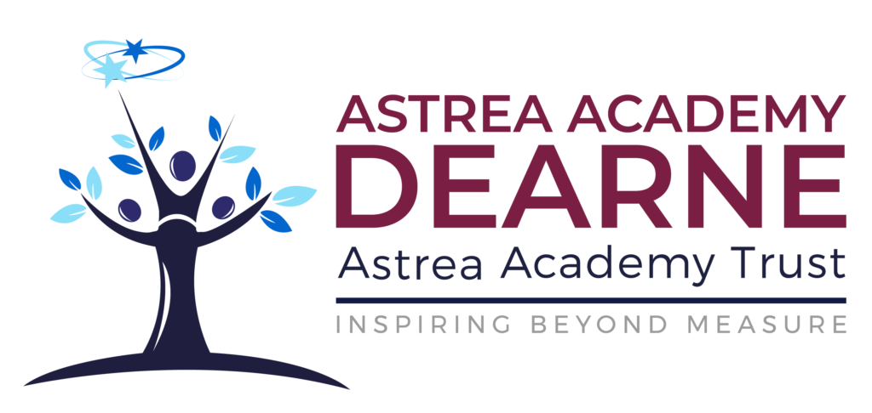

**Booklets Framework**

**Science Faculty**

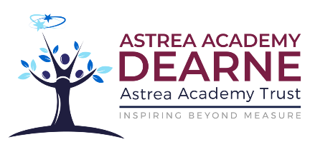

**Booklets Framework**

**Science Faculty**

**Contents**

**Page 3** **Introduction**

**Page 4** **The nature of the Science curriculum**

**Page 7** **Summary and implications: The nature of the Science curriculum**

**Page 8** **The structure of booklets in Science**

**Page 10** **Do Now: The what, the why and the how**

**Page 12** **I wasn’t there but I still care: The what, the why and the how**

**Page 13** **Connect: The what, the why and the how**

**Page 14** **Non-declarative Content**

**Page 17** **Non-declarative Content: Equations**

**Page 19** **Non-declarative Content: Example**

**Page 31** **Declarative Content**

**Introduction**

A How To Guide accompanies this framework. The How To Guide should be the starting point for most staff; this framework provides additional detail and clarification where required.

This framework should be read alongside the Teaching and Learning Framework and Secondary Booklet Framework. By looking at the aforementioned frameworks through the gaze of science practitioners, this framework maximises opportunities for students to make meaning in Science. This framework specifies:

1. What will be included in booklets.
2. Why it will be included.
3. How the content is delivered in the classroom.

The content of this framework draws on current thinking related to subject curricula, particularly the Science subject curriculum. Integration with the evidence-informed professional knowledge contributing to The Astrea Way: Principles of Teaching and The Astrea Way: Booklets gives a powerful model to support students in making meaning, and performing strongly, in science.

**The intended audience of the Framework is:**

* All Science teachers who deliver lessons using booklets.
* All Science teachers who write content for booklets.
* The line manager of the Science faculty.
* The Principal.

**The nature of the Science curriculum**

Every subject introduces students to a discipline which has its own unique way of seeking knowledge and making new meaning. How we approach the teaching of our subject reflects this. We would not, and should not, expect generic strategies to be applied uniformly across all subjects; the way that we teach, and use booklets to support this, should reflect the unique nature of science as a discipline and a subject.

The content of a subtopic or sequence in a booklet, and the way in which it is best taught, reflects both the nature of knowledge being taught and the relations between knowledge in the science discipline and subject.

**Categories of knowledge**

‘Knowledge comes in different types, like different materials. These types have their own properties and can be handled more effectively when we understand those properties and can give names to them. Subjects as wholes can be better understood when the nature of knowledge within them is brought to light.’ (Ruth Ashbee, 2021).

Substantive knowledge

Substantive knowledge is what is taught as established fact or content from within a particular domain (Adam Boxer - https://achemicalorthodoxy.files.wordpress.com/2019/06/thinking-curriculum-the-one-stop-shop-v2.pdf).In Science, the substantive body of knowledge is both broad and deep.

Disciplinary knowledge

Disciplinary knowledge represents the rules that justify what counts as established (Adam Boxer).

In Science, we tend to think of this as the methods used to establish the ‘facts’ (i.e. working scientifically).

**When considering how to teach specific knowledge, categorising it as declarative knowledge or non-declarative is informative; these categories determine the strategies that are most effective.**

Declarative knowledge

Ruth Ashbee defines this as articulatable knowledge. For example, facts, concepts and ideas.

The Science subject curriculum contains a large body of declarative knowledge that students need to understand as individual ideas and in how they relate to each other. Specific examples include properties of molecules with ionic bonds, why scientific ideas change, and the particle model and its applications.

Non-declarative knowledge

Non-declarative knowledge (e.g., procedural knowledge) involves following a procedure or process. For example, completing a calculation, analysing texts, writing a risk assessment and solving problems.

Motor knowledge is a type of non-declarative knowledge related to how to complete practical tasks. For example, measuring using a measuring cylinder.

**The Science subject curriculum contacts significant amounts of declarative and non-declarative knowledge; the type of knowledge being addressed determines the content of booklets and how teaching should proceed. The extent of each type of knowledge is both broad and deep necessitating efficient evidence - informed teaching methods and support materials embedded into booklets.**

**Relations of knowledge**

All subjects are divided into sections and sub-sections. For example, science is typically divided up into Biology, Chemistry and Physics. Each of these sections is divided further into sub-sections. The interactions between the different areas of the subject curriculum are being meticulously mapped because the relationships enhance meaning making.

The relations of knowledge can be thought of in four categories. Each category has implications for the teaching of our subject.

Ontology

The ontology of a curriculum reflects the strength and frequency of links between different areas of knowledge in a curriculum. The discipline of science has a tall ontology; scientific concepts are connected to many other ideas.

A tall ontology brings benefits and risks. If the links between concepts are well made the student develops a rich schema for each subject it is easier for them to recall information from their long-term memory. It also means that they develop a strong foundation upon which to develop new knowledge.

However, if spurious links are made (e.g. misconceptions) the student will have a poor foundation that amplifies misconceptions once built upon. The absence of links can be overwhelming for students, and they may see science as a large collection of facts to be memorised rather than understood.

The tall ontology of science also means that student absence has a disproportionate effect on their progress; if students were absent when foundation knowledge or didn’t learn content that new content links too, it is harder for them to make meaning.

For this reason, we must expend significant effort in identifying the most productive links to make and then ensuring that these are taught accurately and carefully. The links to be taught are identified in booklets. Where students are absent, we need to give them opportunity to catch up on missed learning.

Integration

Integration reflects the consistency within a curriculum. For example, the strength of the rules for applying concepts and procedures.

Science has strong integration of knowledge. For example, students are expected to use universal and precise definitions, standard units, apply concepts in a consistent manner follow procedures with high fidelity. For example, we apply ideas about natural selection to novel situations using the same thought processes every time. Also, we evaluate data through determining repeatability, reproducibility, accuracy and precision. The quality of data reflects the consistency with which a scientific procedure is followed. Also, where ideas about energy are used in multiple topics we always use the common language of energy stores and pathways.

For this reason, we need to communicate and demonstrate with care so that misconceptions do not arise and students learn how to act and communicate with high fidelity. We need to check understanding so that misconceptions are identified early and addressed quickly.

It is essential that teachers pre-plan explanations, questions, answers to written questions and means of participation. The booklets support this by reducing the workload associated with producing resources for topics and sub-topics.

Epistemology

Epistemology reflects the methods used to discover new meaning within a subject.

Science has unifying epistemology where new meaning is made and either fits into pre-existing knowledge or replaces earlier ideas. Scientists do this through five types of enquiry (secondary sources; comparative / fair testing / observing over time; pattern seeking; classifying). The scientific community has an important role in confirming new meaning through empirical studies.

In the Science subject curriculum, students learn about how and why ideas change over time. They also learn about the role of the scientific community.

Through ‘working scientifically’, students use similar techniques as scientists use. However, it is important to recognise that students usually confirm existing knowledge whereas scientists create new knowledge; students are not working like scientists they are learning about how scientists work and the results of their endeavours.

‘Working scientifically’ includes declarative, procedural, and motor knowledge. These are being mapped across the curriculum. Teachers are expected to identify the type of knowledge being addressed in a subtopic and to structure booklet activities and teaching appropriately.

Manthology

The manthology of a subject determines the sequence which concepts are taught in. It also determines the depth of knowledge that is addressed at different points in time. For example, challenging concepts ideas be taught later in the curriculum even if they are required for a deep understanding of a concept.

The Science subject curriculum has a helical structure; topics are revisited several times and a deeper meaning is developed each time a topic is revisited. The tall ontology is reflected in explicit links that are identified throughout the curriculum.

**Summary and implications: The nature of the Science curriculum**

* Science is a complex subject that incorporates declarative and non-declarative knowledge. Each type of knowledge is taught differently using methods that are most effective for that knowledge type.
* Booklets support meaning making through containing content that is informed by evidence and reflects the most effective approach to making meaning for each knowledge type.
* Each knowledge type is explicitly taught within booklets at pre-planned points in the curriculum.
* Links between topics should be explicitly taught.
* Where students are absent, they need to be given the opportunity to catch up on missed work.
* Science has strong integration and so requires precise communication, demonstration and checking of understanding.
* Booklets support this through freeing up planning time so teachers can pre-plan:
* Explanations
* Questions
* Desired responses to questions
* Means of participation.
* Booklets are built that account for the nature of the Science subject curriculum. This includes revisiting concepts to add new meaning, ensuring threshold topics are taught prior to teaching, identifying strong links between topics, and activities and sequences of activities that reflect the type of knowledge being taught.

**The structure of booklets in Science.**

The diligent planning of booklets has immense value. When well written, booklets:

* Ensure high challenge for all with appropriate scaffolding and communicate high expectations.
* Define the content of the curriculum.
* Define the most efficient and effective way to learn the content of the curriculum.
* Enable staff to focus on aspects of lesson planning that have the greatest impact on learning (e.g., explanations, questions, means of participation).

The writing of booklets is also a valuable source of professional development.

**From The Astrea Way: Booklets:**

**Ruth Ashbee, in ‘Curriculum: Theory, Culture and the Subject’, states that *‘the content of the curriculum and the work that pupils do needs to be well codified and can only be achieved by careful, rigorous curriculum planning, achieved through "engagement with the subject & its discourse and detail about the content and the ways children learn."* (Ashbee p116). She goes on to say that *"it is the planned discussion and the professional development around these documents, and what is done with them once they have been produced, that results in deep and sustained growth in the department."***

Such is the value of thoughtfully written booklets, and the negative impact of weaker booklets, the expectation must be that all staff will apply themselves diligently and produce booklets of the highest standards. Where they require support, it is expected that they will seek out that support in good time to meet deadlines. Knowing when to seek support and guidance is a trait valued by this faculty. Being prepared to support colleagues is equally important.

**Teacher booklets.**

We produce student booklets and teacher booklets. Teacher booklets contain content in addition to that found in the student booklet that supports planning for exceptional learning experiences:

* Content from the exam specification.
* Content classified as declarative or non-declarative knowledge to guide planning.
* Suggested chunking of subtopic content.
* Model explanations for content.
* Answers for all activities.
* Lined pages where teachers can plan explanations, questions, means of participation etc. It is expected that all staff explicitly plan these components of lessons.

**Booklets non-negotiables.**

All subjects write booklets in line with the same set of non-negotiables. Those related to formatting of content in science booklets are:

* All booklets will be printed in black and white; colour images etc will appear in black and white.
* Tasks and information should use Calibri size 12; this includes exam questions if you have used them.
* Headings and bold should be in Calibri size 14.
* Sub-headings should be in Calibri size 12 and in bold.
* Line spacing should be 1.5 lines.
* Lines should be dotted rather than solid lines. This includes for exam questions if you use them.
* All tasks and information should be in typed text rather than a image of a worksheet question etc.
* Terms used for fading are “I do”, “We do” and “You do” only. Alternatives should not be used.
* Where images are used, they should be sharp images; pixelated and unclear images are not acceptable. If they are not sharp, redo them.
* Bodies of text should not be included as images.
* Definitions need to be precise; they should be obtained from the exam specification. Where this is not possible, the Collins textbook should be used.

**Lesson structure**

At Astrea Academy Dearne we have considerable flexibility in how we structure lessons. However, lessons have common components with associated TLAC techniques (those listed are from TLAC 3.0):

* Do Now – TLAC 20: Do Now; 47: Threshold and Strong Start; 7: Retrieval Practice.
* Connect – TLAC Mental models.
* I do – TLAC 22: Board is Paper.
* We do – TLAC 10: Show Me; 33: Wait Time; 34: Cold Call; 15: No Opt Out.
* You do – TLAC 30: Work the Clock; 24: Circulate; 39: Show Call.
* Learning review – TLAC 26: Exit Ticket.

This sequence is not meant to be linear; components should be used in a sequence that best suits the content being taught (including repetition of some sections). However, there should be a Do Now at the start of every lesson as it forms part of the Entry Routine. Connects should also be at the start of the lesson. However, depending on the lesson you are teaching, you might combine it with the Do Now activity.

The following sections of this framework provide guidance on:

* What each section involves and will be included.
* Why it is included.
* How this content should be used within lessons.

These sections will reflect the nature of the science curriculum and the types of knowledge being addressed.

**Do Now: The what, the why and the how.**

**What?**

Upon entering the classroom, students collect their booklets and work independently to complete retrieval questions covering high priority content from prior learning.

Students receive immediate feedback after they have completed the Do Now.

**Why?**

* The Do Now, along with the TLAC techniques of Strong Start and Threshold (see, Lemov, 2021), are part of the Entry Routine embedded across the academy. This routine sets expectations from the minute when students enter the room. This ensures an efficient and orderly start to the lesson and ensures that the teacher can take the register within the first ten minutes of the lesson; this is a safeguarding duty.
* Use of this routine by all staff helps embed a culture of excellence and scholarship within your classroom and throughout the school. Where this is not done diligently, so students respond appropriately through habit, the teacher undermines their own efforts and those of colleagues.
* The emergence of cognitive science has provided considerable insight into how learning happens. The act of recalling information from memory, formerly referred to as the ‘testing effect’ (Roediger and Karpicke, 2006), has a positive effect on long-term retention. The effect on test outcomes exceeds that of cramming (Cepeda et al, 2008). Retrieval practice can, and should, be used throughout lessons and over different periods of time. The Do Now activity is one type of retrieval activity.
* The body of evidence obtained in **applied settings** (e.g. in schools and colleges) related to retrieval practice has uncovered the following:

1. Teacher feedback following retrieval practice improves students’ incorrect answers and their low confidence responses (Agarwal et al, 2009)
2. Retrieval practice without immediate feedback has little impact (Agarwal et al, 2009). Note that this is not found in laboratory settings (see Butler et al, 2008).
3. Students with lower working memory capacity benefit the most from retrieval practice with feedback (those that struggle the most, benefit the most). However, all students benefit (Agarwal et al, 2017).
4. Students need to retrieve the types of content tested; if the final assessment contains fact and higher order questions, retrieval practice needs to include fact questions and higher order questions (Agarwal et al, 2019).

The impact of the Do Now activities, and other forms of retrieval practice, need to take these findings into account.

**How?**

* Do Now questions should be planned in advance by the class teacher using outcomes from formal assessments, observations during lessons and outcomes of formative assessments. For example, they might be used to reinforce learning from the reteach periods that follow summative assessments. Space is provided in the teacher booklets for this purpose.
* Given the high breadth and depth of knowledge in the Science subject curriculum, and its tall ontology, it is not possible to use the Do Now for retrieval of all of the content. High priority content, content that has a wide impact if it is not understood, should targeted in the Do Now.
* Correct answers should be planned in advance of the lesson. Space is provided in the teacher booklets for this purpose.
* Common misconceptions and mistakes should also be anticipated and teacher responses identified. Space is provided in the teacher booklets for this purpose.
* Over time, fact questions and those addressing higher order content (e.g. calculations, applications, evaluations) should be used.
* A timer should be displayed to show the time remaining for the task. The timer should be started from the first minute of the lesson.
* Booklets should be laid out on a desk, along with any other required equipment (e.g. calculators), before students arrive to the lesson.
* Teachers should follow the Entry Routine and support colleagues in ensuring students go straight to lessons.
* Students complete the Do Now task in the allocated space at the back of the booklet, in silence.
* Teachers should give **immediate** feedback related to the Do Now task.
* Feedback should provide students with the correct answer with a brief explanation as to why it is correct. In some cases it may be beneficial to explain why some answers are wrong.
* Content should be retaught where students have struggled.
* Teachers should record any questions where students have struggled; these should be revisited in future lessons once the content has been retaught.

**Useful Reading: Teaching Secondary Science – A Complete Guide by Adam Boxer. Chapter 8 Going over your retrieval quiz: The basics. Pages 83 – 90.**

**References**

* Agarwal, P. K., Karpicke, J. D., Kang, S. K., Roediger, H. L., & McDermott, K. B. (2008). Examining the testing effect with open- and closed-book tests. Applied Cognitive Psychology, 22, 861-876
* Agarwal, P.K., Roediger, H.L., McDaniel, M.A., McDermott, K.B. (2009, November). Feedback increases middle school students’ resolution and retention of correct responses. Poster presented at the 50th Annual Meeting of the Psychonomic Society, Boston, MA
* Agarwal, P. K., Finley, J. R., Rose, N. S., & Roediger, H. L. (2017). Benefits from retrieval practice are greater for students with lower working memory capacity. Memory, 25, 764-771
* Agarwal, P. K. (2019). Retrieval practice and Bloom’s taxonomy: Do students need fact knowledge before higher order learning? Journal of Educational Psychology, 111, 189-209
* Butler, A. C., Karpicke, J. D., & Roediger, H. L. (2008). Correcting a metacognitive error: Feedback increases retention of low-confidence correct responses. Journal of Experimental Psychology: Learning, Memory, and Cognition, 34, 918–928.
* Cepeda, N. J., Vul, E., Rohrer, D., Wixted, J. T., & Pashler, H. (2008). Spacing Effects in Learning: A Temporal Ridgeline of Optimal Retention. Psychological Science, 19(11), 1095–1102. <https://doi.org/10.1111/j.1467-9280.2008.02209.x>
* Lemov, Doug. (2021). Teach Like a Champion 3.0. Hoboken, NJ: Jossey-Bass.
* Roediger, H. L. III, & Karpicke, J. D. (2006). Test-enhanced learning: Taking memory tests improves long-term retention. Psychological Science, 17(3), 249–255. <https://doi.org/10.1111/j.1467-9280.2006.01693.x>

**I wasn’t there but I still care: The what, the why and the how**

**What?**

Instead of completing the Do Now, students who have missed a previous lesson complete a separate task that familiarises them with the most important points from the previous lesson.

Where a subtopic spans several lessons, and the student missed the first lesson, the student reads a relevant piece of text and summarises the main points.

**Why?**

Poor school attendance is a substantial problem in the UK that has increased in magnitude: In 2020 the overall absence rate was 4.9% and the percentage of persistent absentees was 13.1% (Gov.uk, 2020); in 2023, the headline figures were 10.7% for overall absence and 22.3% for persistent absence (Gov.uk, 2023).

Poor attendance is linked to poor academic attainment (Balfanz & Byrnes, 2012; London et al., 2016) and antisocial and negative behaviour (Gottfried, 2014; Baker, Sigmon, & Nugent, 2001). However, meaningful impacts can be obtained from only small increases in attendance (EEF, 2021).

Even low levels of absence are associated with decreases in attainment; when all other factors are controlled, for each session missed (half a day) across KS4 there is 1.8% decrease in likelihood of achieving five grade 5 grades and a 2.1% decrease in likelihood of achieving the English Baccalaureate (Department for Education, 2016). In 2019, of the pupils who missed no sessions over KS4, 83.7% achieved grade 4 or higher in English and Maths compared to 35.6% of pupils who were persistently absent (Gov.uk, 2022).

The high impact of even low levels of absence on attainment necessitate that we attempt to minimise the impact of that absence. This takes on even greater importance when we account for the tall ontology of the Science subject curriculum; we can reasonably expect absenteeism to have a higher impact on attainment in our subject relative to attainment in subjects with a flatter ontology.

**How?**

The ‘I wasn’t there but I still care’ activity is pre-planned in the booklet. It can be found towards the beginning of the activities for each sub-topic.

When writing the activity for their allocated lessons, teachers will need to think carefully about what the most important points of the missed learning were. The activity needs to directly address the points that, when addressed, will enable the student to make the most progress in the upcoming lesson and subtopic.

Students who miss the first lesson of a multi-lesson subtopic will be allocated reading from an appropriate text. The teacher will need to have identified a relevant text for the student to work with. The student should identify the main points and make a note of these on the notes page at the back of their booklet (ensuring that the work is dated).

If time permits, the teacher should assess the extent of the students understanding whilst other students complete the Do Now. Remediation should take place where required.

**References**

* Baker, M. L., Sigmon, J. N., & Nugent, M. E. (2001, September). Truancy reduction: Keeping students in school. Juvenile Justice Bulletin. Retrieved from <https://www.ncjrs.gov/pdffiles1/ojjdp/188947.pdf>
* Balfanz, R., & Byrnes, V. (2012). The importance of being in school: A report on absenteeism in the nation’s public schools. Education Digest, 78(2), 4–9
* Department for Education (2016). The link between absence and attainment at KS2 and KS4. Accessed at: <https://assets.publishing.service.gov.uk/government/uploads/system/uploads/attachment_data/file/509679/The-link-between-absence-and-attainment-at-KS2-and-KS4-2013-to-2014-academic-year.pdf>
* EEF (2021) Rapid evidence assessment on attendance interventions for school aged pupils Protocol for a rapid evidence assessment Principal investigators: Jonathan Kay, Rupal Patel, Hannah Blausten, Harry Madgwick
* Gottfried, M. A. (2014). Chronic absenteeism and its effects on students’ academic and socioemotional outcomes. Journal of Education for Students Placed at Risk, 19, 53–75.
* Gov.uk (2020) Pupil absence in schools in England: autumn term (online). Accessed at: <https://explore-education-statistics.service.gov.uk/find-statistics/pupil-absence-in-schools-inengland-autumn-term/2019-20-autumn-term>
* Gov.uk (2022) The link between absence and attainment at KS2 and KS4 (online). Accessed at: <https://explore-education-statistics.service.gov.uk/find-statistics/the-link-between-absence-and-attainment-at-ks2-and-ks4>
* Gov.uk (2023) Pupil attendance in schools (online). Accessed at: <https://explore-education-statistics.service.gov.uk/find-statistics/pupil-attendance-in-schools>
* London, R. A., Sanchez, M., & Castrechini, S. (2016). The dynamics of chronic absence and student achievement. Education Policy Analysis Archives, 24, 112. doi:10.1080/10824669.2014.962696

**Connect**

The Connect is used to place the new content within the bigger picture for the students. This may include:

* A review of prior learning (careful consideration should be given to means of participation)
* Teacher exposition resulting in students understanding of where new learning will fit within the bigger picture
* The Connect occurs in every lesson rather than just once every sub-topic. Teachers will need to plan their own Connect session to fit their context.

**Non-declarative content**

Non-declarative knowledge (procedural knowledge) requires students to follow a process. However, it would be unreasonable to just give the procedure to students and assume that they have learnt it because they can perform related tasks in the lesson.

Examples of procedural knowledge in science:

1. Completing a risk assessment (simple procedure)
2. Applying the steps in natural selection to a novel situation (simple procedure)
3. Calculating, speed, distance or time using the equation for speed (complex procedure)

There is considerably range in the challenge of these examples. Fortunately, cognitive science gives some clear indications as to how we should proceed when teaching them.

**What?**

The teacher building the content for the teacher booklet must include the following:

* **Text** should be included that introduces the concept and its place within the bigger picture. This should include examples and, if relevant, non-examples. The range of examples should be representative of the concept.

For example, if we want students to apply the steps in natural selection to novel situations, it might include the importance of variation to survival of individuals and populations, how natural selection enables species to survive and evolution.

**Examples:** Peppered moths responding to environmental changes; banded snails; pesticide resistance in insects; Galapagos finches in relation to food sources; nylon-eating bacteria; lactose intolerance in humans declining following domestication of cattle.

A broad range of examples should be used so we don’t introduce misconceptions related to the extent of situations where natural selection occurs.

* The **steps** involved in the procedure should be explicitly included in the text. This will facilitate discussion of examples and fading (Ido, we do, you do).
* A **worked example** showing how to apply the procedure in a task.
* **One question labelled ‘I Do’;** this is for the teacher to live model how to answer a question. A model answer must be included.
* **One question labelled ‘We Do’;** this is for the teacher to complete with the students. A model answer must be included.
* **A large number of questions labelled ‘You Do’;** students complete these independently but with support if required.

**The questions should all be of very similar difficulty and format. This reduces cognitive load whilst students so they can concentrate on applying the procedure. Format and difficulty should be incrementally increased as the list of questions is descended.**

The teacher delivering the lesson will need to:

* Plan explanations (including explaining examples) and questions.
* Plan strategies to encourage students to engage with the text during or after reading.
* Plan means of participation (e.g. use of mini-whiteboards, cold-call etc).
* Rehearse model answers for each question.

**Why?**

* As classroom teachers we often work with students at the novice end of the novice-expert continuum in relation to the content they are studying. This needs to be taken into consideration when planning booklets and activities.
* Teaching through examples (and non-examples) has been shown to be highly impactful on attainment and understanding (see, Engelmann and Carnine, 1982 for underlying theory).
* The use of worked examples and guidance-fading is fully aligned with our understanding of how learning happens using the lens of cognitive science (Sweller et al, 2019).
* The use of worked examples reduces cognitive load because some elements of the task can be outsourced from working memory (Schwonke et al, 2009). This makes the use of worked examples a good starting point for novices especially if they are followed by problems. The use of teacher led faded scaffolding following study of the worked example enables impactful use of teacher expertise.
* Novices benefit from the use of worked examples and scaffolding that is faded as expertise increases (C.J Rauch, 2022). So, we include worked examples and scaffolding (I do, we do, you do) to expediate acquisition of expertise.
* Novices benefit from scaffolding, including worked examples. However, as expertise increases, the benefits decrease. This is the expertise reversal effect (Kalyuga and Renkl, 2010). It follows that it is important to provide scaffolding in booklets. However, its impact will be greatest for novices; students would benefit from moving onto problem solving activities once they have developed expertise (Sweller et al, 2019).
* Similar questions are initially used because changing the difficulty and format increases cognitive load. Once students have developed expertise, changing the format and difficulty can increase learning (Sweller et al, 2019).

**How?**

* During the Connect phase of the lesson, the teacher needs to place the new learning in the context of the bigger picture. A text is provided to support with this. The reading should be teacher led with students following along using a ruler under the words.
* Students should actively engage with the text through summarising paragraphs, identifying unknown tier 2 and 3 vocabulary, and through answering questions (means of participation needs to be carefully considered).
* Examples (and non-examples) should be explained and similarities and differences identified. Asking students to identify something as an example / non-example is a strong method for checking understanding.
* The worked example should be used to exemplify the process that students will follow. There are mots of ways to do this that are impactful. However, at this point in our journey, the teacher can talk students through the process.
* I DO – The teacher uses the steps identified in the worked example to complete the question ‘live’. This answer needs to be pre-planned to minimise the teachers cognitive load.
* WE DO – Students and teacher complete the question together. All students should be engaged through use of the mini-whiteboards. For example, if applying the steps in a natural selection questions, students might be asked : Which type of organism is the question about?; Describe the variation shown within the species; how does this variation help the organism to survive? Which step do we talk about next?

This answer needs to be pre-planned to minimise the teachers cognitive load.

* YOU DO – Students complete similar questions independently.
* Students may then progress onto questions where the format and difficulty has changed.
* Note that students will acquire expertise at different rates. Those that progress more quickly would be expected to move onto the more challenging questions earlier.

**Useful Reading: Teaching Secondary Science – A Complete Guide by Adam Boxer.**

**Chapter 10 Explaining Science. Pages 99 – 106.**

**Chapter 11 Sequencing Examples. Pages 107 – 112.**

**Chapter 27 Practising Procedural Knowledge. Pages 239 – 250.**

**References**

* Booth, J. L., McGinn, K. M., Young, L. K., & Barbieri, C. (2015). Simple Practice Doesn’t Always Make Perfect Evidence From the Worked Example Effect. Policy Insights from the Behavioral and Brain Sciences, 2(1), 24-32
* Engelmann, S., & Carnine, D. (1982). Theory of Instruction: Principles and Applications. New York: Irvington Publishing, Inc.
* Kalyuga, S., Renkl, A. Expertise reversal effect and its instructional implications: introduction to the special issue. Instr Sci 38, 209–215 (2010). <https://doi.org/10.1007/s11251-009-9102-0>
* Rauch, C. J. Novices and Experts. Evidence Based Education (blog). 23rd March, 2022.
* Schwonke, R., Renkl, A., Krieg, C., Wittwer, J., Aleven, V., & Salden, R. (2009). The worked-example effect: Not an artefact of lousy control conditions. Computers in Human Behavior, 25(2), 258–266. <https://doi.org/10.1016/j.chb.2008.12.011>
* Sweller, J., van Merriënboer, J.J.G. & Paas, F. Cognitive Architecture and Instructional Design: 20 Years Later. Educ Psychol Rev 31, 261–292 (2019). <https://doi.org/10.1007/s10648-019-09465-5>

**Non-declarative content: Equations**

Use of equations introduces another level of challenge because the calculation might require that the equation be rearranged; there will be more than one form of the equation that students need to use.

Some of the same strategies are used as in the previous section. However, cognitive load is managed by blocking practice questions (each block requiring only one form of the equation) before interleaving the questions; interleaved examples have greater challenge as students need to decide which strategy to use.

**What?**

Teachers writing the content need to include the following in addition to that from the previous section:

* A block of calculations for each type of calculation performed. For example, if students are using speed = distance / time, they can be asked to calculate speed, distance or time. There should be one block of calculations for speed, one for distance and one for time. In more complex calculations (e.g. rate of change of momentum), exam questions might only refer to calculating certain components of the equation. The number of blocks can be limited by the number of components questions refer to).
* Calculations where the component being calculated changes randomly within the list of questions; the demand is increased because the questions are interleaved.
* Interleaved questions from a broader range of contexts. For example, the calculations taught might be interleaved with related calculations from the specification. Alternatively, the calculations might be interleaved with related declarative content (e.g. calculations related to momentum might be interleaved with conceptual questions related to momentum).

**Why?**

* Our students are generally novices and so we need to manage their development and cognitive load carefully. By putting calculations for students first exposure to a specific calculation in a block, cognitive load is reduced. Blocks also enable us to carefully manage load and aspects of questions that may change.
* Interleaving increases challenge, and so follows blocked activities. It brings other benefits including: higher scores in intermediate and delayed tests compared to just blocked practice (Rohrer et al, 2015); it can have quite a dramatic effect on learning and retention (Dunlosky et al, 2013); interleaving of retrieval tasks has a positive long term effect relative to blocked retrieval (Sana and Yan, 2021); enhancing memory and problem solving ability (Samani and Pan, 2021).
* Interleaving is of greatest use when the differences between items is subtle and requires that the student discriminates between items (Firth et al, 2021). It would be less effective where interleaved items are unrelated. For this reason, we initially interleave between closely related items. We then interleave with items from prior learning so as to benefit from interleaved retrieval.
* There is an expertise reversal effect; students benefit less as they acquire expertise. They might even be detrimental (Kalyuga et al, 2013). The teacher therefore needs to be well informed about their students’ level of expertise and plan for their use rather than just using every activity with every student.

**How?**

* The process is similar to the previous description of addressing procedural knowledge. For the first block, the teacher completes the I DO. The teacher then engages students when completing the WE DO (having pre-planned means of participation, questions to ask, who to ask etc). Students then complete independent practice.
* The process is repeated for remaining blocks.
* Students complete interleaved questions.
* Similar processes are used with many calculations throughout the course. If a group of students has developed high expertise then they should be accelerated through the activities in order to reduce or remove the expertise reversal effect.

**Useful Reading: Teaching Secondary Science – A Complete Guide by Adam Boxer.**

**Chapter 10 Explaining Science. Pages 99 – 106.**

**Chapter 11 Sequencing Examples. Pages 107 – 112.**

**Chapter 27 Practising Procedural Knowledge. Pages 239 – 250.**

**References**

* Dunlosky, J., Rawson, K. A., Marsh, E. J., Nathan, M. J., & Willingham, D. T. (2013). Improving students’ learning with effective learning techniques: Promising directions from cognitive and educational psychology. Psychological Science in the Public Interest, 14, 4 –58. doi: 10.1177/1529100612453266
* Firth, J., Rivers, I., & Boyle, J. (2021). A systematic review of interleaving as a concept learning strategy. Review of Education, 9(2), 642–684.
* Kalyuga S, Law YK and Lee CH (2013) Expertise reversal effect in reading Chinese texts with added causal words. Instructional Science 41(3): 481–497.
* Rohrer, D., Dedrick, R. F., & Stershic, S. (2015). Interleaved practice improves mathematics learning. Journal of Educational Psychology, 107(3), 900–908. <https://doi.org/10.1037/edu0000001>
* Samani, J., Pan, S.C. Interleaved practice enhances memory and problem-solving ability in undergraduate physics. npj Sci. Learn. 6, 32 (2021). <https://doi.org/10.1038/s41539-021-00110-x>
* Sana, F., & Yan, V. X. (2021, November 9). Interleaving Retrieval Practice Promotes Science Learning. <https://doi.org/10.1177/09567976211057507>
* Sweller J, van Merriënboer JJG and Paas F (1998) Cognitive architecture and instructional design. Educational Psychology Review 10: 251–296.

**Non-declarative content: Example – Changes in momentum (blocking and interleaving)**

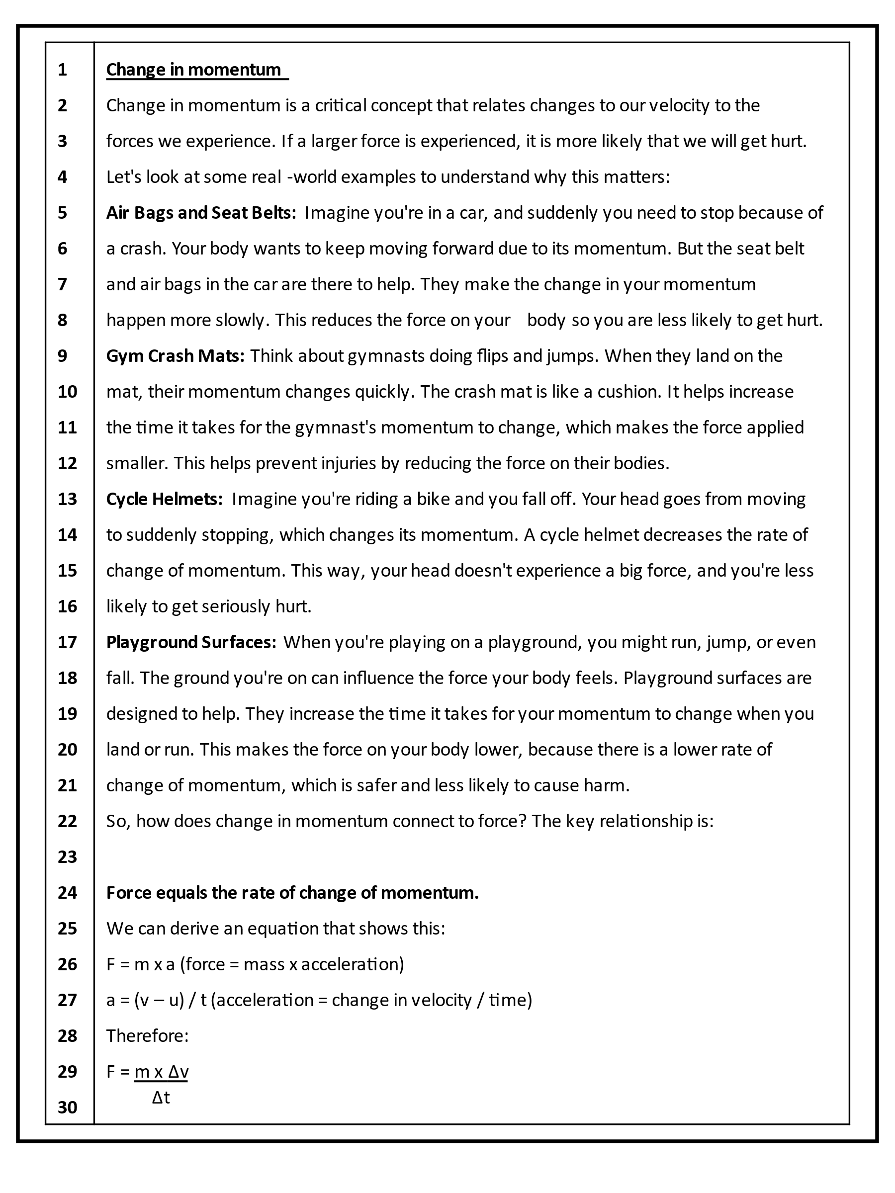

The knowledge content of this lesson is complex. Due to this, the text has been kept relatively simple.

The text explains the importance of changes in momentum and how they relate to forces.

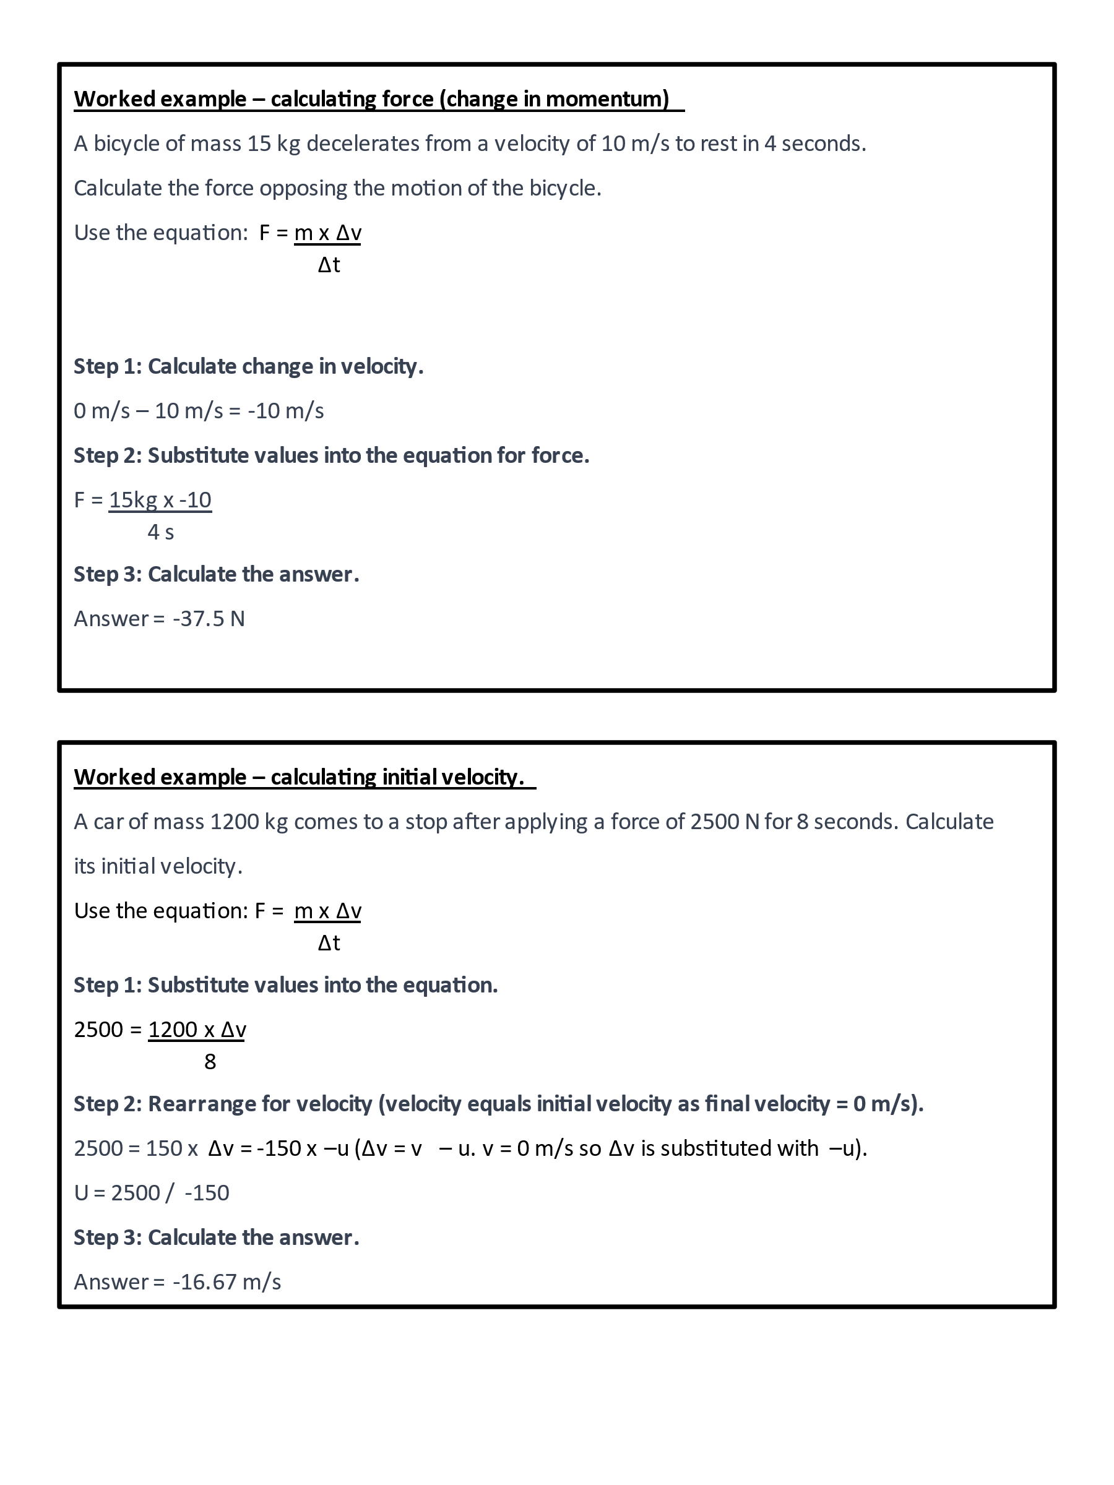

Worked examples are included. The first example only requires values to be substituted into the equation.

The second requires the subject to be changed.

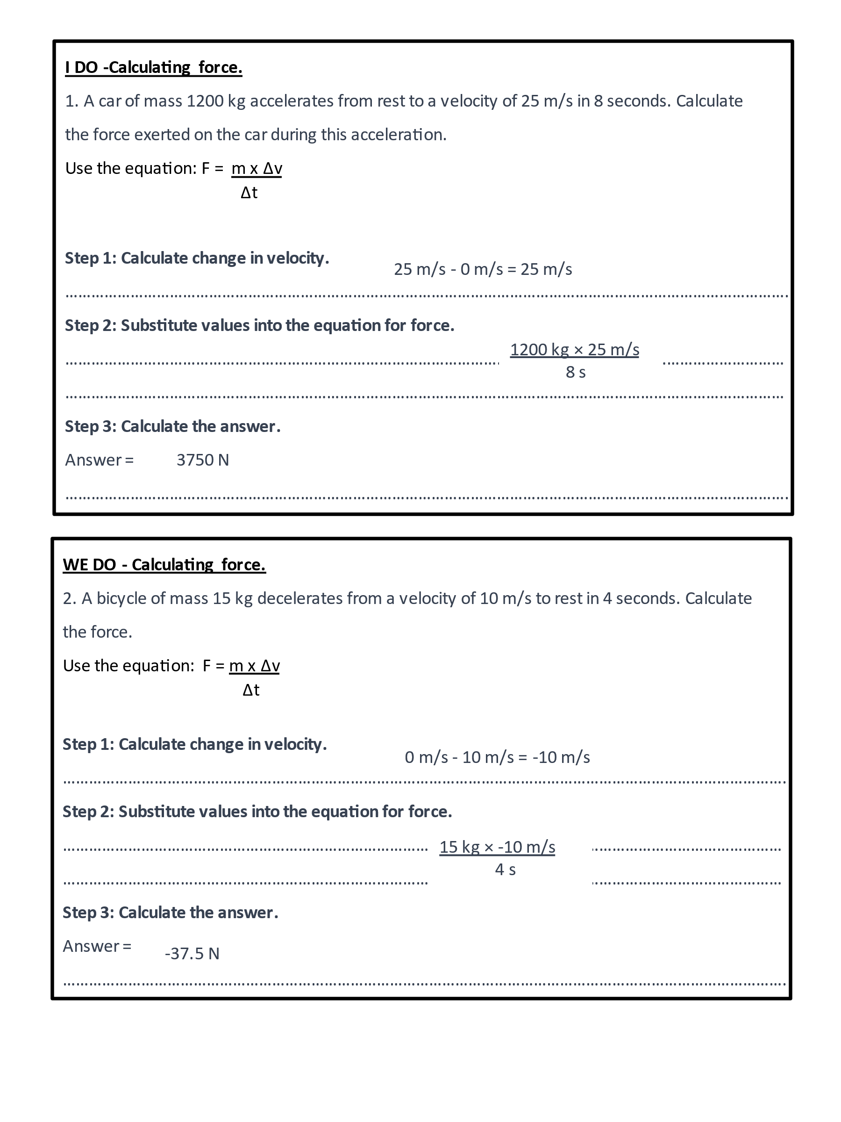

**Block 1:**

Scaffolded examples for calculation of force.

The teacher completes the I DO.

The teacher involves students in completing the WE DO.

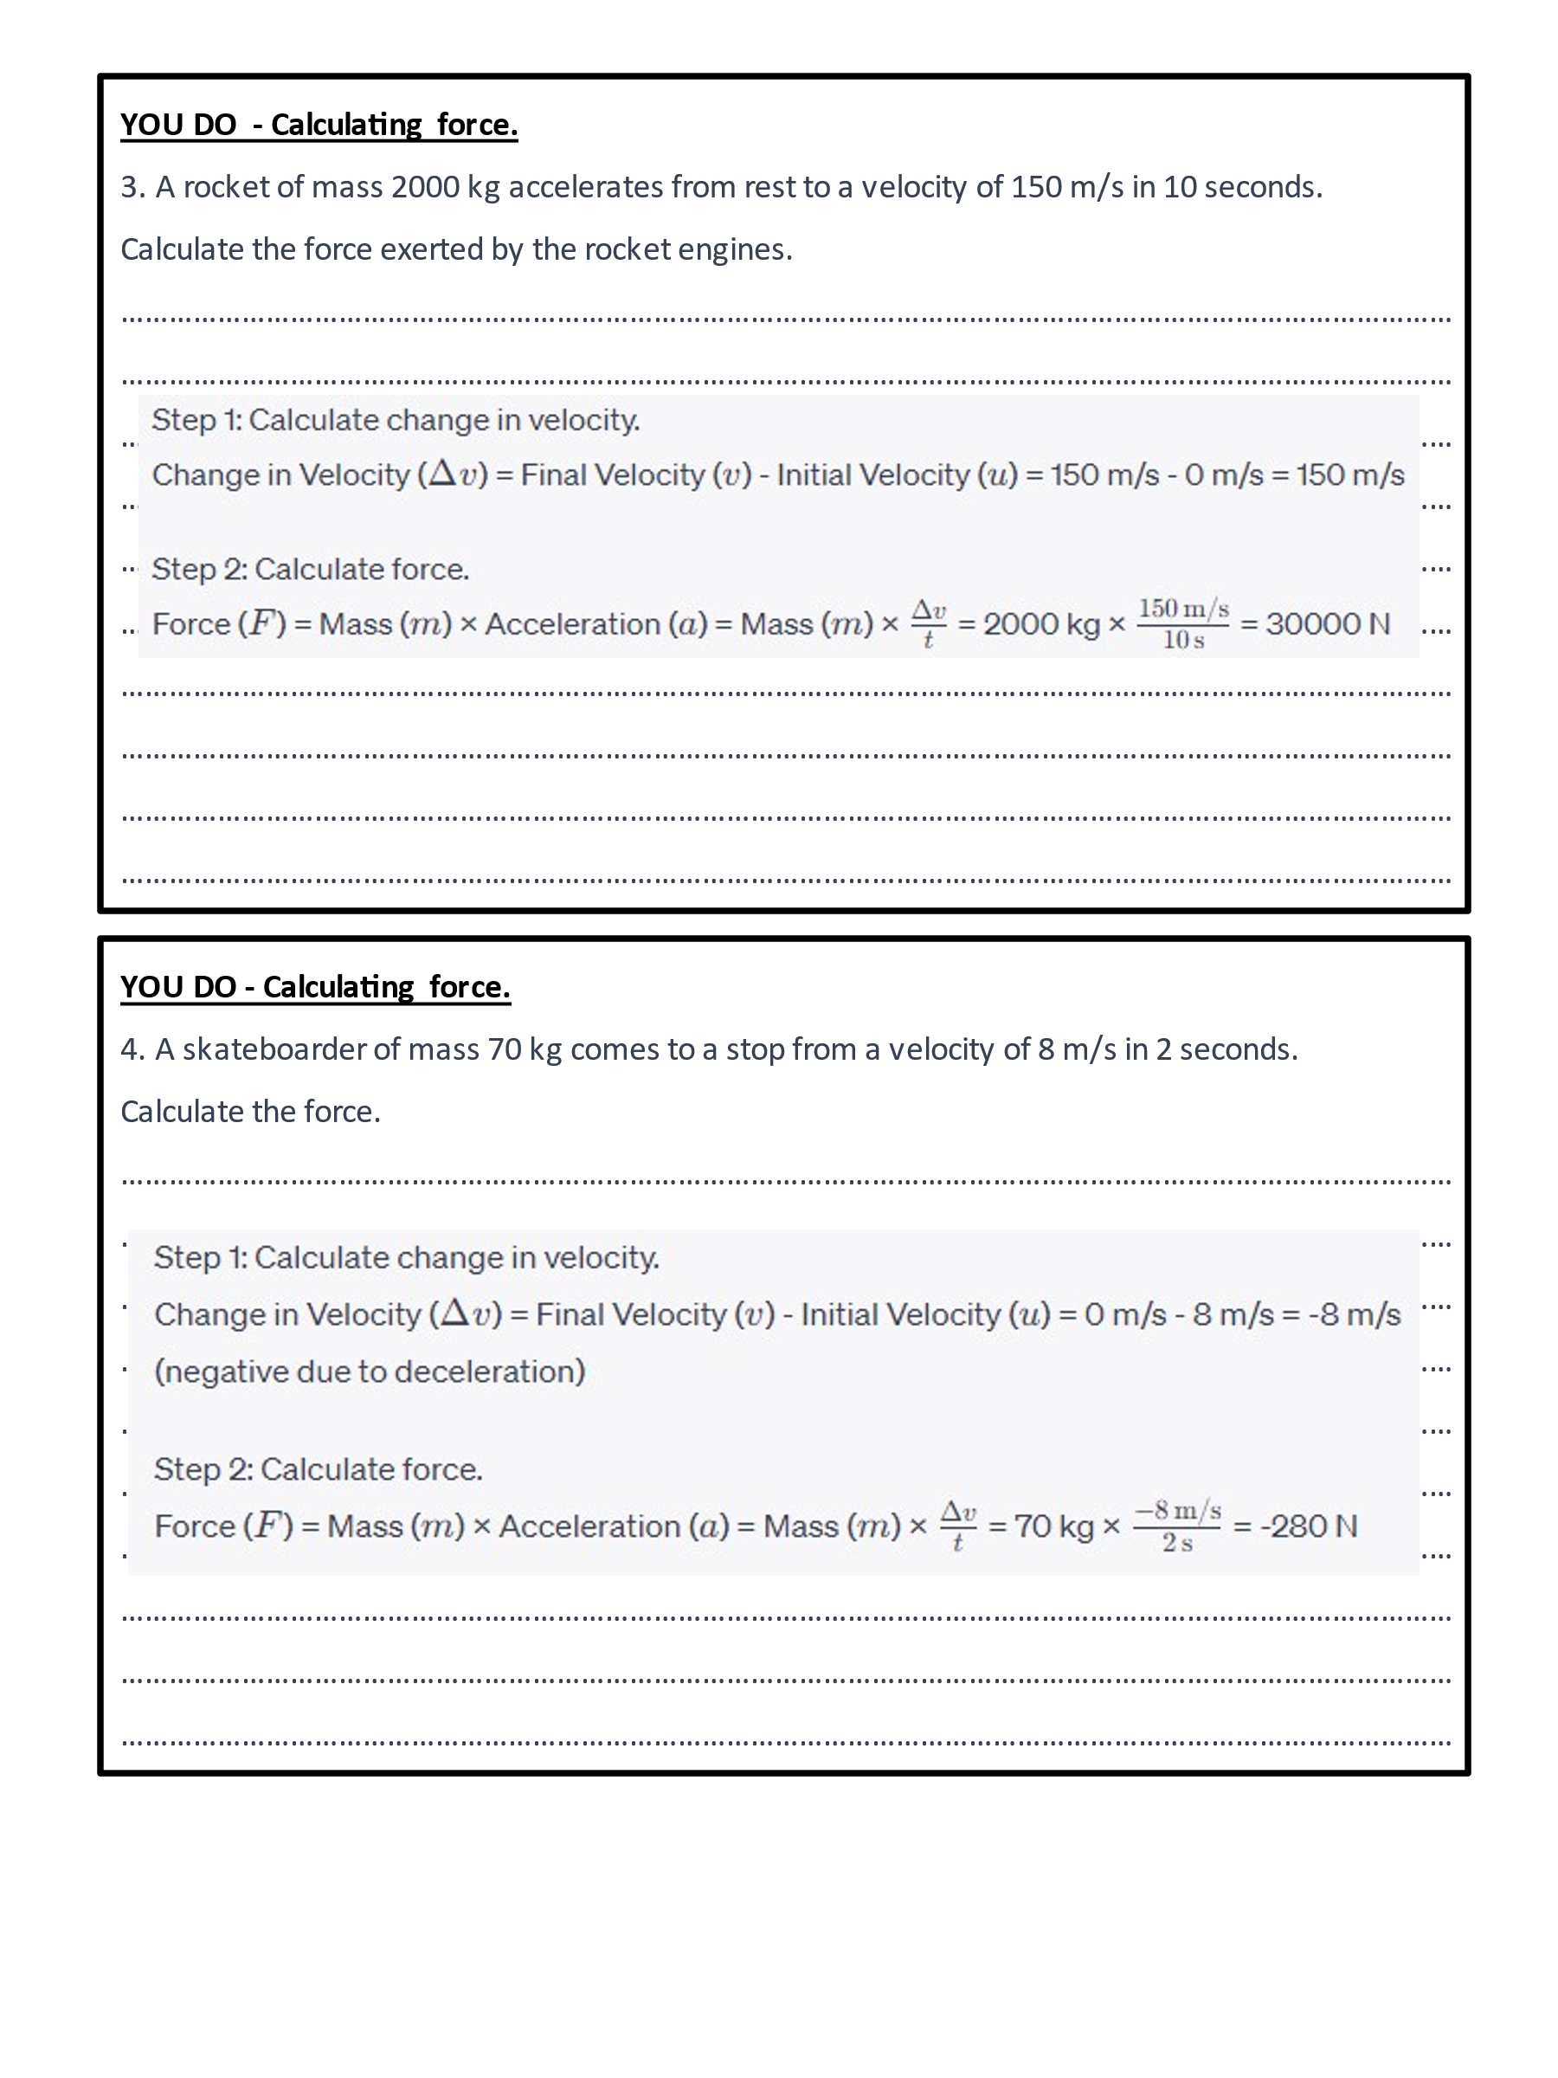

**Block 1:**

Independent practice.

More questions should be included.

Incremental changes to the question format and difficulty (e.g. conversion of units is required) can be introduced with later questions.

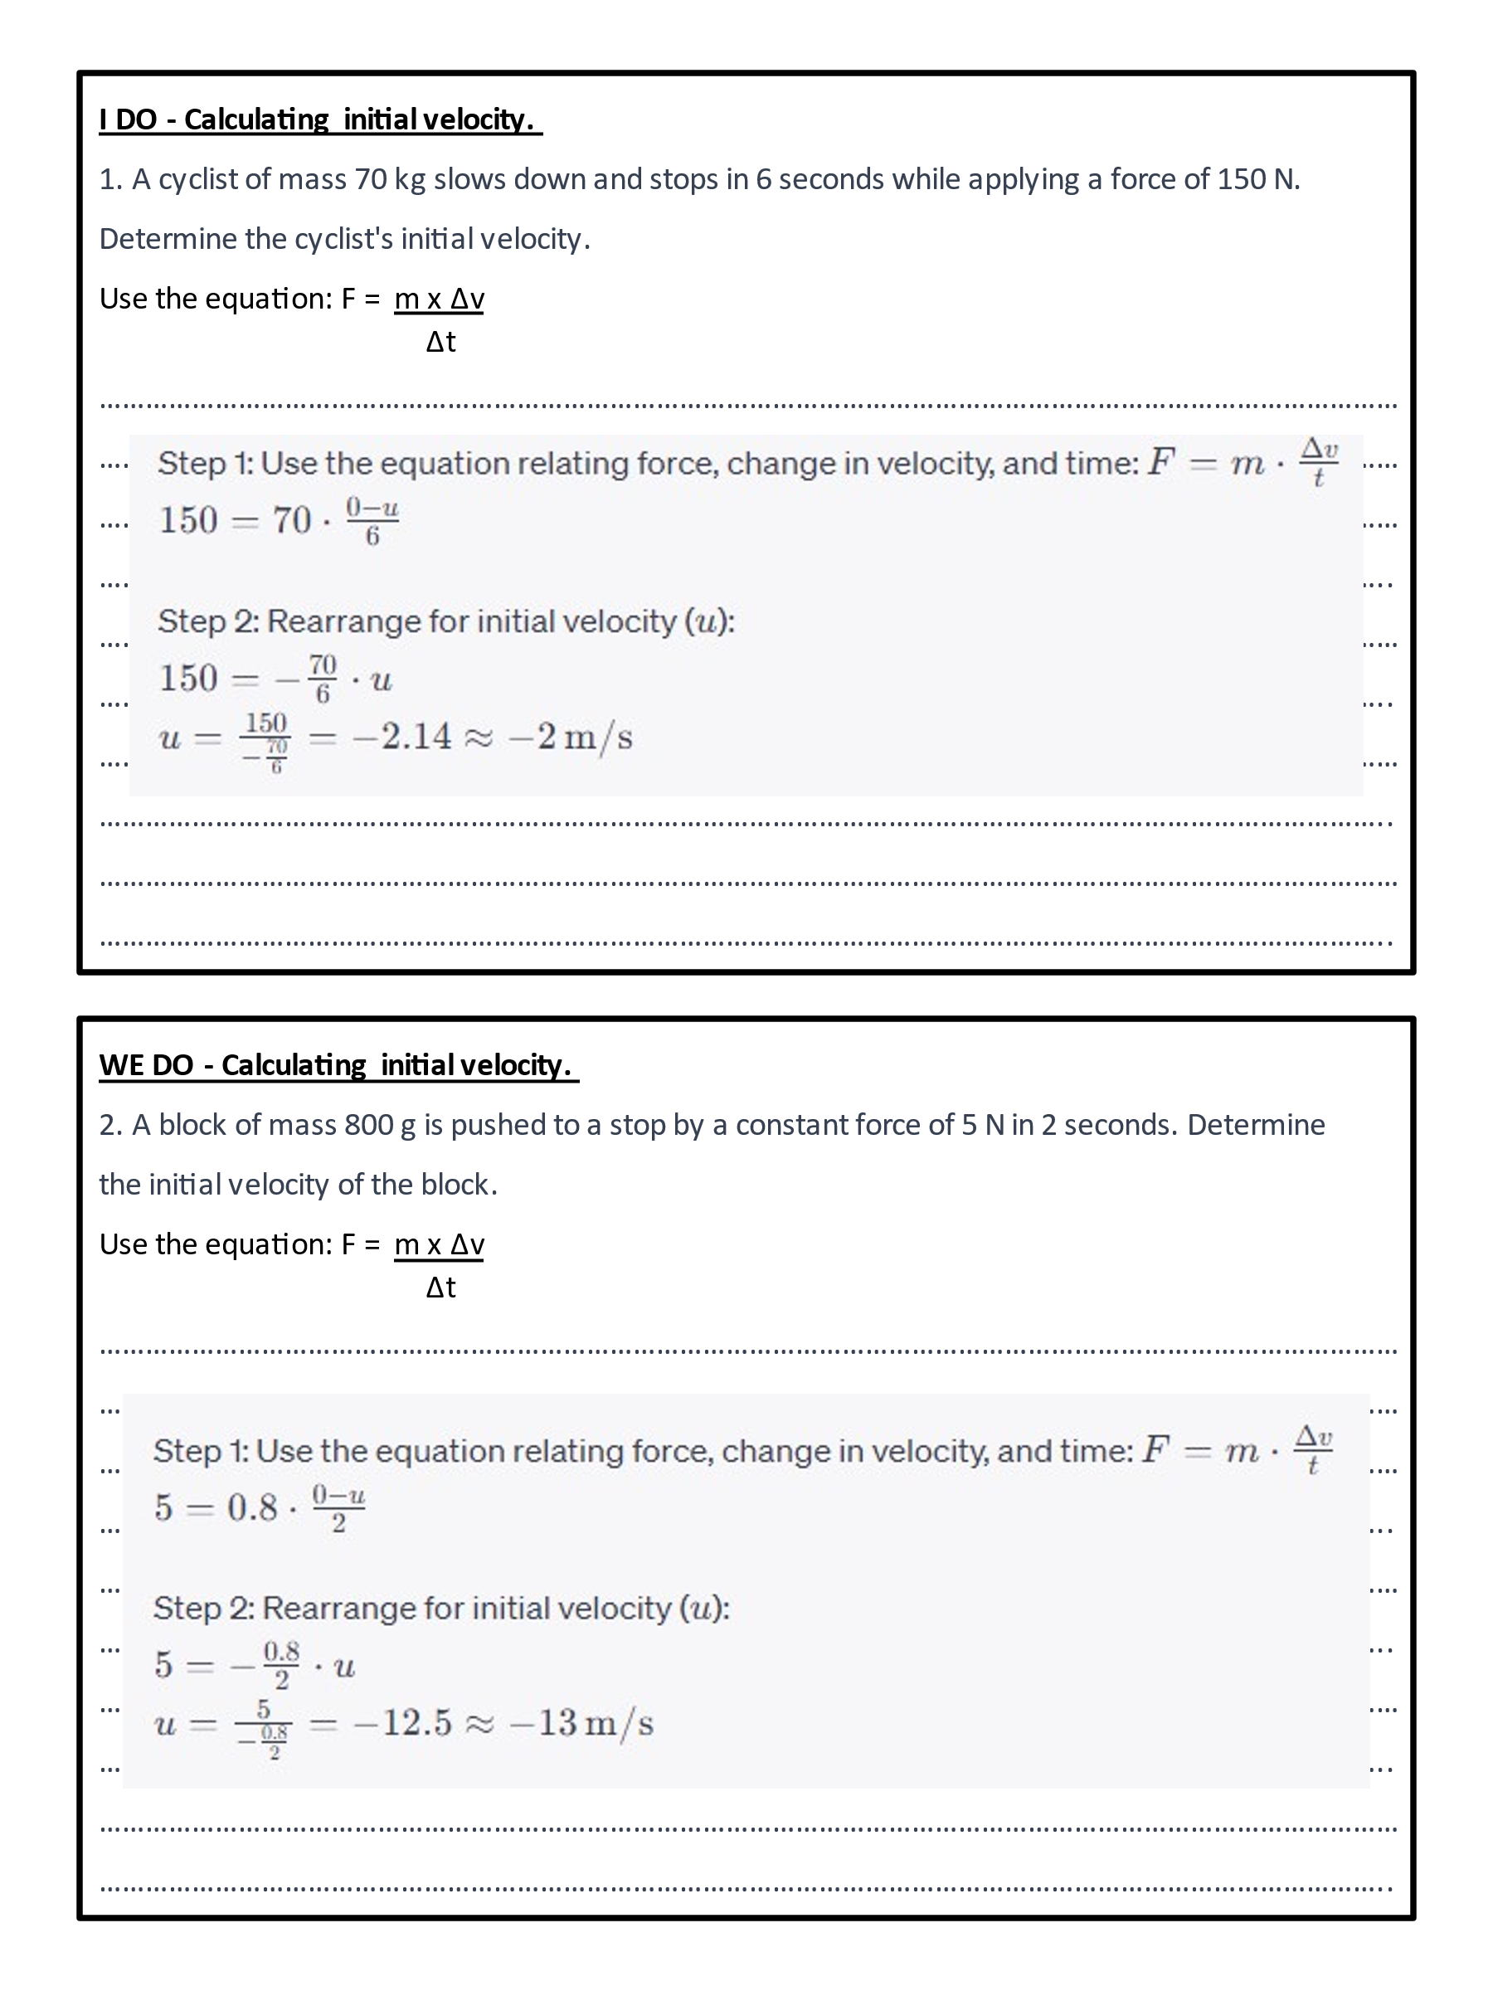

**Block 2:**

Scaffolded examples for calculation of force.

The teacher completes the I DO.

The teacher involves students in completing the WE DO.

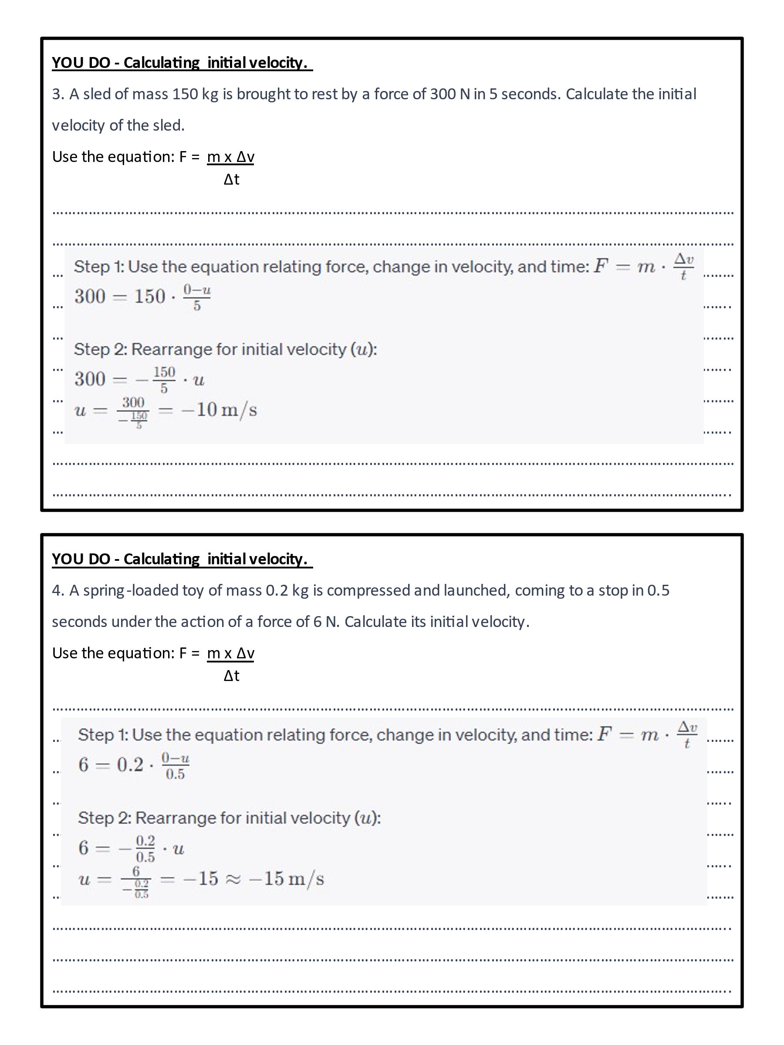

**Block 2:**

Independent practice.

More questions should be included.

Incremental changes to the question format and difficulty (e.g. conversion of units is required) can be introduced with later questions.

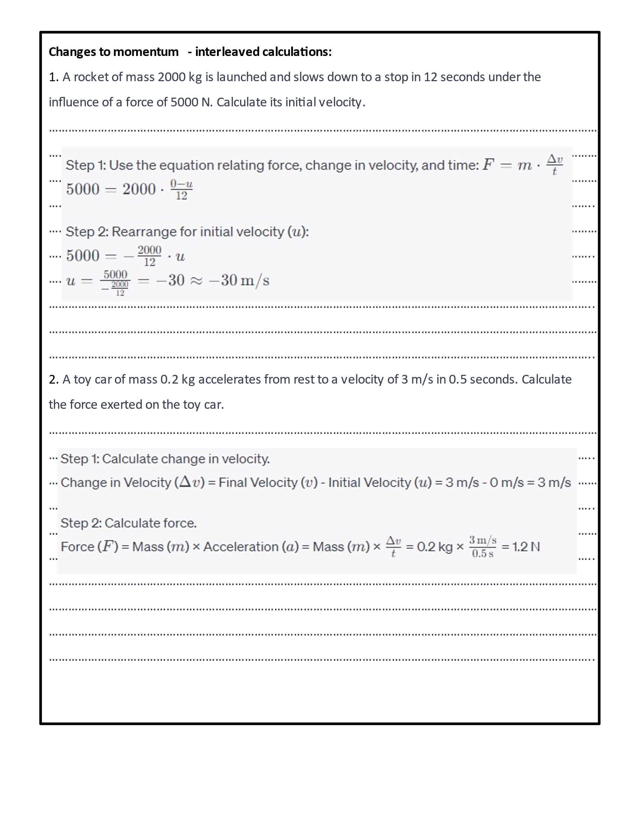

**Interleaved calculations:**

Students need to discriminate between calculations for velocity and those for force.

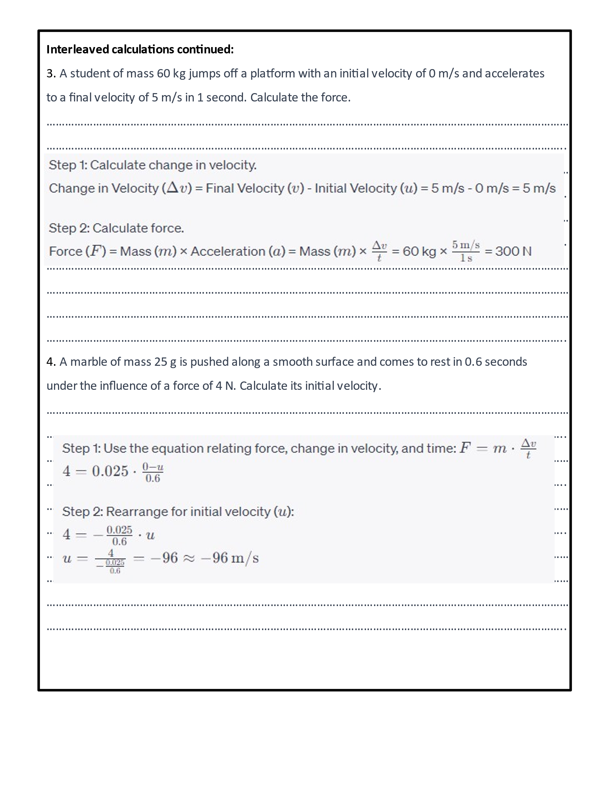

**Interleaved calculations:**

Students need to discriminate between calculations for velocity and those for force.

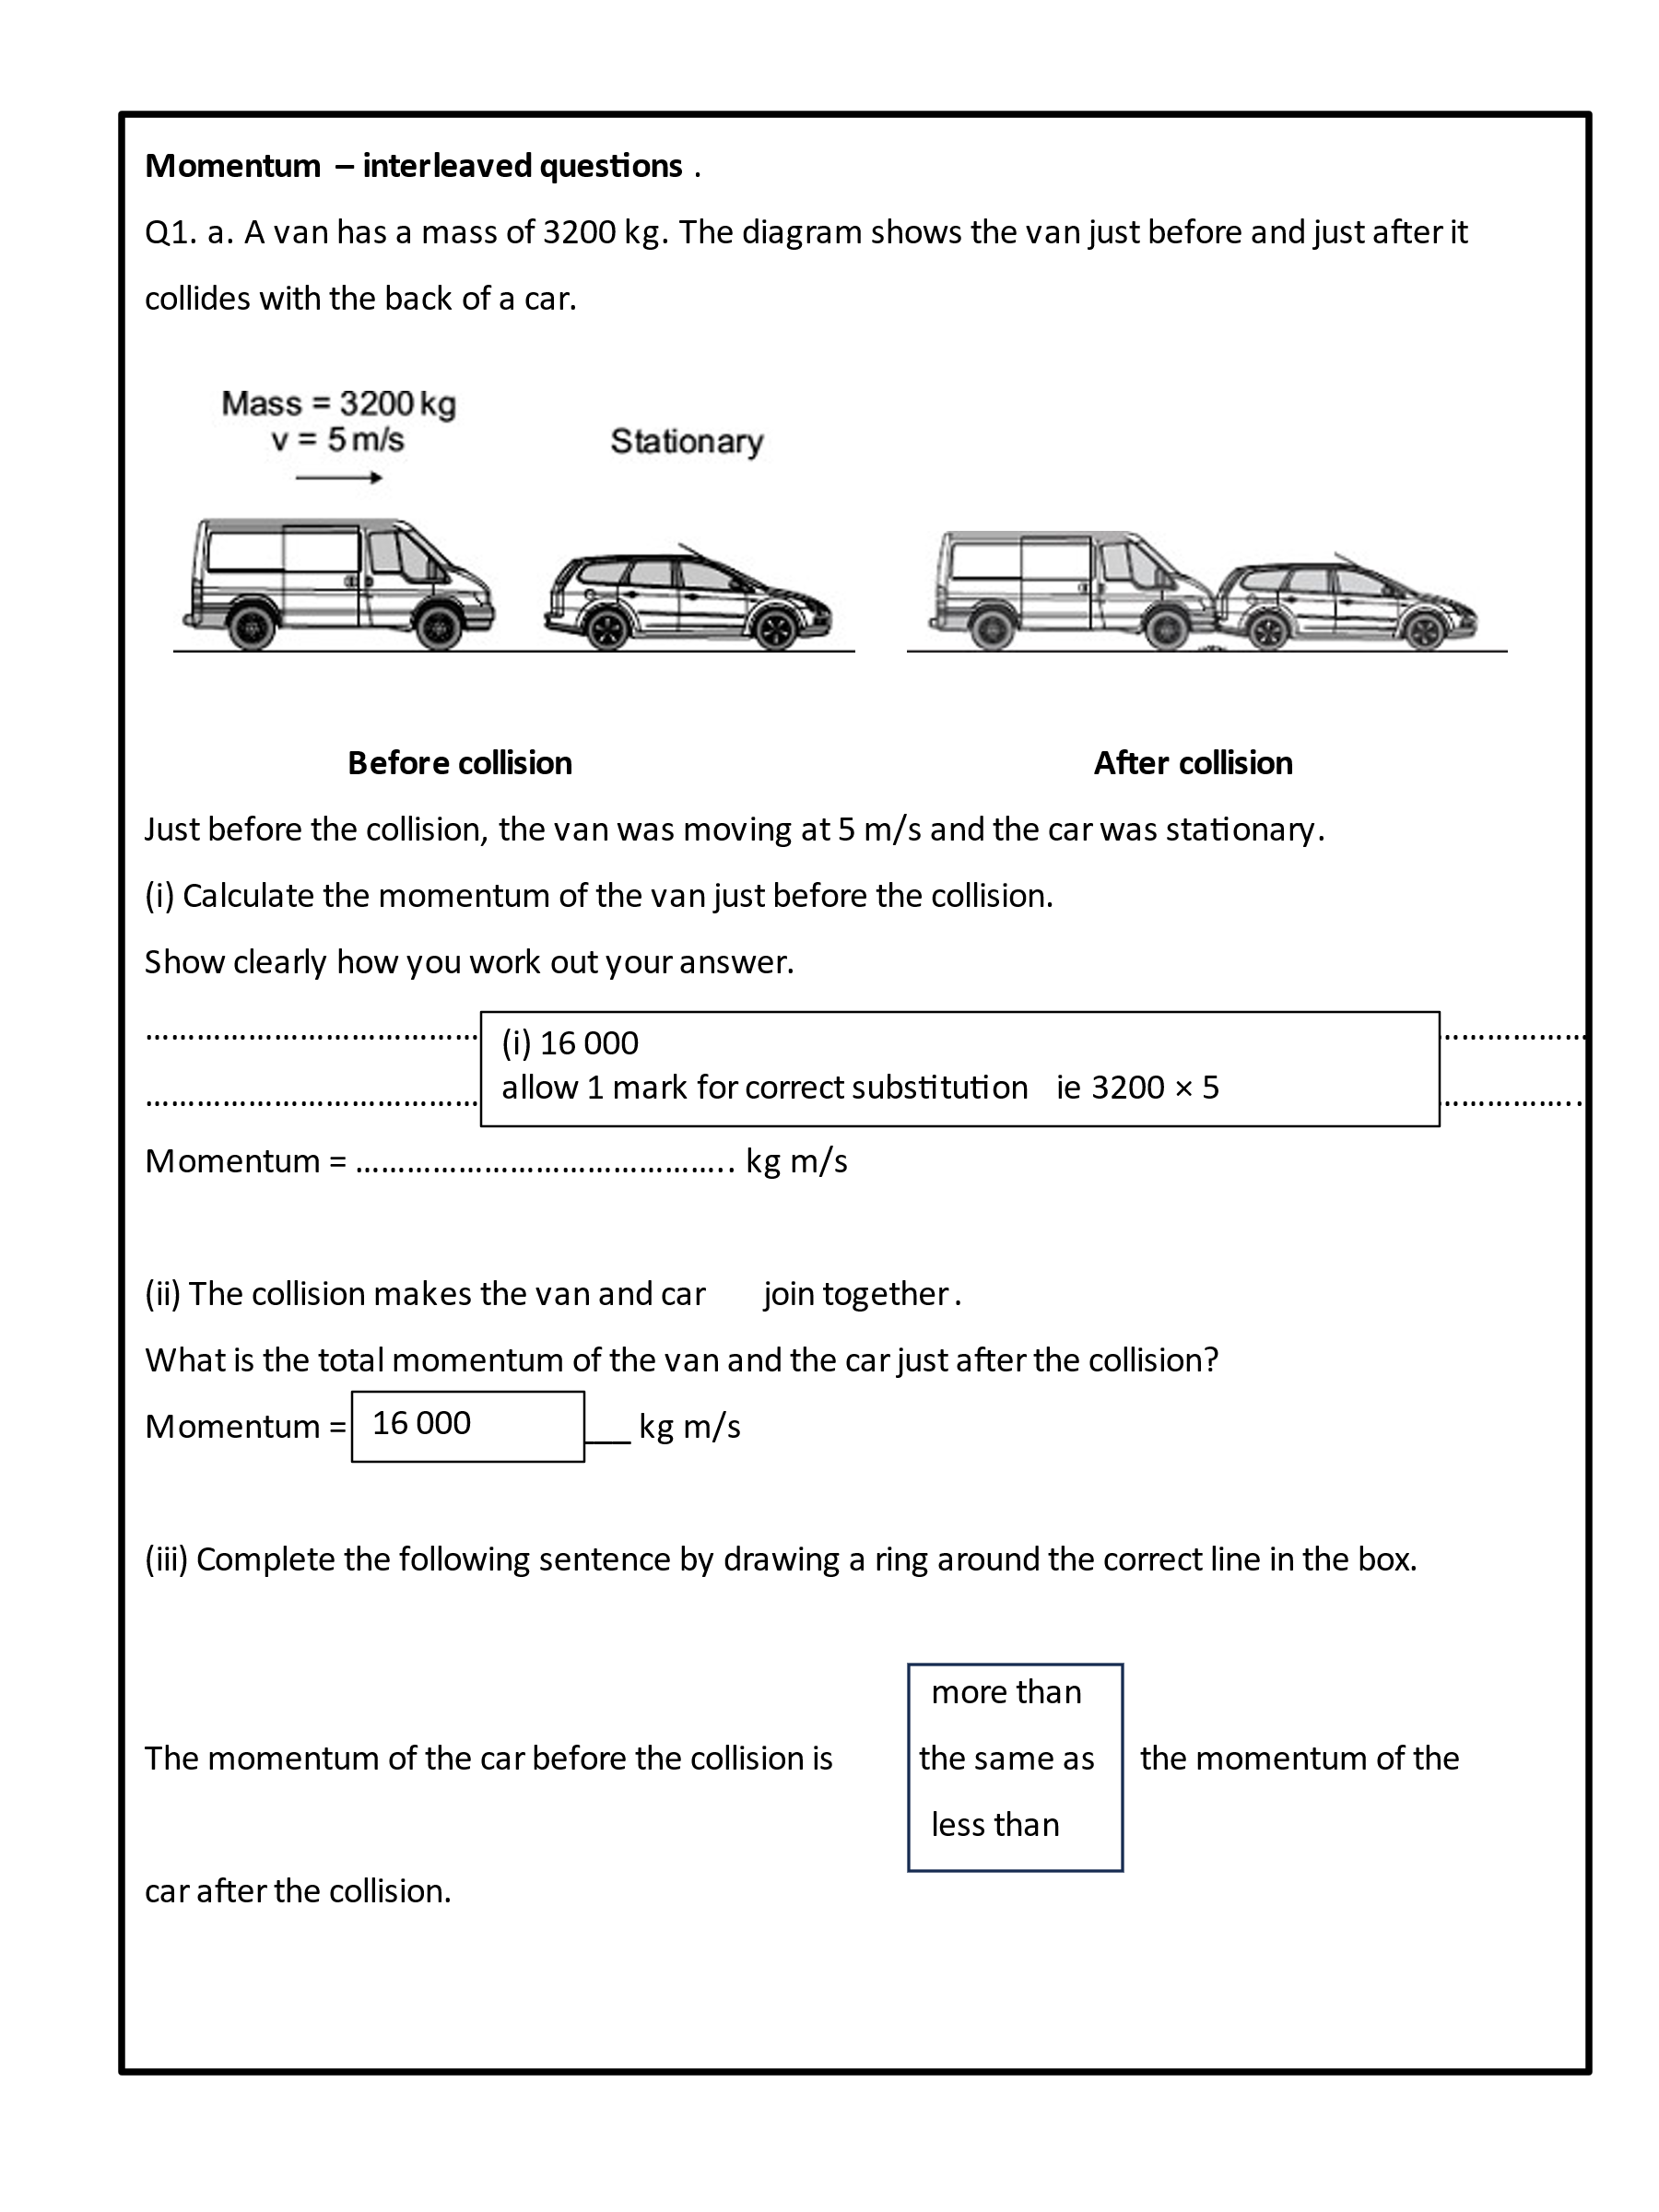

**Interleaving:**

New content interleaved with that from prior learning.

Cognitive load is higher due to format of lesson, range of content assessed and types of content assessed.

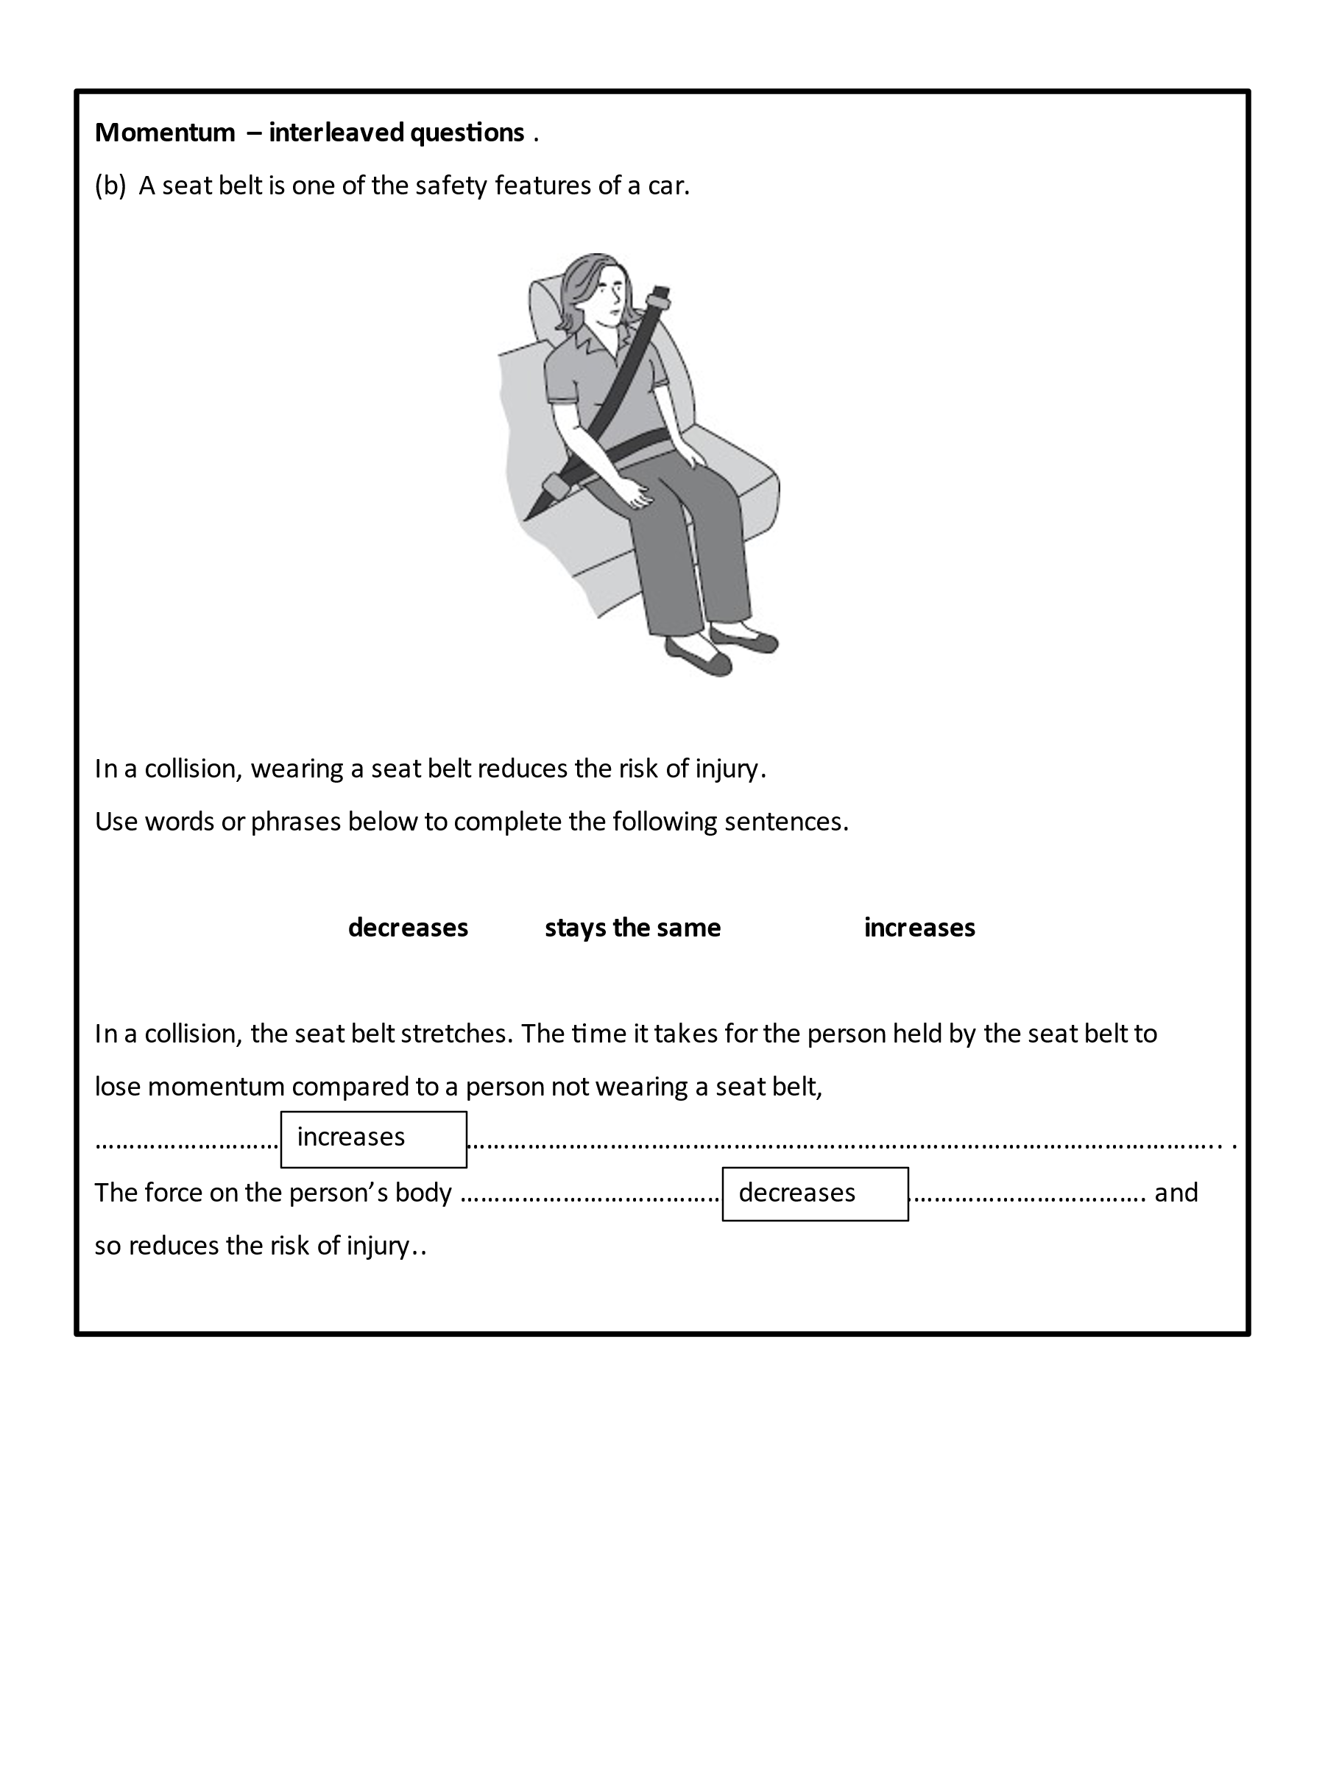

**Interleaving:**

New content interleaved with that from prior learning.

Cognitive load is higher due to format of lesson, range of content assessed and types of content assessed.

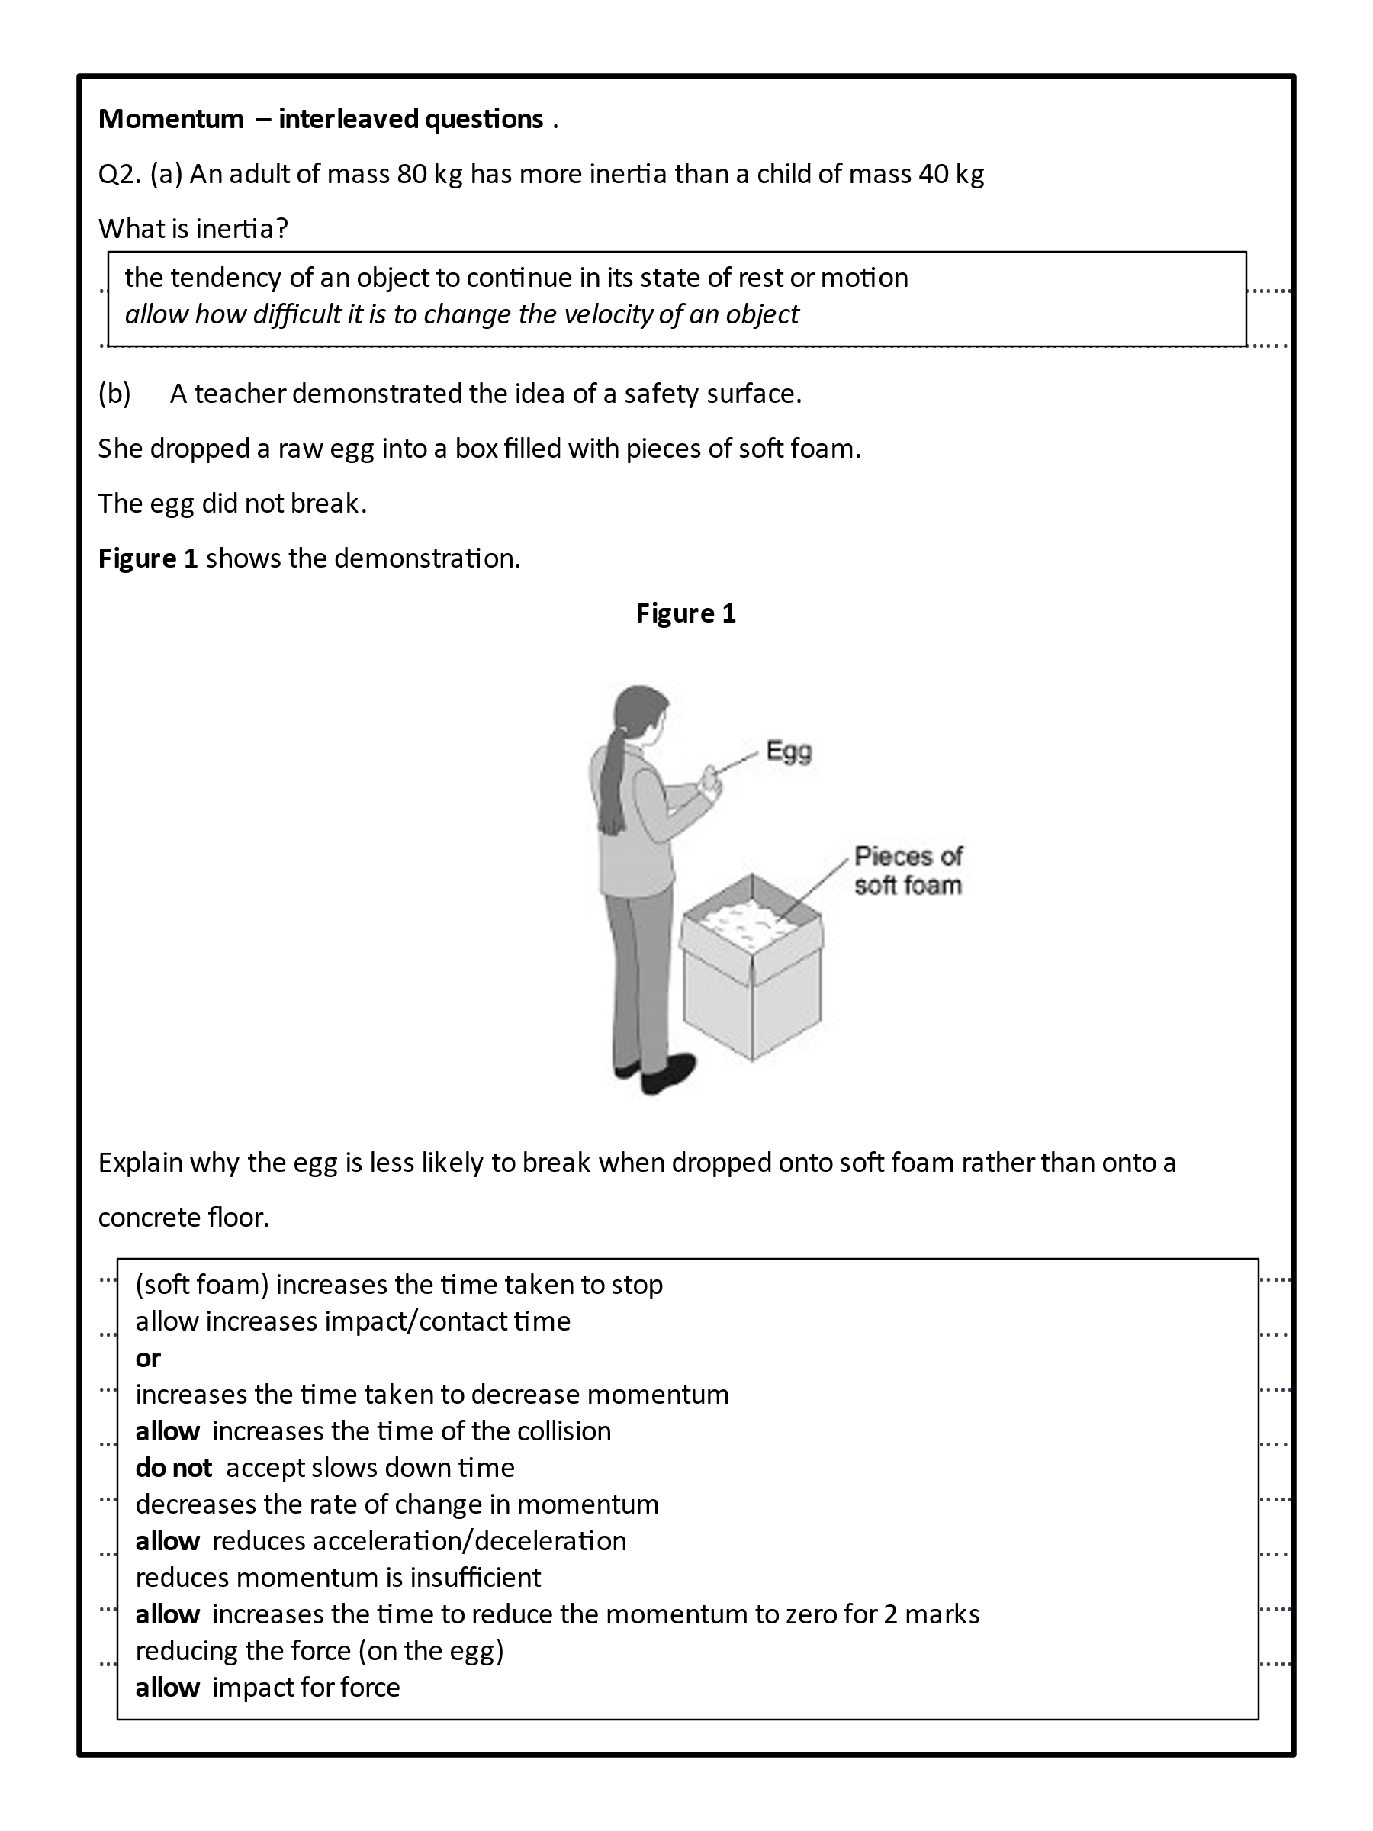

**Interleaving:**

New content interleaved with that from prior learning.

Cognitive load is higher due to format of lesson, range of content assessed and types of content assessed.

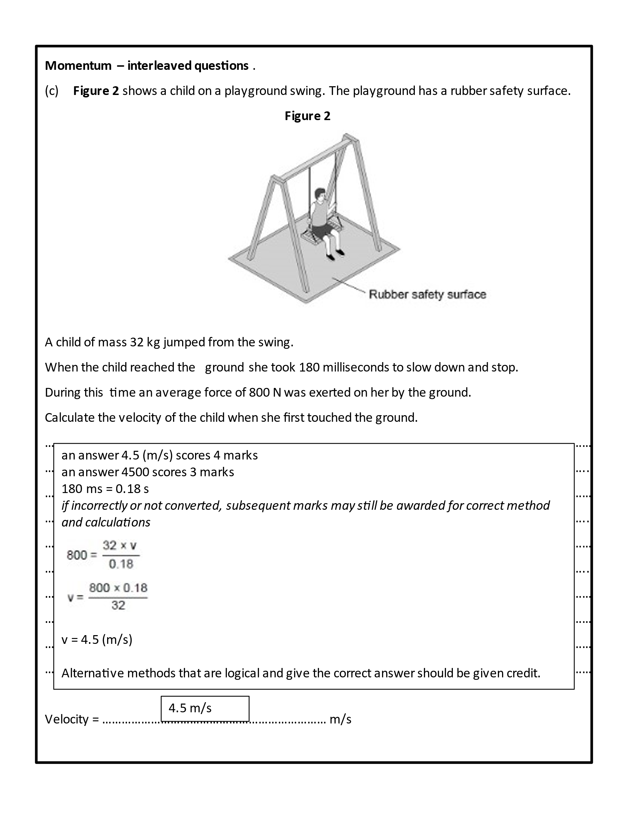

**Interleaving:**

New content interleaved with that from prior learning.

Cognitive load is higher due to format of lesson, range of content assessed and types of content assessed.

**Declarative content**

Procedural content is reasonably straight forward to plan activities and scaffolding for. Declarative content is more challenging. However, there are tried and tested structures that we can use to maximise the impact of our teaching. These will draw heavily on the contents of:

* Adam Boxer’s exceptional book, ‘Teaching Secondary Science’.
* A blog by Shaun Killian which can be found [here](https://www.evidencebasedteaching.org.au/the-i-do-we-do-you-do-model-explained/).

Adam Boxer provides some simple strategies that can be used to maximise opportunities for students to make meaning.

**What?**

The teacher building the content for the teacher booklet must include the following:

* **Text** should be included that introduces the concept and its place within the bigger picture. This should include examples and, if relevant, non-examples. The range of examples should be representative of the concept.

For example, if we were teaching the start of electrolysis, examples of the following should be included:

1. Images of examples showing different sets of apparatus. This enables students to identify that a container, electrodes, power source and an electrolyte are always used.
2. Situations in which electrolysis is used.

* A method for organising material. This might simply involve annotating the supplied text. Alternatively, it might require students to translate the text into a mind map (so, provide a basic outline for a concept map).
* Ten to twenty questions (with answers) that assess the basic knowledge content. Questions should be repeated further down the list, however, the syntax or emphasis of the question needs to be changed when it is repeated. For example:
* Question 1: What is the function of mitochondria?
* Question 7: A cell has many mitochondria. What is their function?
* OR Question 7: Mitochondria are a type of organelle. What is their function?
* Questions that ask students to engage more deeply with content. Adam gives several options in his book (more can be found on the CogSciSci website):
* Technique 2: Contrasting concepts.
* Technique 3: If I didn’t.
* Technique 4: Wrong answers.
* Technique 5: Because / but / so.

**Two techniques should be used as a minimum.**

**For each technique, there should be a minimum of five questions.**

**Questions need to follow the I DO, WE DO, YOU DO format.**

**Suggested answers should be given.**

* Questions that have been interleaved with content learnt previously; various formats including a cloze procedure, MCQs, short answer questions etc. These questions can be from prior learning from this topic or from other topics. An excellent example is given on page 263 of Adam’s book:

*Example: The muscle cell.*

*Students have previously studied particles and cells. They are currently studying energy, and following introduction to stores and pathways, they practise their new knowledge before attempting the question set below:*

*This question is about a muscle cell.*

1. *What is the function of a muscle cell?*
2. *How is the muscle cell adapted to its function?*
3. *What is the name of the process that releases energy in the muscle cell?*
4. *In which organelle does this take place?*
5. *The muscle cell uses glucose to release energy in a chemical reaction. Which energy store is involved with the glucose in this store?*
6. *Muscle cells work together to bring about movement. What is the name for something made of many cells working together?*
7. *When a person moves their muscles move, they start to feel warm. Which energy store is filling up?*
8. *A person who has just exercised touches a cold object and warms it up a bit. What energy transfer is involved?*
9. *The object they touched was an ice-cube. What happens to it if they hold it for a long time?*
10. *Draw a particle diagram of an ice cube.*
11. *Explain why the ice cube cannot flow.*

* A maximum of three complete exam questions that address new learning and prior learning.

**Why?**

The content has been included to enable:

* New learning to be put into the context of the bigger picture. This helps students to see the relevance of what they are learning, it helps activate prior understanding, also to support students in building richer schema.
* The sequence of activities increases in challenge and increasingly aids students with integrating new learning with existing schemata.

**How?**

* During the Connect phase of the lesson, the teacher needs to place the new learning in the context of the bigger picture. A text is provided to support with this. The reading should be teacher led with students following along using a ruler under the words.
* Students should actively engage with the text through summarising paragraphs, identifying unknown tier 2 and 3 vocabulary, and through answering questions (means of participation needs to be carefully considered). Alternatively, they can summarise key points as a mind map etc if a template is provided.
* Examples (and non-examples) should be explained and similarities and differences identified. Asking students to identify something as an example / non-example is a strong method for checking understanding.

**From this point, the teacher has considerable flexibility with how to use tasks.**

**Teachers do not have to use all tasks provided; they should plan a sequence that is most likely to be productive for their class.**

* Understanding of the basic content should be checked. The first block of questions, where questions are repeated using a different format, aids this.
* Of the two techniques provided (techniques 2 – 5 in Adam Boxers book, one or two should be used to build understanding. These need to follow the I DO, WE DO, YOU DO format so as to ensure high quality answers.
* Interleaved questions should be used to facilitate the making of links, take advantage of an opportunity for retrieval.

**References**

* Boxer, A. (2021). *Teaching Secondary Science – A Complete Guide.* John Catt Educational Ltd. Woodbridge, UK.
* Killian, S. The I Do WE Do YOU Do Model Explained. Evidence Based Teaching. 21st February, 2023.