**Year 7 – Knowledge Booklet**

Key Stage 3 Science:

**Energy**

**This booklet is for use in your Science lessons. Please look after it in the same way you would your exercise book and ensure that your presentation is always PROUD.**

**Ensure that your booklet is returned to your class book box at the end of the lesson.**

**Lesson 1: What is energy and how is it stored?**

“I’ve got no energy”

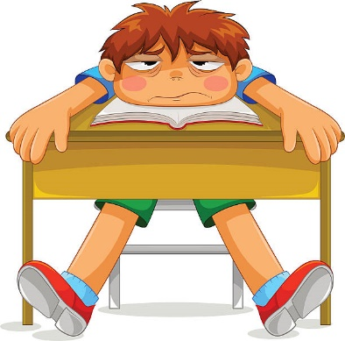

|  |  |
| --- | --- |
| 1 | The image shows a child saying “I’ve got no energy”. |
| 2 | The child does have energy – the child is warm and can move. |
| 3 | The student gets their energy from digesting the food they eat. |
| 4 | The image shows a burger – this is a store of energy |

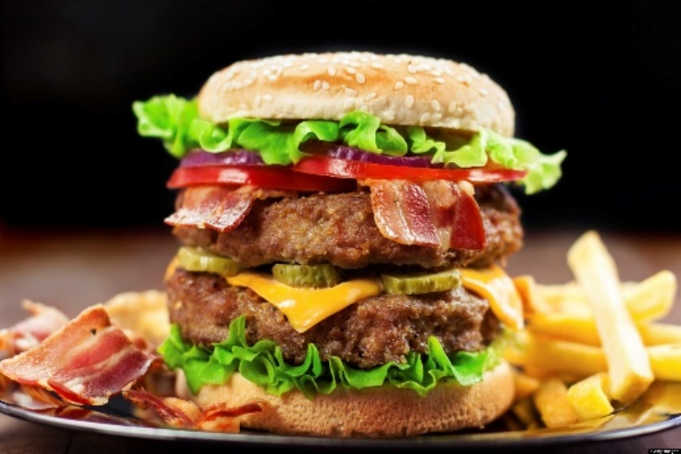

|  |  |
| --- | --- |
| 5 | The child is not using a scientific definition of energy |
| 6 | The scientific definition of energy is “**the ability to do work**”. |
| 7 | In Science, the word “work” also has a specific definition |
| 8 | The scientific definition of work is “**when work is done, energy has been transferred from one energy store to another**” |
| 9 | Here are definitions of the different energy stores: |
| 10 | Thermal Energy Store – filled when an object is warmed up |
| 11 | Chemical Energy Store – Emptied during chemical reactions when energy is transferred to the surroundings |
| 12 | Gravitational Potential Energy Store – Filled when an object is raised |
| 13 | Kinetic Energy Store – Filled when an object speeds up |
| 14 | Elastic Energy Store – Filled when a material is stretched or compressed |

|  |  |
| --- | --- |
| 15 | Here are images of 5 different energy stores: |
| See the source image | A radiator is a store of Thermal Energy |
| See the source image | A car at the top of a rollercoaster is a store of Gravitational Potential Energy |
| See the source image | A runner is a store of Kinetic Energy |
| See the source image | Sweets are a store of Chemical Energy |
| See the source image | A catapult is a store of Elastic Energy |

|  |  |
| --- | --- |
| **16** | Energy stores do not hold a fixed amount of energy. |
| **17** | The amount of energy in a store can increase and decrease when transfers are made. |
| **18** | Energy in a store can be compared to the amount of money in a bank account. |
| **19** | Here is an image of a bank account with deposits and withdrawals  See the source image |

|  |  |
| --- | --- |
| 20 | Here are images of 2 elastic bands that have been stretched different amounts.  See the source imageSee the source image |
| 21 | The greater the stretch, the greater the amount of energy stored in the elastic band. |
| 22 | The more energy in a store, the greater the amount of work can be done (in the example above, the elastic band that has been stretched the greatest will travel the furthest when released). |
| 23 | Here is an image of a £20 note and a stack of pennies  See the source imageSee the source image |
| 24 | It is more useful to have a £20 note rather than £20 in pennies (think about how heavy it would be to carry all those coins around!) |
| 25 | When energy is spread out into little bits (like the piles of 1p coins) it is not in a useful form. |
| 26 | When energy is spread out into little bits, we say that it has been **dissipated**. |

**Lesson 2: How is energy transferred from one store to another?**

|  |  |
| --- | --- |
| 1 | In lesson 1 you learnt about energy stores |
| 2 | Energy is like the money of being able to do work |
| 3 | An energy store can contain different amounts of energy |
| 4 | Food contains energy in the chemical store |
| 5 | Different foods contain different amounts of energy in the chemical store |
| 6 | Eating and digesting food transfers the energy from the chemical store in the food |
| 7 | The human body needs to transfer a minimum amount of energy from food just to stay alive |
| 8 | The energy is transferred into the thermal store to maintain our body temperature, the Kinetic Store to move, and others. |

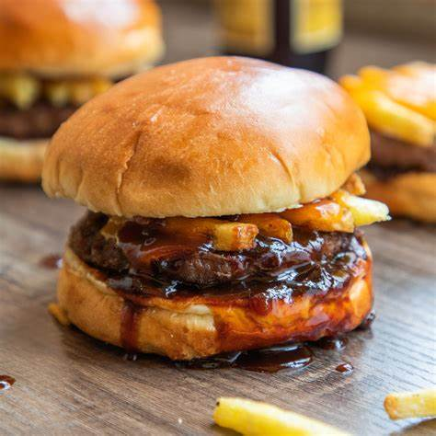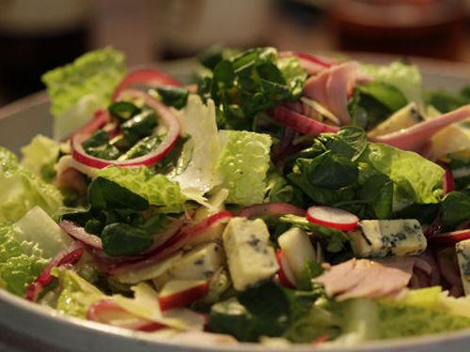

|  |  |
| --- | --- |
| 9 | Energy that is not used goes into the chemical store in the body (usually in the form of fat) |
| 10 | To lose weight, you need to eat foods with a small chemical store (less than the amount of energy required to live), this makes the body transfer energy from the chemical stores (fat) in the body. |

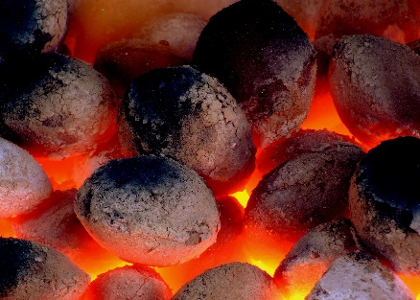

|  |  |
| --- | --- |
| 11 | Coal stores energy in a chemical store |
| 12 | Burning the coal transfers the energy from the chemical store |
| 13 | The energy warms up the air – the energy in the thermal store in the air increases. |
| 14 | Below are the 4 energy transfers and examples of each |

**Examples of energy transfers**

**Mechanical work**

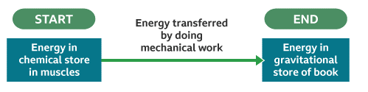

**Electrical work**

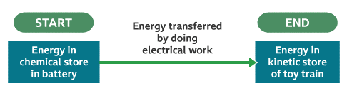

**Heat Transfer**

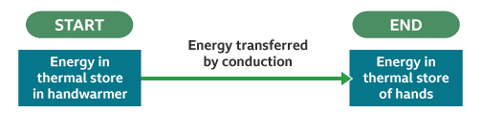

**Radiation**

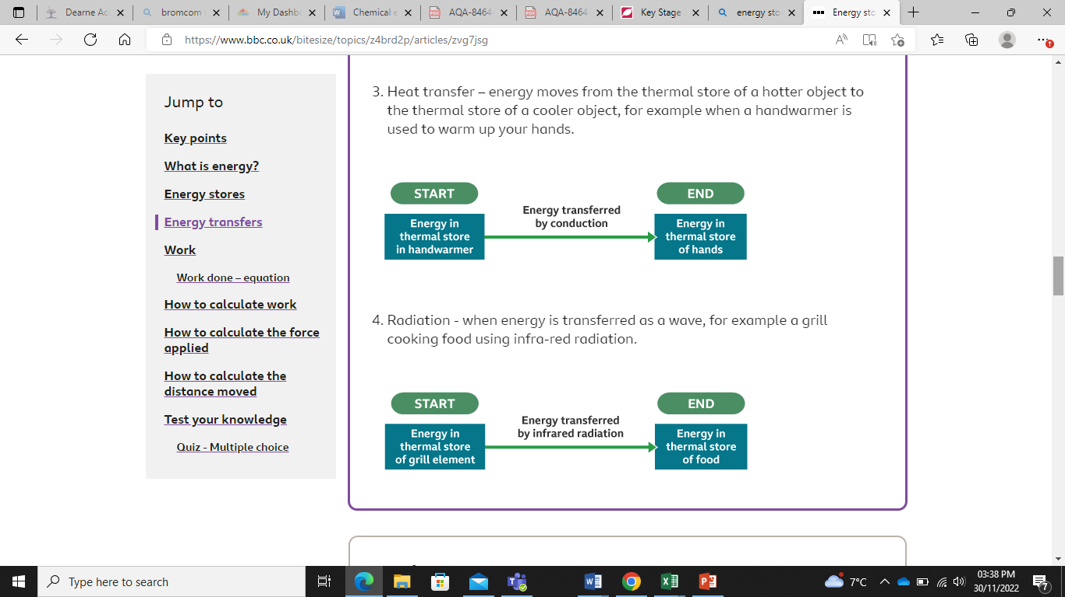

|  |  |
| --- | --- |
| 15 | The diagram below shows how energy is transferred between stores |

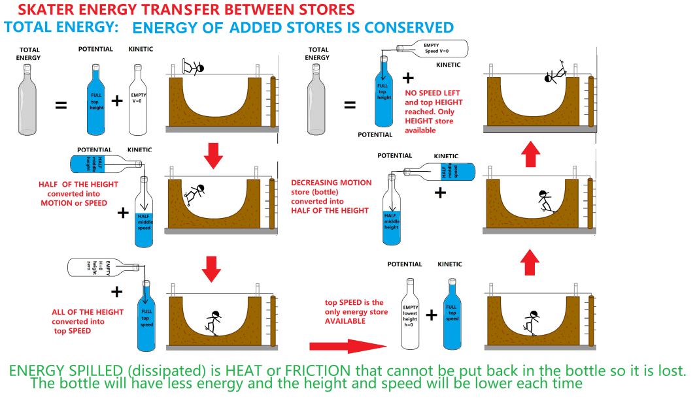

**Lesson 3: What energy transfers are related to friction?**

|  |  |
| --- | --- |
| 1  2  3  4  5 | Energy can be transferred from one energy store to another. For example, when a car moves its chemical energy store is transferred into a kinetic energy store. It is quite rare for all of the energy to transfer from one store to another. Often, some energy is transferred into energy stores that aren’t useful. For example, energy is transferred into the thermal energy store. |
| 7  8  9  10  11  12  13 | When two surfaces move relative to each other they resist each other’s movement. For example, brake pads on a bike press against the rim of the wheel. The brake pad makes the wheel move more slowly. Scientists call this force friction. In this situation, some of the bike’s kinetic energy store is transferred to the environment’s thermal energy store. Friction can be both useful (e.g. in brakes on a vehicle) and unhelpful (e.g. in the engine of a vehicle). |
| 14  15  16 | When energy is wasted, it often goes into the environment and spreads out. Scientists say that the energy has dissipated. Once the energy has spread out it is hard to recover. |

**Lesson 4: Conservation Of Energy**

|  |  |
| --- | --- |
| 1  2  3  4  5 | Energy is often transferred from one energy store to another. When this happens, the total quantity of energy before the transfer occurred is exactly the same as after it occurred; scientists say that it is conserved. We say that the amount of energy is conserved. This means that if energy is transferred out of a store, it must move into another store; it is never ‘lost’. |
| 7  8  9  10  11 | Energy from one store often transfers into several other stores at the same time. This means that if we know the amount of energy transferred into other stores, we can calculate the amount of energy we started with (input energy). To do this, we simply add up the energy in all of the stores after the transfer has happened. |
| 14  15  16 | The total amount of energy is conserved. This allows us to calculate the amount of energy in an output store if we know the total energy input (how much energy we started with) and the amount in all but one output store. |

**Lesson 5: What does it mean if we say a device is efficient?**

|  |  |
| --- | --- |
| 1  2  3  4 | Energy can be transferred between different stores via different pathways.  For each device, some energy transfers are **useful** and some are **wasted.**  An energy transfer is **useful** if it allows a device to carry out its job / function.  An energy transfer is **wasted** if it does not help a device to carry out its job / function. |

***Example 1: A battery-operated toy train***

Energy input: 100J

(From the chemical store)

Energy output:

50J to the kinetic store

50J to the thermal store

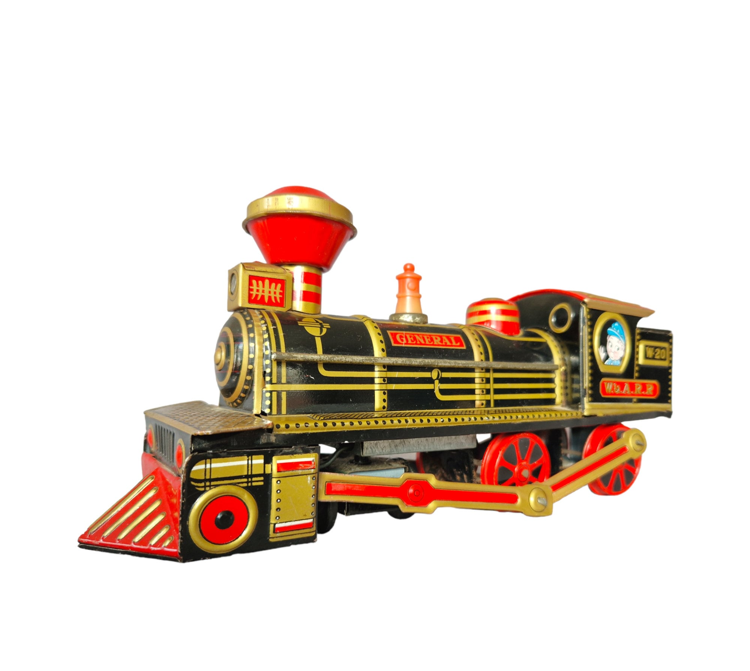

|  |  |
| --- | --- |
| 5  6  7 | The input energy, from the chemical store of the battery, is transferred to the kinetic store of the toy train **and** to the thermal store.  The useful output energy is kinetic, as this causes the train to move.  The wasted energy output is thermal, as this does not help the toy to work. |

***Example 2: An electric heater***

Energy input: 1500J

(From the chemical store via electrical work)

Energy output:

700J dissipated as sound waves

800J to the thermal store

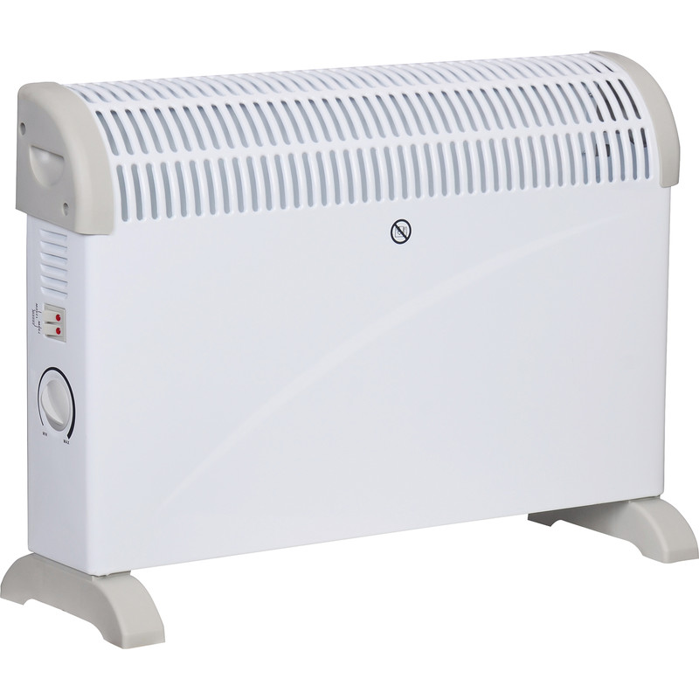

|  |  |
| --- | --- |
| 8  9  10 | The total input energy is 1500J.  800J of the input energy, transferred via electrical work, is transferred to the thermal store.  This is a useful energy output, as it allows the electrical heater to increase the temperature of the surroundings.  700J of energy is dissipated (spreads out to the environment) as sound waves. This is a wasted energy output, as the sound does not help the electric heater to work. |

***Example 3: A tumble drier:***

Energy input: 1800J

(From the chemical store via electrical work)

Energy output:

1000J to the thermal store of the drier.

400J to the kinetic store.

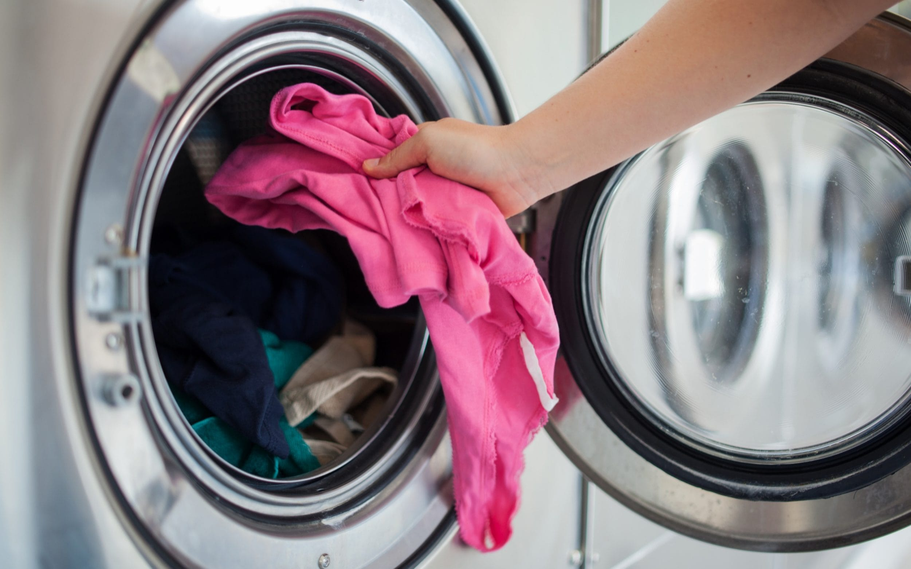

200J dissipated as sound.

200J dissipated to the thermal store of the surroundings.

|  |  |
| --- | --- |
| 11  12  13  14  15  16  17  18 | The total input energy is 1800J.  1000J of the input energy, transferred via electrical work, is transferred to the thermal store of the drier.  This is a useful energy output, as it allows the drier to heat the clothes and dry them.  400J of the input energy is transferred to the kinetic store.  This is a useful energy output, as it allows the drier to spin the clothes, heating and drying them faster.  200J of energy is dissipated (spreads out to the environment) as sound waves. This is a wasted energy output, as the sound does not help the drier to dry the clothes.  200J of energy is dissipated to the thermal store of the surroundings. This is a wasted energy output, as this does not help the drier to dry the clothes.  The total input energy is equal to the sum of the different energy outputs. This is due to **conservation** of energy (energy can neither be created or destroyed). |
| 19  20  21 | **Energy efficiency calculations**  How good a device is at transferring energy input to **useful energy output** is called efficiency.  A **more efficient** appliance will transfer more of its input energy into a **useful energy output** and less into a **wasted energy output.**  A **less efficient** appliance will transfer less of its input energy into a **useful energy output** and more into a **wasted energy output**. |

***Lightbulb A:***

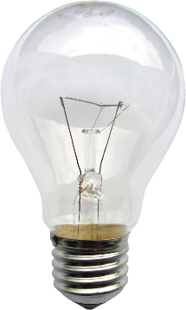

Energy input: 100J

(From the chemical store via electrical work)

Energy output:

20J transferred to light

80J transferred to the thermal store

|  |  |
| --- | --- |
| 22  23  24  25  26  27 | ***Calculating the efficiency of lightbulb A:***  Efficiency = Useful energy output ÷ Total energy input  **Useful energy output: 20J**  **Total energy input: 100J**  **Efficiency =** 20 ÷ 100 = 0.2  **Multiply by 100 to convert to a percentage:** 0.2 x 100 = 20%  **This calculation tells us that 20% of the input energy to the bulb is transferred to a useful output energy.** |

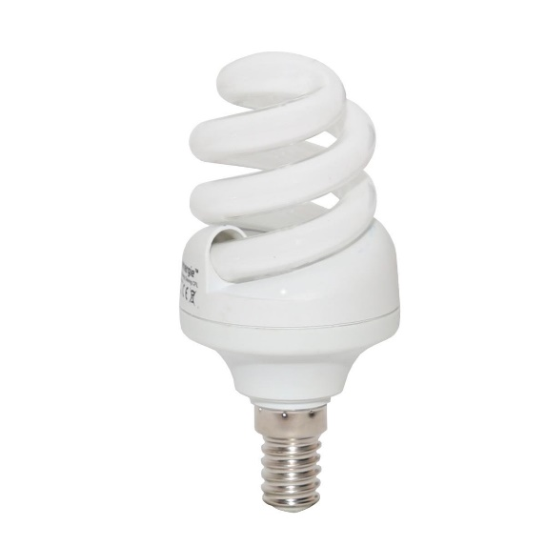***Lightbulb B:***

Energy input: 100J

(From the chemical store via electrical work)

Energy output:

60J transferred to light

40J transferred to the thermal store

|  |  |
| --- | --- |
| 28  29  30  31  32  33 | ***Calculating the efficiency of lightbulb B:***  Efficiency = Useful energy output ÷ Total energy input  **Useful energy output: 60J**  **Total energy input: 100J**  **Efficiency =** 60 ÷ 100 = 0.6  **Multiply by 100 to convert to a percentage:** 0.6 x 100 = 60%  **This calculation tells us that 60% of the input energy to the bulb is transferred to a useful output energy.** |
| 34  35  36  37  38  39 | For both lightbulbs, the useful energy output is **light**.  For both lightbulbs, the wasted energy output is to the **thermal store**.  Lightbulb A is **less efficient** than lightbulb B.  This is because a **smaller proportion / percentage** of the input energy is transferred to the **useful energy store**.  Lightbulb B is **more efficient** than lightbulb A.  This is because a **greater proportion / percentage** of the input energy is transferred to the **useful energy store (light)**. |

**Lesson 7: How do we use diagrams to show energy transfers?**

|  |  |
| --- | --- |
| 1  2  3  4 | Energy transfers can be represented with box and arrow diagrams that clearly show the different energy stores *and* the ways in which the energy is transferred. Sankey diagrams do not show the ways that energy is transferred, but they do show the relative amounts of energy transferred in different ways. |
| 5  6  7  8  9 | Conservation of energy means that the amount of energy input into a system is the same as the amount of energy transferred out of the system. Along different pathways into different stores of energy it should be identifiable to account for all the energy transferred out. Even if some of the energy transferred is now in the form of wasted energy store it can be accounted for. |

**Lesson 8 – Which foods contain the most energy?**

|  |  |
| --- | --- |
| 1  2  3  4  5  6  7  8  9 | Food labels show us the nutrient contained in food. They also tell us their energy content, in both kilojoules (KJ) and calories (cal).  Below are some examples of food labels:  See the source imageSee the source image  **Bread**  **Pork chops**  The recommended daily intake (RDI) for energy and nutrients is different for everyone. This is because daily energy requirements are different depending on individual circumstances.  The recommended daily intake for the **average** adult male is 2500 calories.  The recommended daily intake for the **average teenaged** male is 2000 calories.  The recommended daily intake for the **average** adult female is 2000 calories.  The recommended daily intake for the **average teenaged** female is 1600 calories. |
| 1  2  3  4  5  6  7  8  9  10  11  12  13  14  15  16  17  18  19  20  21  22 | Lets look at some examples of different people with different requirements:  See the source image  Joe is 29 years old.  He is very active, and works as a personal trainer.  He also spends most of his free time being active, either at the  gym or hiking on the local trails.  A person with a white beard  Description automatically generated with low confidence  Colin is 76 years old.  He is retired, and occasionally looks after his grandchildren.  He doesn’t leave the house very often, and when he does he needs to use his mobility scooter.  Image result for pregnant woman  Maria is 24 years old.  She works as mortgage adviser in a bank, but has recently  started maternity leave.  She is currently 8.5 months pregnant, and is looking forward to  being a mother. She enjoys attending prenatal yoga classes.  When determining the daily energy requirements of an individual, you have to consider their  circumstances:   * Gender * Age * Job * Hobbies * Pregnancy * Body weight | |

|  |  |
| --- | --- |
| 1  2  3  4  5  6  7  8  9  10  11  12  13  14  15  16  17  18  19  20  21  22  23  24  25  26 | We will be completing an investigation to determine which type of food contains the most energy. To do this, we will be burning pieces of food, and measuring the temperature of water. Below is a diagram of the equipment we will be using, as well as the method we will be following:   1. See the source imageFirstly, set up your equipment as shown in the diagram. 2. Next, measure 20 cm3 of water, using a measuring   cylinder, and pour this into your test tube.   1. Use a thermometer to measure the temperature of the water at the start of the investigation. 2. Use tongs to pick up a piece of the first food you will   be testing   1. Safely ignite the piece of food using the Bunsen burner. 2. Hold the piece of food below the test tube until it is no longer on fire. 3. Place the burned piece of food safely on the heatproof mat. 4. Use a thermometer to measure the temperature of the water at the end of the investigation. 5. Repeat steps 2-8 for the other types of food. 6. Calculate the temperature change by doing final temperature – initial temperature.   A picture containing glass  Description automatically generatedImage result for crisp on tongsThe energy transfer that is occurring when the food is burning is shown below:  **Thermal energy (water)**  **Chemical energy (food)**  If a food contains more energy, more energy will be transferred to the water. This means the temperature will increase more.  If the food contains less energy, less energy will be transferred to the water. This means the temperature will increase less.  In an investigation, control variables are kept the same, to make the experiment a fair test. Only one thing should be changed (the independent variable), and everything else should be kept the same.  In this investigation, the independent variable was the type of food being burned. This means that everything else should be kept the same. |

**Lesson 9 – Which fuel contains the most energy?**

|  |  |
| --- | --- |
| 1  2  3  4  5  6  7  8  9 | Image result for natural gasImage result for petrolImage result for coalA fuel can be any substance that is burned to release energy. This energy can then be used for a variety of purposes, from transportation to cooking. Below are some examples of fuels, and what they are used for:  Natural gas 🡪 Used for cooking and heating homes.  Petrol / diesel 🡪 Used for powering vehicles  Coal 🡪 Used for generating electricity / heating homes.  All fuels can be categorised as either **renewable** or **non-renewable**.   * A renewable fuel is a fuel which either won’t run out, or can be replaced easily and quickly. * A non-renewable fuel is a fuel which will eventually run out, and cannot be replaced easily.   Fossil fuels are examples of non-renewable fuels.  Fuels produced by, or obtained from, pants and animals are examples of renewable fuels. This is because animals can reproduce, and plants can be replanted. |

|  |  |
| --- | --- |
| 1  2  3  4  5  6  7  8  9  10  11  12  13  14  15  16  17  18  19  20  21  22  23  24  25  26  27 | We will be completing an investigation to determine which fuel contains the most stored energy. To do this we will be burning the fuel using a spirit burner, and using it to heat water. We can then use the temperature change to identify the fuel with the most stored energy.  Below is a diagram of the equipment we will be using, as well as our method:  Image result for spirit burner experiment   1. Set up your equipment as shown in the diagram. 2. Measure 50 mL of water, using a measuring cylinder, and pour it into the calorimeter. 3. Using a thermometer, measure the initial temperature of the water. 4. Light the wick of the spirit burner, and place it underneath the calorimeter. Start your stop clock. 5. Stir the water with the thermometer. 6. Stop the heating after 5 minutes. 7. Using the thermometer, measure the final temperature of the water. 8. Repeat steps 2-7 using different fuels. 9. Calculate the temperature change by doing final temperature – initial temperature.   Image result for spirit burner experimentA picture containing glass  Description automatically generated The energy transfer that is occurring when the fuel is burning is shown below:  **Chemical energy (fuel)**  **Thermal energy (water)**  If the fuel contains more energy, then more energy will be transferred to the water. This would result in a higher temperature increase. However, if the fuel contains less energy, it will transfer less to the water, and so the temperature increase would be lower.  When energy is transferred from one store to another, it can never be 100% efficient. This is because there will always be some energy hat is wasted. This means that, when fuels are burned, some of that energy is wasted and lost to the surroundings.  When burning, soot can also be formed. This black powder is produced when a fuel is not burned completely. It can also absorb some of the energy released when a fuel is burned. |